H1 Fieldwork Questions by Topic (8834 Sec A) — v0.14
Topics follow the SEAB syllabus: H1 Geography 8834 (2026) and H2 Geography 9173 (2026).

Cluster 2: Fieldwork

Fieldwork – Community response to CC

ASRJC 2026 — H1 Paper 1 (8834/01), Q1 [30 marks]
Syllabus: 2 Fieldwork | Fieldwork area: Community response to CC
Section A — Cluster 2 Fieldwork
A group of four Junior College students wanted to investigate how community-led initiatives in Singapore contribute to climate change mitigation by addressing the "buy-and-throw away" culture. They focused on the Repair Kopitiam initiative, which aims to reduce waste and carbon footprints associated with the production of new goods. Volunteer coaches guide members of the public to fix their own broken items.
The students conducted their investigation at Our Tampines Hub, an integrated community hub where monthly repair sessions are held. Their aim was to determine if such community-led sessions effectively encourage residents to adopt sustainable consumption habits which would help to mitigate climate change.
The students’ geographical question was:
“How does awareness of Repair Kopitiam influence the frequency of climate-mitigating repair behaviours among users of Our Tampines Hub?”
The students conducted their data collection on a Sunday between 12:00 pm and 2:00 pm to coincide with a scheduled Repair Kopitiam session at Our Tampines Hub.
They identified the Festive Plaza – the large central sheltered atrium on the ground floor – as the hub's main meeting point for users and conducted their survey there. Using convenience sampling, two of the students approached passers-by within the Festive Plaza to complete their questionnaire. They aimed for a target sample size of 50 users but collected a total of 22 completed responses at the end of the 2-hour period.
The other two students stationed themselves at the Repair Kopitiam coaching stations to take photographs and observe the type of items that were brought for repair. The Repair Kopitiam coaching stations were located at Festive Drive, a separate sheltered walkway and driveway area situated along the perimeter of Our Tampines Hub. This was a 1 to 5-minute walk away from the Festive Plaza, depending on the crowd.
Resource 1 shows photographs of the Festive Plaza and the Repair Kopitiam coaching stations. Resource 2 shows the questionnaire that the students designed to conduct their survey. Resource 3 is a scatter graph of the responses to Question 6 and Question 9 of the questionnaire survey.
(a) Explain why the geographical question is appropriate for this investigation. [4]
(b) With reference to Resource 1, explain how the students could minimise the potential risks and impacts of their investigation at Our Tampines Hub. [6]
(c) With reference to Resource 2, explain how the design of the questionnaire could be improved. [6]
(d) With reference to Resource 3, describe the relationship between awareness of the Repair Kopitiam initiative and frequency of repair by users of Our Tampines Hub. [4]
(e) The students concluded that awareness of the Repair Kopitiam initiative has contributed to a higher frequency of climate-mitigating repair behaviours among users of Our Tampines Hub. Evaluate the validity of their conclusion. [10]

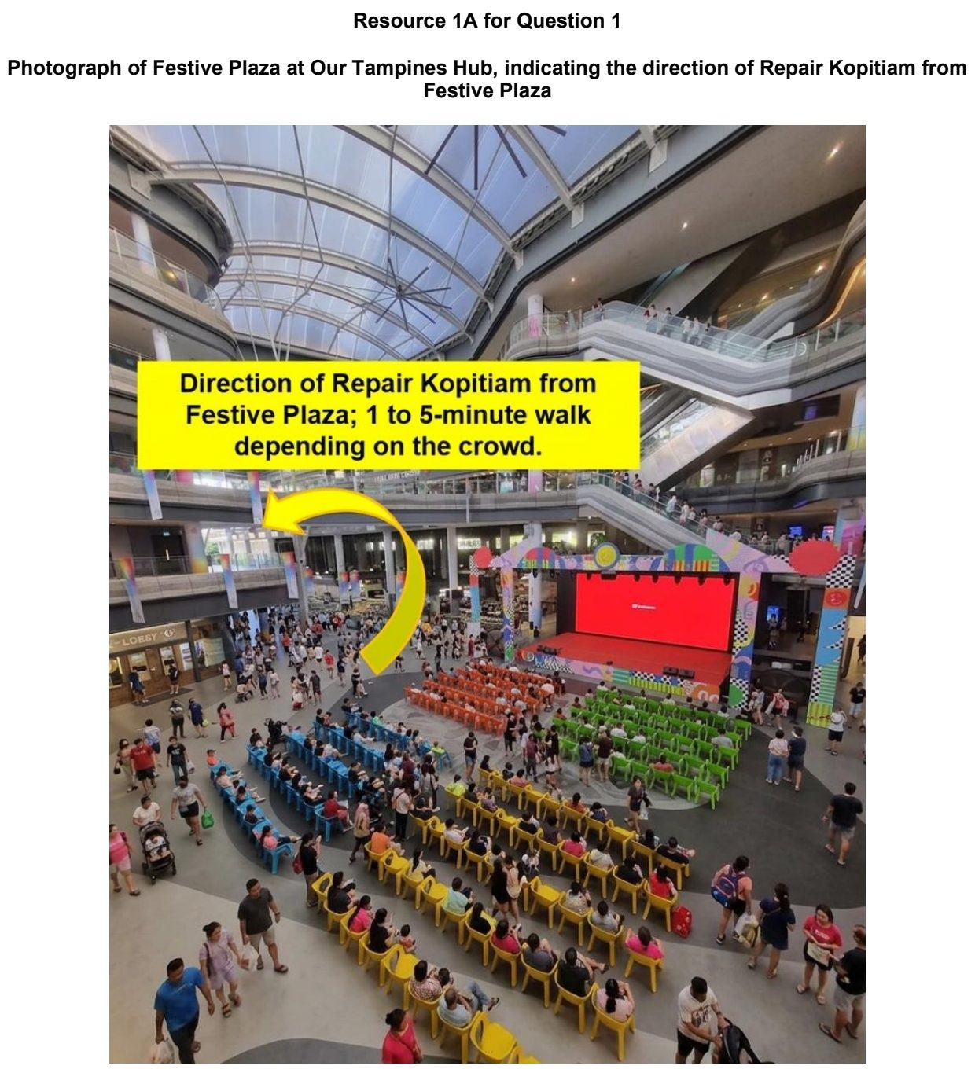

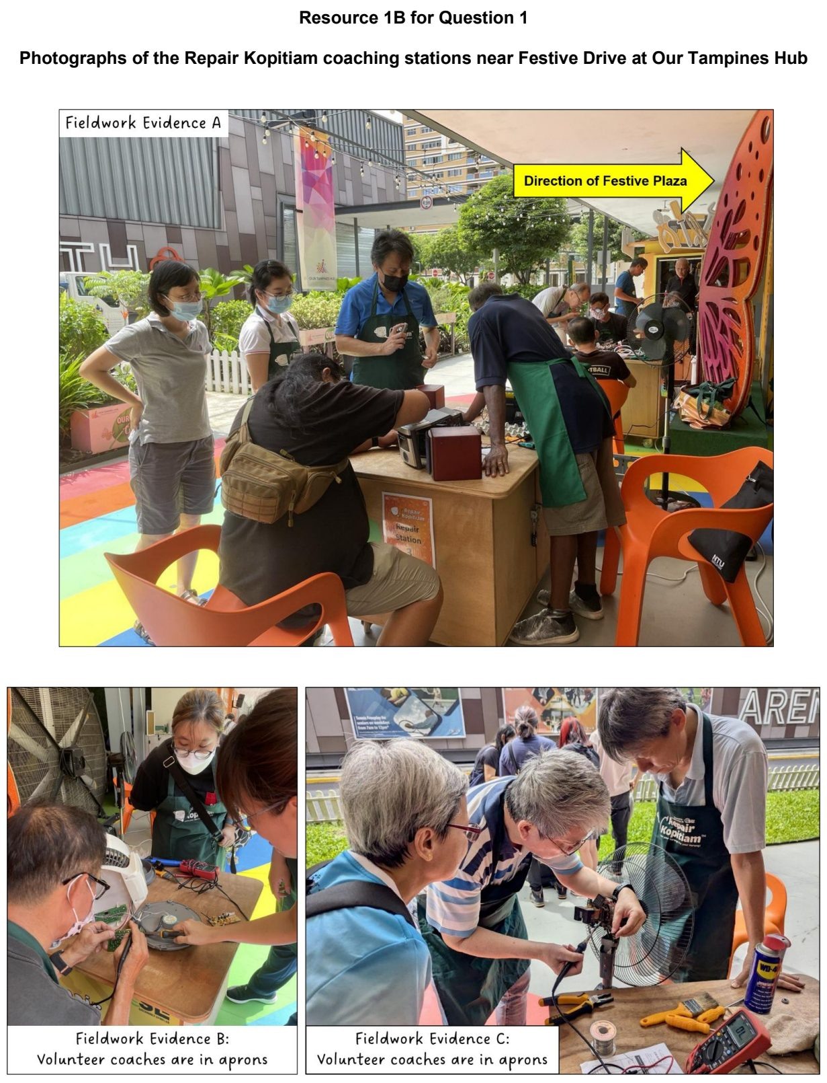

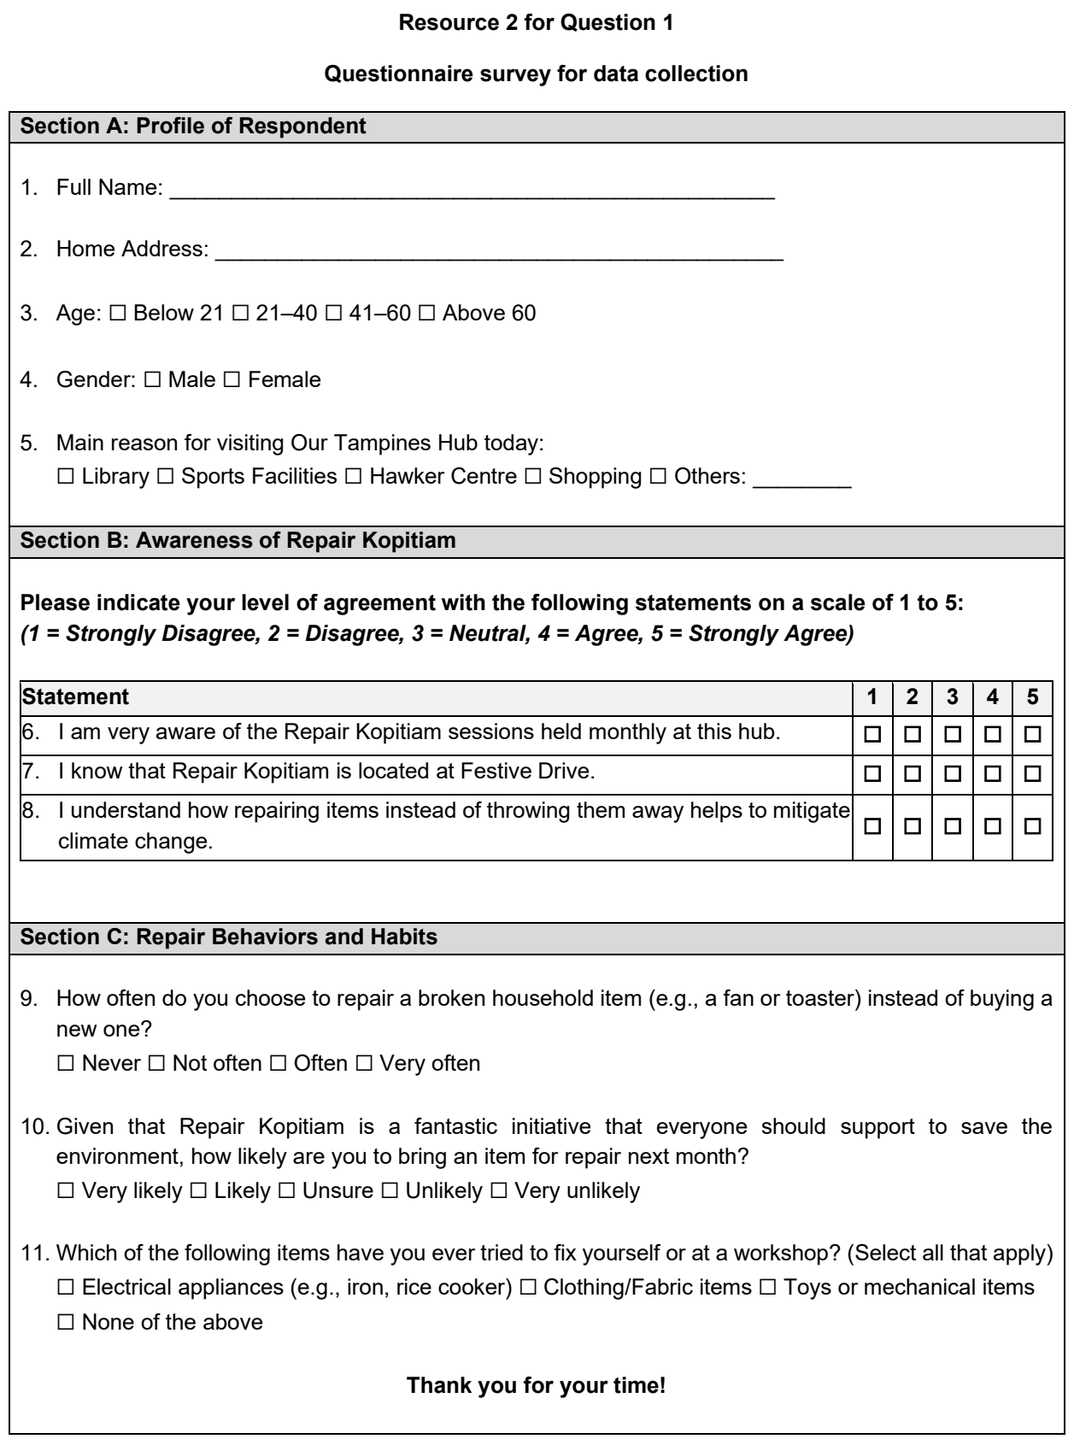

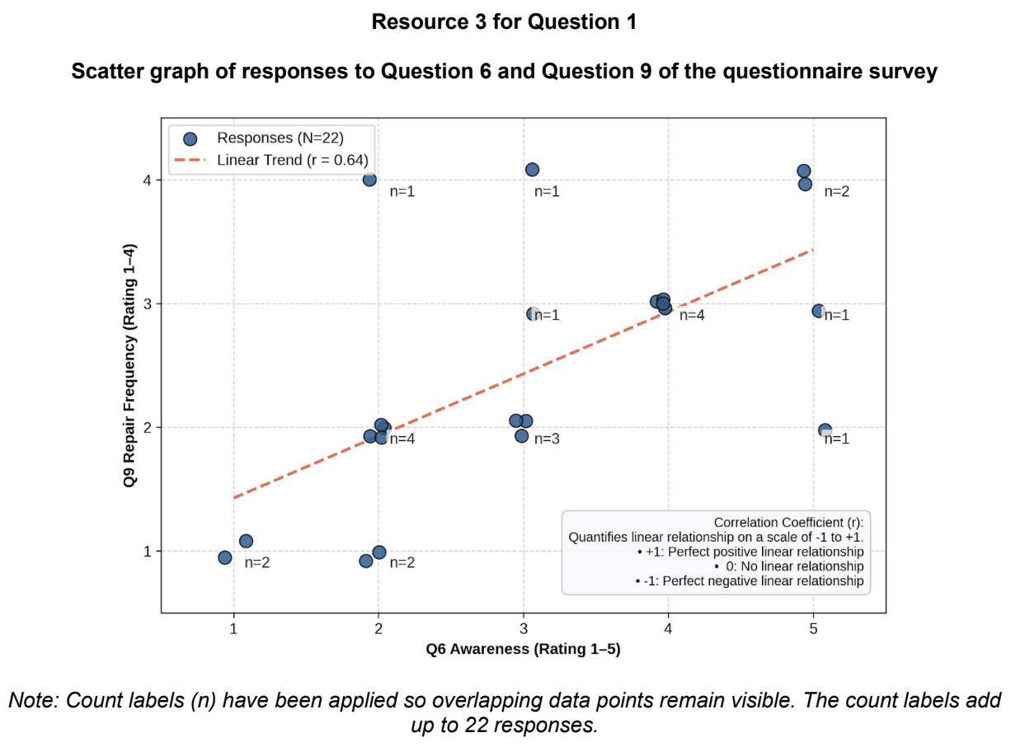

DHS 2026 — H1 Paper 1 (8834/01), Q1 [30 marks]
Syllabus: 2 Fieldwork | Fieldwork area: Community response to CC
Section A — Cluster 2 Fieldwork
Eight students undertook an investigation into access to heat-relief facilities in Chinatown, Boston City, Massachusetts, USA. These facilities are established and managed by local community organisations. They examined the relationship between heat exposure and access to heat-relief facilities by investigating the hypothesis:
“Residents of Boston Chinatown living in areas of greater heat exposure have better access to heat-relief facilities.”
They selected four residential sites A, B, C and D, within Boston Chinatown. They collected data between 1.00 p.m. and 3.00 p.m. on a weekday in July, during the summer period.
Two students were assigned to each site. At their assigned site, they measured air temperature using a digital thermometer and estimated the percentage of shade cover. Both students then walked separately from their respective sites to the nearest heat-relief facility, and their recorded walking times were added together and divided by two to obtain the mean walking time. They also conducted a questionnaire survey with the first 10 adult respondents at each site, who were available and willing to participate, about their perceived accessibility of heat-relief facilities.
Resource 1 is a map of Boston Chinatown showing Sites A, B, C and D and heat-relief facilities. Resource 2 shows information about the age profile of respondents and Boston Chinatown residents. Resource 3 shows the findings of the investigation at the four sites.
(a) Explain one strength and one weakness in the students’ hypothesis. [4]
(b) With reference to Resource 1, explain the strengths and limitations of the students’ choice of the four sites. [4]
(c) Explain the ethical issues that may arise from the students’ investigation. [3]
(d) Explain why the walking time recorded by the students may not be a fully valid measure of residents’ access to heat-relief facilities. [4]
(e) Using Resource 3, construct a suitable graph to show the relationship between air temperature and mean walking time at the four sites. [5]
(f) The students concluded that residents living in areas of greater heat exposure have better access to heat-relief facilities. Evaluate the validity of their conclusion. [10]

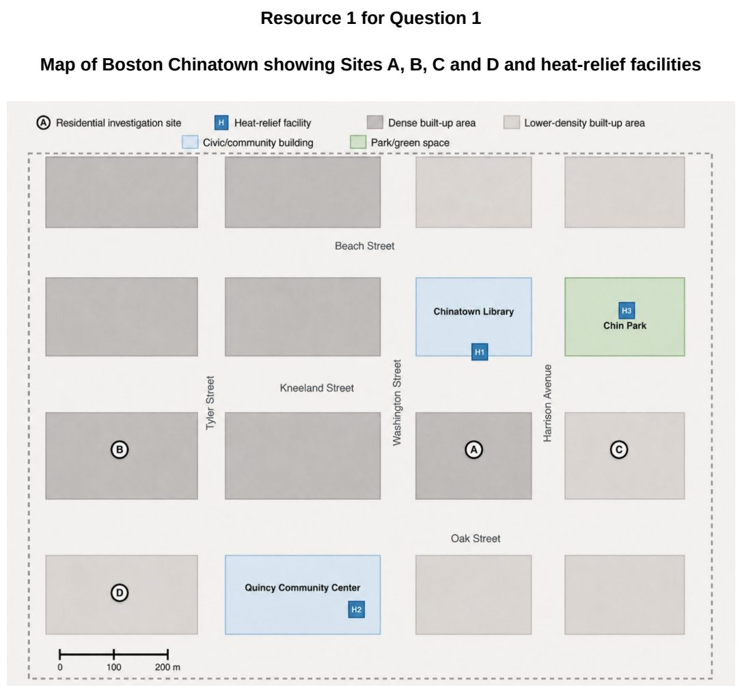

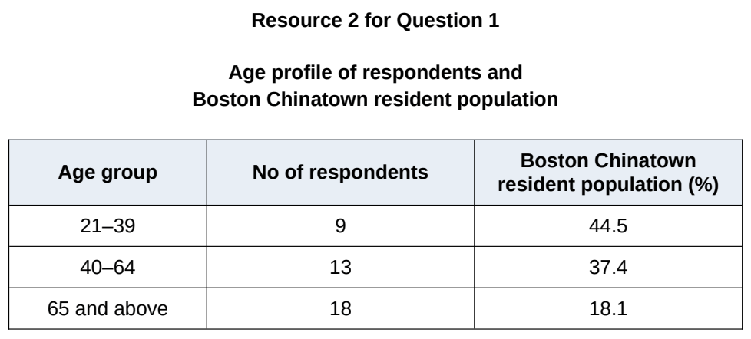

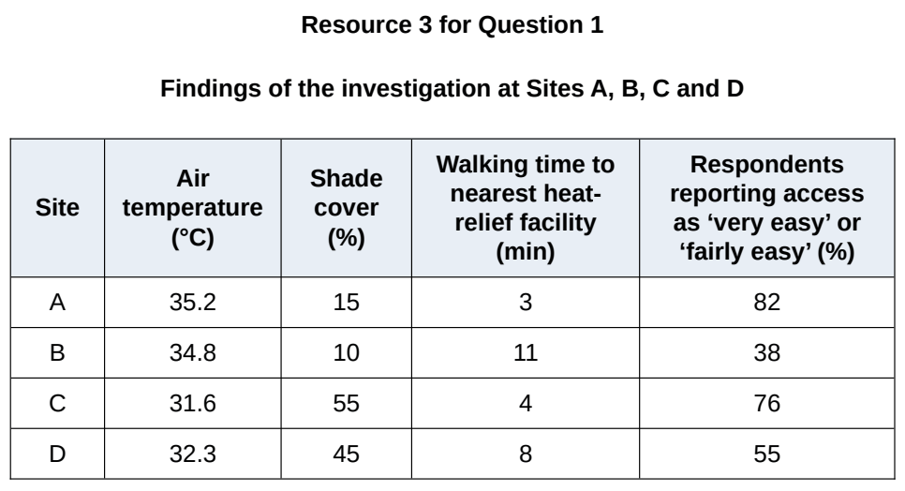

EJC 2026 — H1 Paper 1 (8834/01), Q1 [30 marks]
Syllabus: 2 Fieldwork | Fieldwork area: Community response to CC
Section A — Cluster 2 Fieldwork
A group of five neighbourhood enthusiasts from Tiong Bahru wanted to find out if the recently implemented smart recycling machine called REhub is well-received by residents, after getting inspired by an article they read from Channel News Asia. They came up with the following hypothesis:
“The introduction of REhub in Tiong Bahru has encouraged its residents to recycle.”
The group printed out questionnaire surveys and placed them under the doors of all the residential units in the housing estate. Once residents completed the surveys, they could drop them off at a collection box placed next to REhub in Tiong Bahru Community Centre.
Resource 1 is a map of the housing estate in Tiong Bahru, with an outline of the investigation site. Resource 2 shows an extract of the article from Channel News Asia. Resource 3 shows the questionnaire survey used. Resource 4 shows the data collected for Question 8.
(a) Explain how the hypothesis is appropriate. [4]
(b) Explain the pros and cons of the sampling method used in conducting the questionnaire surveys. [6]
(c) Explain how the questionnaire survey in Resource 3 can be improved. [6]
(d) Sketch a suitable graph to represent the data for Question 8 as shown in Resource 4. [4]
(e) Evaluate the validity of the enthusiasts’ fieldwork. [10]

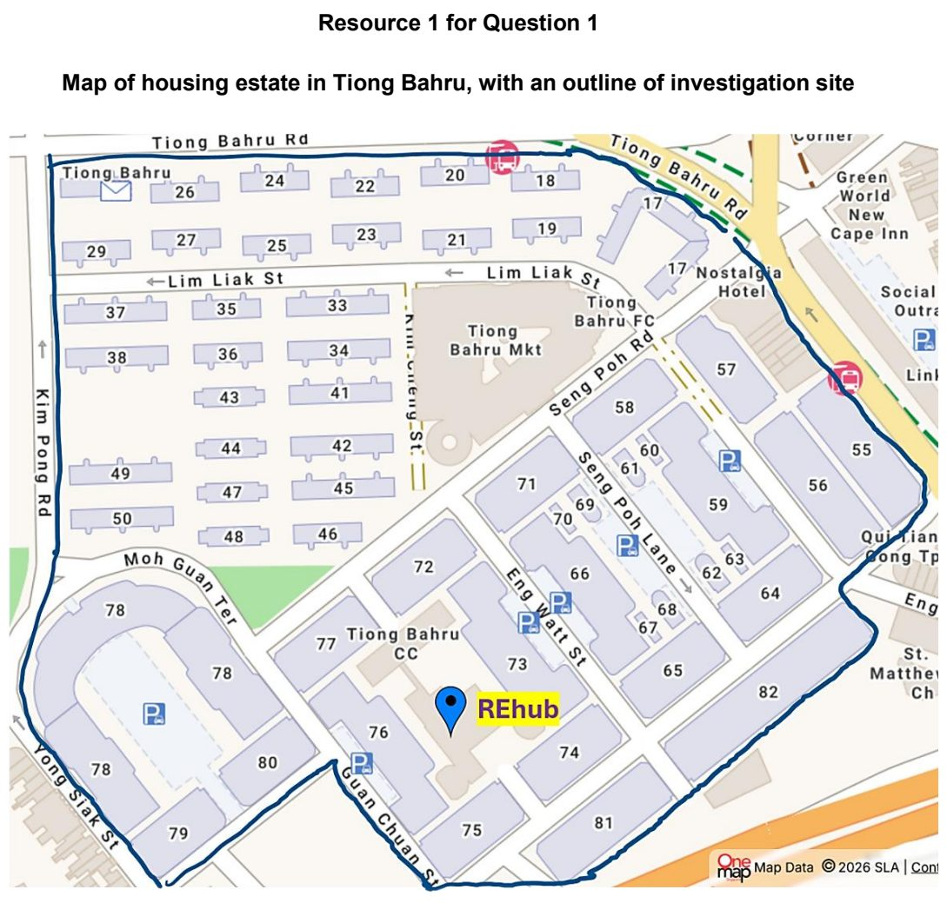

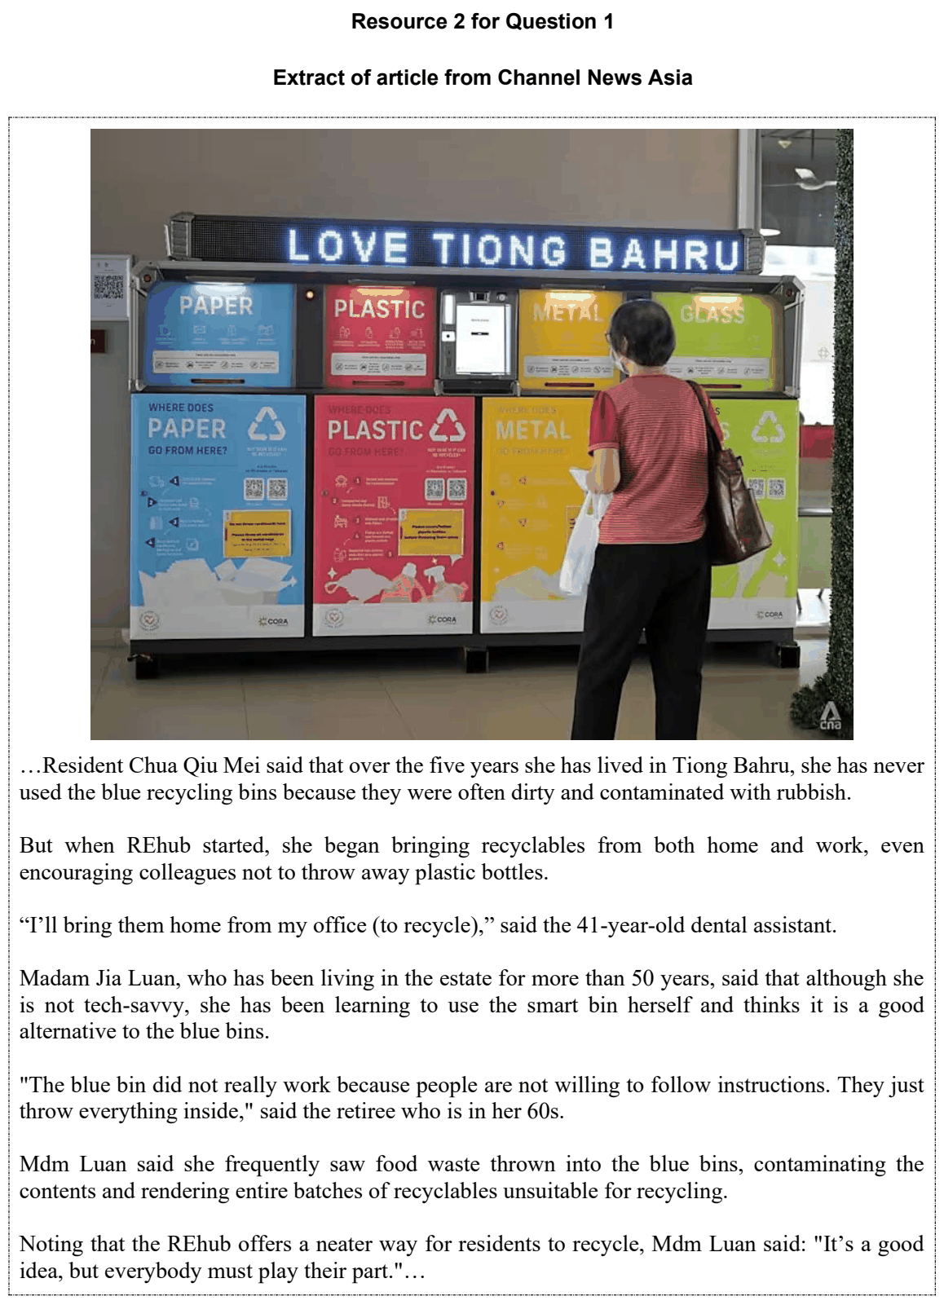

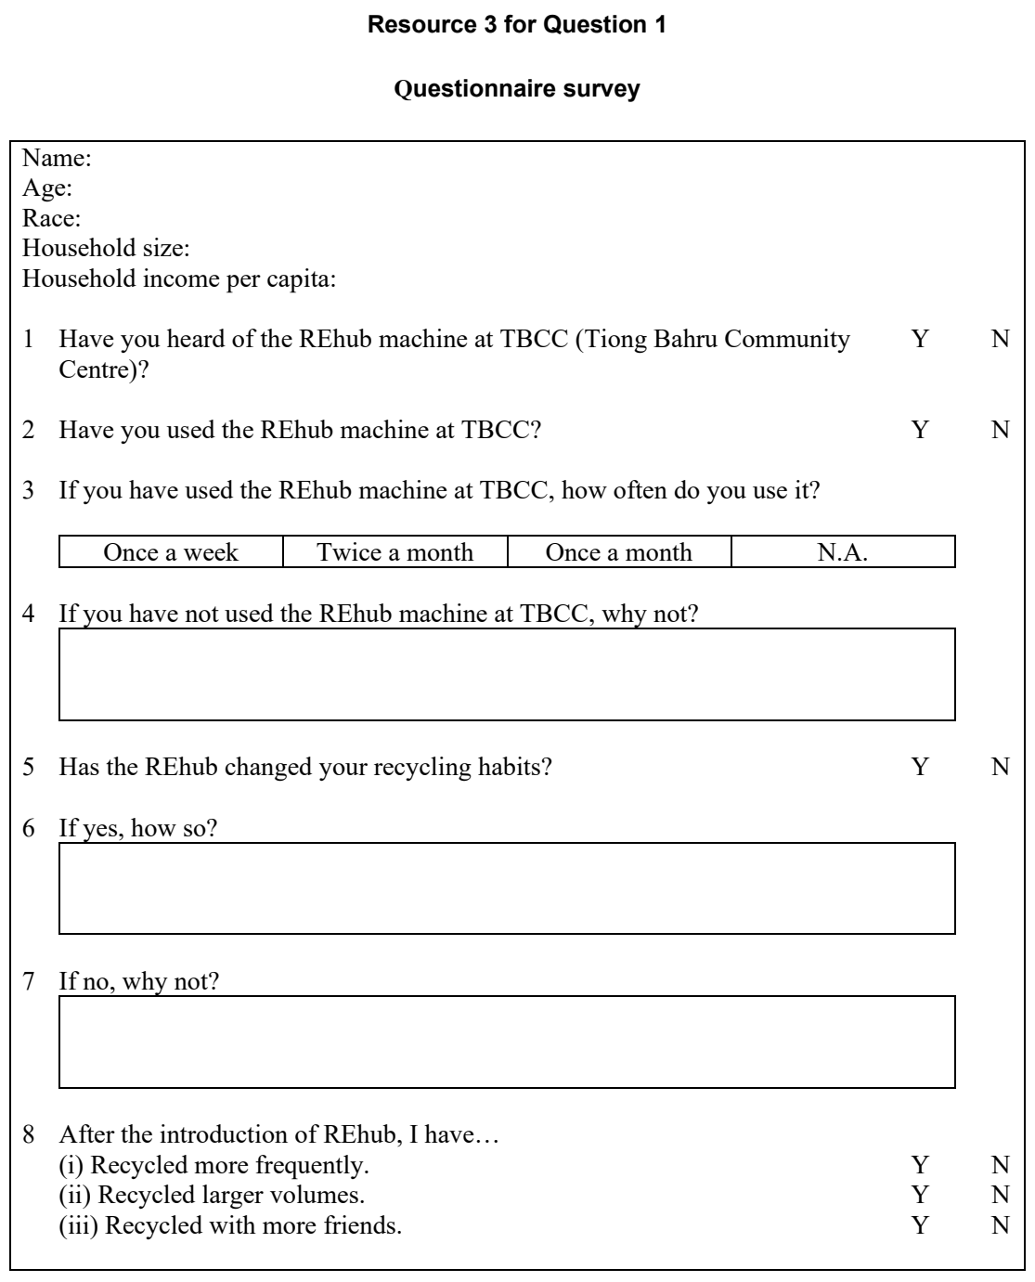

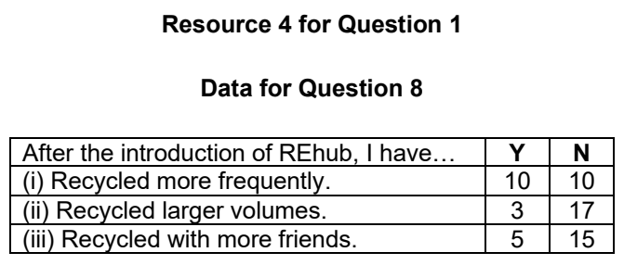

HCI 2024 — H1 Paper 1 (8834/01), Q1 [30 marks]
Syllabus: 2 Fieldwork | Fieldwork area: Community response to CC
Section A — Cluster 2 Fieldwork
Four 17-year old students undertook an investigation about the perception of consumers of community responses to climate change in Singapore. They examined the perception of consumers by investigating the hypothesis -
‘Consumers in Singapore see a stronger role for community response than for government and businesses in tackling climate change.’
Community response was defined as ‘any action carried out by non-governmental and non-corporate stakeholders’.
The students collected primary data by conducting a survey in May and did so by asking their friends to participate in an online survey and sought their help to forward the link to family and friends. When they were unable to reach their targeted sample size of 100 respondents, the students decided to expand their number of responses for the survey by conducting the survey individually outside a busy shopping mall - Bugis Junction - on a Wednesday and Thursday afternoon. Passers-by were approached to do the survey.
In addition to the survey, the students conducted face-to-face interviews with 6 family members and neighbours, including two elderly neighbours. The students also conducted some research on consumers’ perception on climate change and found some data from a perception survey conducted by the National Climate Change Secretariat (NCCS) in 2019.
Resource 1 shows street-level views outside Bugis Junction. Resource 2 shows surveyed Singapore consumers’ perception of different actors’ importance in fighting climate change. Resource 3 shows 2019 selected survey findings by NCCS about Singapore consumers’ perception on the responsibility of different actors in fighting climate change.
(a) Explain why the hypothesis is appropriate for the investigation. [3]
(b) With reference to Resource 1, suggest the challenges that the students may face conducting the survey online and at Bugis Junction. [4]
(c) With reference to Resource 1, suggest how the students could minimise potential risks when administering the survey at Bugis Junction. [5]
(d) Explain the ethical considerations that the students should take note of when conducting the interviews with family members and neighbours. [4]
(e) Compare the consumers’ perception of the actors’ importance in fighting climate change shown in Resource 2. [4]
(f) The students concluded that consumers in Singapore think that community response to climate change is more important than the government and businesses. With reference to Resources 1, 2 and 3, evaluate the validity of their conclusion. [10]

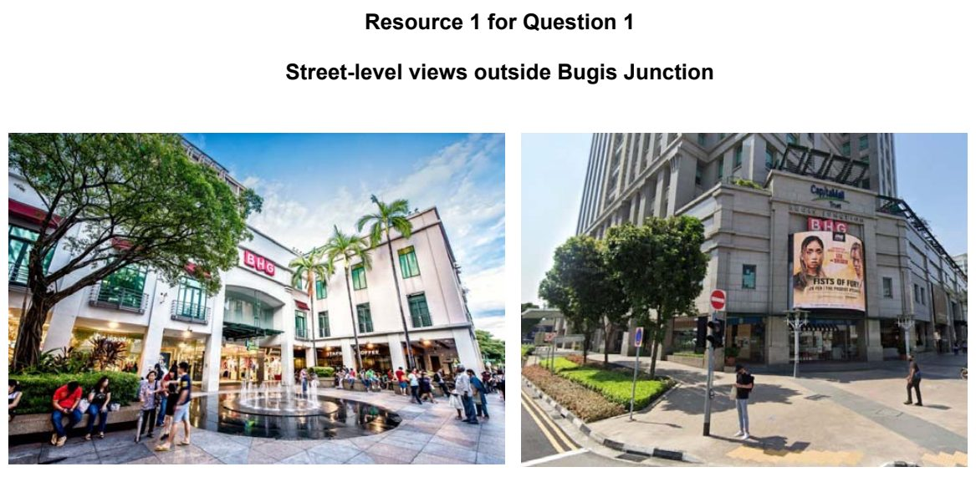

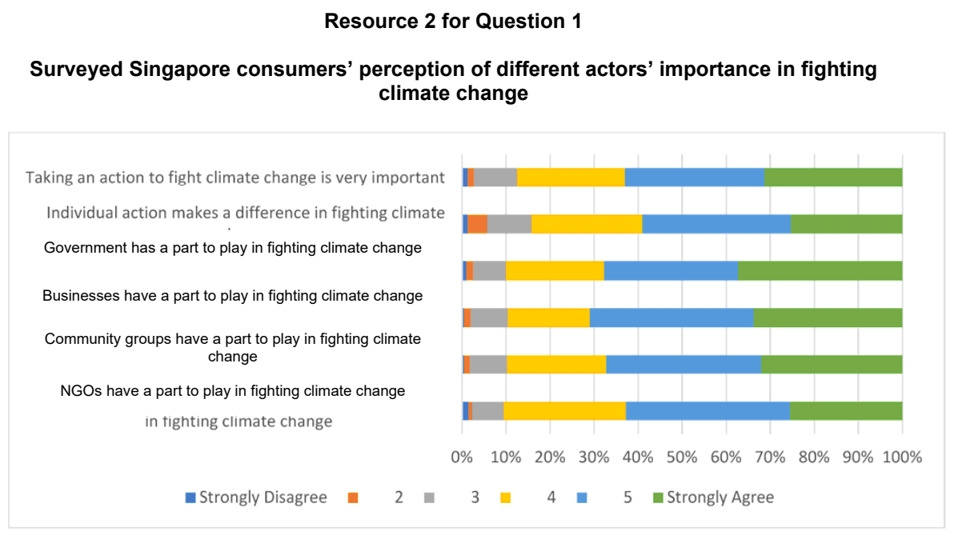

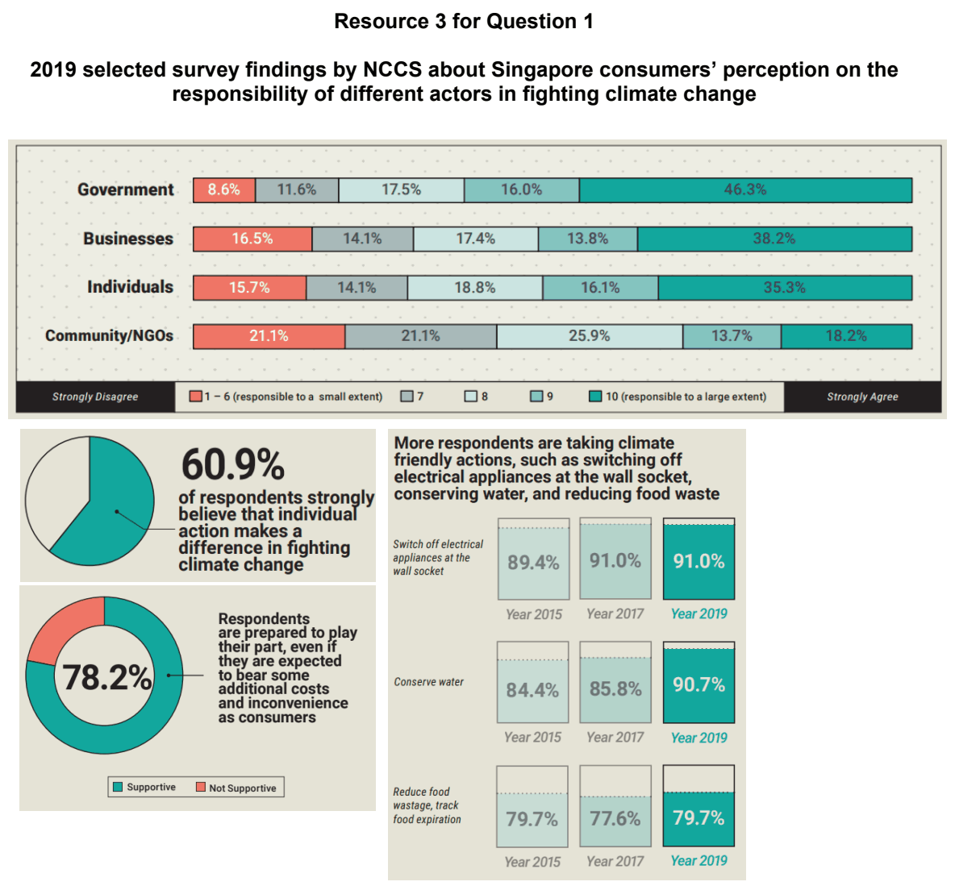

HCI 2026 — H1 Paper 1 (8834/01), Q1 [30 marks]
Syllabus: 2 Fieldwork | Fieldwork area: Community response to CC
Section A — Cluster 2 Fieldwork
A group of four Geography students in Singapore investigated the effectiveness of sheltered walkways as an adaptation strategy for residents coping with rising temperatures. They focused on a route between an HDB residential block next to their school and a nearby Mass Rapid Transit (MRT) station.
The students noted that while a sheltered walkway existed, it was incomplete as the walkway did not cover the entire route to the MRT station. Instead of walking to the MRT station from their homes, many residents continued to take a bus to the MRT station.
The students came up with the following geographical question for their fieldwork:
“Why do residents take a bus to the MRT train station instead of using the walkway?”
They divided themselves into two pairs, and conducted their fieldwork from 4 to 6 pm, every Wednesday in May as it was their designated home-based learning (HBL) day. Each day, one pair would count the number of residents using the sheltered walkway to get to the MRT station, while another pair would count the number of residents alighting from the bus at the MRT station. The students also noted the weather and traffic conditions.
In addition, they used a digital temperature sensor to measure the ambient temperature at seven selected points along the route. They also noted the features and details of the immediate surroundings at each point. They did this at 2 pm on a sunny Thursday afternoon in June.
Resource 1A is a map showing the walking route and the selected temperature measurement points. Resource 1B shows a photograph of a section along the route between Measuring Points 6 and 7. Resource 2 shows the number of residents using the route in the month of May, together with the prevailing weather and traffic conditions on each day. Resource 3A shows the information collected at each selected point along the route in June. Resource 3B shows a picture of the digital temperature sensor.
(a) Explain why the students’ question is appropriate for their investigation. [3]
(b) With reference to Resources 1A and 1B, explain how students can minimise potential risks when conducting their fieldwork along the walkway between their school and the MRT train station. [4]
(c) Suggest reasons for the number of residents walking to the MRT train station shown in Resource 2. [4]
(d) With reference to Resources 1A, 1B, and 3A, explain why the students’ selection of the 7 temperature measurement points is appropriate. [5]
(e) With reference to Resources 3A and 3B, explain how the students can ensure the reliability of the ambient temperature data they collected. [4]
(f) The students concluded that residents do not use the sheltered walkway mainly because it did not fully cover the route between their homes and the train station. With reference to all the resources, evaluate the validity of the students’ conclusion. [10]

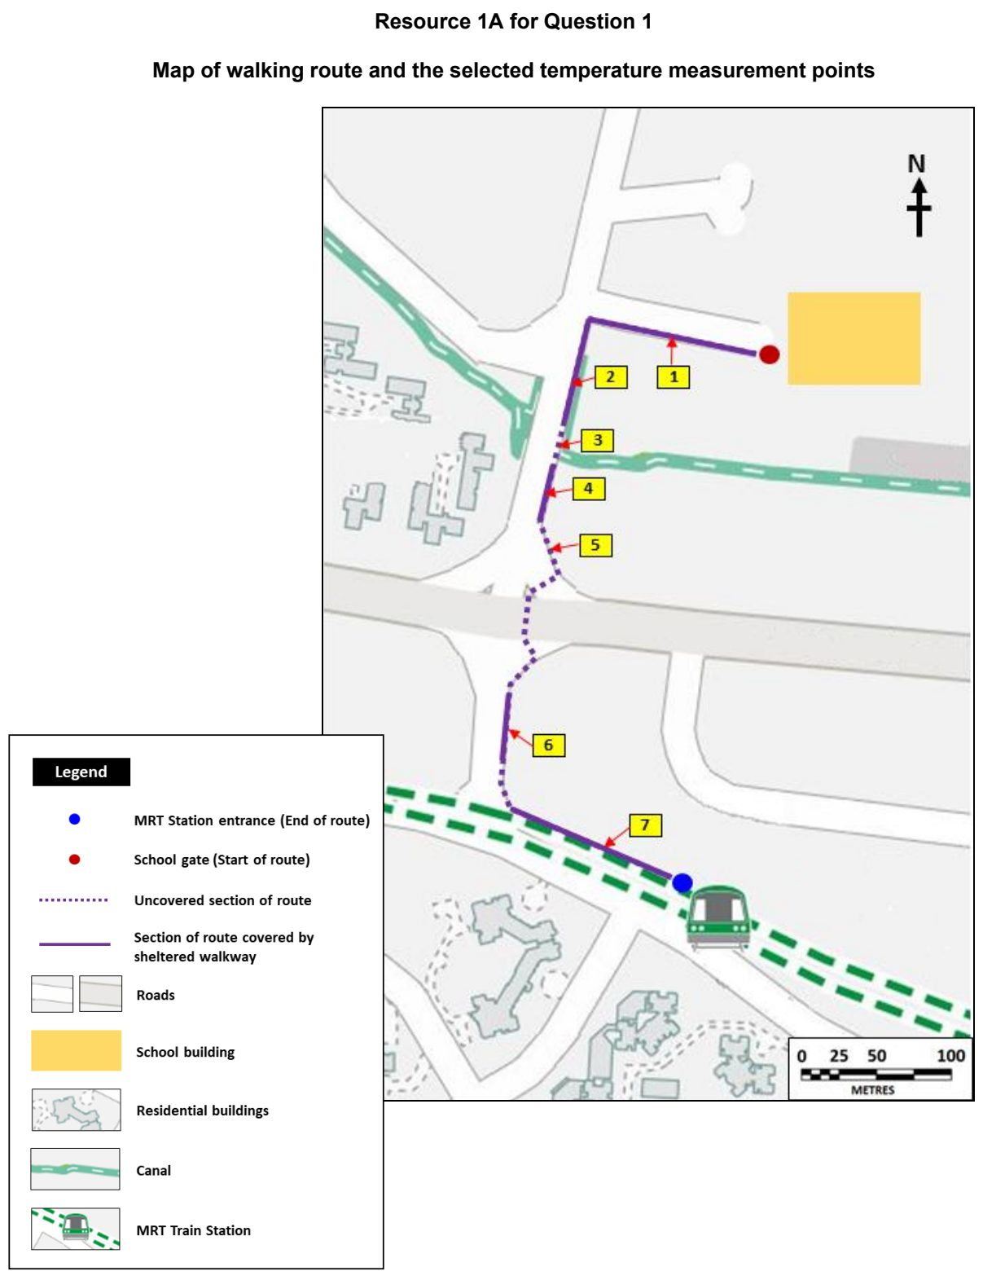

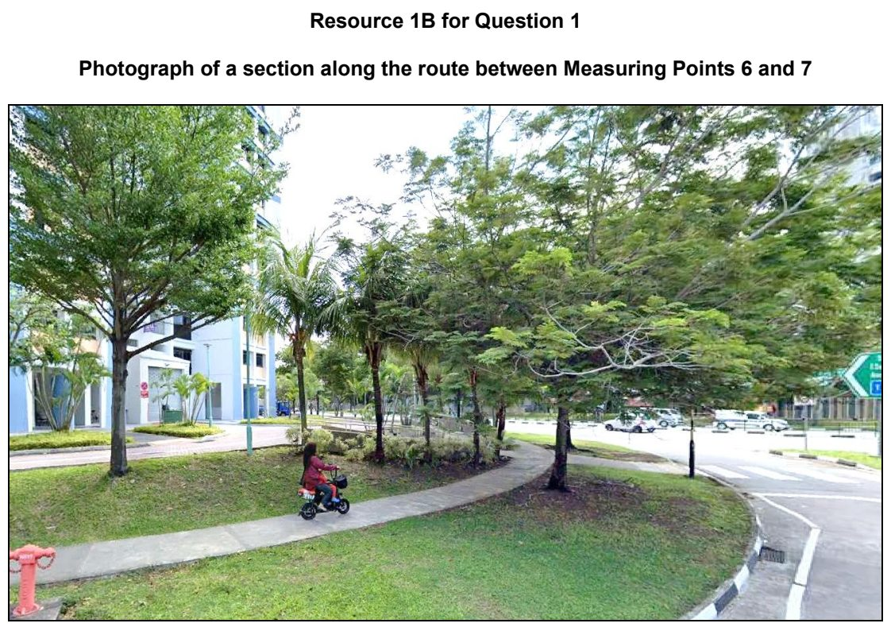

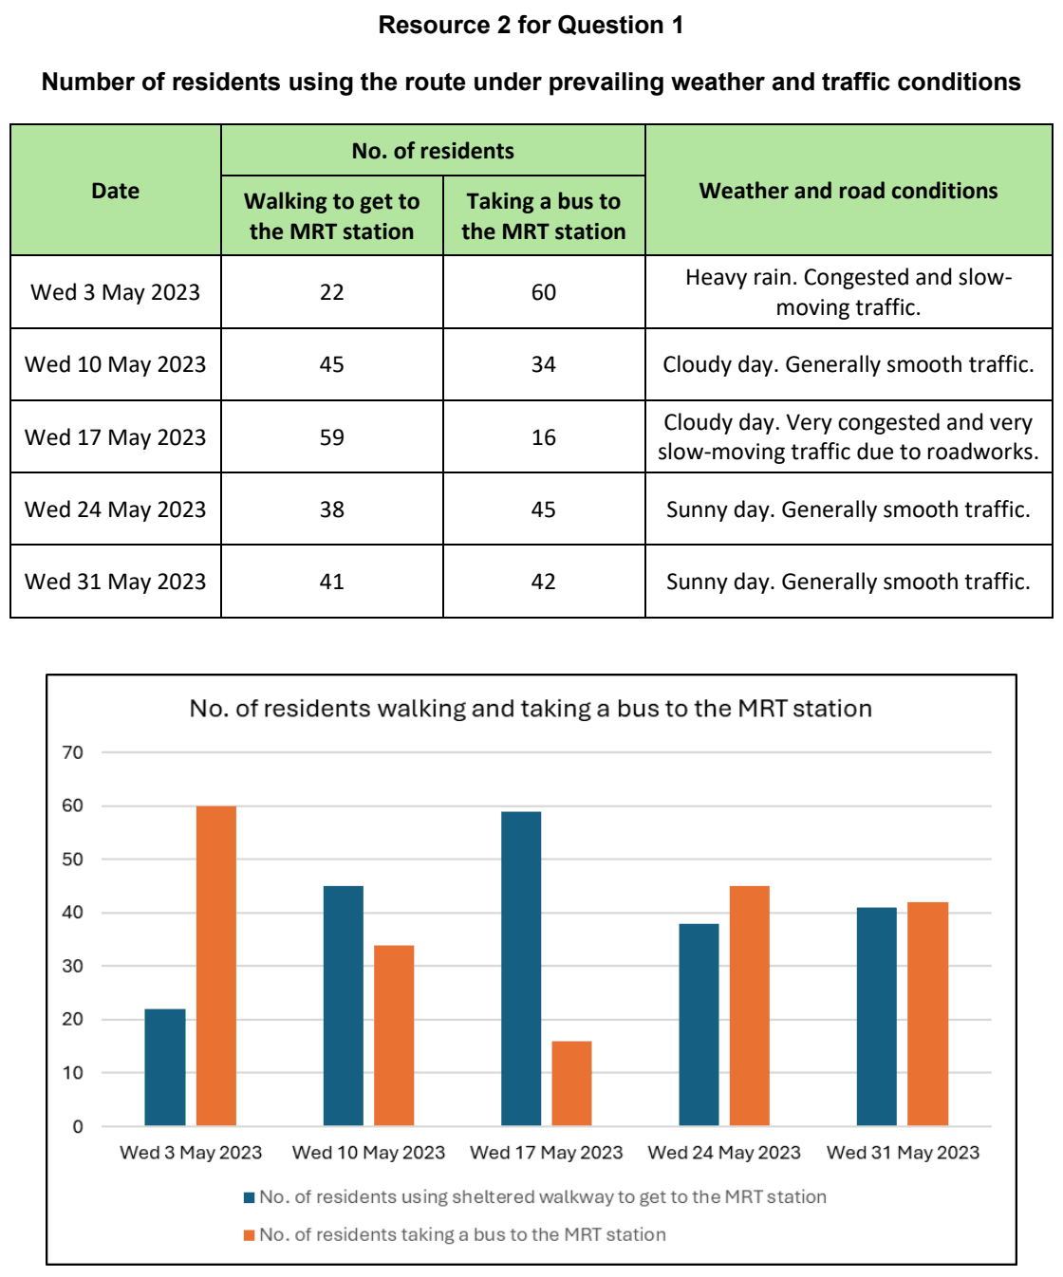

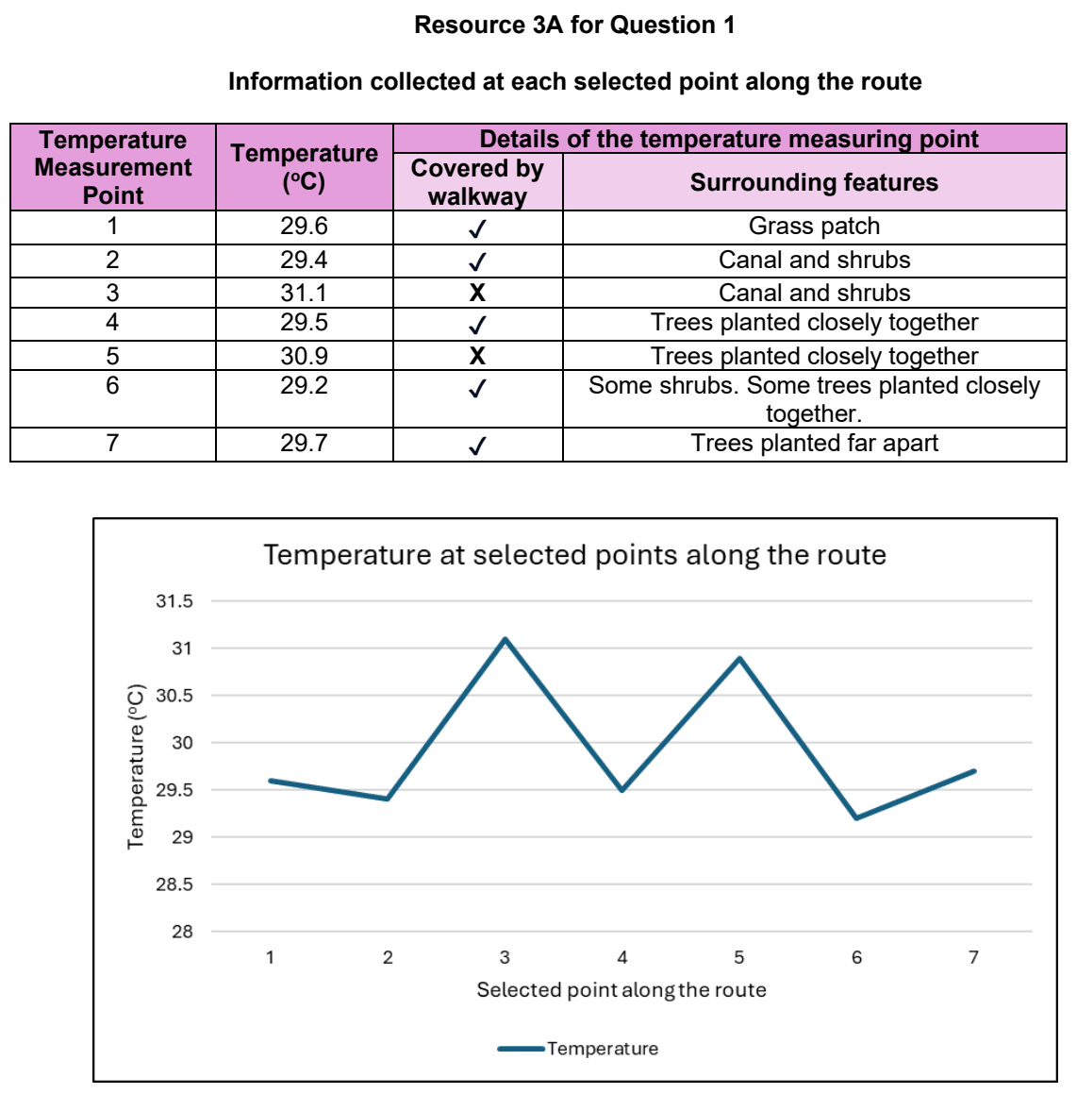

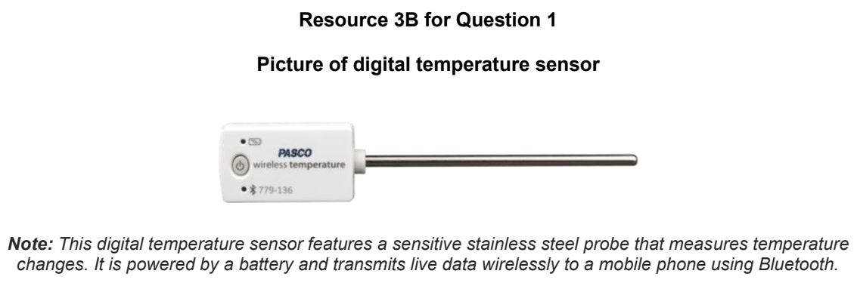

NYJC 2024 — H1 Paper 1 (8834/01), Q1 [30 marks]
Syllabus: 2 Fieldwork | Fieldwork area: Community response to CC
Section A — Cluster 2 Fieldwork
A group of 10 students wanted to investigate if businesses within the community is actively responding to climate change.
They visited Tampines IKEA (a mega home furnishing store) to find out their green initiatives, and did an investigation on people’s awareness and response to climate change actions in Tampines IKEA over a Saturday afternoon from 3pm-5pm where the shop is expected to be crowded to get a bigger sample size.
They developed a research question: Are businesses in Singapore doing enough to encourage climate change action?
The students went around Tampines IKEA in groups of 2 to observe the store and approached any person who was willing to do their questionnaire survey. They surveyed 20 persons in all, including one staff member. Most of those they surveyed were young couples who were there to get furniture for their new homes. They also went round to the showrooms and the restaurant to take photographs of areas they feel the business was doing enough to mitigate climate change.
Resource 1 shows pictures the students took of areas in Tampines IKEA where they felt the business was doing enough to mitigate climate change. Resource 2 shows the questionnaire that the students used to survey some of the shoppers there. Resource 3A and 3B shows the results of the questionnaire survey that the students did to show their questionnaire findings.
(a) Explain two weakness of the student’s research question. [4]
(b) With reference to Resource 1, explain two possible impacts the students might have while doing the investigation. [4]
(c) Suggest how the students could minimise three potential risks while doing their investigation at Tampines IKEA. [6]
(d) With reference to Resource 3A, explain how the students can improve the data presentation method. [6]
(e) Based on observations in Tampines IKEA and the results from the questionnaire survey, the students concluded that businesses in Singapore are doing enough to encourage climate change action. Evaluate the validity of their conclusion. [10]

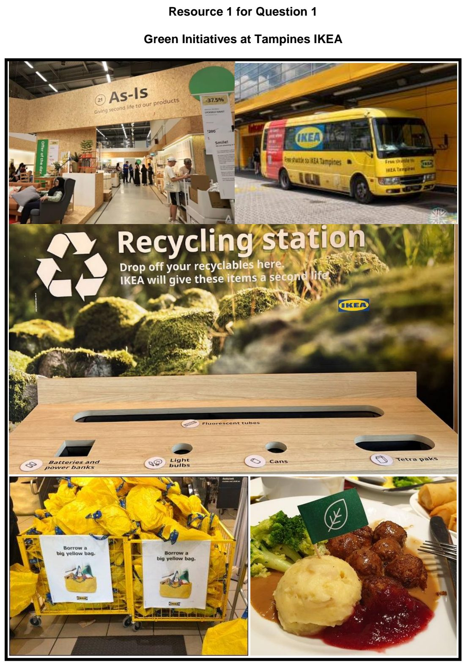

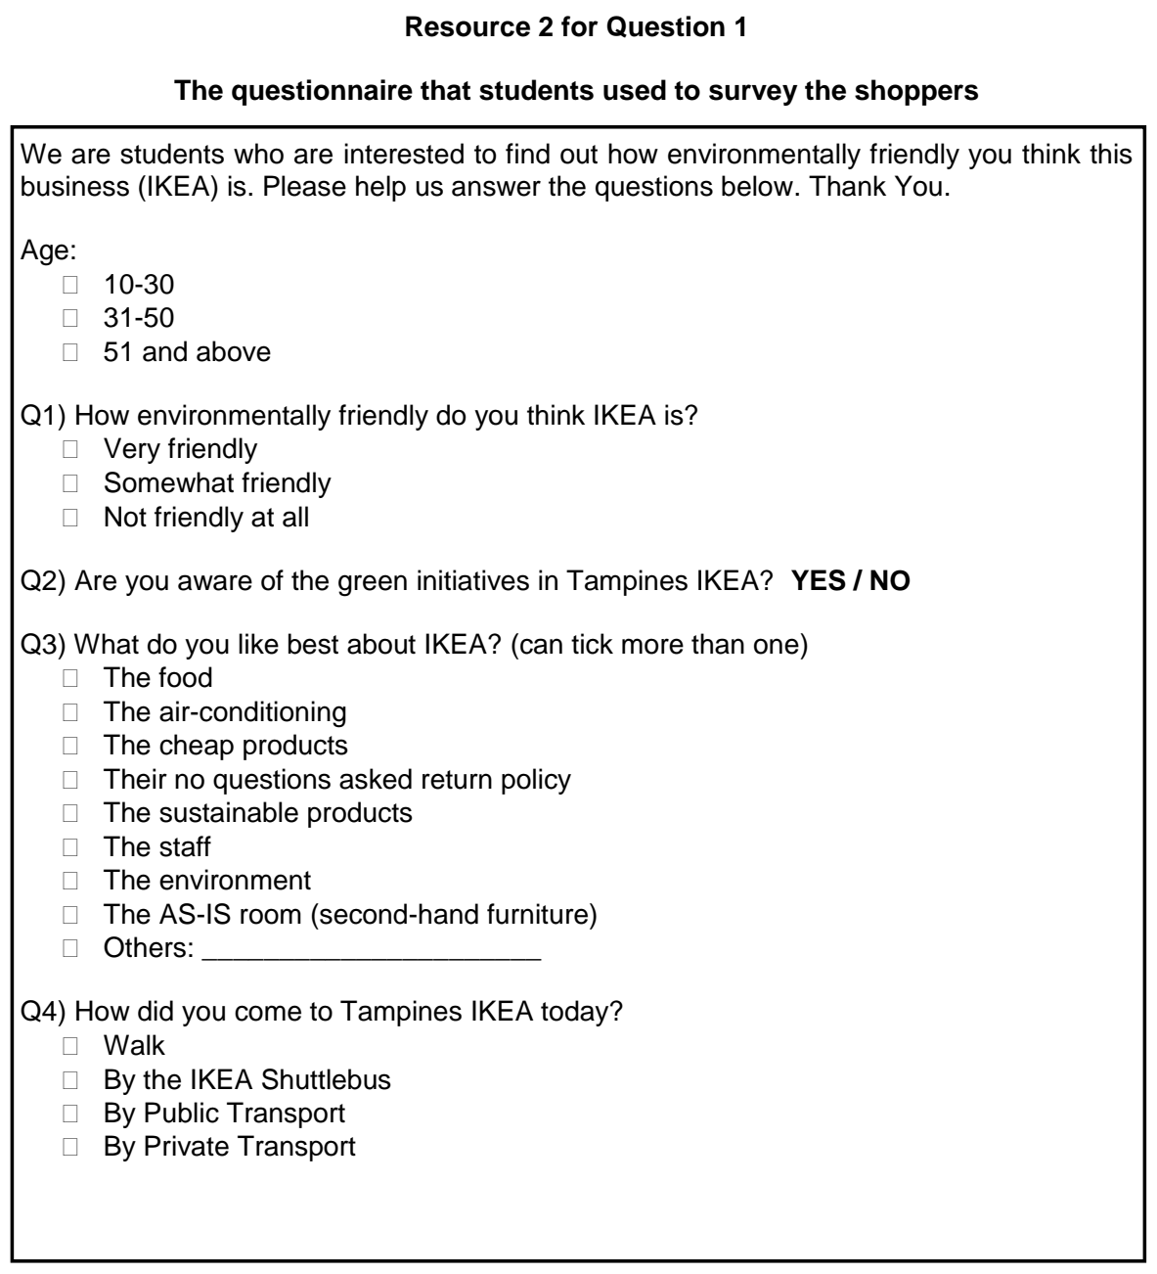

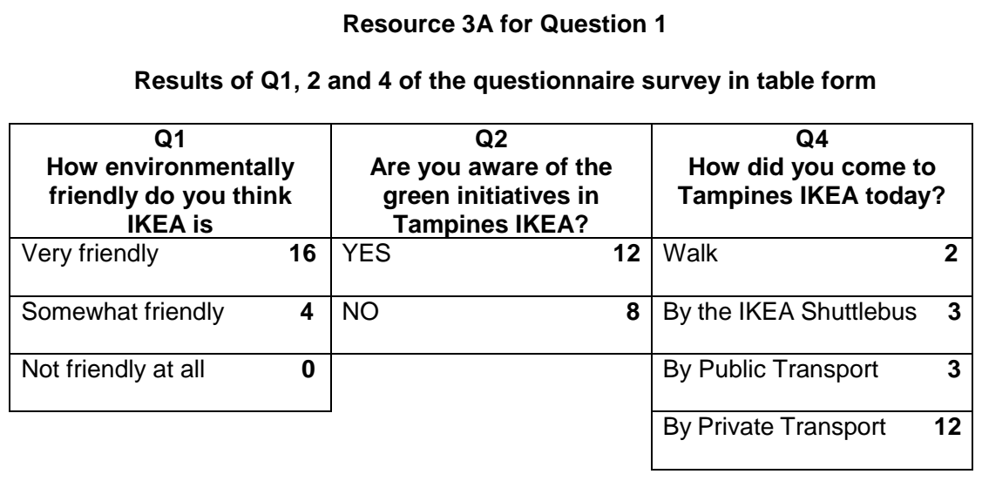

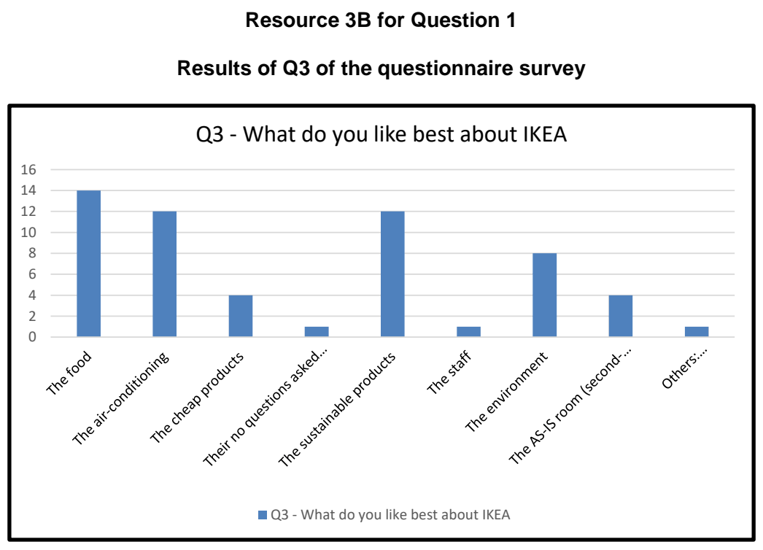

NYJC 2025 — H1 Paper 1 (8834/01), Q1 [30 marks]
Syllabus: 2 Fieldwork | Fieldwork area: Community response to CC
Section A — Cluster 2 Fieldwork — Responding to Climate Change in Punggol, Singapore
A group of four 18-year-old students in Singapore conducted a fieldwork investigation to examine how local communities in Punggol respond to climate change through climate-adaptive initiatives organised for residents.
The students proposed the following hypothesis:
“The presence of community climate initiatives in Punggol has enhanced residents’ awareness of and participation in sustainable practices as part of their response to climate change.”
To support their investigation, the students gathered secondary data from online sources and the Punggol Town Council on community initiatives that promote sustainable living and environmentally friendly practices. Based on preliminary research and observed community activity, they selected four sites for detailed study:
a. Punggol Waterway Park – Tree planting (50 trees) and organic mulching by NurtureStars Punggol.
b. One Punggol – MakeIT space at Punggol Regional Library offering upcycling workshops (e.g., sewing, crafting).
c. Oasis Terraces – Community participation in rooftop gardening.
d. City Sprouts @ Punggol – Residents exploring a pop-up urban farming stall that promotes sustainable living.
The students conducted surveys with 25 respondents using random sampling at Punggol MRT during a weekday in June. The responses were then tabulated and presented in a results table.
Resource 1 shows a map of Punggol highlighting the four sites investigated. Resources 2A to 2D provide photographs of the four sites and their associated sustainable practices. Resource 3 is the questionnaire survey used to collect fieldwork data. Resource 4 presents the tabulated results of the survey questions.
(a) With reference to Resource 1, explain why the investigation is appropriate. [3]
(b) Explain three benefits of using surveys as a tool for data collection. [6]
(c) With reference to Resource 3, explain the strengths and weaknesses of the survey design. [6]
(d) Using a suitable data representation method, present the results to Question 5 from the survey shown in Resource 4, and justify your choice. [5]
(e) With reference to all the resources, evaluate the validity of the students’ conclusion that residents in Punggol are not participating actively in climate actions because they are not aware of climate-adaptive initiatives in the area. [10]

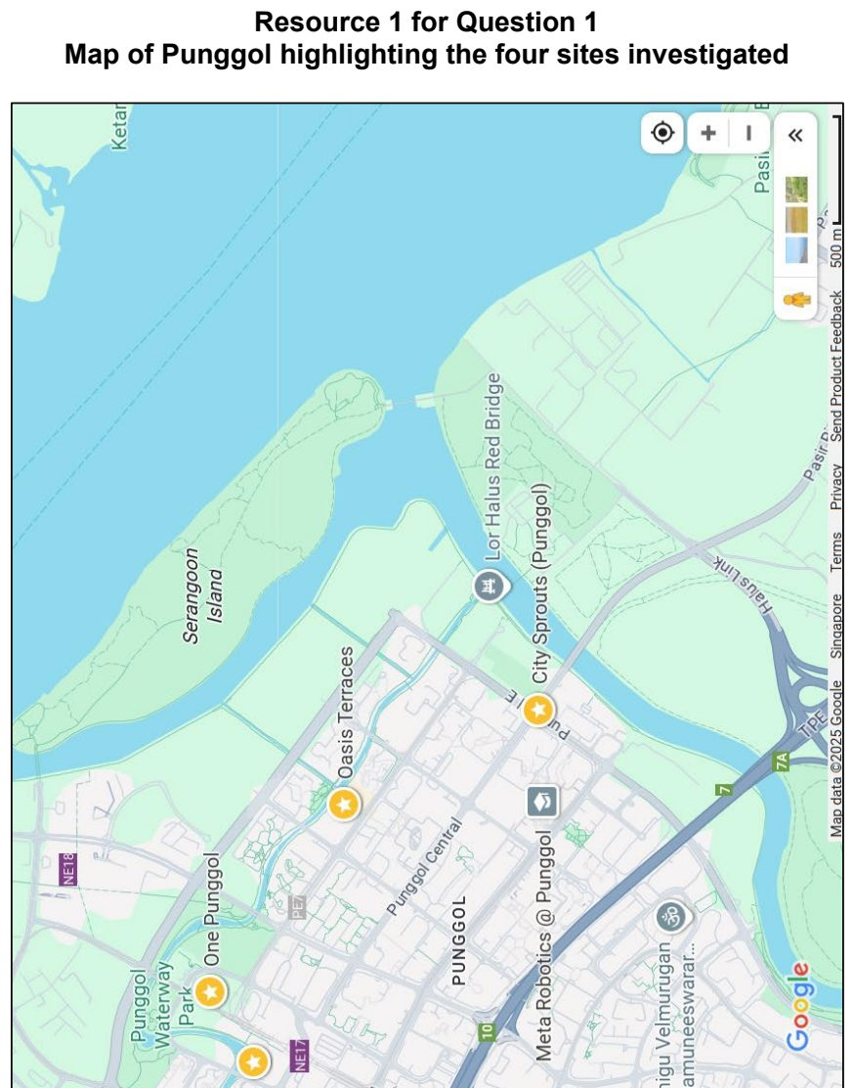
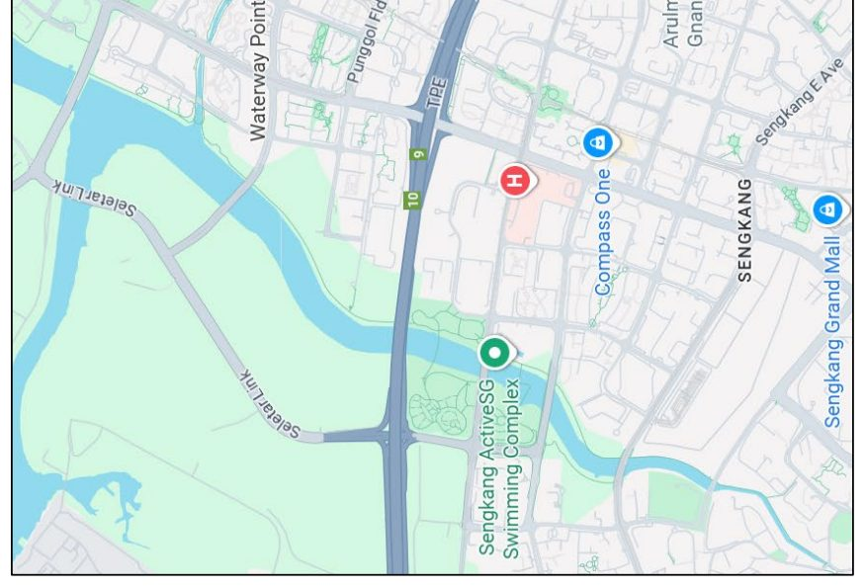

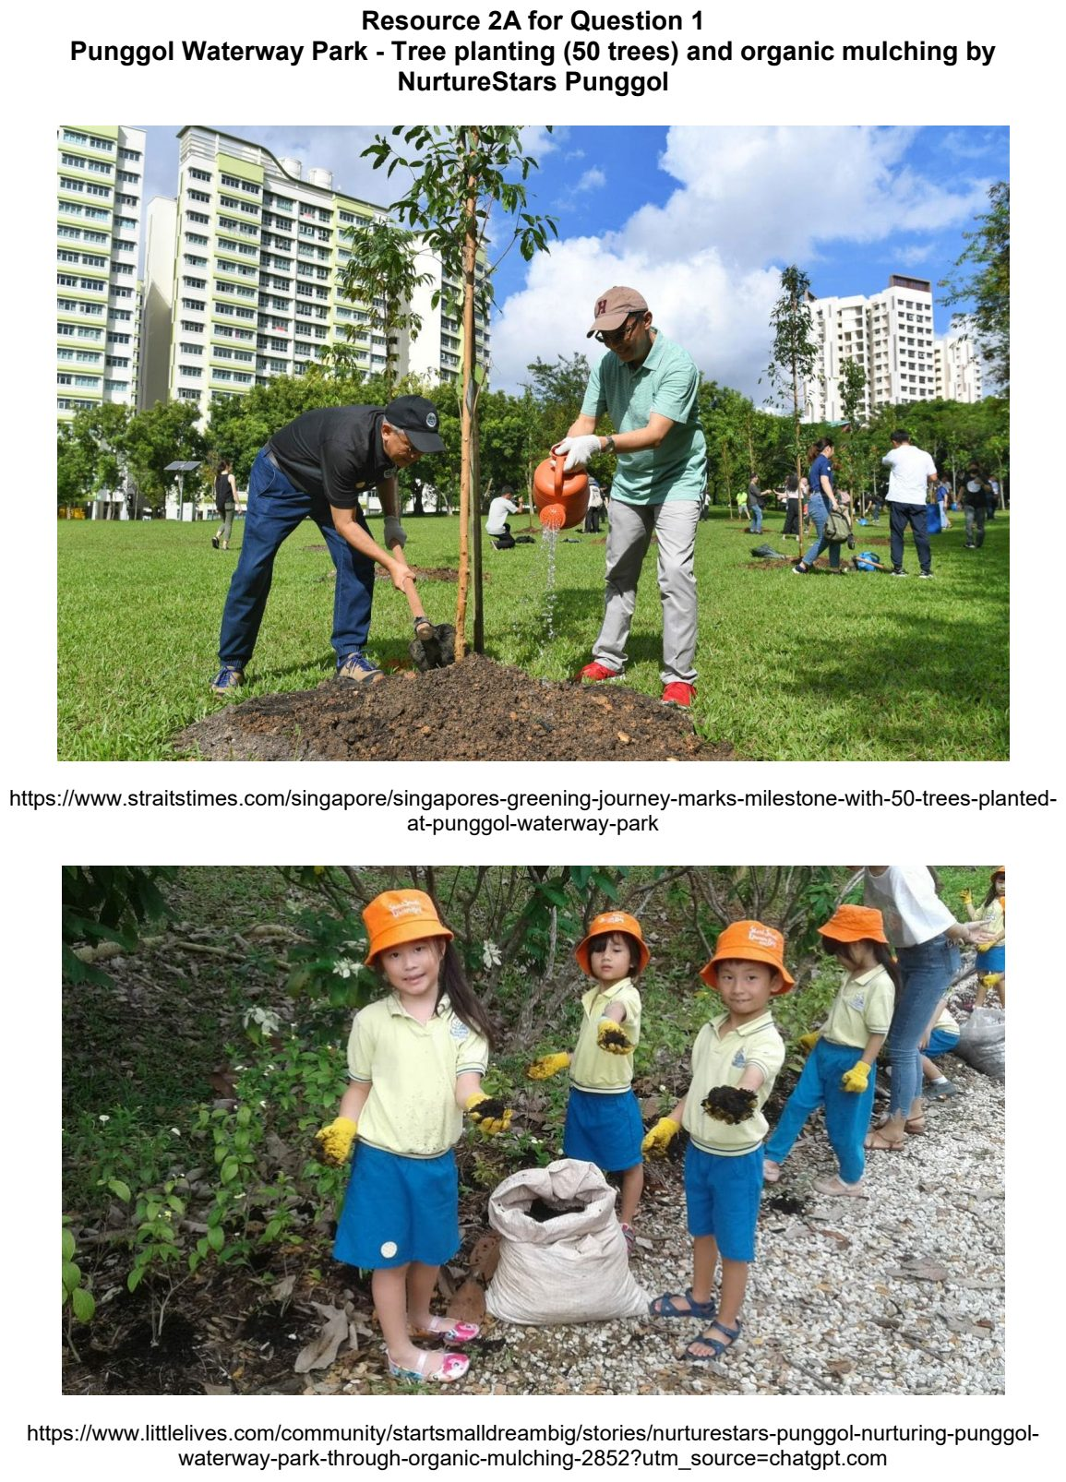

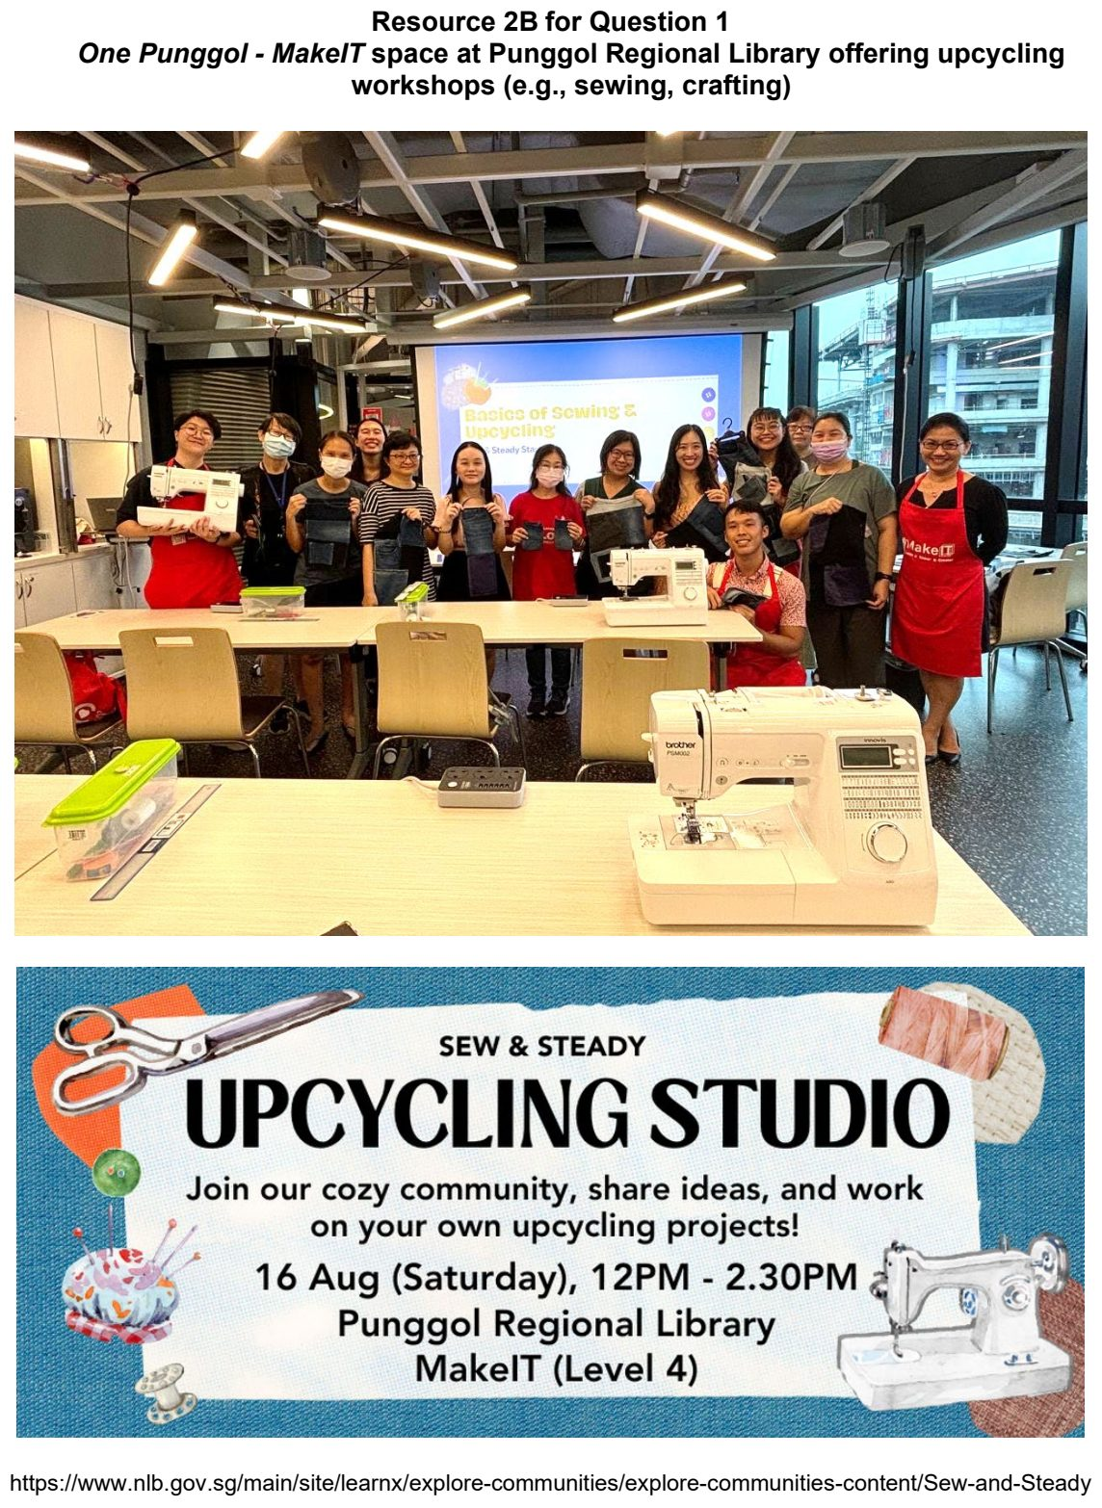

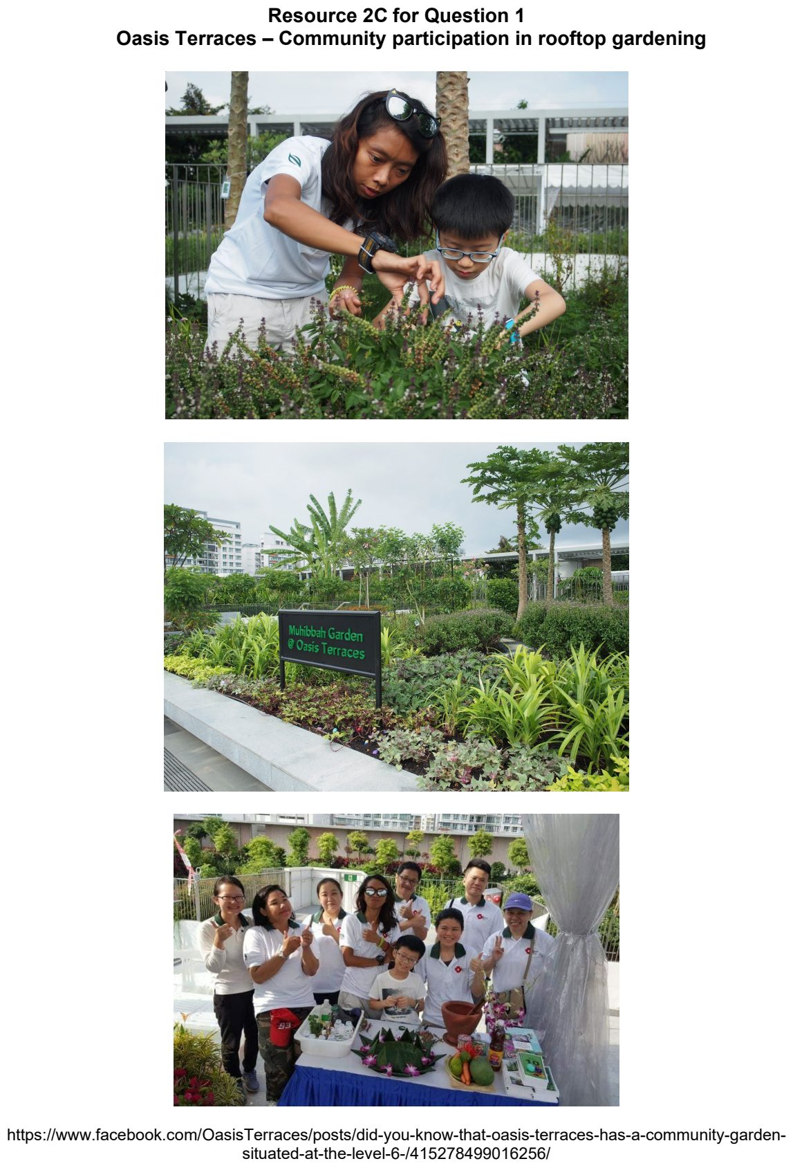

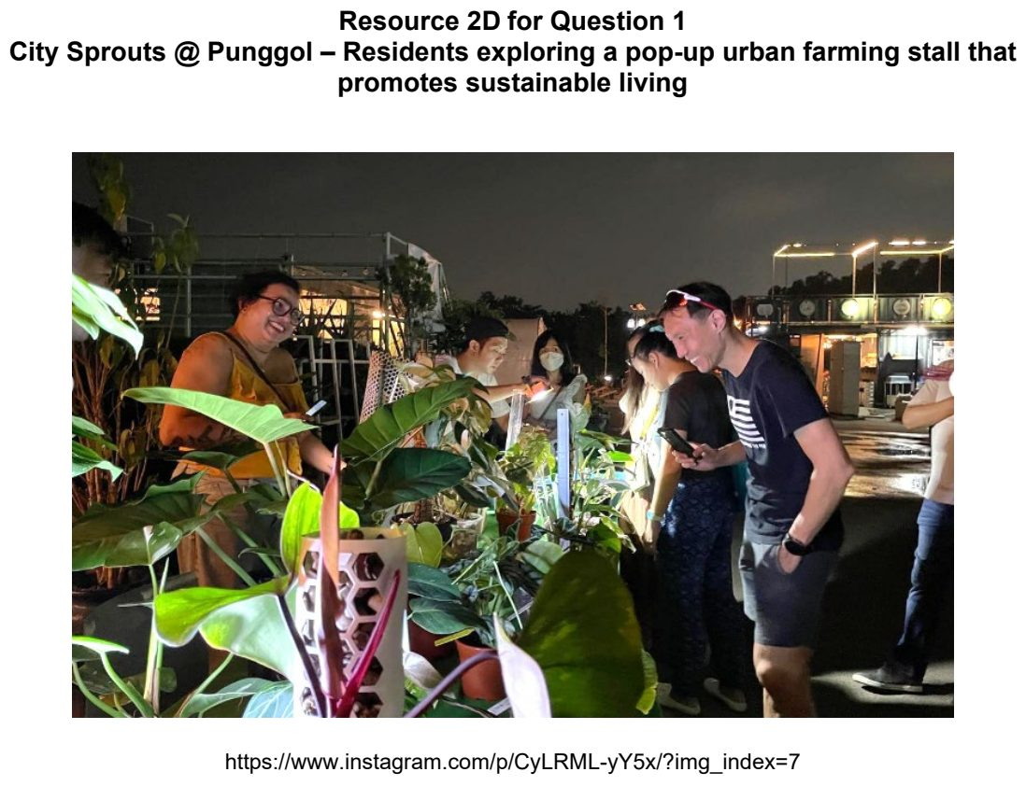

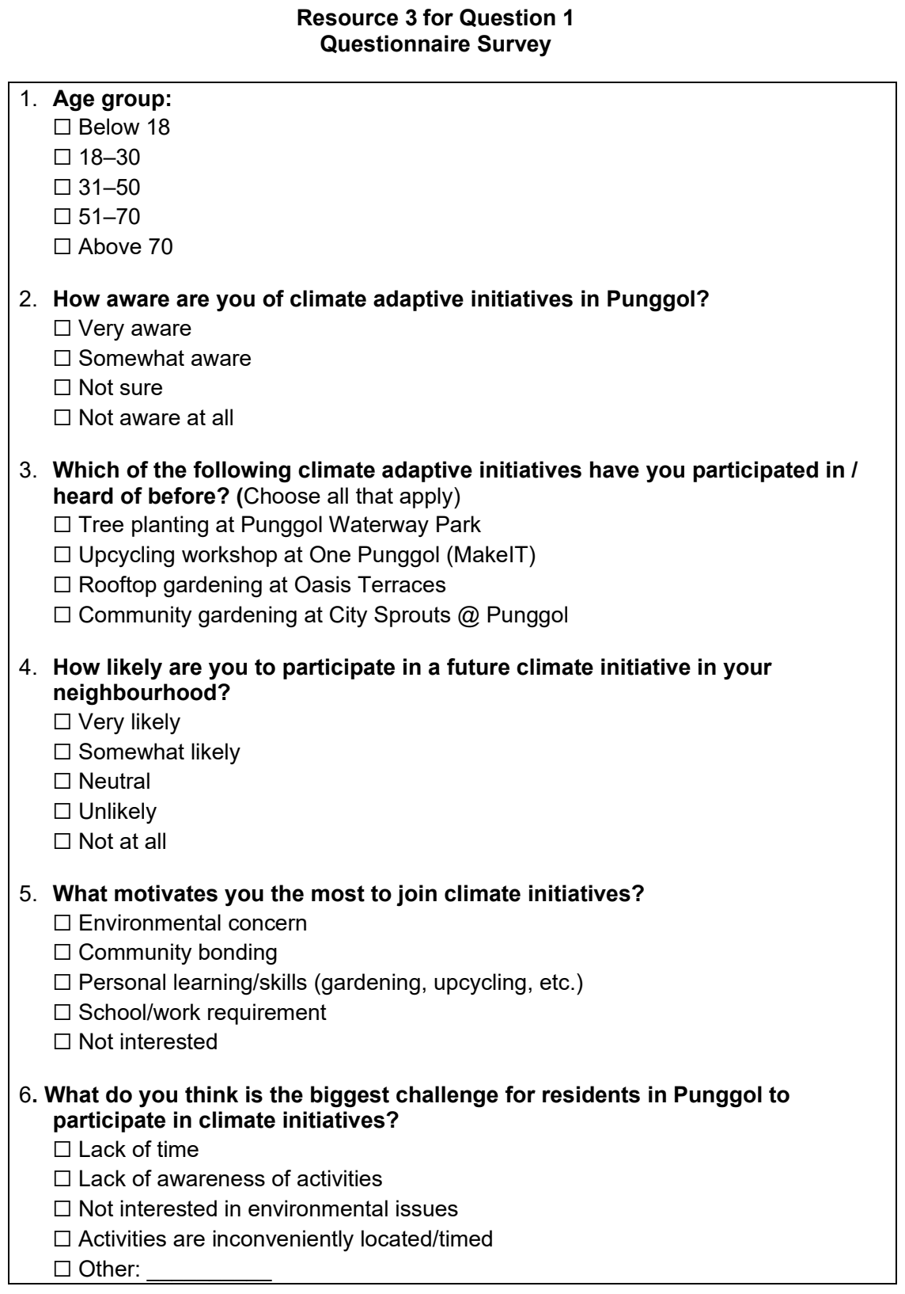

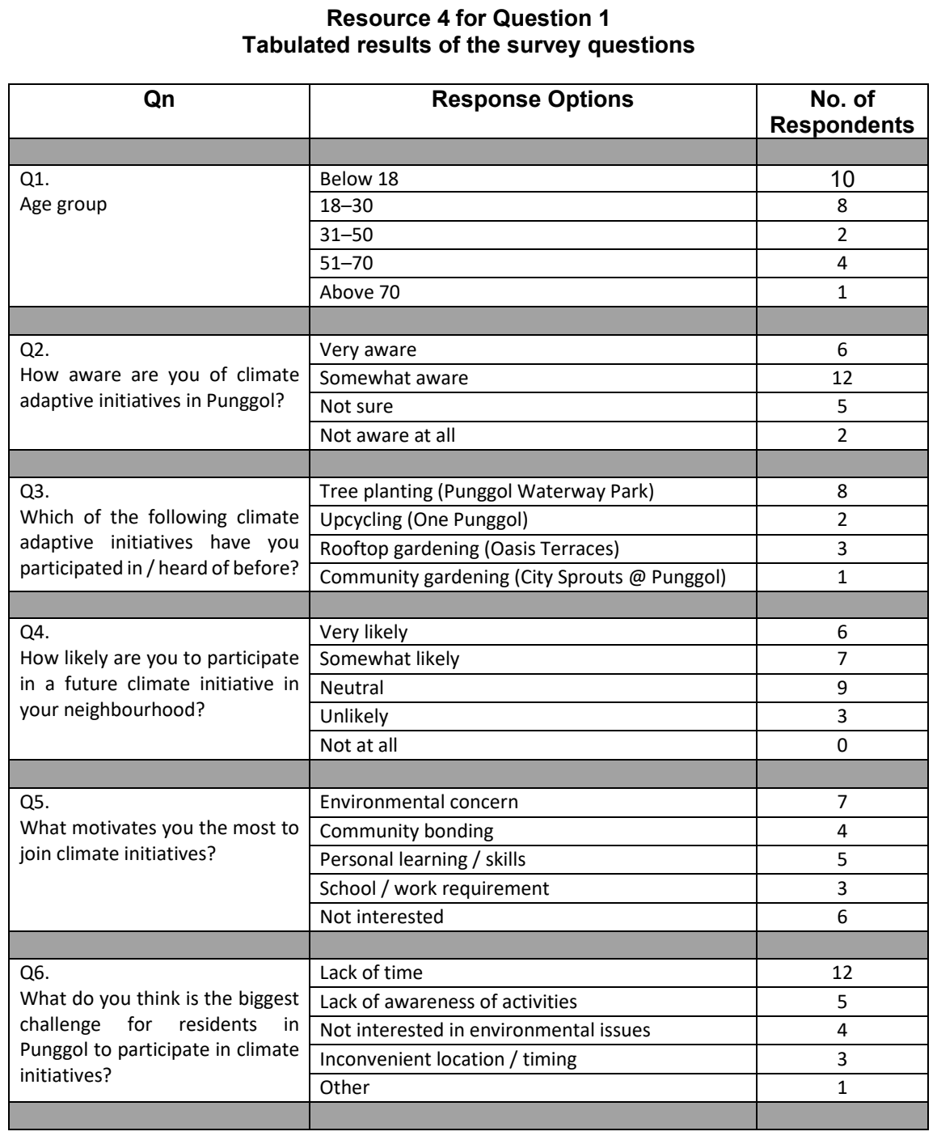

NYJC 2026 — H1 Paper 1 (8834/01), Q1 [30 marks]
Syllabus: 2 Fieldwork | Fieldwork area: Community response to CC
Section A — Cluster 2 Fieldwork
A group of 10 JC2 Geography students conducted fieldwork to investigate whether community responses to climate change were influenced by age. They decided to do their study in Queenstown, a mature town in Singapore so that they might be able to get a bigger representation of the older age group.
The students proposed the following hypothesis: Community response to climate change is more evident in younger people than the elderly in Queenstown, Singapore.
They measured community response with the following yardsticks: 1. awareness of climate-change initiatives; 2. concern about climate change; 3. willingness to adopt climate-friendly actions; and 4. participation in climate-friendly activities.
The students conducted their fieldwork on a Saturday from 11 am to 2pm at two different sites. At each site, they approached every third adult passer-by near the two sites and obtained 120 complete questionnaires in total. They also conducted visual observations of the place and the passers-by to identify evidence of how the local community was responding to climate change.
Resource 1 shows the 2 sites where the students did their fieldwork - Queenstown MRT Station Exit A and Margaret Drive Hawker Centre. Resource 2 shows the questionnaire the students used to conduct their fieldwork. Resource 3 shows the collated results of the fieldwork. Resource 4 shows the student’s visual observation of the surroundings and behaviour of people at the two sites, together with photographs.
(a) with reference to Resource 1, explain why the hypothesis is appropriate for the investigation. [4]
(b) Identify two potential risks the students might face when carrying out fieldwork at both sites and explain how they could minimize these risks. [6]
(c) With reference to Resource 3, explain the usefulness and limitations of the representation method used to present the data collected. [6]
(d) Suggest two ethical issues that might arise from the students’ investigation and explain how each could be addressed. [4]
(e) The students concluded that community responses to climate change are more evident among younger people than among the elderly in Queenstown. Evaluate the validity of this conclusion with reference to all the resources. [10]

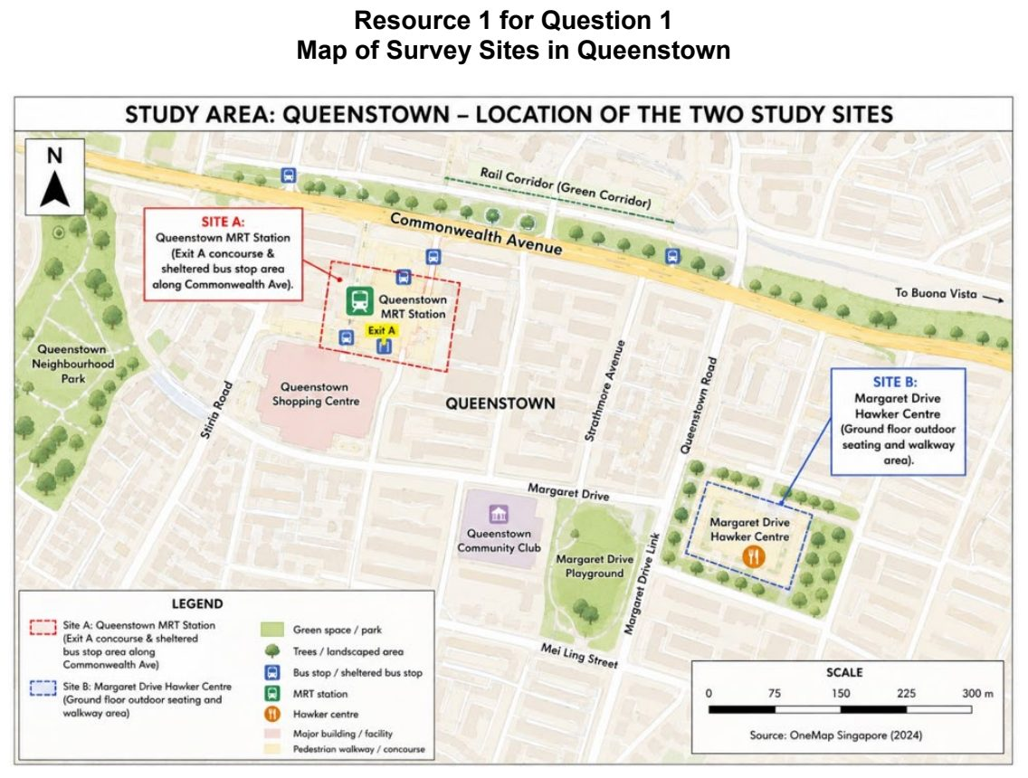

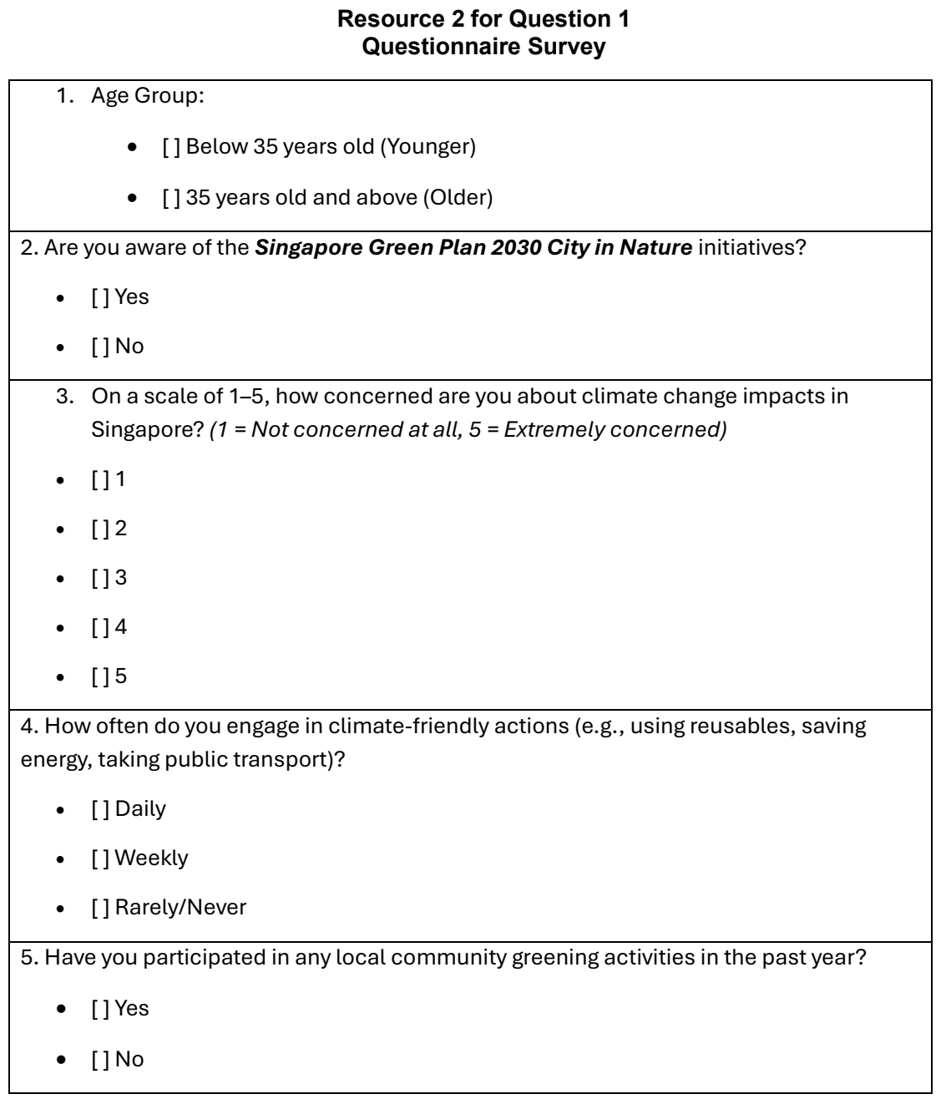

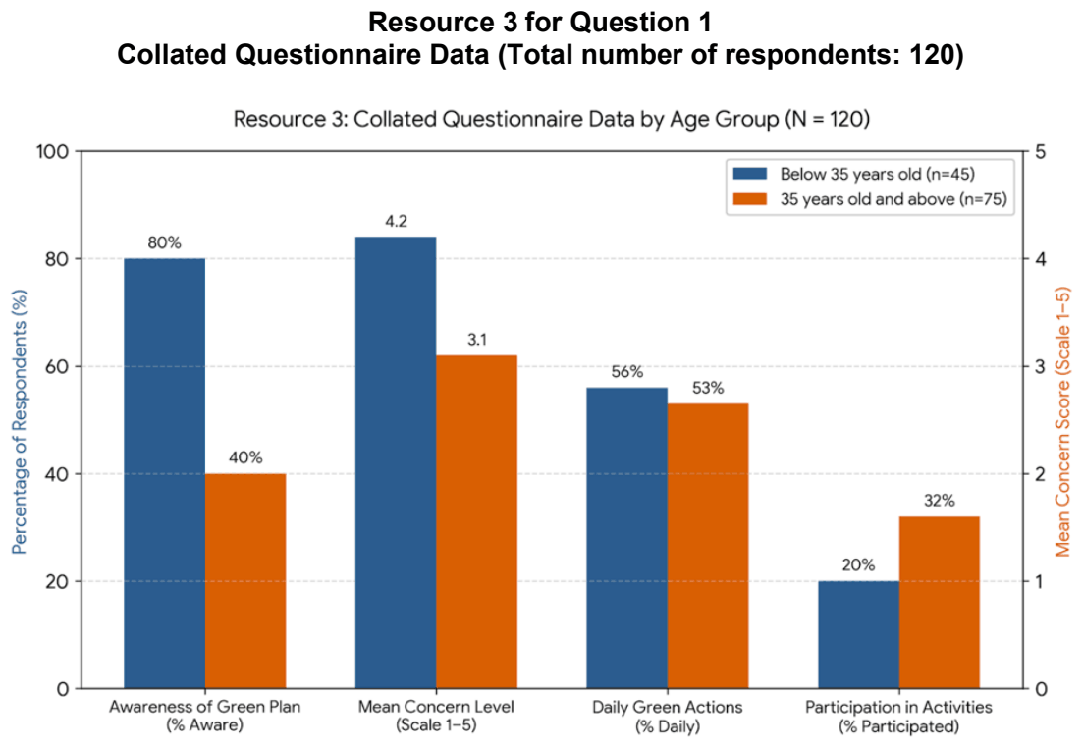

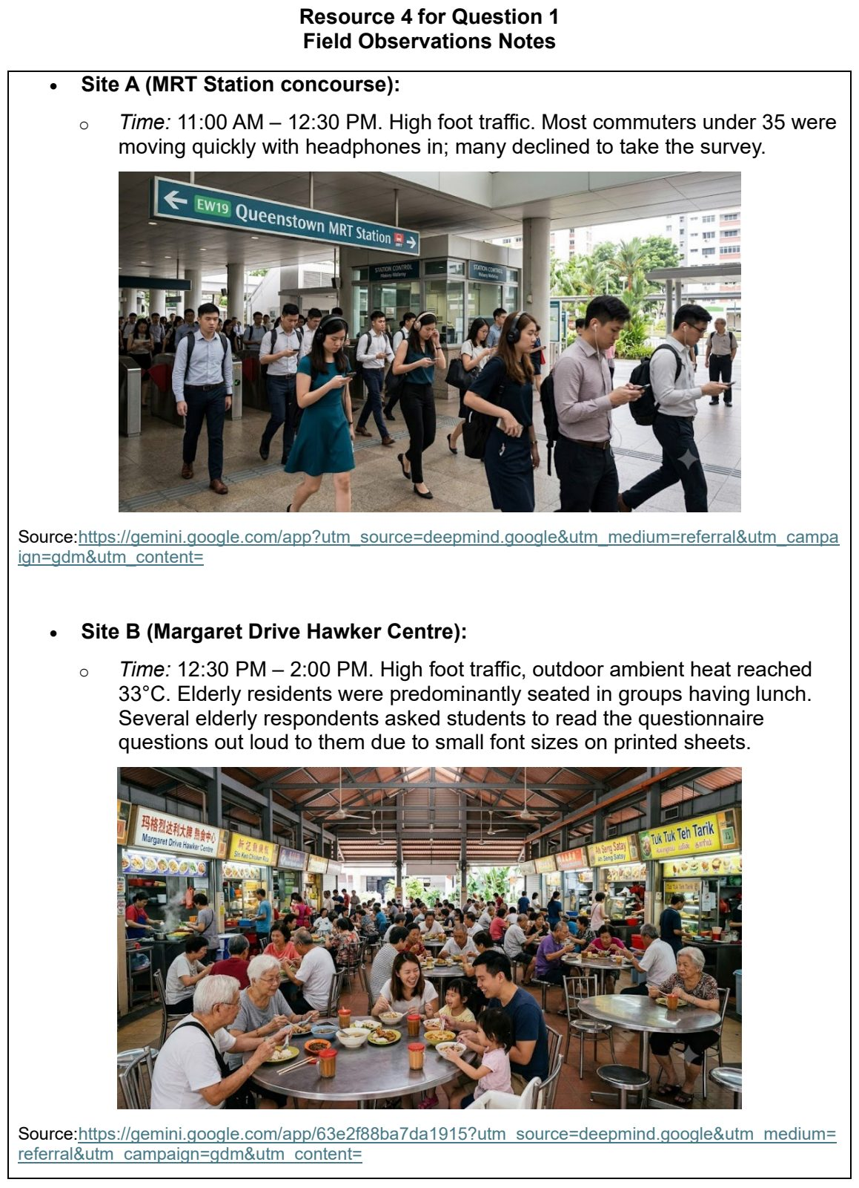

RI 2026 — H1 Paper 1 (8834/01), Q1 [30 marks]
Syllabus: 2 Fieldwork | Fieldwork area: Community response to CC
Section A — Cluster 2 Fieldwork
A group of students from Marymount Junior College wanted to investigate the local community's response to dengue cases in the Marymount–Shunfu area. The target population comprised approximately 8,000 residents living in the area, with about half residing in HDB public housing and the other half living in private housing. The students decided to test the following hypothesis:
Within the Marymount–Shunfu area, residents living in private housing are more likely to adopt dengue prevention measures than residents living in public housing.
The students used a questionnaire survey to collect primary data for their investigation. The survey was conducted during the June school holidays, as June is typically associated with a higher incidence of dengue cases in Singapore. In addition, the month is characterised by warmer temperatures and occasional rainfall, creating favourable conditions for mosquito breeding. Mosquitoes are the vectors that transmit the dengue virus.
To administer the questionnaire, the students selected two locations: inside Shunfu Market and outside Marymount MRT Station. At both locations, they randomly approached members of the public to participate in the survey. Each respondent was given a printed questionnaire sheet and a pen to complete the survey.
In total, the students surveyed more than 100 individuals across both locations. Following data collection, incomplete questionnaires and responses from individuals who did not reside within the study area were excluded. This screening process resulted in a final sample of 62 valid responses, consisting of fully completed questionnaires from residents of the Marymount– Shunfu area, the target population for the study.
Resource 1 shows a map of the area under study within the Marymount-Shunfu area. Resources 2A and 2B show photographs of the two locations for conducting questionnaire surveys. Resource 3 shows the questionnaire sheet handed out by the students. Resource 4 shows the results for Q3.1 to Q3.8 from the 62 valid responses.
(a) Using Resource 1, compare the two locations chosen to conduct the questionnaire survey. [4]
(b) With reference to Resources 2A and 2B, suggest how the students could minimise potential risks when visiting both locations. [6]
(c) Using Resource 3, describe the strengths and limitations of the questionnaire survey. [6]
(d) Using Resource 4, compare the results for public housing with private housing. [4]
(e) Evaluate the data collection process of this fieldwork. [10]

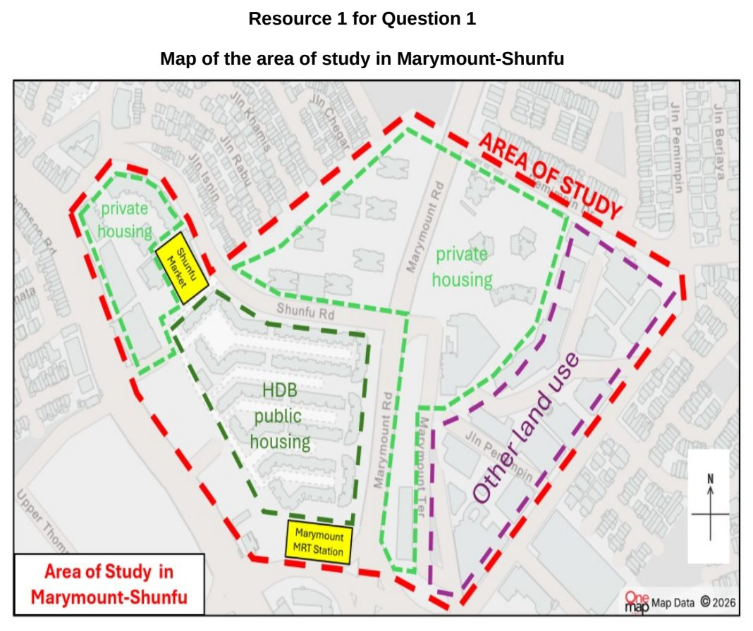

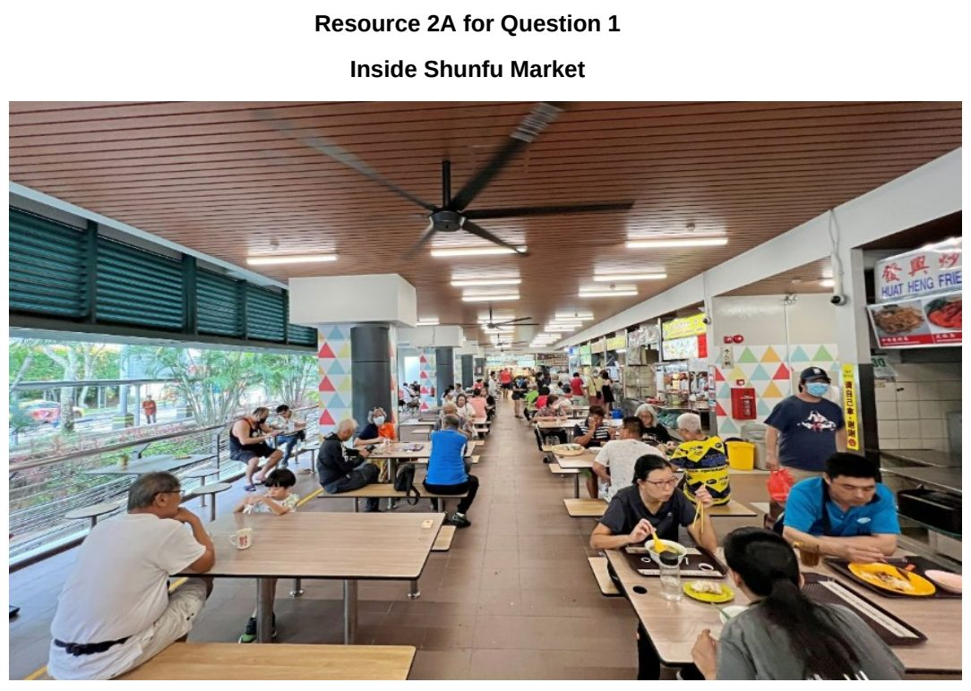

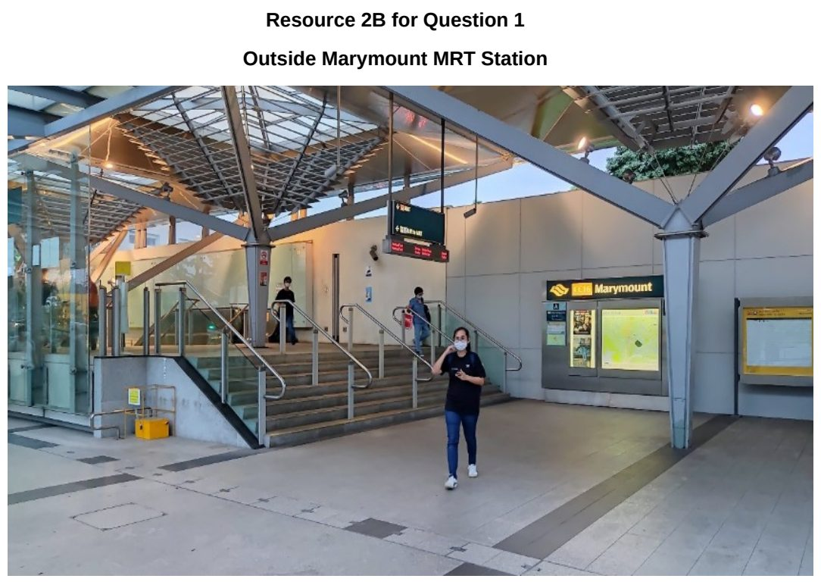

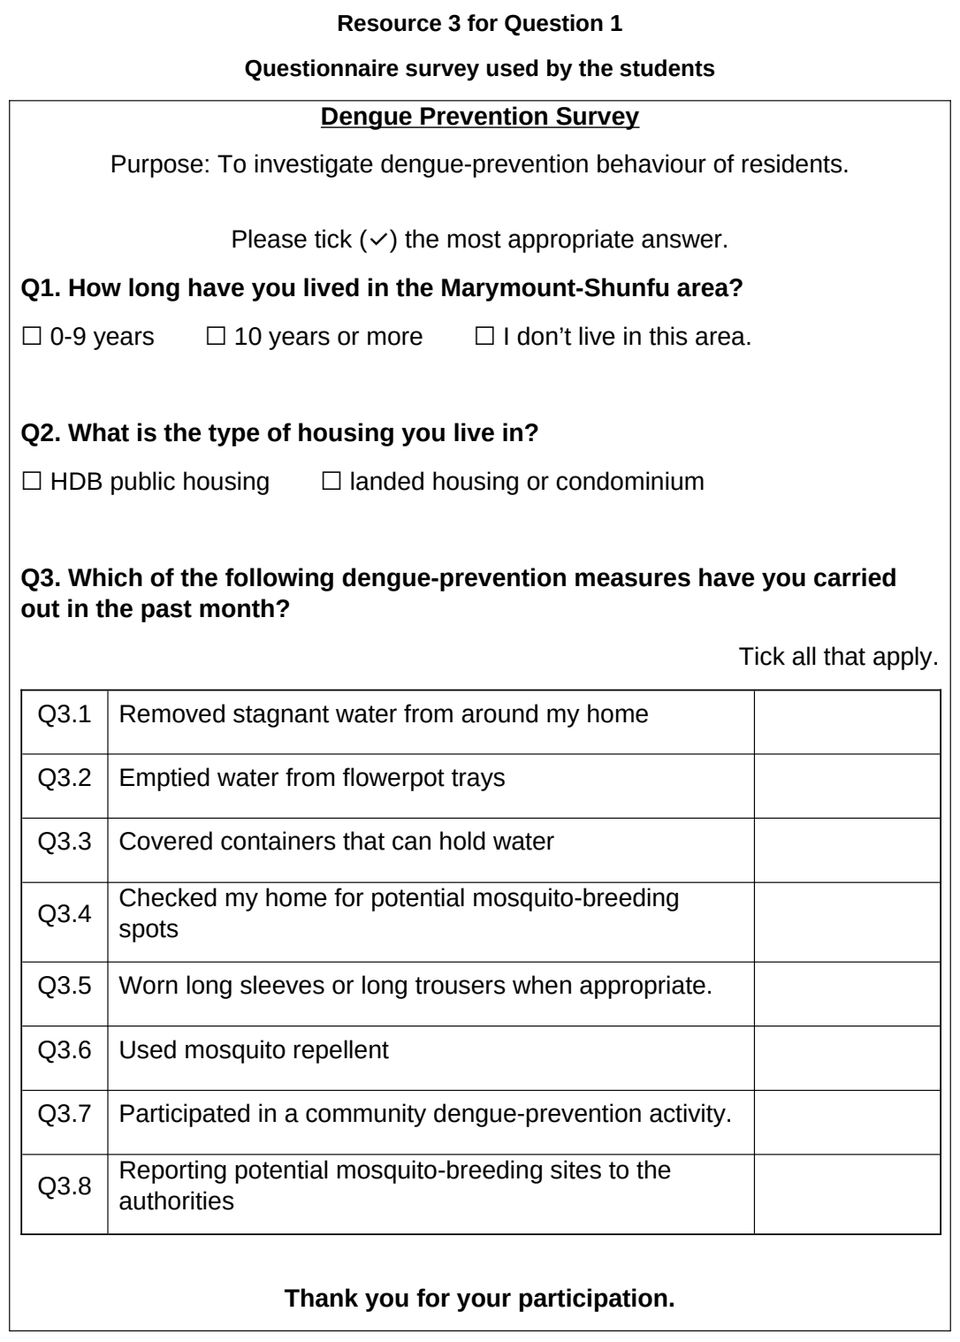

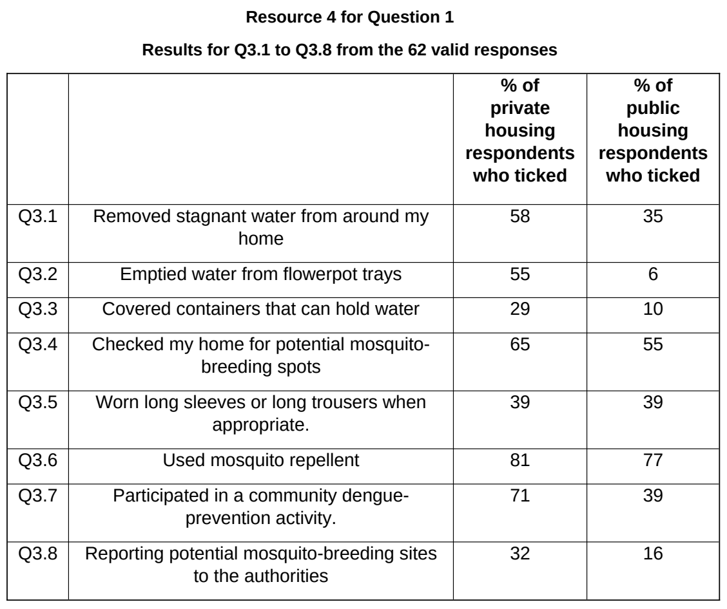

SAJC 2026 — H1 Paper 1 (8834/01), Q1 [30 marks]
Syllabus: 2 Fieldwork | Fieldwork area: Community response to CC
Section A — Cluster 2 Fieldwork
A group of six junior college students, as part of their school project, wanted to investigate community response to climate change in Singapore. They decided to investigate participation in Singapore's Beverage Container Return Scheme (BCRS).
Under the BCRS, consumers pay a 10-cent deposit when purchasing eligible beverages in plastic bottles and metal cans carrying the Deposit Mark. The deposit can be recovered when the empty container is returned to a designated return point.
The students investigated the following hypothesis:
Convenience has a greater influence than concern about climate change on people's participation in the Beverage Container Return Scheme.
They selected three shopping centres in different parts of Singapore, each with a reverse vending machine (RVM). The students divided themselves into three pairs, with one pair at each site.
At each site, they: ● surveyed 30 people near the RVM using convenience sampling;
● used the same questionnaire; ● conducted the survey between 12.00 pm and 4.00 pm on one Saturday in August 2026; and ● counted the number of people using the RVM during a 30-minute period.
At the time of the investigation, the BCRS was still in its transition period. Some beverage containers in circulation did not yet carry the Deposit Mark and could not be returned for the 10-cent refund.
Resource 1 shows the locations and characteristics of the three fieldwork sites. Resource 2 shows photographs of examples of reverse vending machines in Singapore. Resource 3 shows the questionnaire used by the students. Resource 4 shows the results of the investigation.
(a) Explain one strength and one weakness of the students' hypothesis. [4]
(b) With reference to Resources 1 and 2, explain the factors that the students should consider when selecting sites to investigate how convenience influences participation in the Beverage Container Return Scheme. [5]
(c) Suggest how the students could improve the accuracy and reliability of the data collected on the number of people using the RVMs. [4]
(d) With reference to Resource 3, explain the strengths and limitations of the questionnaire used in the investigation. [4]
(e) Using Resource 4, describe the relationship between mean convenience score and participation in the BCRS at the three sites. [3]
(f) Evaluate the validity of the students' fieldwork. [10]

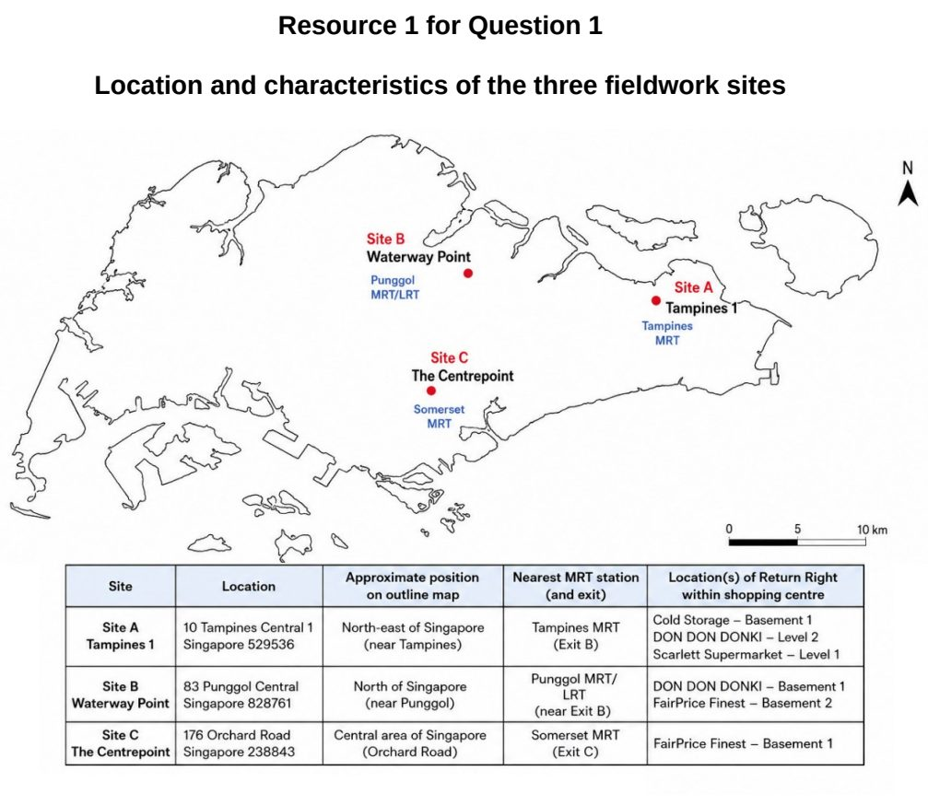

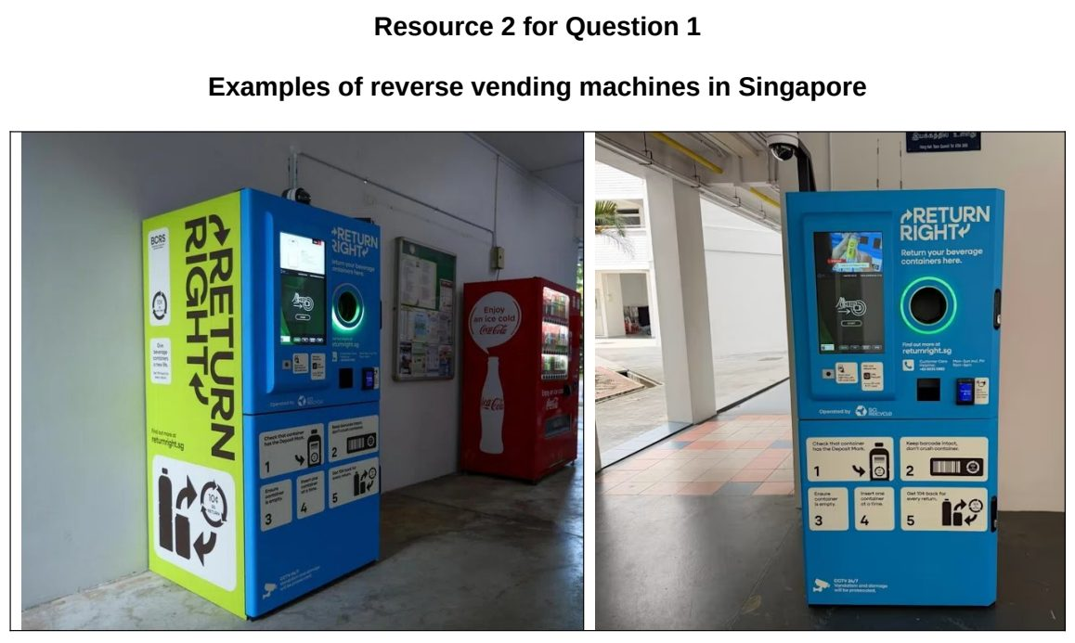

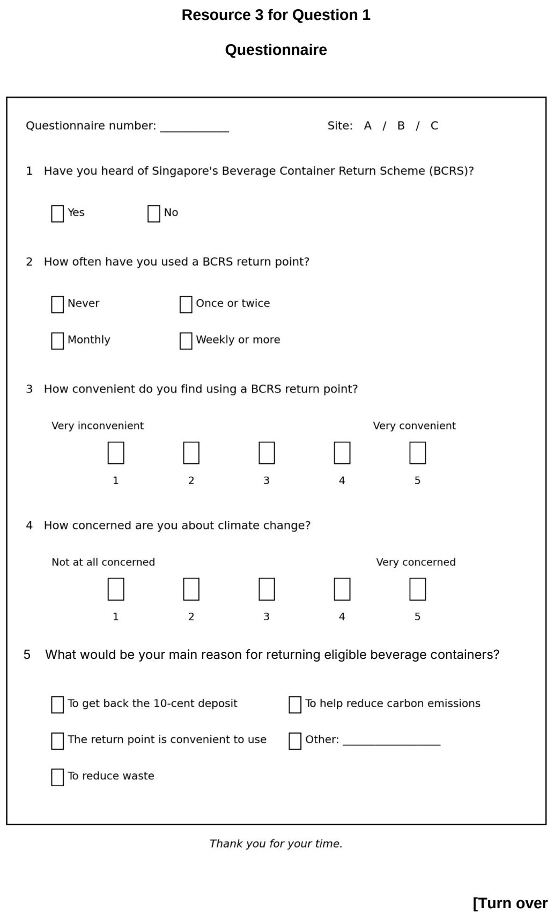

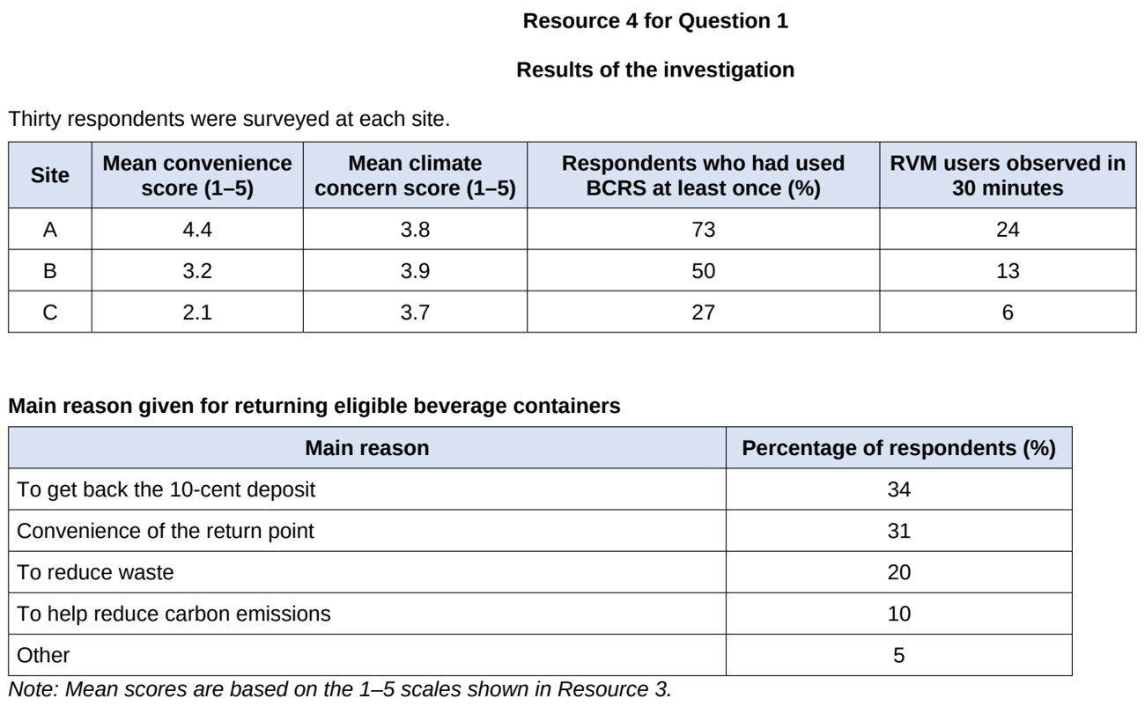

TJC 2024 — H1 Paper 1 (8834/01), Q1 [30 marks]
Syllabus: 2 Fieldwork | Fieldwork area: Community response to CC
Section A — Cluster 2 Fieldwork
A group of 20 students from Temasek Junior College carried out fieldwork to investigate the attitudes and responses of local residents towards climate change. They focused on the environmental lifestyle choices of the local community in Tampines, a neighbourhood in Singapore. The research question for their investigation was:
‘To what extent is the local community in Tampines making lifestyle changes to reduce their carbon footprint?’
In 10 groups of 2, the students approached 100 people in Tampines Regional Centre who seemed like a resident in the area and administered a questionnaire to survey their attitudes towards climate change. The survey was conducted on a Wednesday afternoon after school hours.
Following the questionnaire survey, the students conducted a waste visual assessment and interview by recruiting 10 respondents to gain richer qualitative insights into their waste management practices and requested them to take a photograph of their waste bin (as shown in Resource 4).
Resource 1 shows the map of Tampines, Singapore. Resource 2 shows photographs of Group 1’s and Group 2’s survey sites in the Tampines neighbourhood. Resource 3 shows results of the questionnaire survey. Resource 4 shows the sorting of waste in one respondent’s home.
(a) Explain why the research question is appropriate for the investigation. [3]
(b) With reference to Resources 1 and 2, suggest how the students could minimise potential risks when visiting the Tampines neighbourhood for their investigation. [4]
(c) Explain three criteria the students could use to select participants for the waste visual assessment and interview. [3]
(d) Use a suitable data representation technique to represent the tallied data shown in Question 1 of Resource 3. [5]
(e) Using Resources 3 and 4, answer the research question. [5]
(f) Evaluate the students’ investigation of residents’ attitudes and responses towards climate change. [10]

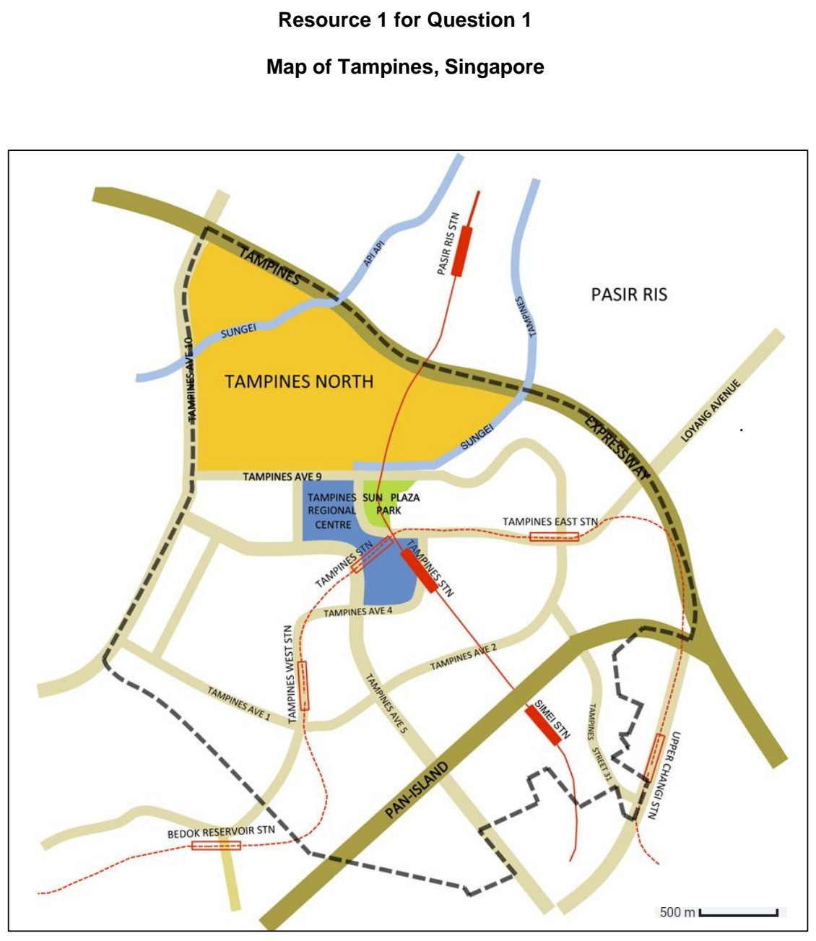

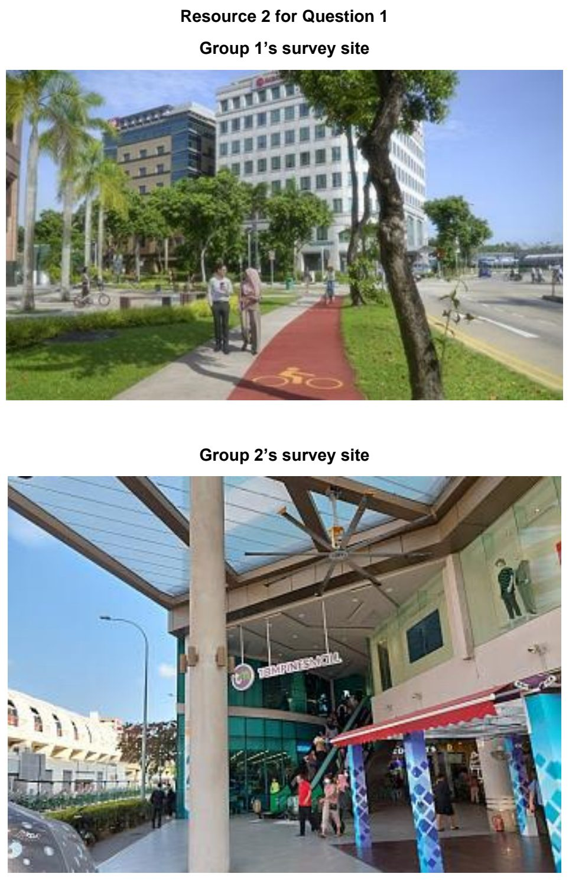

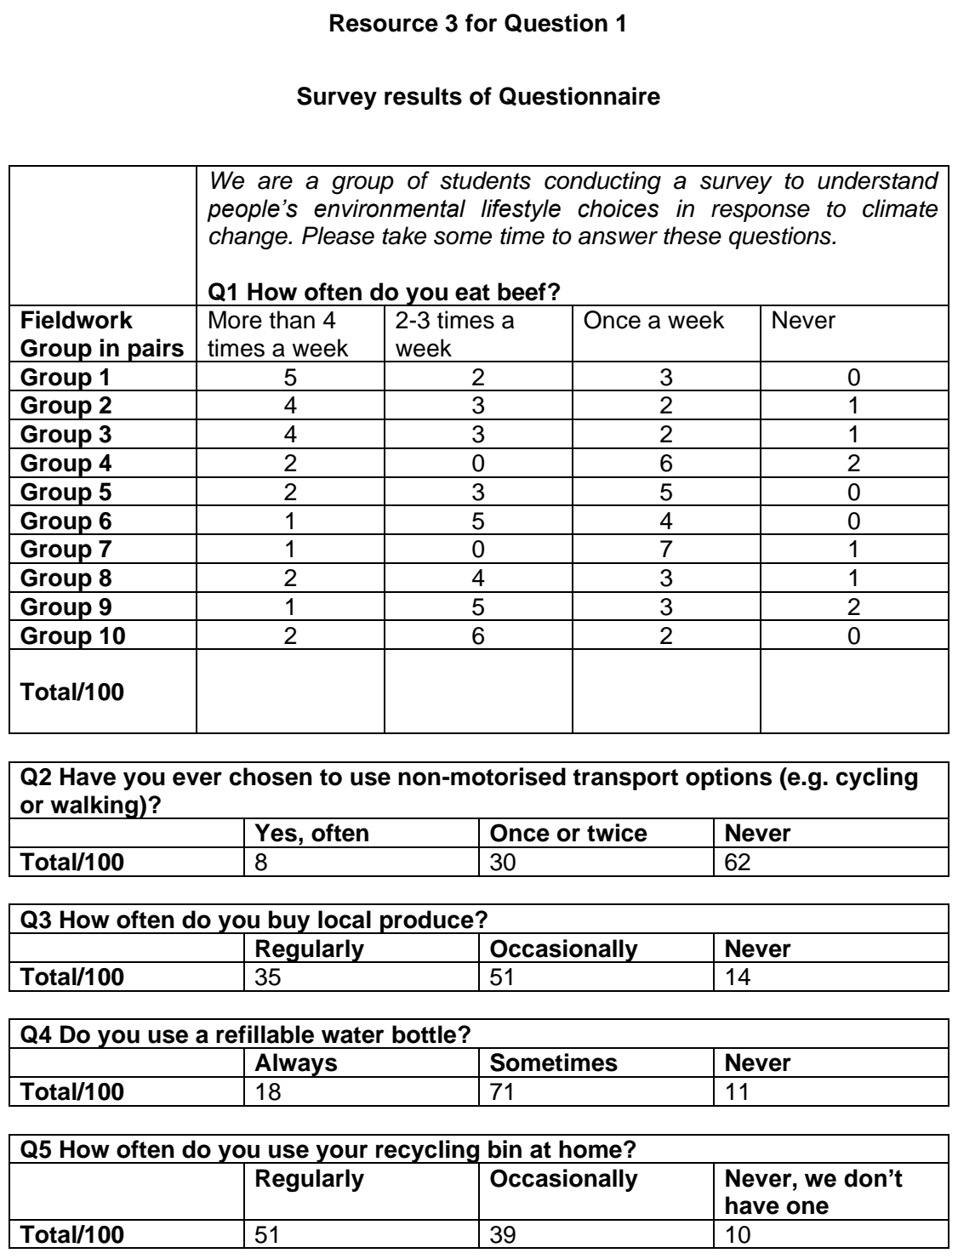

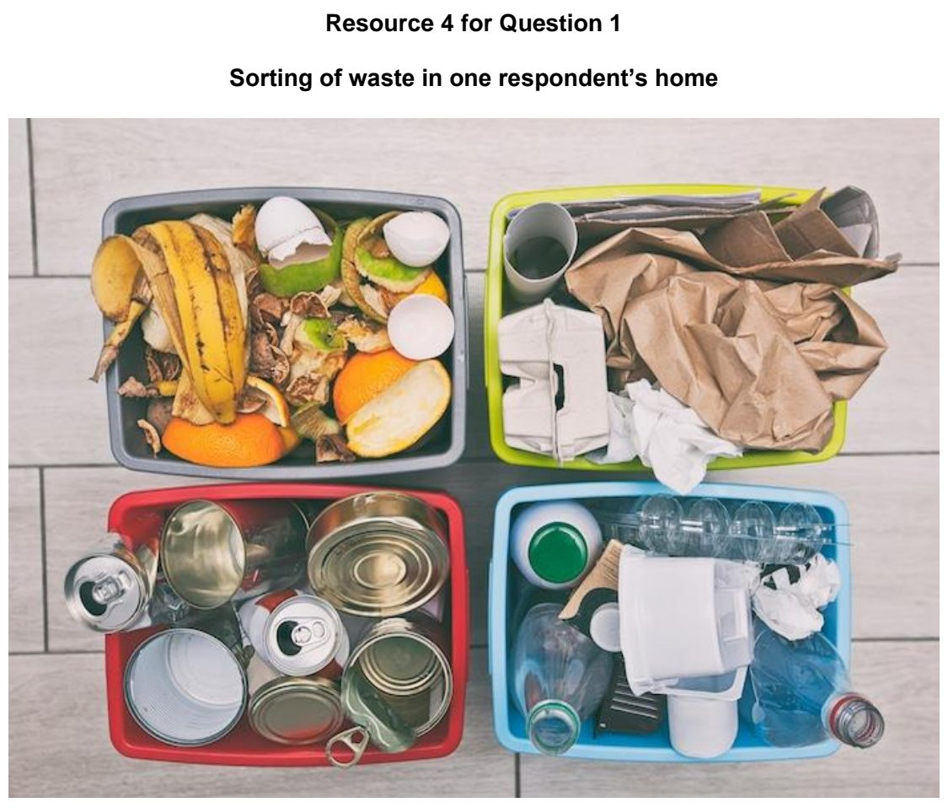

TJC 2025 — H1 Paper 1 (8834/01), Q1 [30 marks]
Syllabus: 2 Fieldwork | Fieldwork area: Community response to CC
Section A — Cluster 2 Fieldwork
A group of four students conducted fieldwork to investigate how the installation of solar panels contributes to community-level responses to climate change in Singapore. Their research question was:
‘To what extent does the installation of solar panels influence local microclimate and community attitudes towards solar energy as a climate change response in Singapore?’
The students first consulted secondary sources and obtained a base map showing the distribution of solar panel installations across Singapore. They selected two Housing Development Board estates, Bukit Panjang and Punggol, as their study sites.
At each site, they identified one HDB block equipped with rooftop solar panels, selected based on convenience. They measured ground-level microclimatic conditions (e.g., temperature and relative humidity) near the selected block and compared them with data from nearby blocks without solar panels.
To examine community perceptions, they also administered a questionnaire survey to 20 residents per site on a weekday afternoon. They approached any available individuals to ask if they were willing to participate in the questionnaire survey. The survey explored residents’ awareness, perceived benefits, concerns, and observations of environmental changes linked to the solar panels.
Resource 1 shows the locations of the two sampled sites on a basemap, with the number of solar energy installations in Singapore. Resource 2 show photographs taken by the students of the Bukit Panjang and Punggol study sites. Resource 3 shows some of the equipment used to measure and record weather variables, as well as other notes made during the investigation. Resource 4 shows the questionnaire survey used in the investigation. Resource 5 shows collated data for the questionnaire survey on residents’ support for the use of solar energy in public housing estates.
(a) Explain why the research question is appropriate for the investigation. [3]
(b) With reference to Resource 2, suggest how the students could minimise potential risks and ethical issues when conducting their fieldwork. [4]
(c) Suggest why the two pieces of equipment shown in Resource 3 would be important for the student to use while conducting the fieldwork. [3]
(d) Using Resource 4, explain how the design of the survey questionnaire could be improved. [5]
(e) Use a suitable data representation technique to represent the data shown in Resource 5. [5]
(f) The students concluded that the installation of solar panels is positively viewed as a climate change response by residents in Singapore. Evaluate the validity of their conclusion. [10]

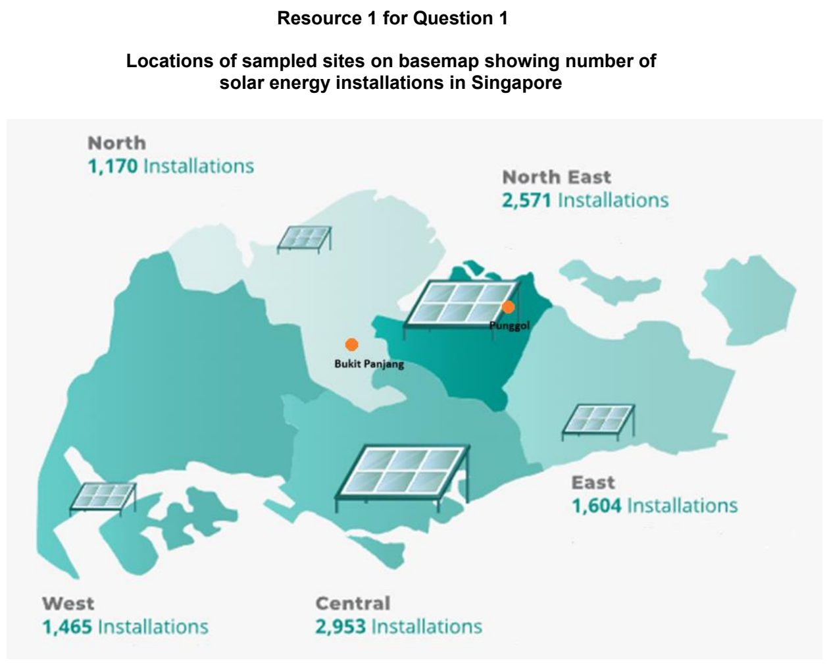

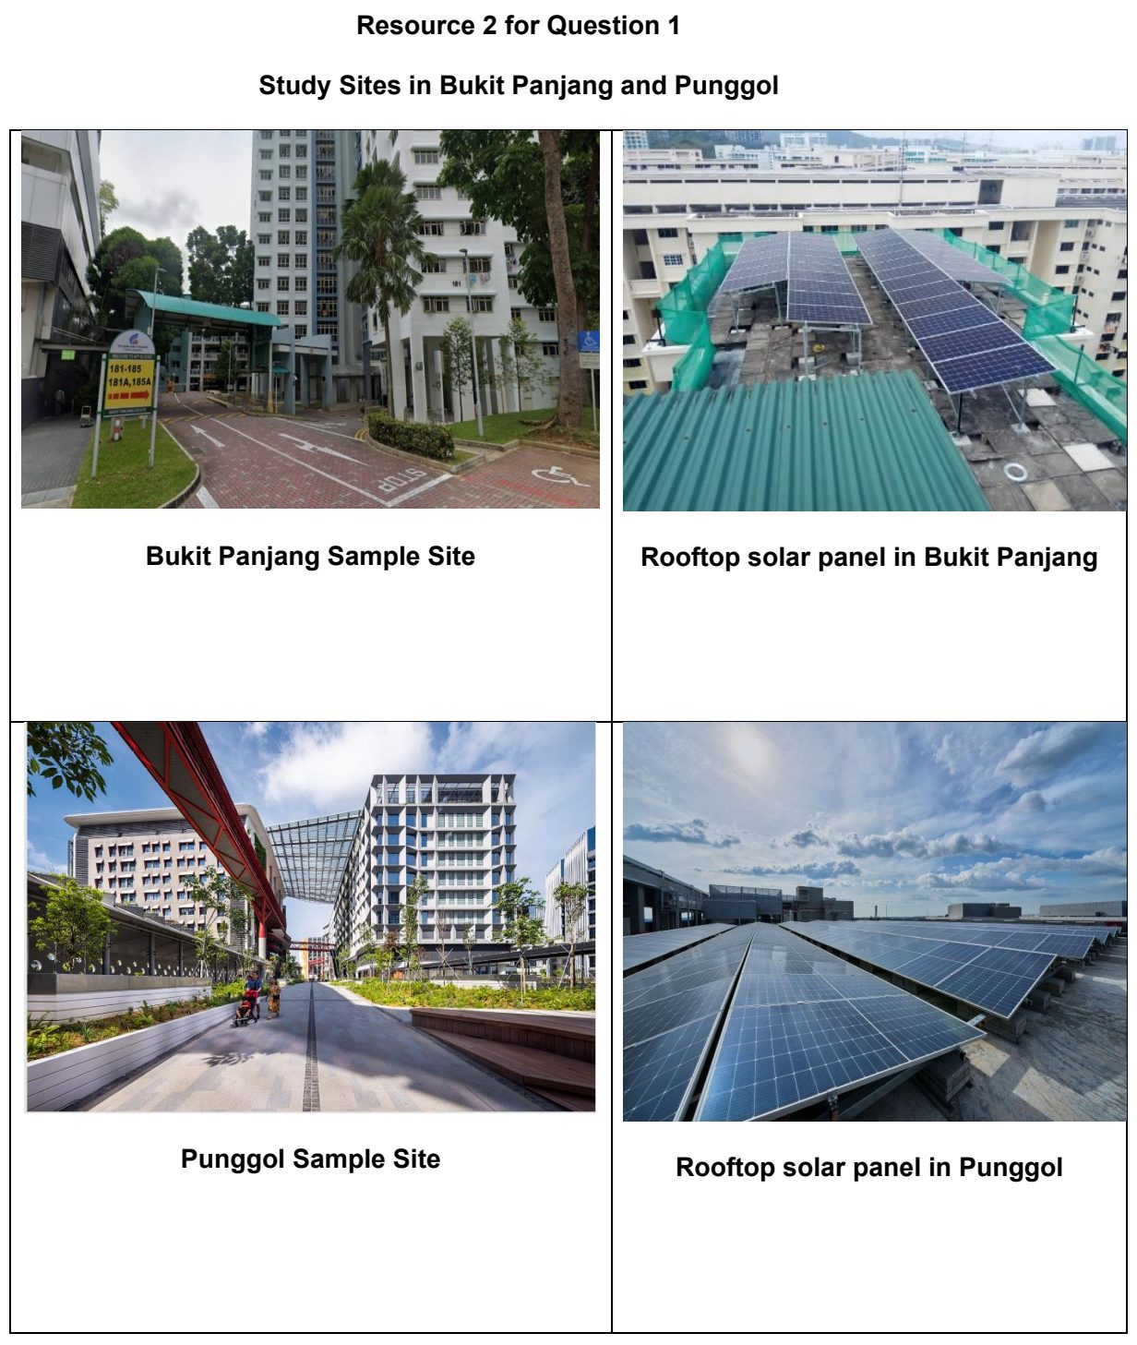

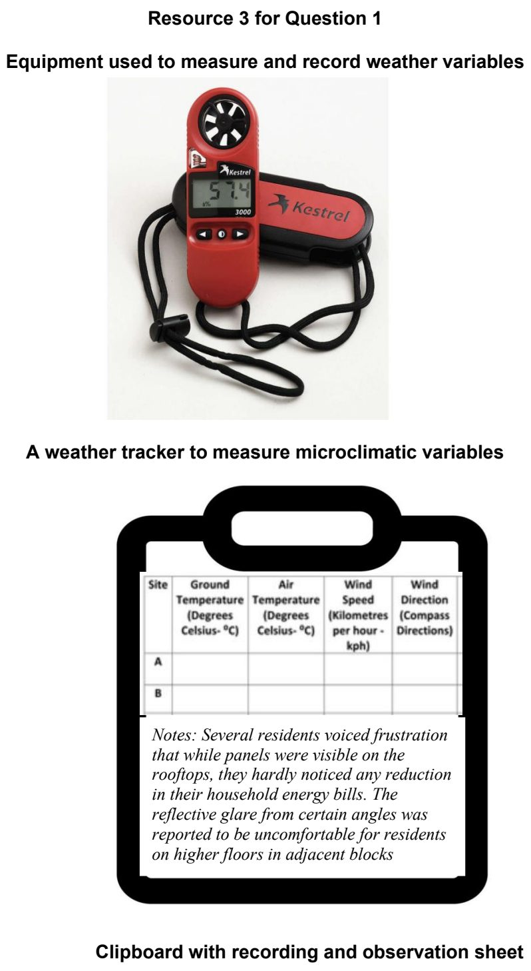

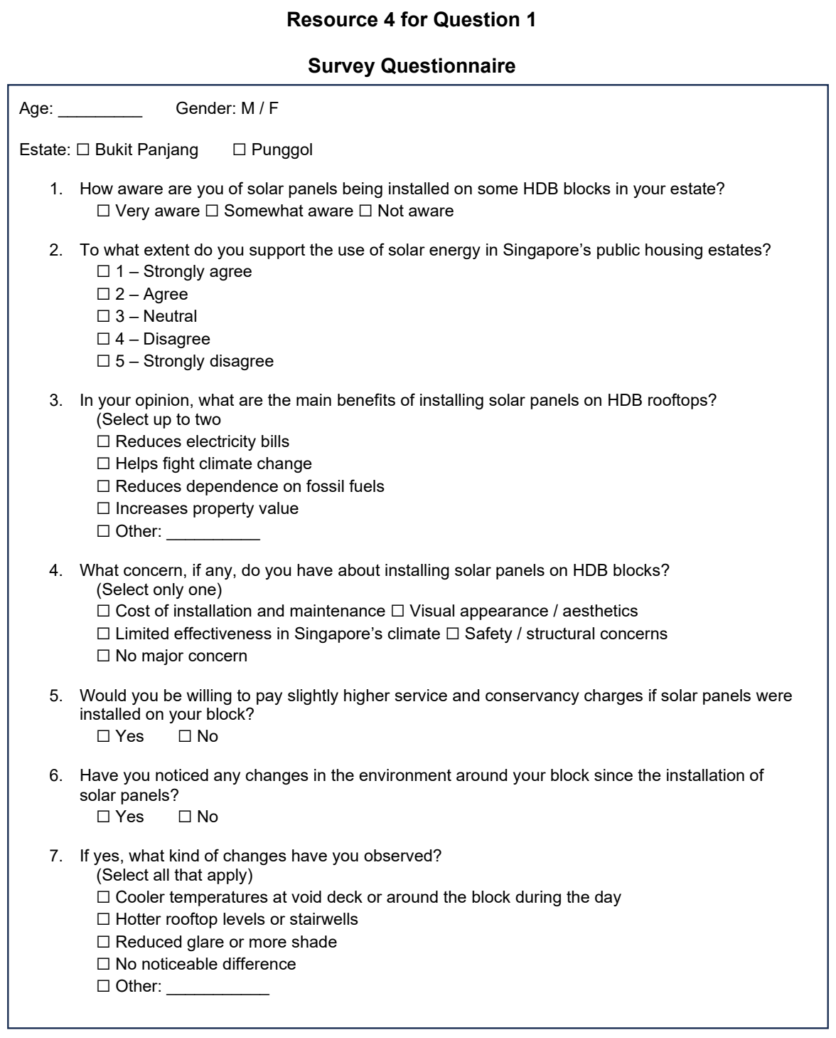

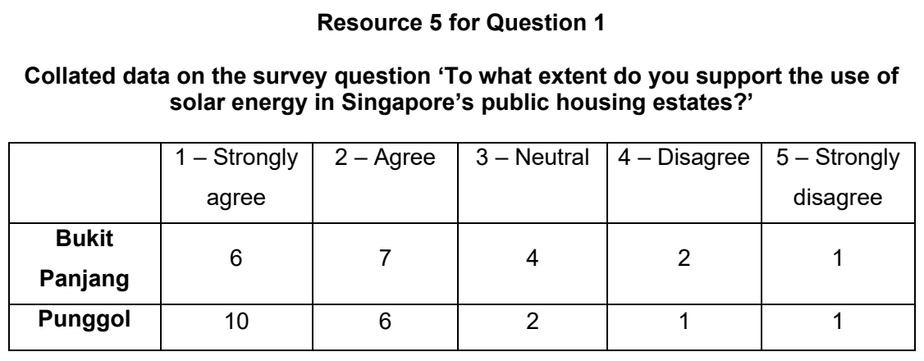

TJC 2026 — H1 Paper 1 (8834/01), Q1 [30 marks]
Syllabus: 2 Fieldwork | Fieldwork area: Community response to CC
Section A — Cluster 2 Fieldwork
A group of 20 students carried out fieldwork in Toa Payoh, a mature housing estate in Singapore. They wanted to investigate community recycling as a response to climate change and resource scarcity. Their research question was:
‘To what extent does the accessibility of recycling facilities influence correct recycling practices in Toa Payoh?’
Using a base map of Toa Payoh, the students selected eight sites across study area. At each site, they identified the nearest blue recycling bin and conducted a visual audit. Without touching or removing any waste, they classified the first 20 clearly visible items in the top layer of the bin as either correctly deposited recyclables or contamination. The audit was conducted in pairs from 4.00 pm to 6.00 pm on one Tuesday in July. They then administered the same questionnaire to 80 people. They approached anyone who said they lived in Toa Payoh.
Resource 1 is a base map of Toa Payoh and its surrounding area. Resource 2A shows the visible contents in the top layer of a blue recycling bin during the waste audit. Resource 2B shows students conducting the survey. Resource 3 is the survey questionnaire used by the students. Resources 4A and 4B show the results of the visual waste audit and survey questionnaire respectively.
(a) Explain why the research question is appropriate for this investigation. [3]
(b) With reference to Resources 2A and 2B, suggest how the students could minimise potential risks during the investigation. [5]
(c) With reference to Resource 3, explain the limitations of the survey questionnaire when used to survey residents during the investigation. [4]
(d) Using Resource 4A, describe the extent of correct recycling practices in Toa Payoh. [4]
(e) With reference to Resource 4B, use a suitable data representation technique to show the main barriers to recycling identified by respondents. [4]
(f) With reference to all the resources, evaluate the reliability and accuracy of the investigation. [10]

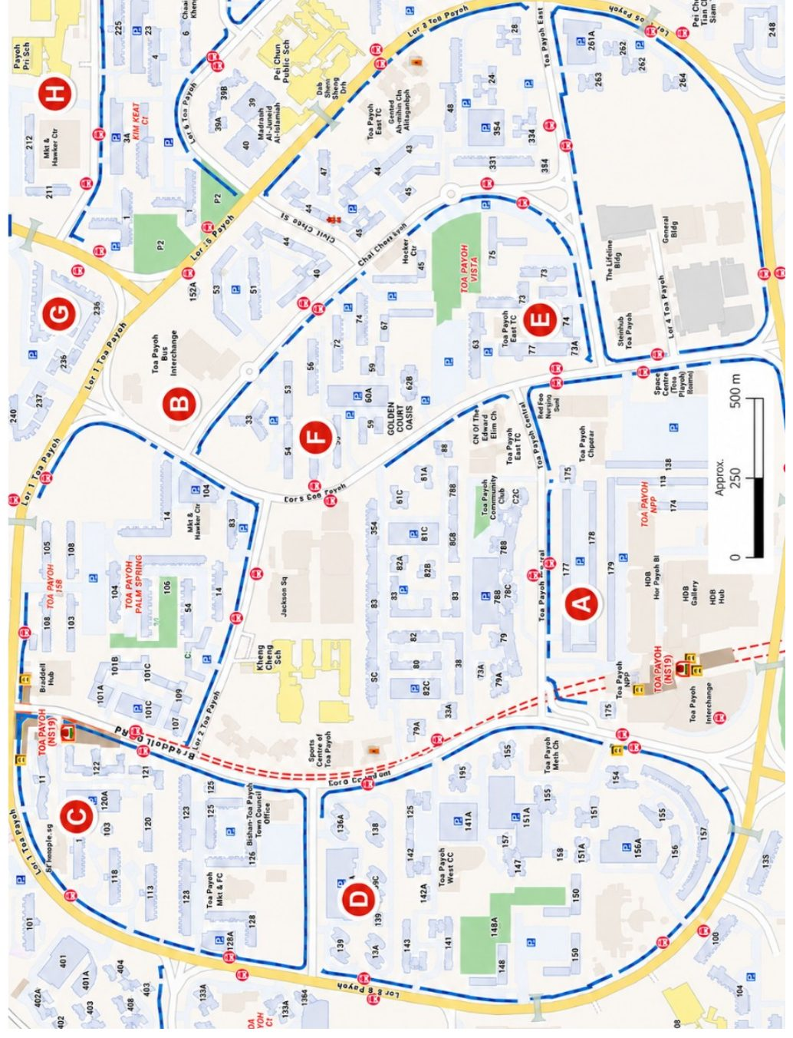

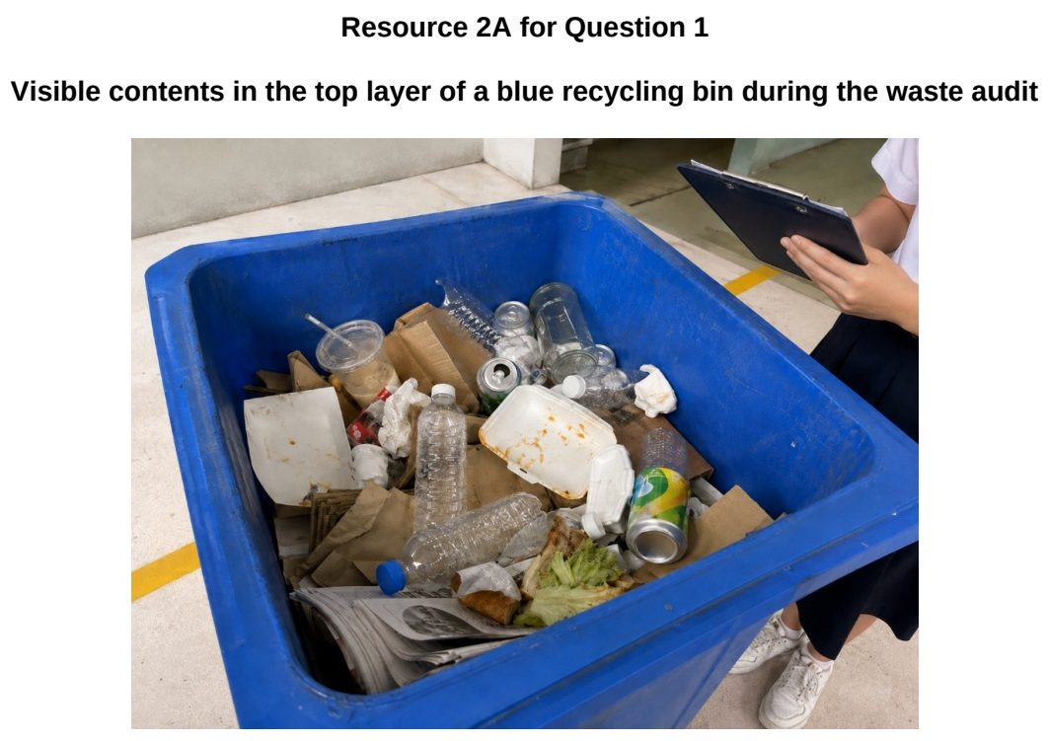

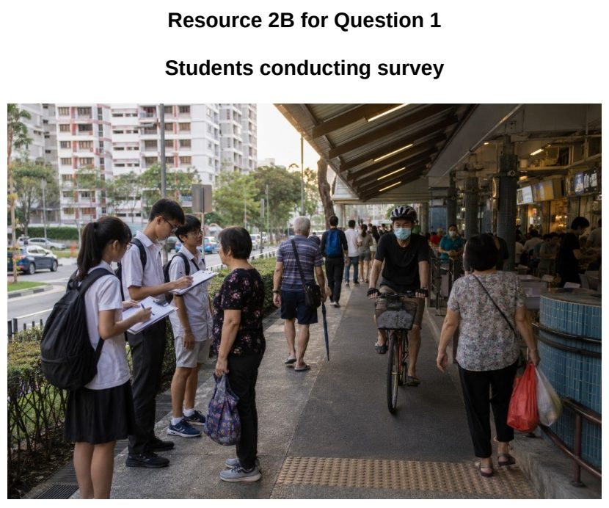

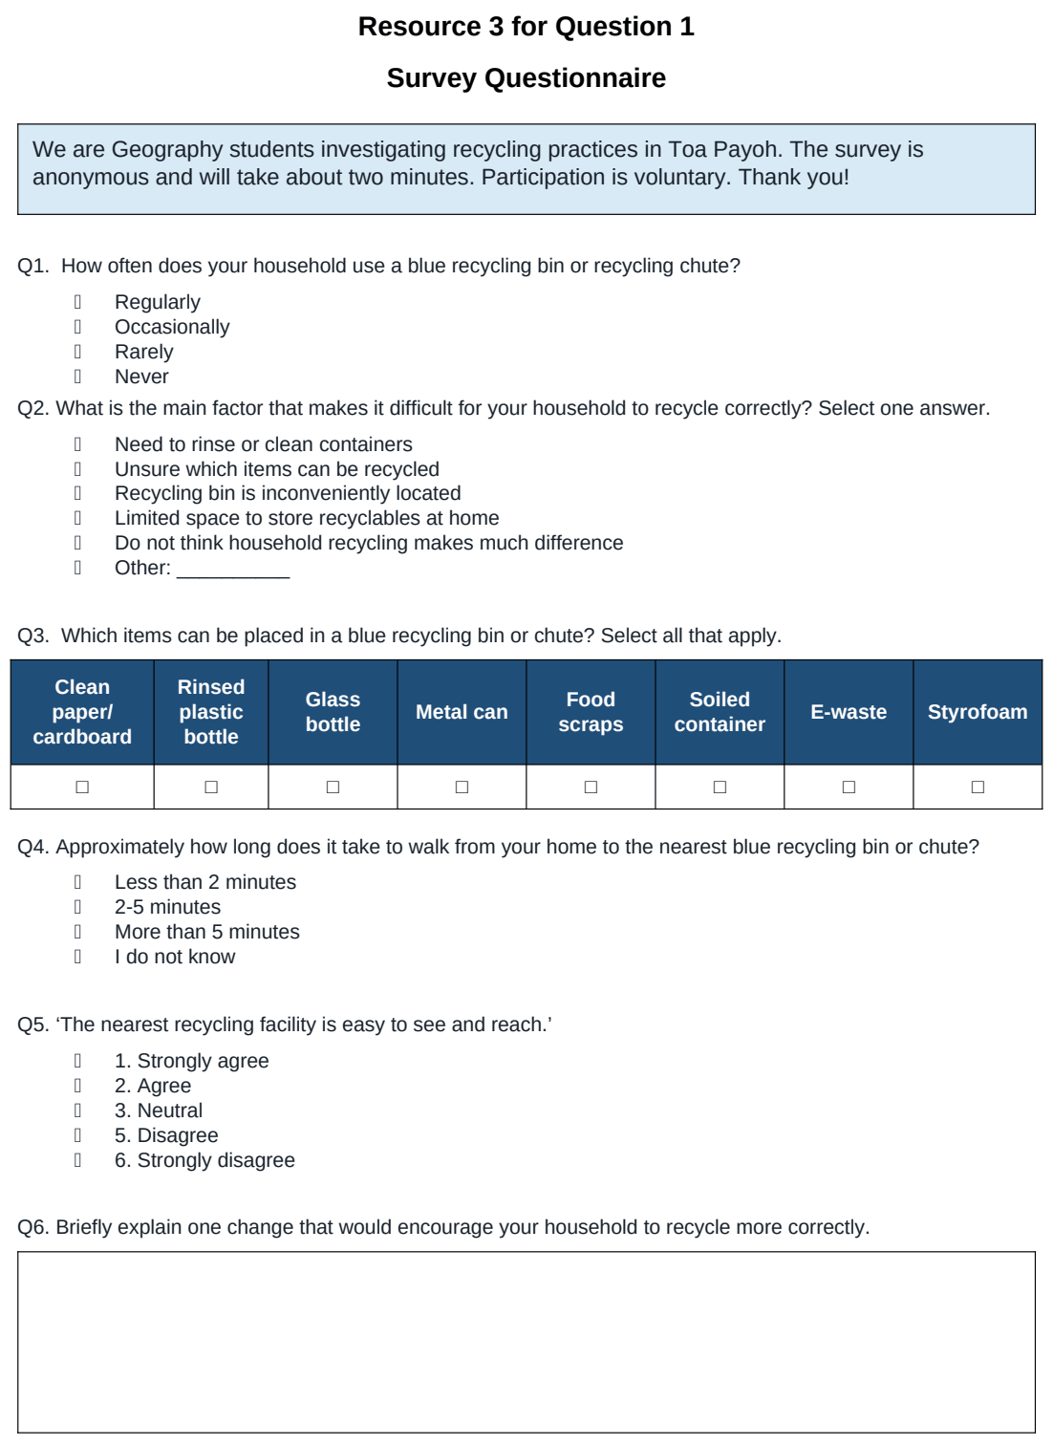

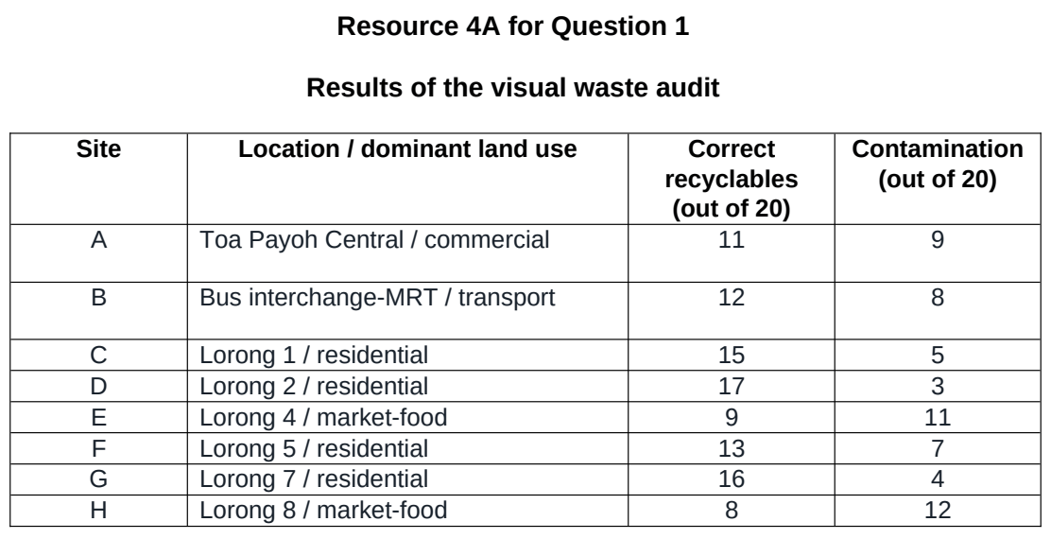

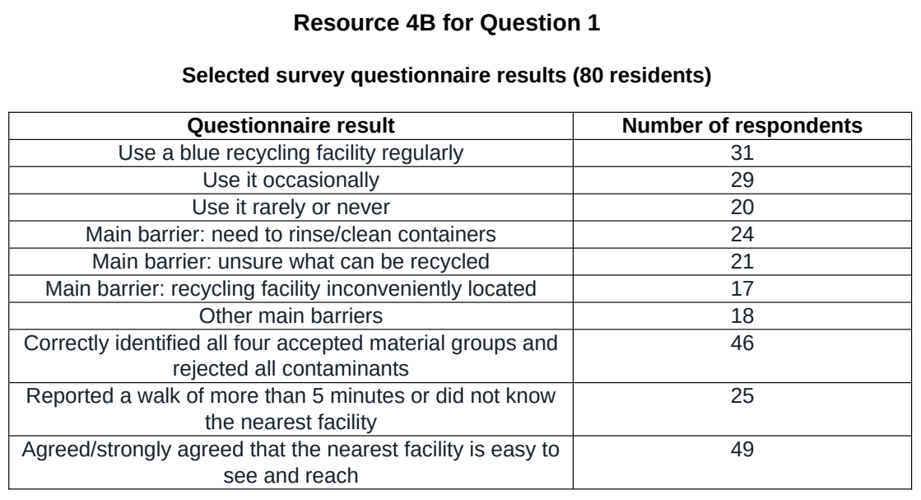

TMJC 2024 — H1 Paper 1 (8834/01), Q1 [30 marks]
Syllabus: 2 Fieldwork | Fieldwork area: Community response to CC
Section A — Cluster 2 Fieldwork
The Singapore Green Plan 2030 includes a strong push to electrify our vehicle population, to help Singapore achieve our vision of 100% cleaner energy vehicles by 2040. After reading about the Singapore Green Plan, a group of 12 students wanted to find out if drivers in Tampines estate are willing to purchase electric cars for their daily use instead of the conventional petroleum-reliant cars.
They decided to conduct a study on the following hypothesis: ‘Drivers in Tampines estate will buy electric cars for their daily use.’
For their investigation, they identified the electric car charging stations in Tampines via the local Land Transport Authority app. On a Monday afternoon, the students set off on their fieldwork with one group of 4 students conducting a questionnaire survey to determine the preferences of drivers stopping at a Petrol station at Site A for their choice of cars. Another group of 4 students conducted the same survey at a Housing Board Flat along Tampines Avenue 4 at Site B where there is a nearby Tesla electric car charging station. The remaining 4 students were stationed at Site C, which is the Tampines 1 shopping mall’s entrance, to conduct the survey.
In collecting their data, the groups used the convenience sampling method.
Resource 1 shows a map of chosen fieldwork sites in Tampines estate. Resource 2 shows the questionnaire used by the students for the survey. Resource 3 shows selected results of the questionnaire survey.
(a) Explain why the hypothesis is appropriate for the investigation. [3]
(b) With reference to Resource 1, explain the factors that the students could consider when choosing the site to carry out the survey. [4]
(c) Referring to Resource 2, explain ethical issues that may arise due to the students’ data collection at the shopping mall’s entrance. [4]
(d) With reference to Resource 2, explain how the students’ survey form may affect the reliability of data collected. [4]
(e) Sketch a diagram to represent the data collected shown in Resource 3. [5]
(f) Evaluate the students’ investigation and explain how it can be improved. [10]

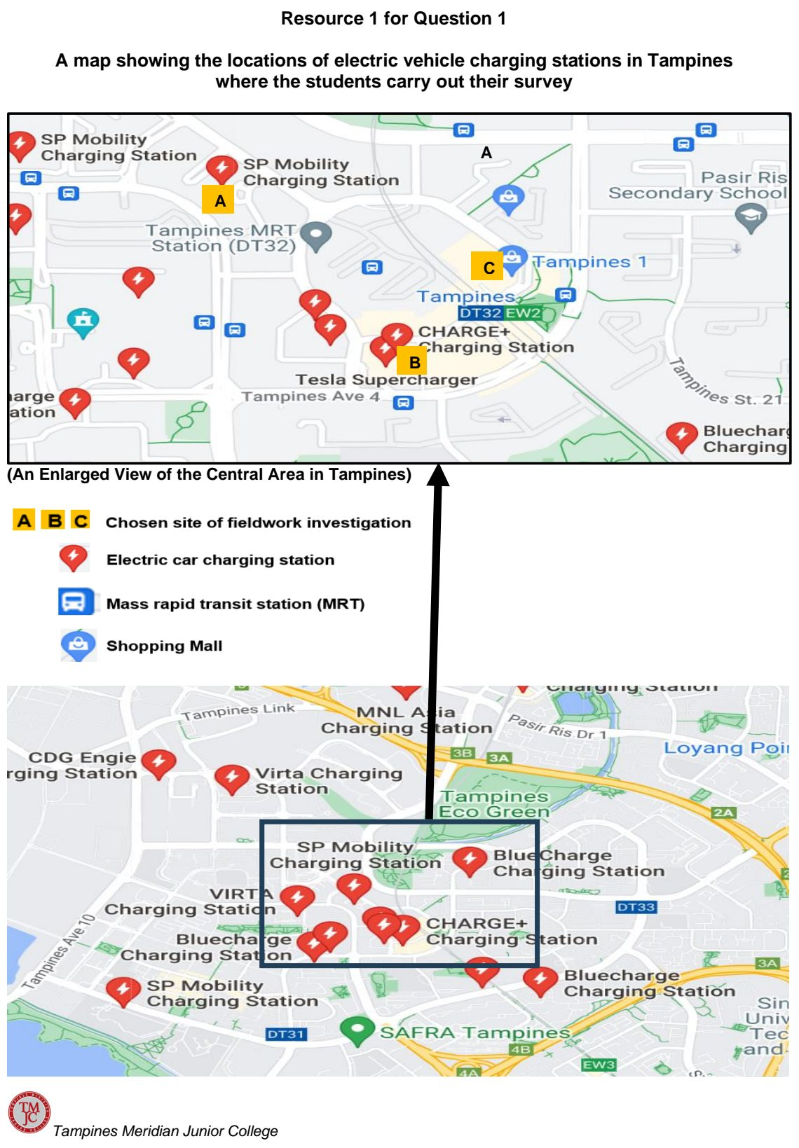

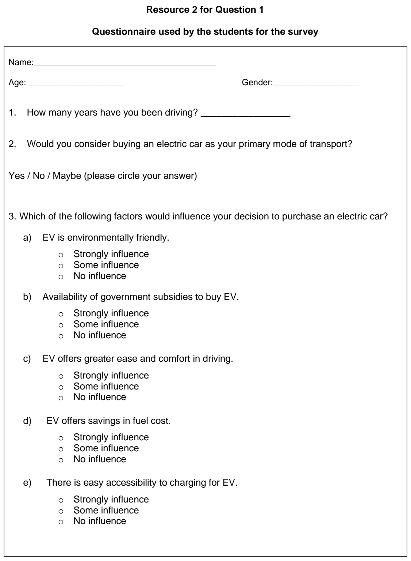

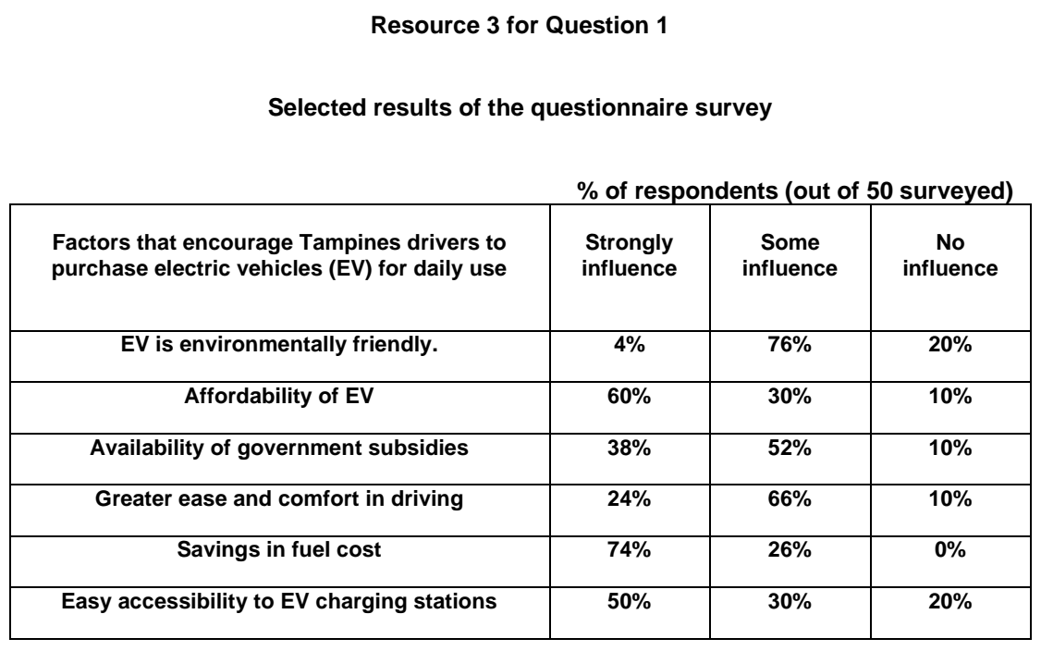

TMJC 2026 — H1 Paper 1 (8834/01), Q1 [30 marks]
Syllabus: 2 Fieldwork | Fieldwork area: Community response to CC
Section A — Cluster 2 Fieldwork
A group of eight 18 year-old students from Tampines Meridian Junior College wanted to investigate the success of Singapore’s Beverage Container Return Scheme in encouraging recycling. The Beverage Container Return Scheme commenced on 1 April 2026 and encourages consumers to “Return Right” by returning their empty plastic and metal beverage containers at dedicated return points across Singapore. Under the Scheme, pre-packaged beverages in plastic and metal containers will carry a 10-cent deposit. These containers will feature a Deposit Mark and can be returned at any of the 'Return Right' Reverse Vending Machines (RVMs) across Singapore to redeem the 10-cent deposit via either SimplyGo EZ-Link or DBS PayLah!. Students and seniors can use their EZ-Link concession cards to get refunds.
The students came up with the following hypothesis: “The Beverage Container Return Scheme has been successful in increasing recycling in Singapore”.
The students designed a survey questionnaire and carried out the survey on four days between 11am and 2pm. For both days, they split themselves into 4 pairs to conduct the survey. They approached persons who had bought beverages in the food outlets in each of the malls and asked them to fill up the questionnaire. For the first day, 2 pairs visited Northpoint City and Junction 8 each, and for the second day, they completed the questionnaires at Jurong Point and Pasir Ris Mall. In the span of 2 days, they managed to survey a total of 60 persons.
Resource 1A shows a map of the survey sites in Singapore. Resource 1B shows one of the food outlets (in Junction 8) where the surveys were carried out. Resource 2 shows the questionnaire the students used for their survey. Resource 3 shows selected results of the survey.
(a) Explain whether the students’ hypothesis is suitable. [3]
(b) Suggest how the students could minimise two potential risks arising from undertaking the fieldwork in the locations shown in Resources 1A and 1B. [4]
(c) Suggest possible issues related to research ethics for this investigation. [4]
(d) Explain the strength(s) and limitation(s) of the survey questionnaire seen in Resource 2. [6]
(e) With reference to Resource 3, explain how the data representation can be improved. [3]
(f) The students concluded that the Beverage Container Return Scheme has been successful in increasing recycling in Singapore. Evaluate the validity of their conclusion. [10]

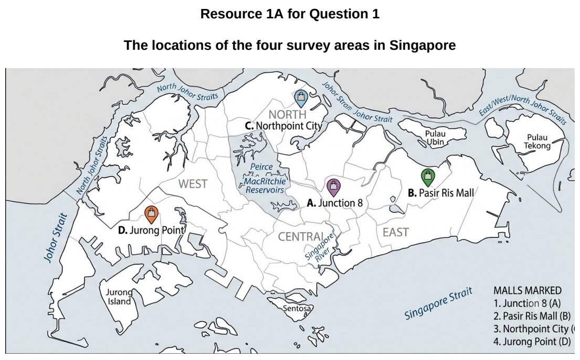

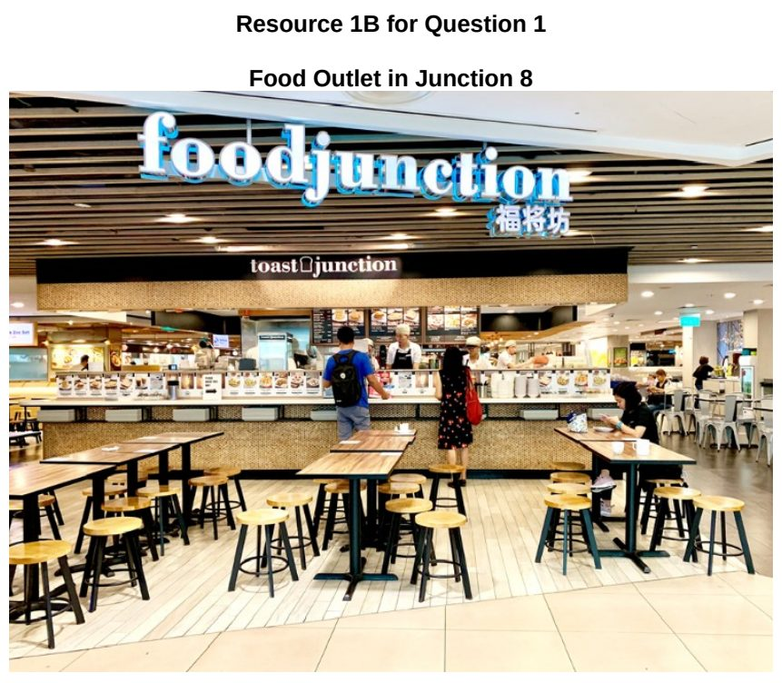

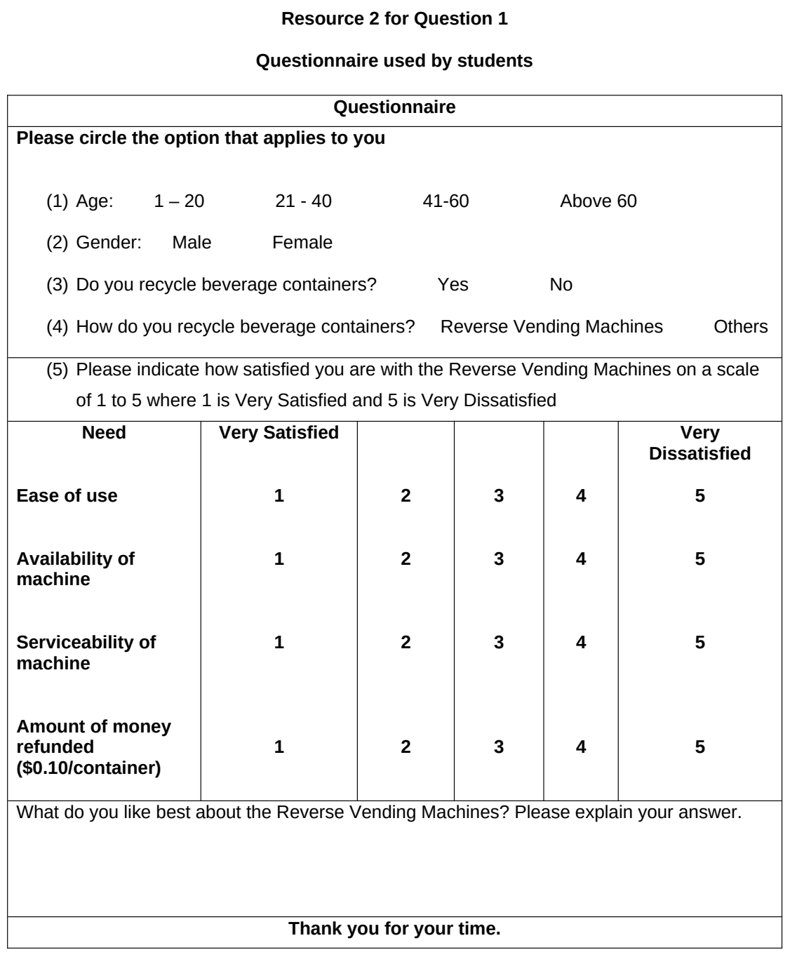

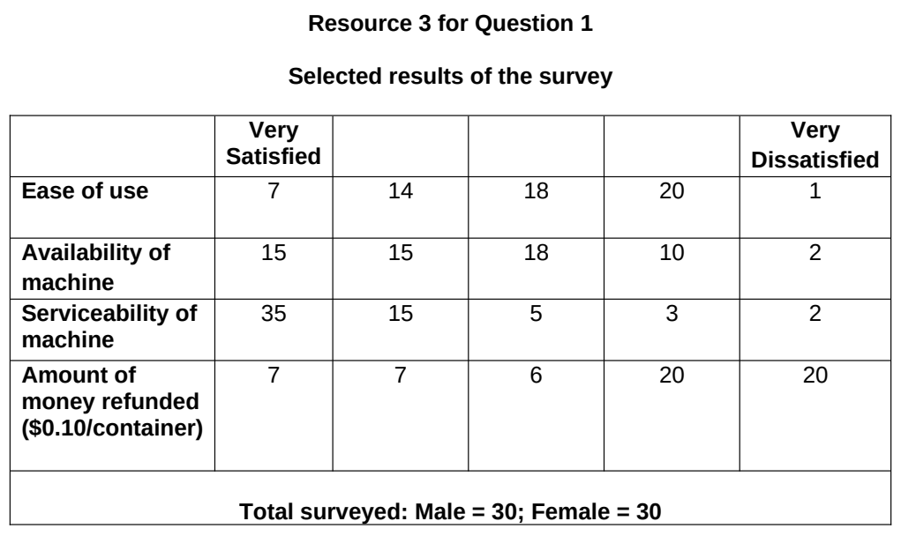

Fieldwork – Elderly needs

ACJC 2024 — H1 Paper 1 (8834/01), Q1 [30 marks]
Syllabus: 2 Fieldwork | Fieldwork area: Elderly needs
Section A — Cluster 2 Fieldwork
A group of students conducted a fieldwork investigation on the accessibility of transportation and quality of outdoor spaces for the elderly in Bukit Merah. The focus of their investigation was to assess how well the community's infrastructure supports the elderly in staying active and independent. The hypothesis for their study was:
‘Public transportation and outdoor spaces in Bukit Merah do not adequately meet the needs of elderly residents.’
The students conducted the investigation over two weekdays in August, between 9am and 12pm. The two main locations selected were the Bukit Merah Bus Interchange and the Tiong Bahru Plaza shopping mall. These locations were chosen based on their accessibility and frequency of use by elderly residents. The students decided to collect data by conducting a survey and taking photographs of the area.
A total of 30 elderly respondents, aged 60 and above, participated in the survey. The aim was to gather data on their experiences with transportation and outdoor spaces.
Resource 1 shows photographs of Bukit Merah Bus Interchange and Tiong Bahru Plaza shopping mall. Resource 2 shows the survey that the students used. Resource 3 shows selected results of the survey.
(a) Explain why this hypothesis is appropriate for the investigation. [4]
(b) Describe how the students can improve the sampling method used in their investigation. [3]
(c) With reference to Resources 1 and 2, explain two possible issues related to ethics when students collect primary data. [4]
(d) With reference to Resource 1, suggest how the students could minimise potential risks when they undertake fieldwork at Bukit Merah Bus Interchange and Tiong Bahru Plaza shopping mall. [6]
(e) With reference to Resource 3, explain the limitations of the data representation shown. [3]
(f) Evaluate the validity of the data shown in Resource 3 in answering the hypothesis. [10]

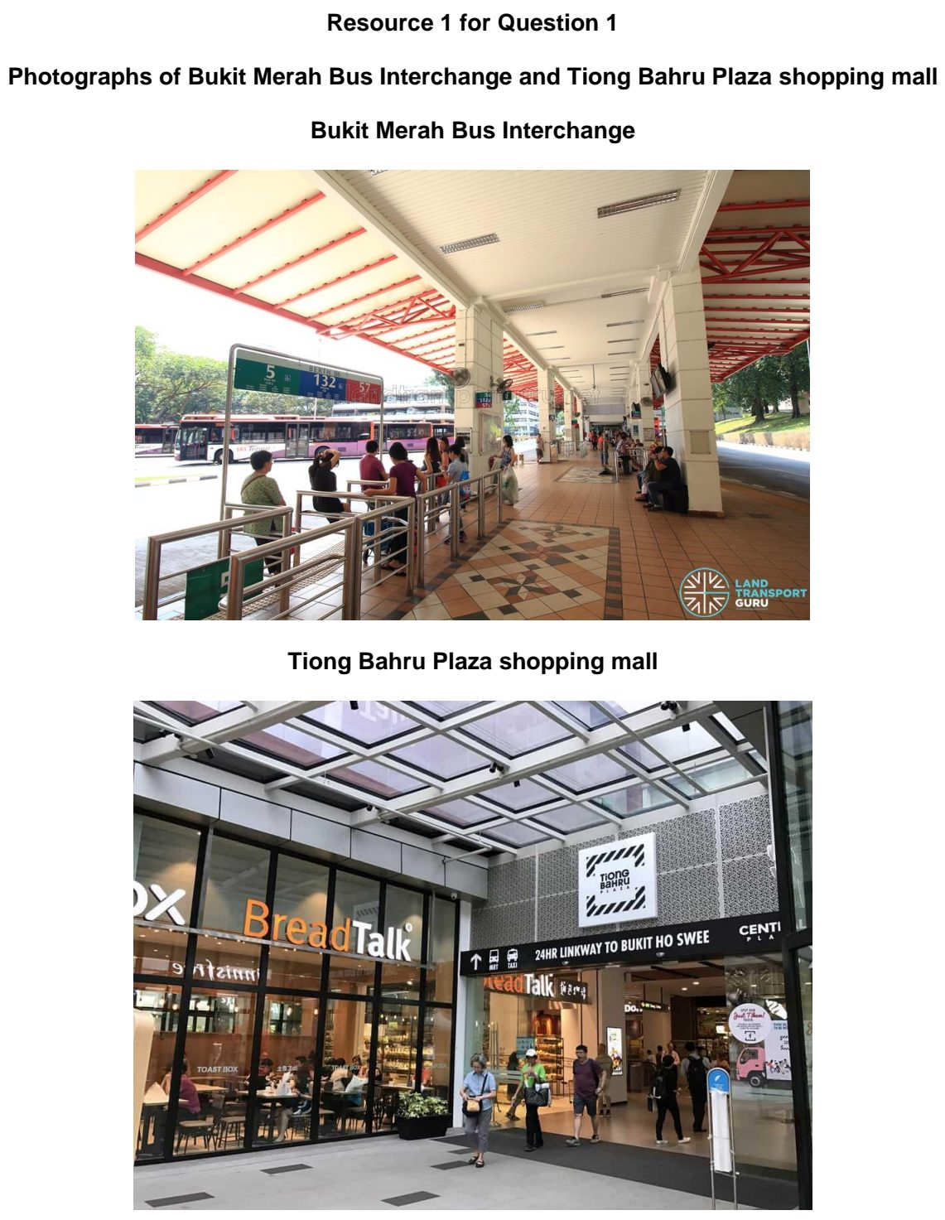

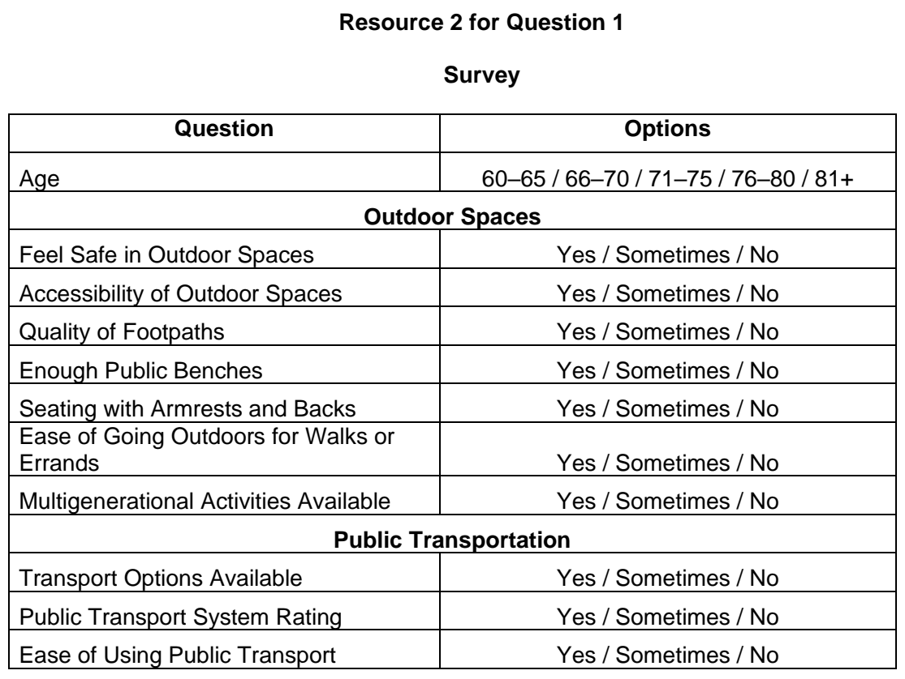

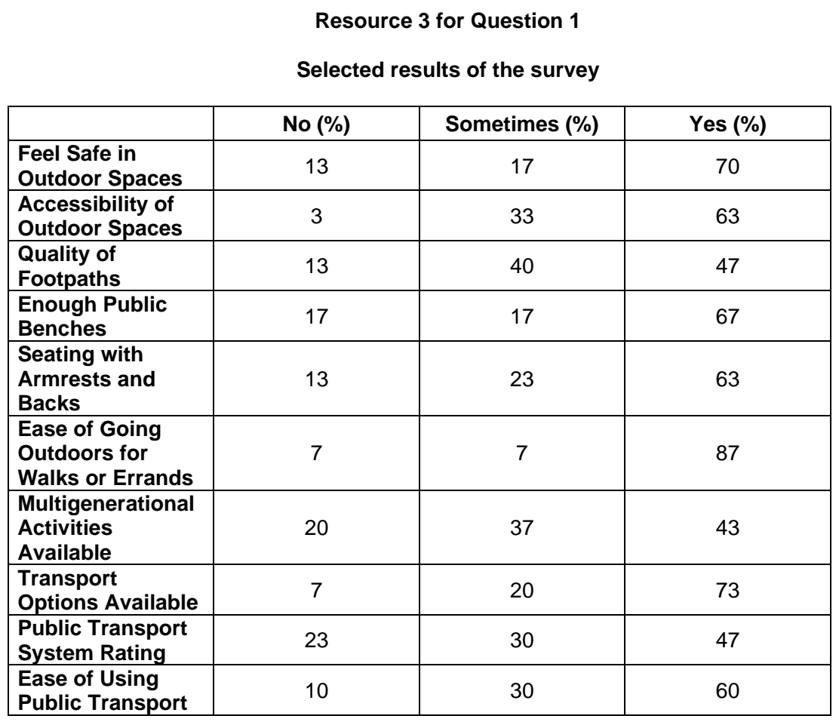

ACJC 2025 — H1 Paper 1 (8834/01), Q1 [30 marks]
Syllabus: 2 Fieldwork | Fieldwork area: Elderly needs
Section A — Cluster 2 Fieldwork
A group of students conducted a fieldwork investigation on the needs of elderly residents in Toa Payoh, Singapore. The focus of their investigation was to assess how well pedestrian pathways and neighbourhood amenities support elderly residents in staying active and independent. The hypothesis for their study was:
‘Pedestrian pathways and the markets in Toa Payoh adequately meet the needs of elderly residents.’
The students conducted the investigation over two weekdays in October, between 9am and 12pm. The students started by firstly doing a pre-fieldwork site visit of Toa Payoh Estate. The main locations selected were a pedestrian pathway in Toa Payoh Central and another in the hawker and market centre.
They then started to collect data by conducting a survey of elderly residents at the two locations. The aim was to gather data on their experiences about the pedestrian pathways and the markets in Toa Payoh. They approached anyone that they thought looked over 60. A total of 40 elderly respondents, aged 60 and above, participated in the survey. They also took photographs of the pathways and the markets in the area.
Resource 1 shows a map of Toa Payoh and the locations of the fieldwork sites. Resource 2 shows photographs of the pedestrian pathways and the market in Toa Payoh. Resource 3 shows the results of the survey about pedestrian pathways. Resource 4 shows the results of the survey about markets in Toa Payoh.
(a) Explain why this hypothesis is suitable for the investigation. [4]
(b) With reference to Resources 1 and 2, suggest how the students could minimise potential impacts at the sites while conducting their investigation. [5]
(c) Explain the benefits of conducting a pre-fieldwork site visit of Toa Payoh estate. [4]
(d) With reference to Resource 3, describe the results on satisfaction with pedestrian pathways. [3]
(e) Sketch a graph to present the data in Resource 4. [4]
(f) Evaluate the usefulness of the investigation in helping students understand factors affecting liveability for the elderly living in Toa Payoh. [10]

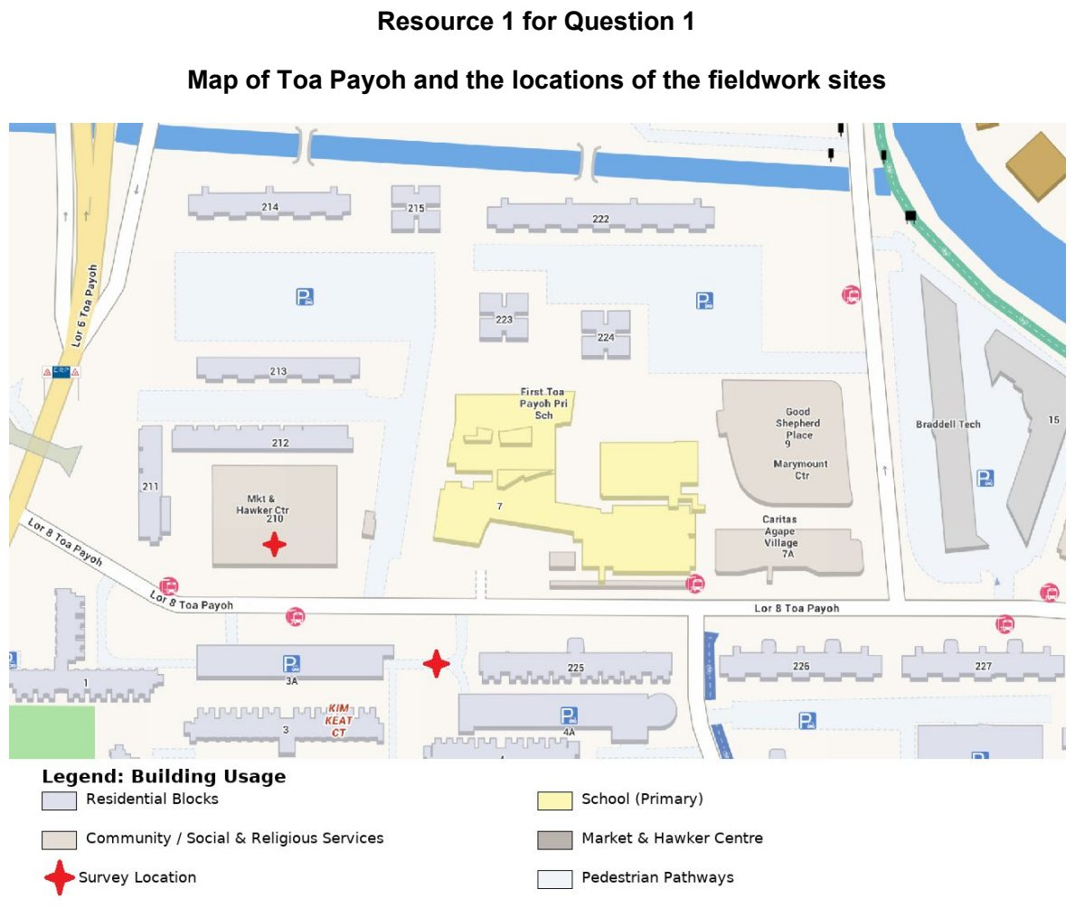

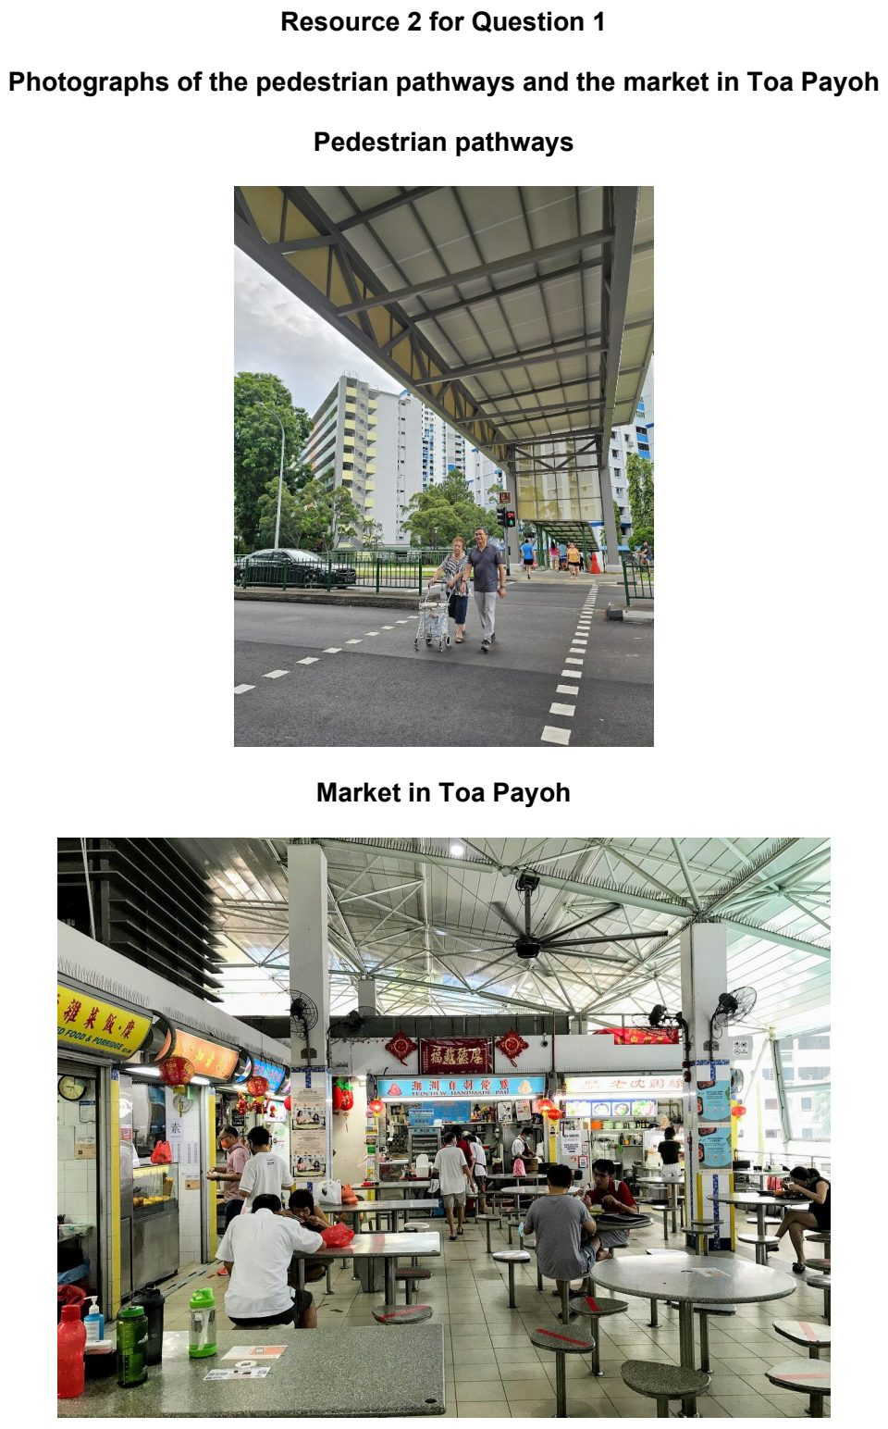

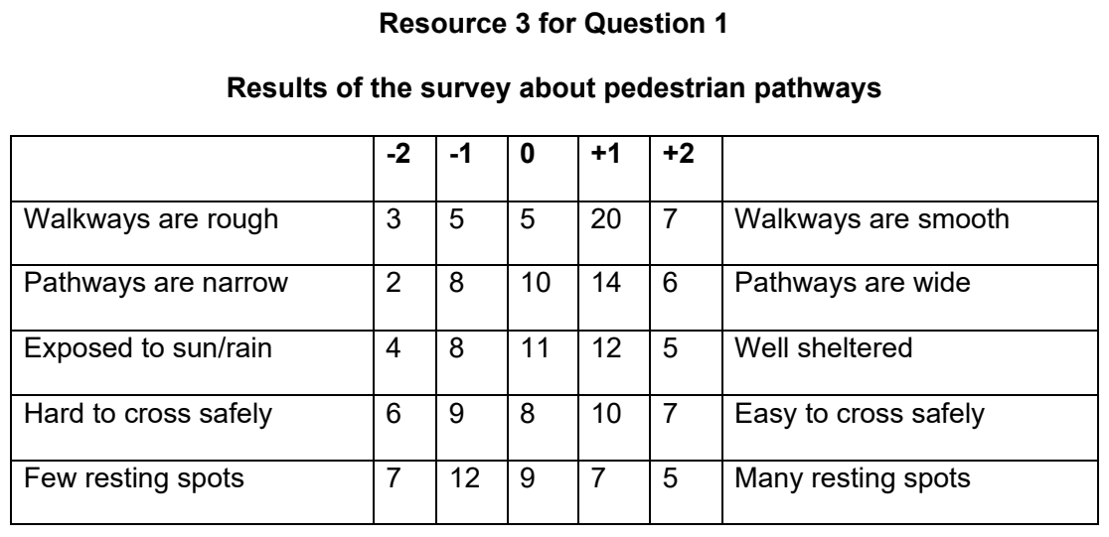

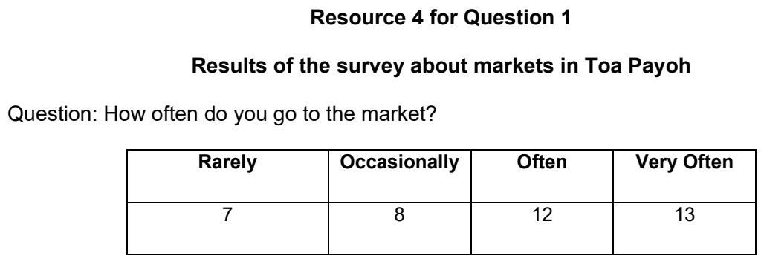

ASRJC 2025 — H1 Paper 1 (8834/01), Q1 [30 marks]
Syllabus: 2 Fieldwork | Fieldwork area: Elderly needs
Section A — Cluster 2 Fieldwork
Eight students conducted a study on a Saturday morning in June (9:00–11:00 AM) to investigate whether frequent visits to Kim Pong Park improve the mental well-being of elderly residents. They located their fieldwork investigation in a cluster of eight low-rise apartment blocks in Tiong Bahru. Light rain had fallen earlier in the morning before the study.
They agreed on the following hypothesis:
“Elderly residents who often visit neighbourhood parks tend to have better mental well-being.”
The students split themselves into two groups and surveyed 20 elderly residents:
• Group 1 (4 students): Conducted on-the-spot interviews at the park exit with 10 elderly visitors.
• Group 2 (4 students): Conducted in-home interviews with 10 residents from Blocks 49 and 50.
Resource 1 shows Kim Pong Park with an exit point and nearby low-rise apartment blocks (43 to 50). Resource 2 shows the survey questionnaire used by the students. Resource 3 shows data collected on the park visit frequency and self-reported mood among the elderly participants.
(a) Explain whether the students’ hypothesis is suitable. [3]
(b) With reference to Resource 1, explain how each group of students could have best selected the respondents for their interviews. [4]
(c) With reference to Resource 1, suggest how the students could minimise potential risks in conducting the survey. [3]
(d) Explain the strengths and limitations of the survey questionnaire shown in Resource 2. [5]
(e) Sketch a graph to present the information on “Visits per week” and “Mood Rating” in Resource 3 and explain its suitability. [5]
(f) Evaluate the validity of the students’ investigation. [10]

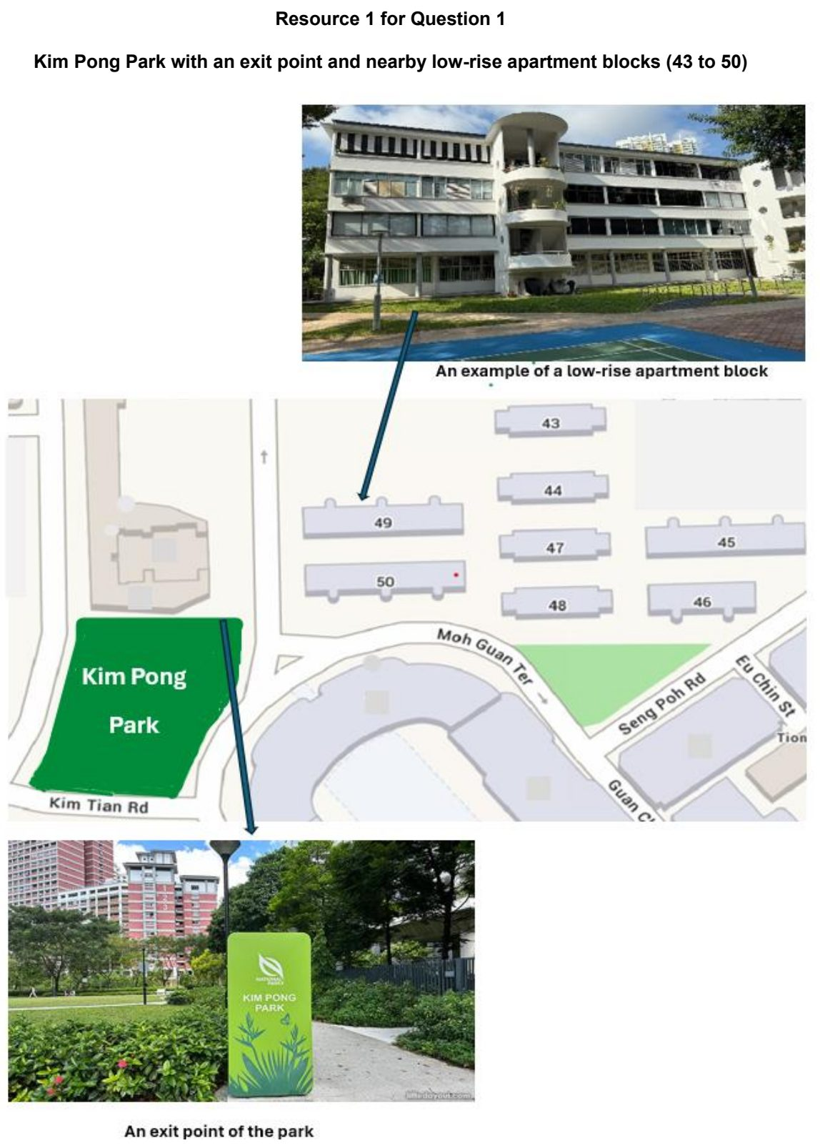

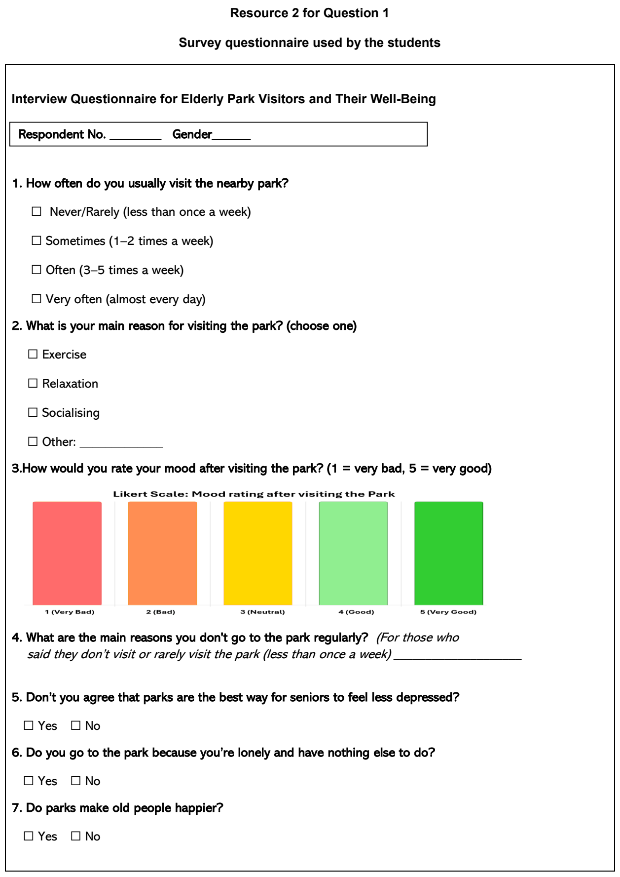

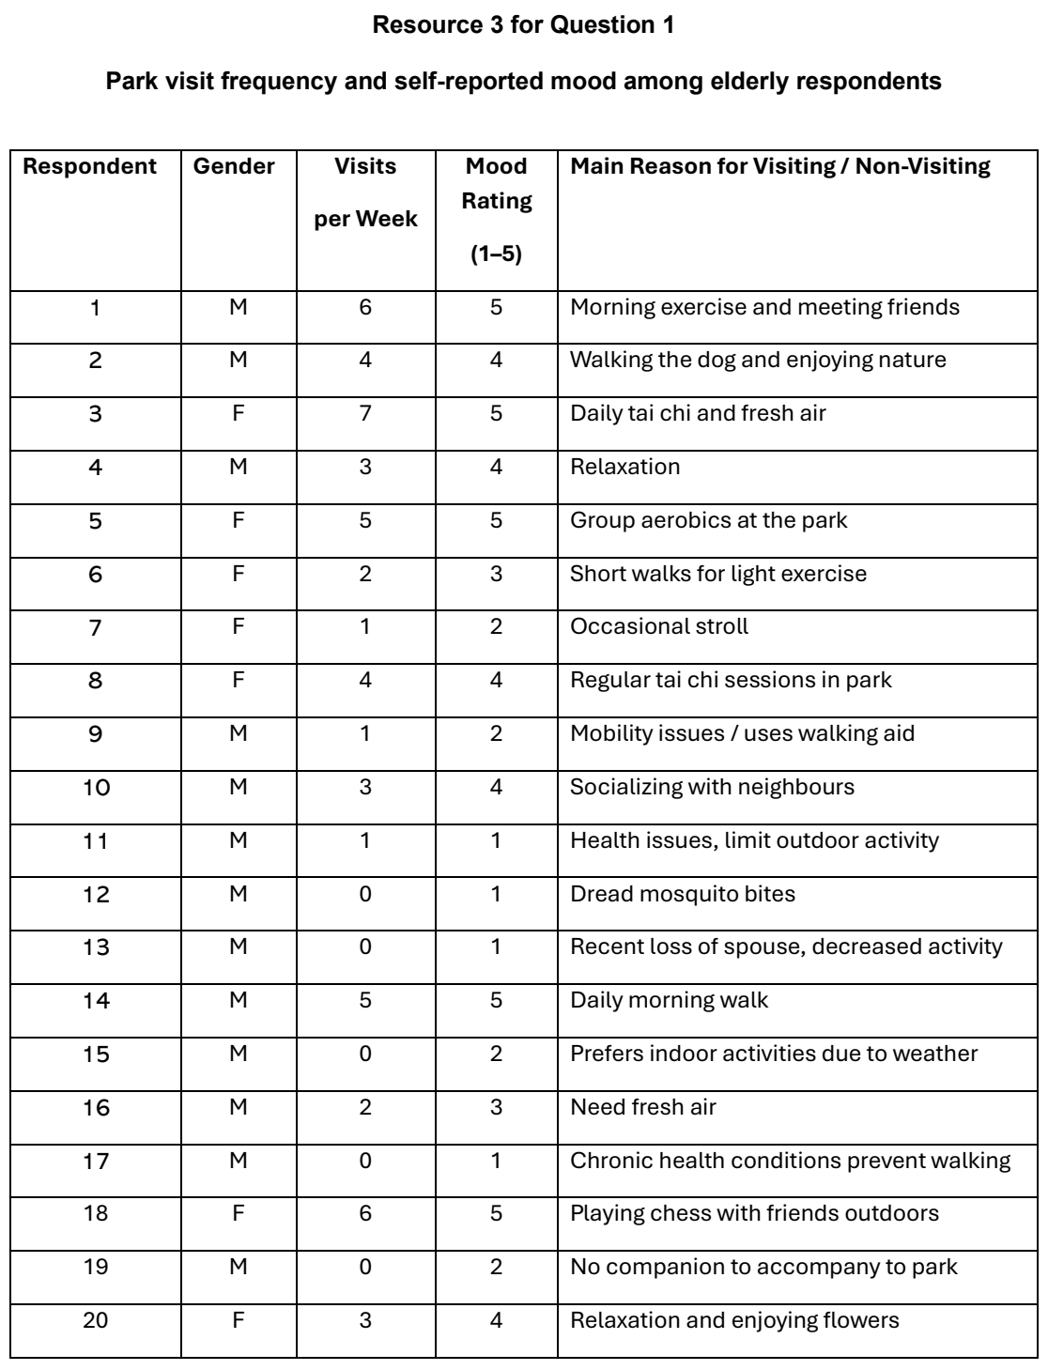

CJC 2025 — H1 Paper 1 (8834/01), Q1 [30 marks]
Syllabus: 2 Fieldwork | Fieldwork area: Elderly needs
Section A — Cluster 2 Fieldwork
A group of four students carried out fieldwork to investigate whether Randwick, a suburb in Sydney, supports the psychological well-being of its elderly residents. Their investigation focused on two aspects — sense of community and perceived safety. Their hypothesis was:
Elderly residents in Randwick feel a strong sense of community and personal safety in their neighbourhood.
The students approached elderly residents at Alison Park and Royal Randwick on a weekday afternoon. They surveyed 18 residents aged 67 to 84 using a short questionnaire containing both closed and open-ended questions about their interactions with neighbours, participation in local activities, and feelings of safety in public areas. Four of these residents agreed to participate in brief, informal interviews to elaborate on their experiences.
The group also split up to conduct observations at four public spaces commonly used by the elderly.
• Royal Randwick
• Randwick City Library
• St. Basil’s Centre
• Alison Park They used a checklist to assess features such as lighting, seating, visibility, cleanliness, and number of users.
Resource 1 is a map of Randwick showing the data collection sites. Resource 2 shows photographs of selected public spaces. Resource 3 shows the questionnaire used. Resource 4 shows selected findings from the survey and observations.
(a) Explain one weakness and one strength of the students’ hypothesis. [4]
(b) With reference to Resources 1 and 2, explain the possible risks the students might face during the investigation. [3]
(c) With reference to Resource 2, suggest how the students could minimise the impact of their investigation on the community. [4]
(d) With reference to Resource 3, explain how the questionnaire might help the students collect accurate data for their investigation. [5]
(e) With reference to Resource 4A, describe the elderly’s perceptions of sense of community and safety in their neighbourhood. [4]
(f) Evaluate the validity of the students’ investigation. [10]

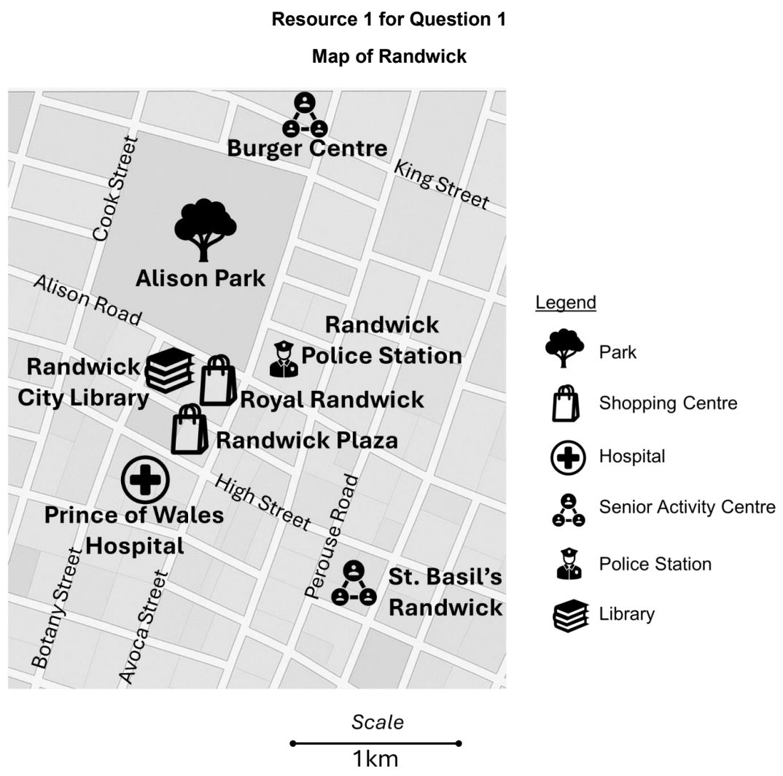

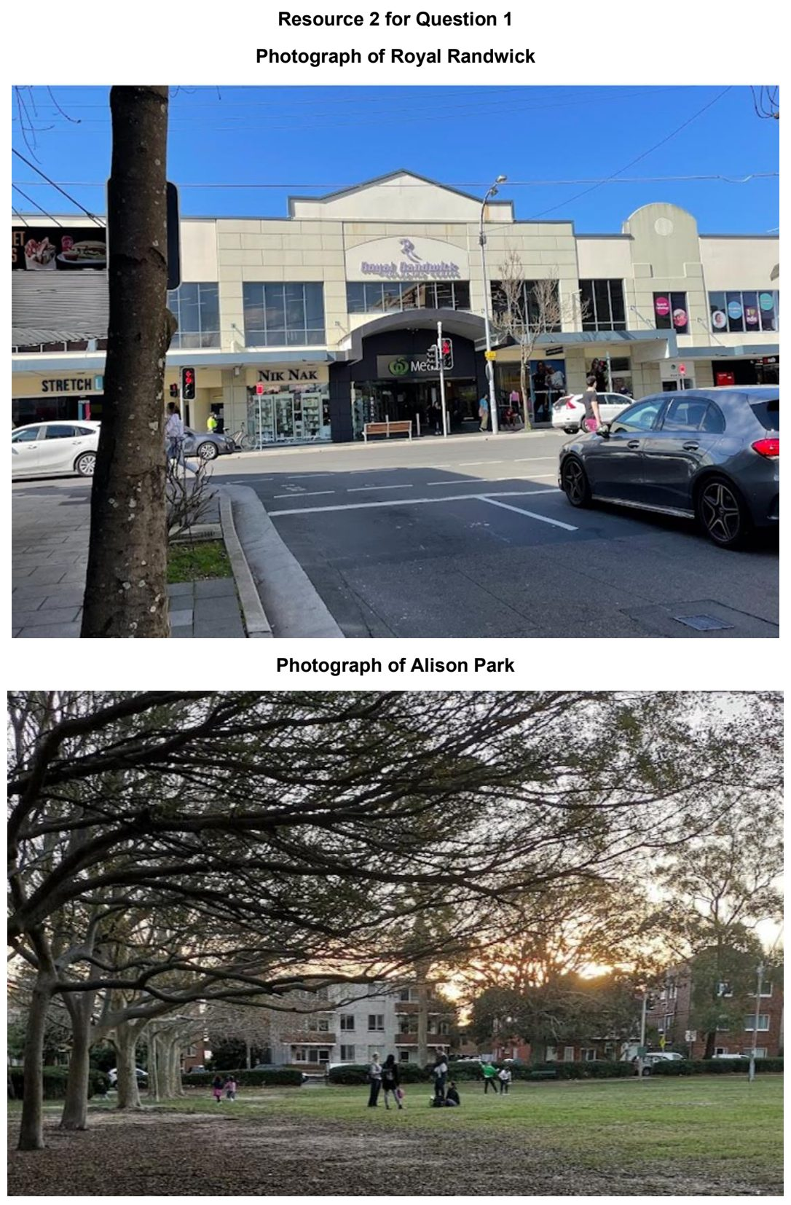

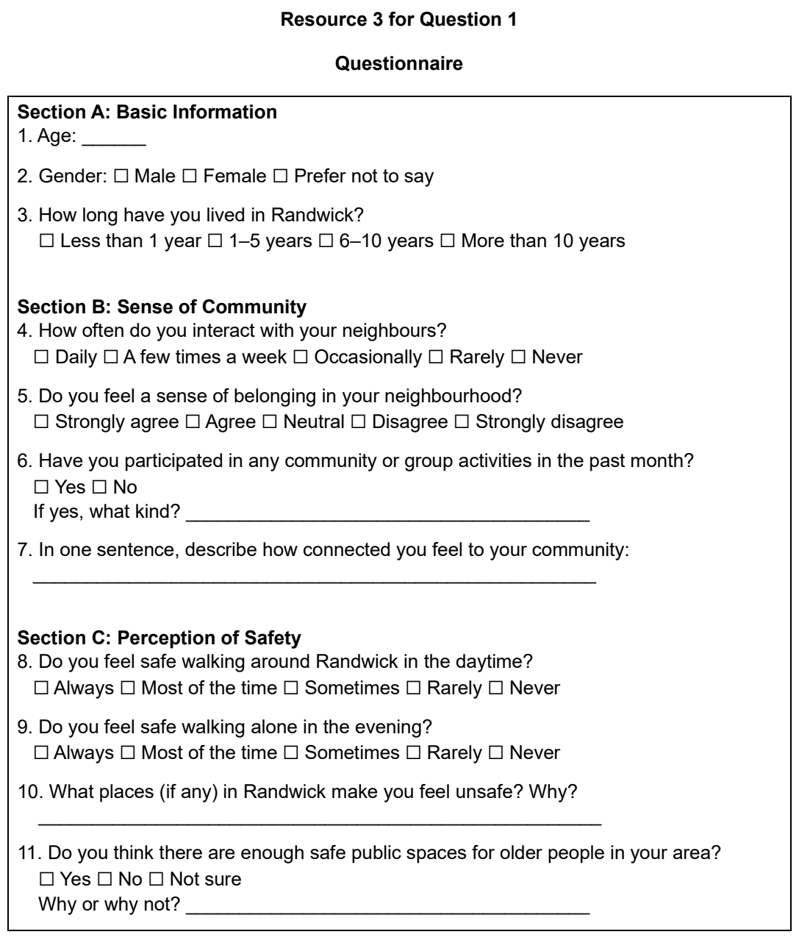

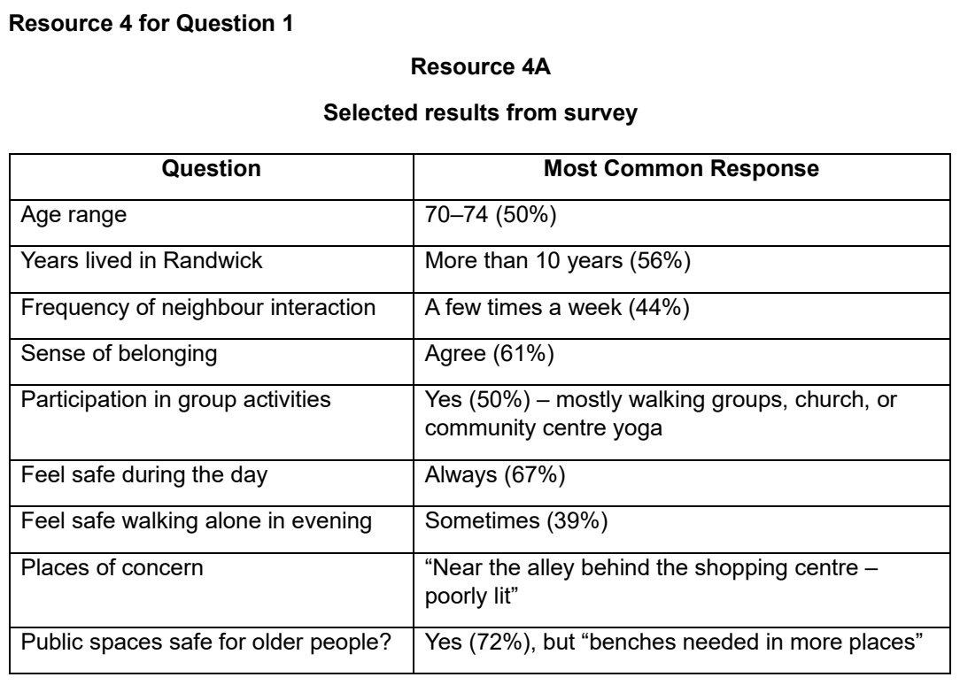

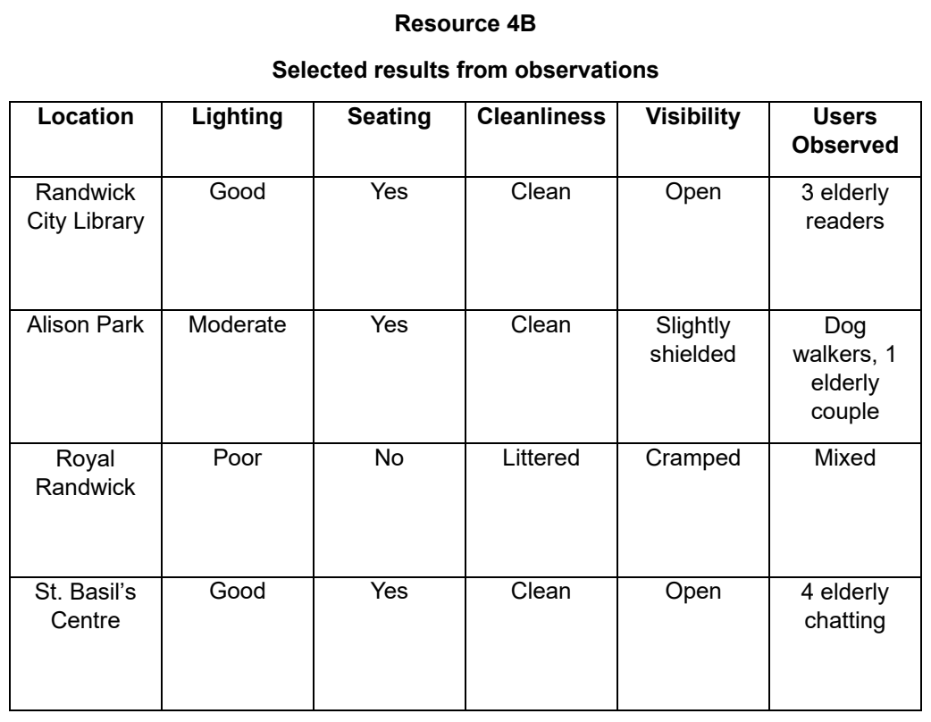

CJC 2026 — H1 Paper 1 (8834/01), Q1 [30 marks]
Syllabus: 2 Fieldwork | Fieldwork area: Elderly needs
Section A — Cluster 2 Fieldwork
A group of four students carried out fieldwork to investigate whether Melbourne Central Business District (CBD) supports the well-being of the elderly. Their investigation focused on transportation access to social amenities. Their hypothesis was:
The quality and accessibility of Melbourne CBD's public transport network positively influence the social well-being of elderly people.
The students allocated 3 hours for their investigation on a weekday afternoon.
The students visited Southern Cross Station to collect data. They surveyed 18 Caucasian elderly aged 67 to 84 years old. They used a short questionnaire containing both closed and open-ended questions.
They also boarded 4 trams around the CBD to conduct observations about the accessibility of public transport for elderly people. They took photographs and used a checklist to assess features such as lighting, reserved seating for the elderly, wheelchair access and space.
Resource 1 is a map of Melbourne CBD. Resource 2 shows photographs of the sites that students visited to collect data. Resource 3 shows the questionnaire used by the students for survey in fieldwork. Resources 4A, 4B and 4C show the profile of respondents and selected findings from the survey and observations.
(a) Explain one weakness and one strength of the students’ hypothesis. [4]
(b) With reference to Resource 2, explain the possible risks the students might face during the investigation. [3]
(c) With reference to Resource 2, explain how the students could address the ethical issues in their investigation. [4]
(d) With reference to Resource 3, explain the strengths and limitations of the questionnaire in helping the students collect accurate data. [5]
(e) Explain how the data in Resource 4B may be represented using a graph. [4]
(f) The students concluded that public transportation in Melbourne CBD supported the social well-being of the elderly. Evaluate the validity of the students’ conclusion. [10]

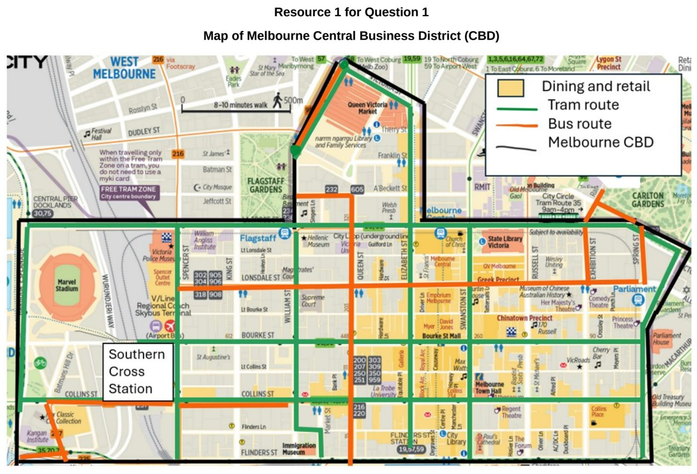

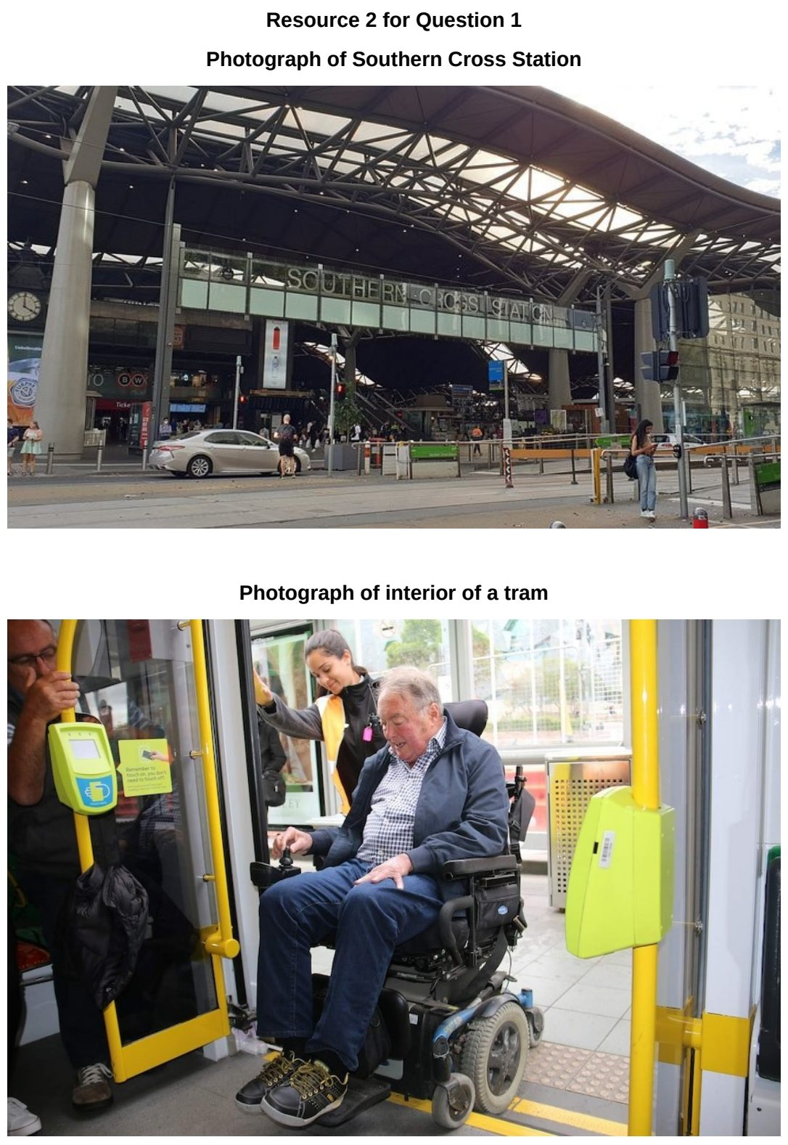

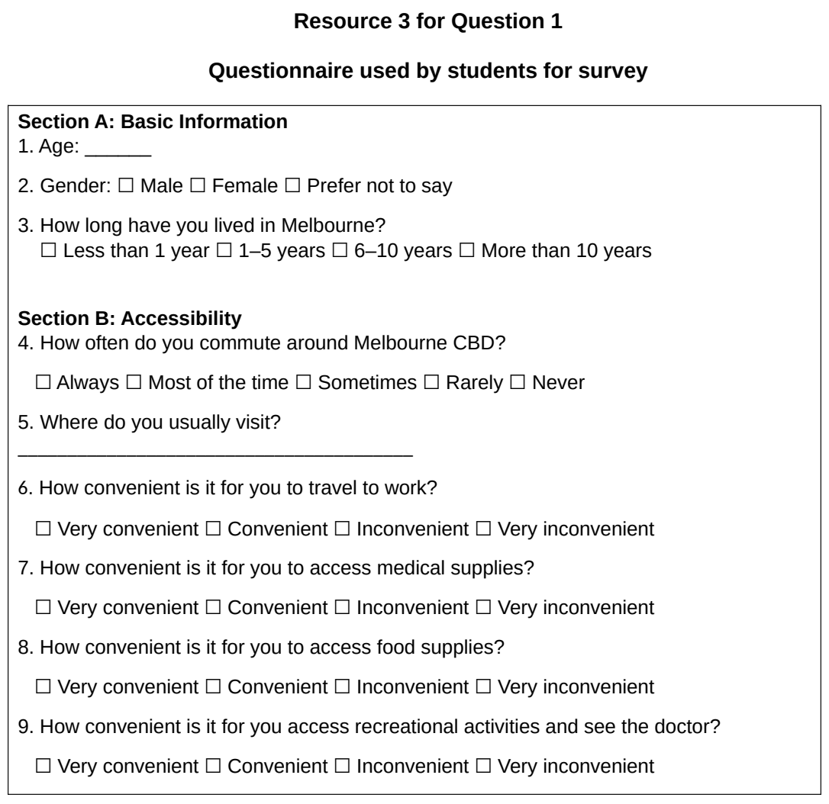

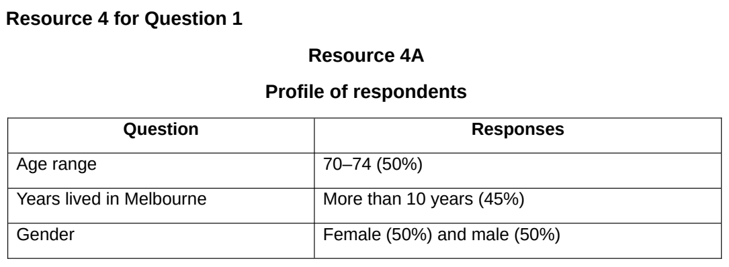

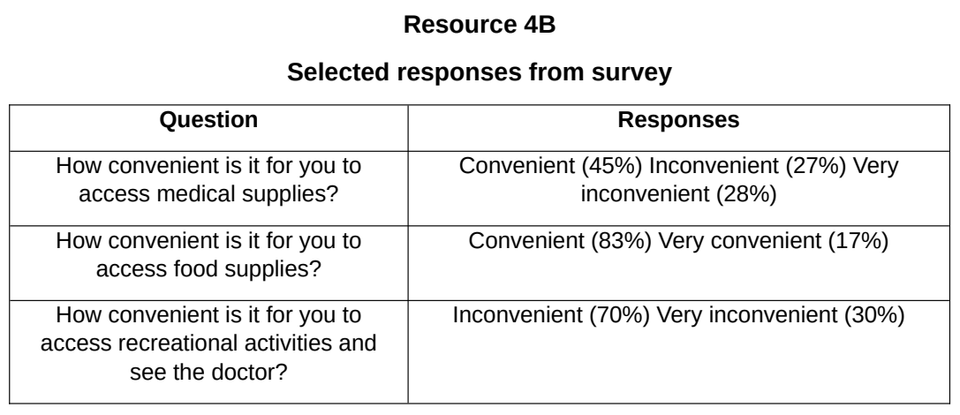

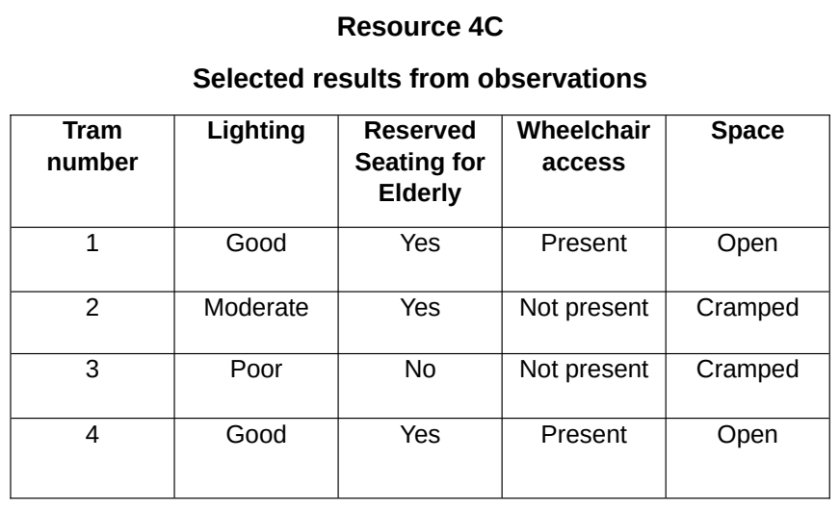

DHS 2025 — H1 Paper 1 (8834/01), Q1 [30 marks]
Syllabus: 2 Fieldwork | Fieldwork area: Elderly needs
Section A — Cluster 2 Fieldwork
Five students wanted to carry out an investigation of the social needs of the elderly in a housing estate. In their secondary research, they found that the estate with the largest proportion of elderly in Singapore is Bedok and in the following proportions by age group:
Age group 60-69: 15.0% 70-79: 10.7% 80 and above: 4.6%
The students produced a questionnaire to assess the needs of the elderly and to compare with the existing facilities in Bedok. Three sites, shown in Resource 1, were identified as potential sites to conduct the survey. After a preliminary visit to assess the suitability of the sites, the students eventually selected Site 1. On a weekday, between 0800h to 1000h, in June, the students conducted their survey at Site 1. They approached people, who appeared to be elderly and were willing to be surveyed, and verified their age and residential status before they conducted their survey using the questionnaire shown in Resource 2.
They surveyed a total of 65 elderlies: 20 aged 60-69 years 25 aged 70-79 years 20 aged 80 and above years
Resource 1 shows the locations of the potential and actual survey sites. Resource 2 is a sample of the survey questionnaire. Resource 3 is the results of the survey collected by the students.
(a) Suggest a hypothesis for the investigation and explain why it is suitable. [4]
(b) With reference to Resource 1, explain why the students selected Site 1 and not the other sites to conduct their survey. [3]
(c) With reference to Resource 2, explain the strengths and limitations of the survey questionnaire. [4]
(d) Use a suitable method to represent the results for Question 1 for the 70-79 age group shown in Resource 3. Justify your choice of method. [5]
(e) Compare the results for Question 1 for the 60-69 age group with the 80 and above age group shown in Resource 3. [4]
(f) Evaluate the extent to which the students can use the collected data to address the aim of their investigation. [10]

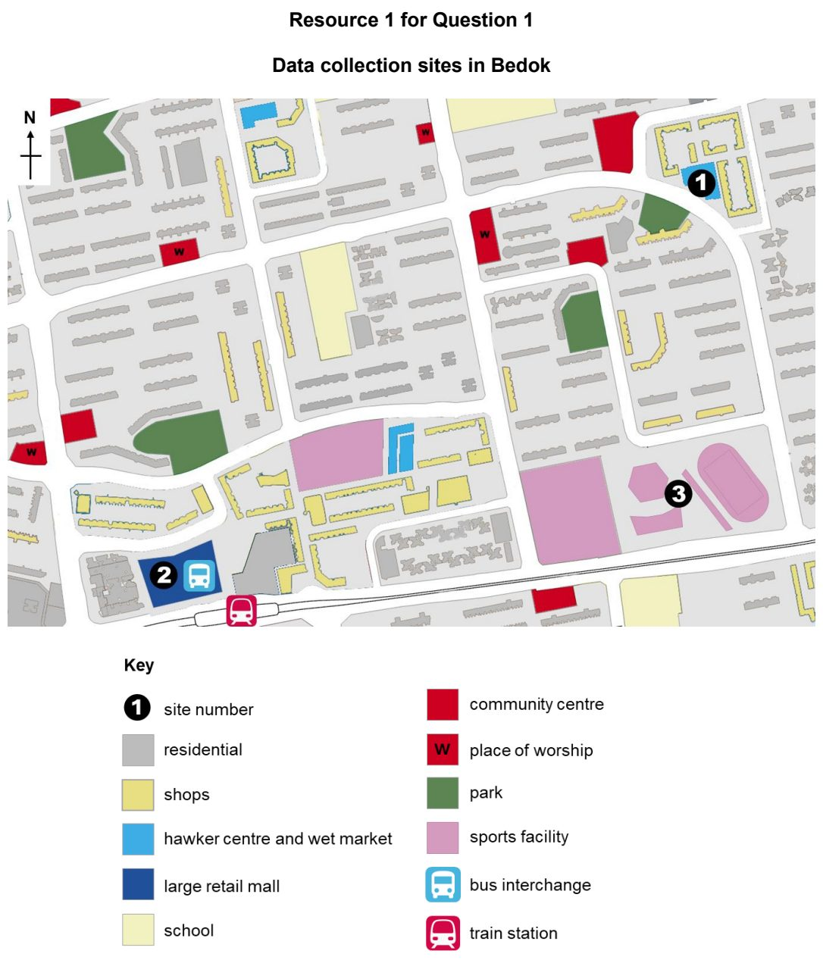

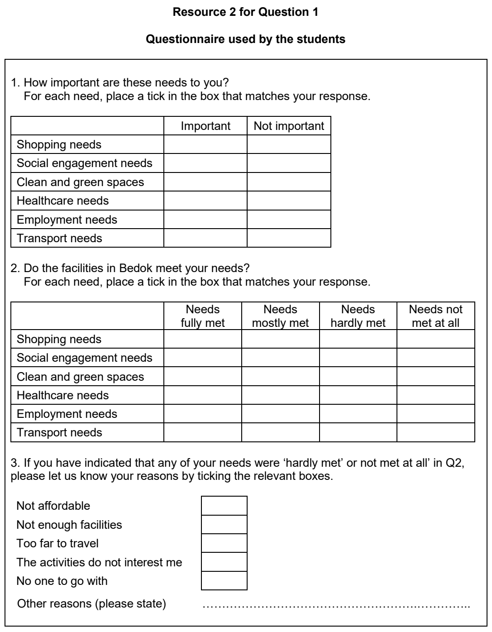

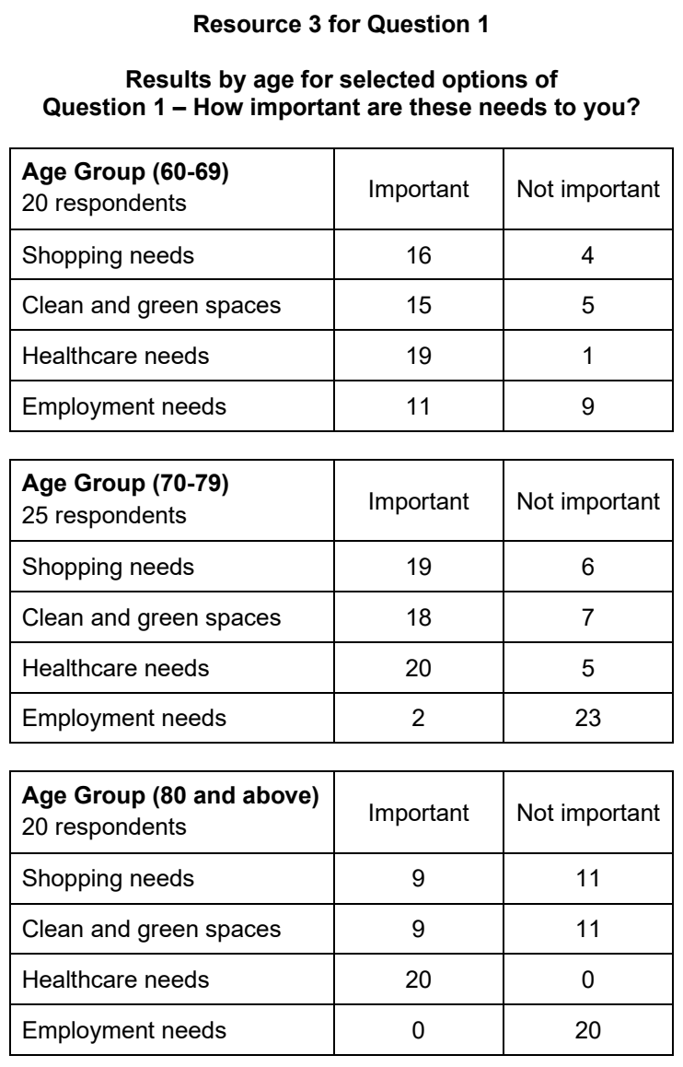

EJC 2025 — H1 Paper 1 (8834/01), Q1 [30 marks]
Syllabus: 2 Fieldwork | Fieldwork area: Elderly needs
Section A — Cluster 2 Fieldwork
A group of four students wanted to investigate whether the urban neighbourhood of Kampong Admiralty is a supportive environment for elderly residents to live in.
They crafted the following hypothesis:
“Kampong Admiralty is a liveable neighbourhood that meets the social and psychological needs of the elderly.”
To test the hypothesis, the students conducted the survey questionnaire that was translated into English, Malay, Chinese and Tamil. As it was during the June school break, the students could only afford time on a single Friday during the June holidays, from 1-2pm to conduct their investigation. The students conducted their fieldwork at the Community Plaza in Kampung Admiralty, approaching any passers-by who looked like they could be 65 years and above. The group ended up with a total of 15 responses.
Resource 1 shows an infographic of infrastructure and amenities in Kampung Admiralty Integrated Development. Resource 2 shows the survey questionnaire used by the students to gather responses from the elderly. Resource 3A shows responses to Questions 4 and 7 of the survey questionnaire, while Resource 3B shows selected responses to Question 9 of the survey questionnaire.
(a) Explain why the students’ hypothesis is suitable for investigation. [4]
(b) Explain how the students can address possible issues related to research ethics when conducting their fieldwork. [4]
(c) With reference to Resource 2, suggest how the design of the questionnaire can be improved. [6]
(d) Sketch a graph to represent the data for Question 4 shown in Resource 3A and give reasons why you have chosen that type of graph. [6]
(e) Based on the students’ investigation, the students concluded that Kampung Admiralty was a liveable neighbourhood for all elderly. With reference to all the Resources, evaluate the validity of this conclusion. [10]

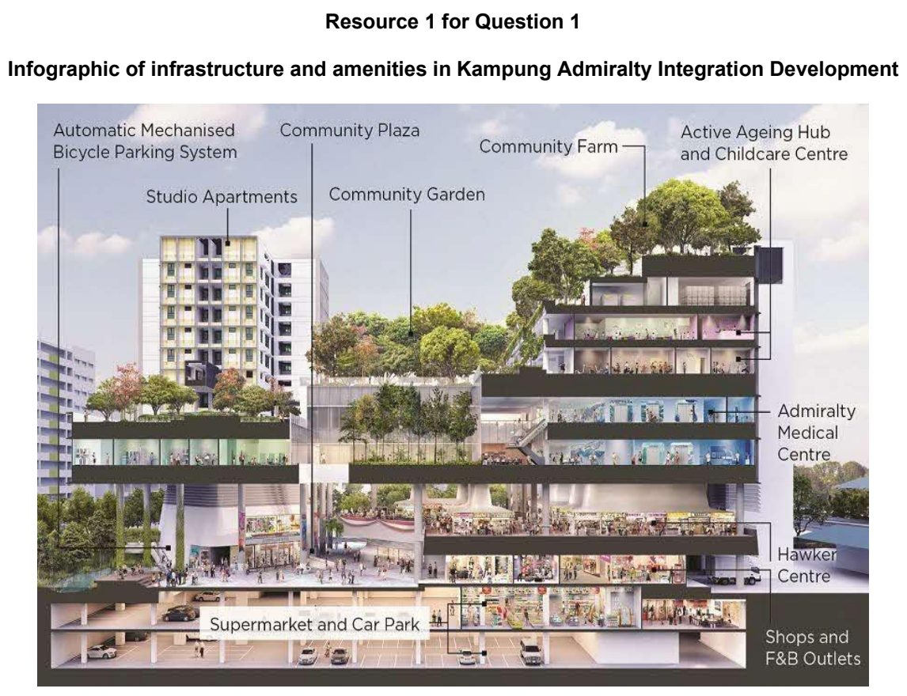

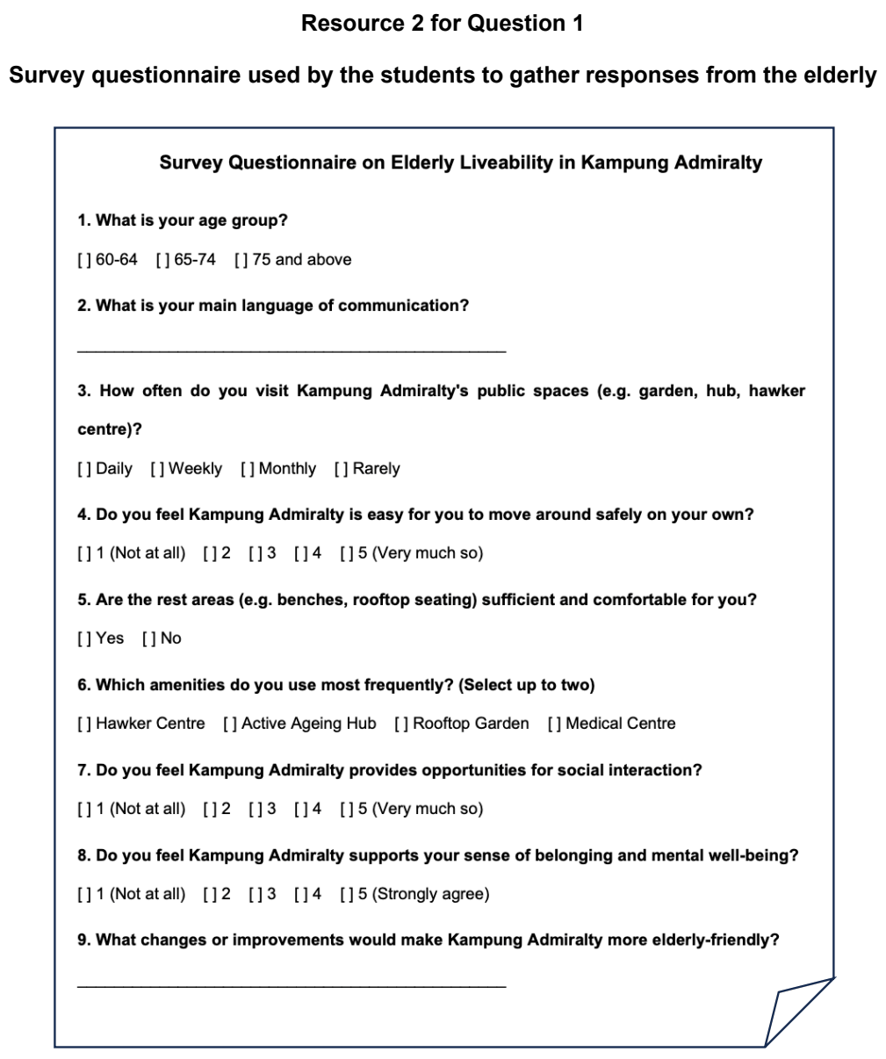

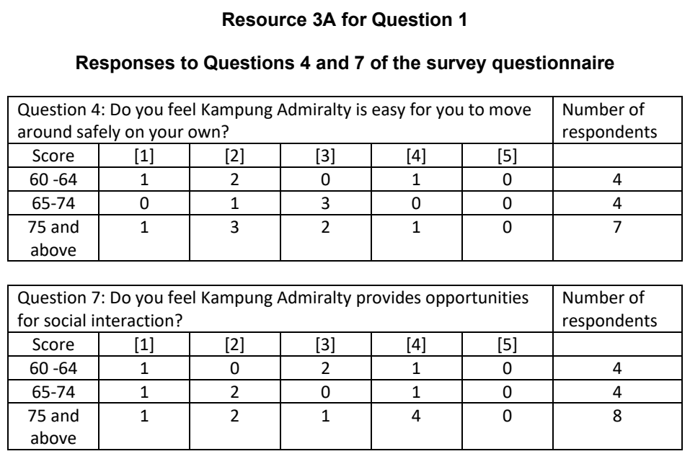

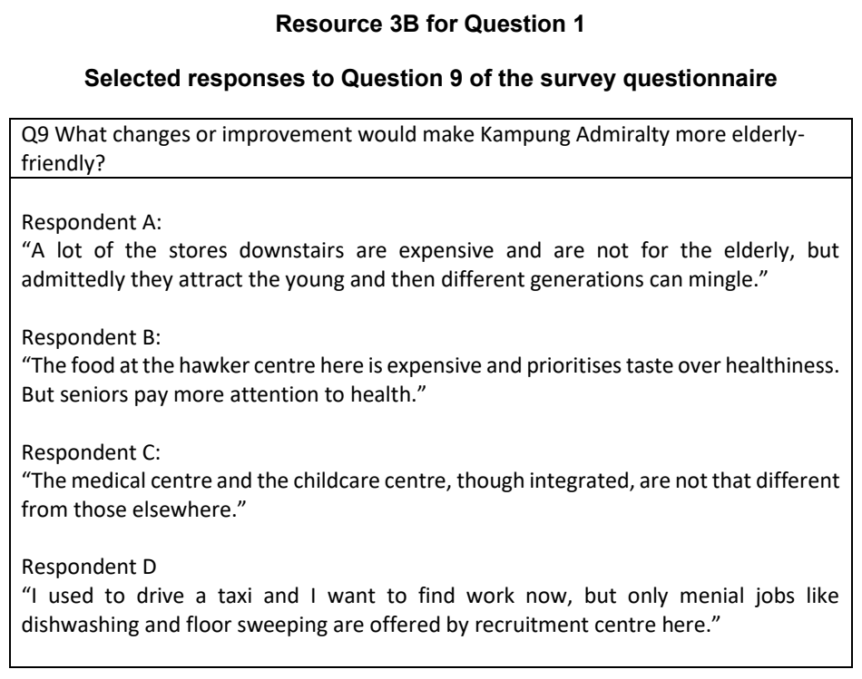

HCI 2025 — H1 Paper 1 (8834/01), Q1 [30 marks]
Syllabus: 2 Fieldwork | Fieldwork area: Elderly needs
Section A — Cluster 2 Fieldwork
Four 17-year old students undertook an investigation about the perception of the elderly population of the level of liveability in Toa Payoh town. They crafted the following hypothesis:
‘The elderly aged 65 years and above living in Toa Payoh experience a high level of liveability.’
The students conducted research on Age-Friendly Cities and decided to focus on the following factors that affect liveability of the elderly:
• Community support and health services
• Outdoor spaces and buildings
• Transportation
The students collected primary data by conducting a survey in May in a central area in Toa Payoh town on two weekday afternoons. When they were unable to reach their targeted sample size of 50 respondents, the students decided to expand their number of responses for the survey by asking their peers, who have elderly relatives living in Toa Payoh, to help administer the survey.
In addition to the survey, the students conducted face-to-face interviews with 6 elderly residents in Toa Payoh. The students also collected data by conducting on-site surveys of specific sites and recorded some physical features they observed in Toa Payoh town.
Resource 1 shows sites in Toa Payoh town where the surveys are conducted. Resource 2 shows the data collection sheet used by students for the survey. Resource 3 shows the survey findings. Resource 4 shows physical features observed in Toa Payoh town during the on-site surveys.
(a) Explain why the hypothesis is appropriate for the investigation. [3]
(b) With reference to Resource 1, suggest the challenges that the students may face when conducting the survey. [4]
(c) With reference to Resource 2, explain one strength and one weakness of the recording sheet. [5]
(d) Explain the ethical considerations that the students should take note of when conducting interviews with the elderly. [4]
(e) Use a sketch graph to represent the ‘mean score for each factor’ shown in Resource 3. [4]
(f) The students concluded that the elderly living in Toa Payoh experience a high level of liveability. With reference to Resources 1, 3 and 4, evaluate the validity of their conclusion. [10]

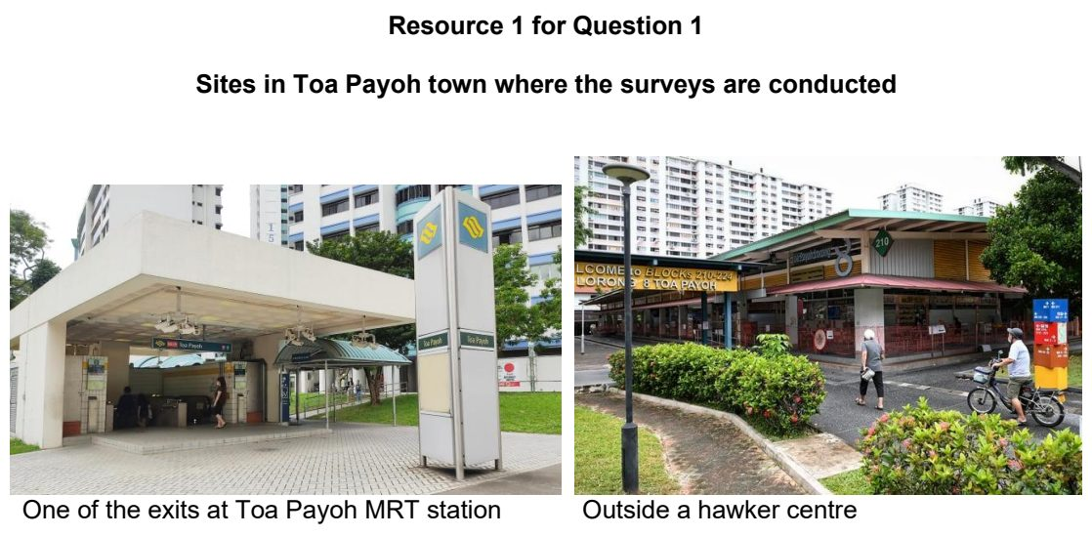

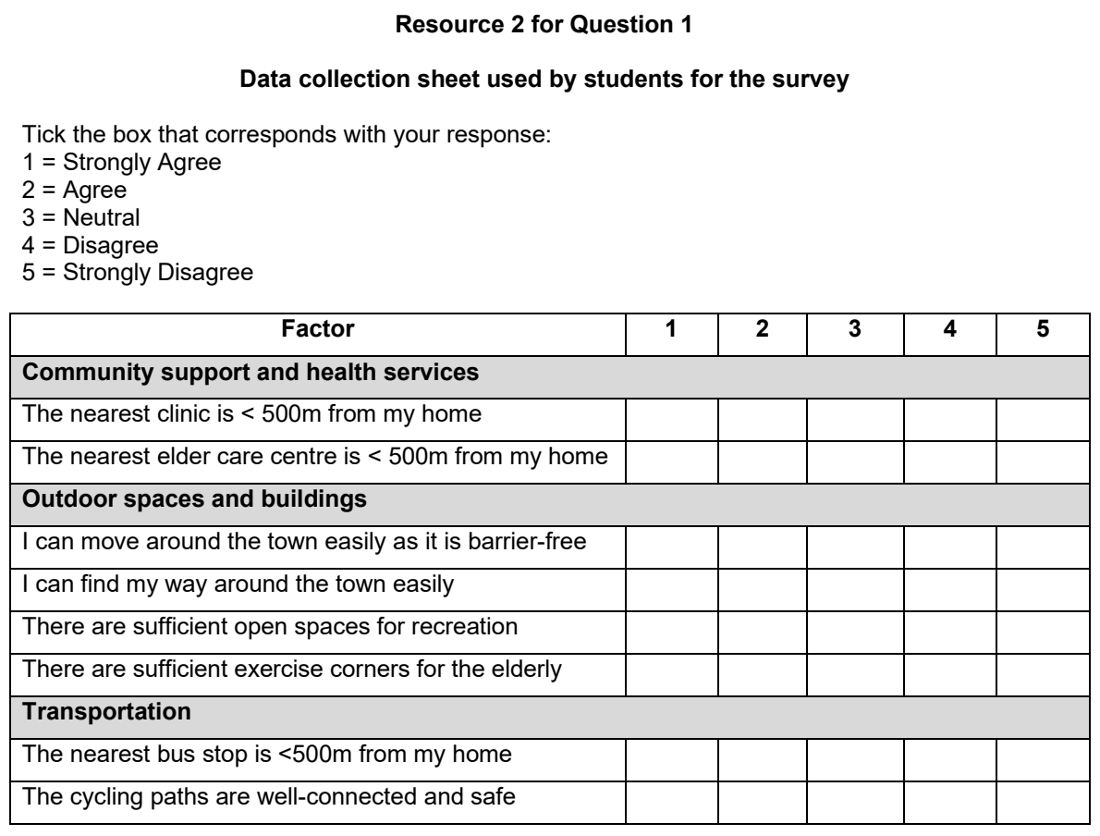

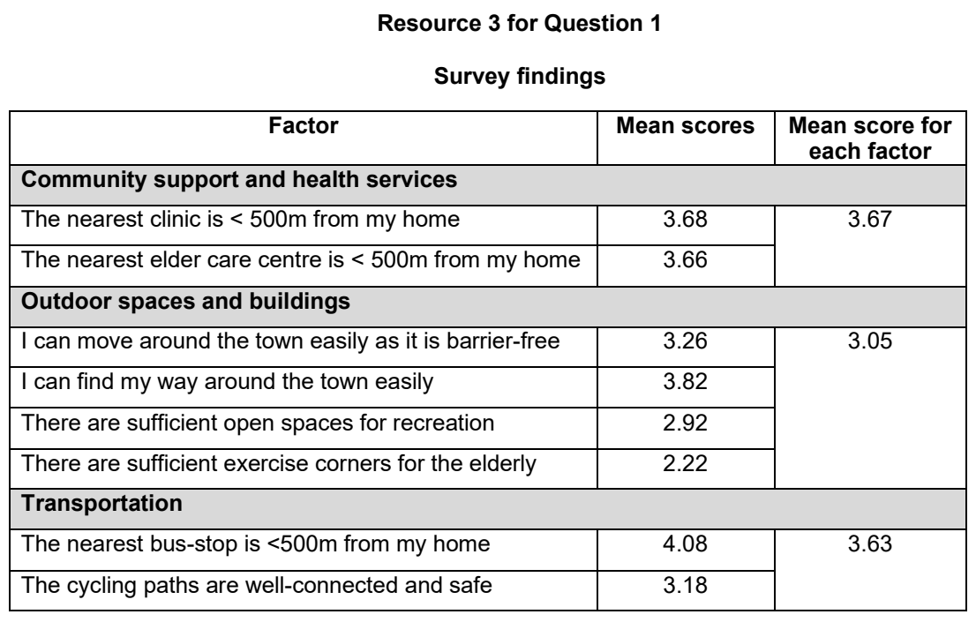

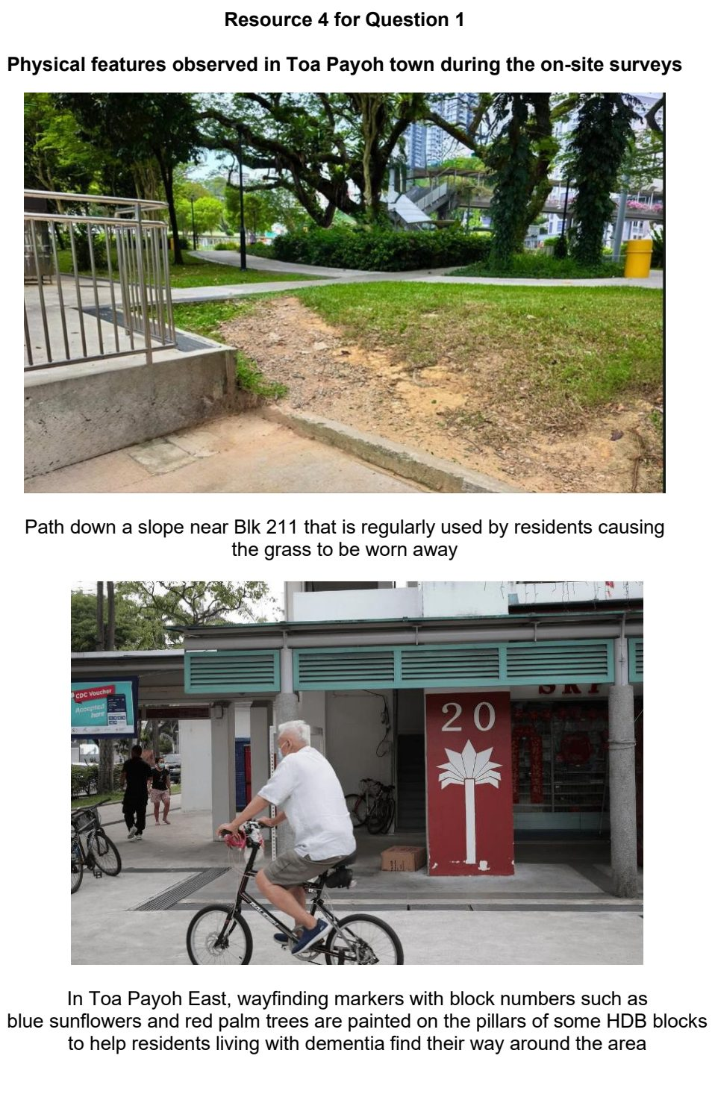

JPJC 2025 — H1 Paper 1 (8834/01), Q1 [30 marks]
Syllabus: 2 Fieldwork | Fieldwork area: Elderly needs
Section A — Cluster 2 Fieldwork
A group of 10 Geography students from a secondary school in Hong Kong conducted fieldwork to investigate the accessibility needs of elderly residents living in the city’s public housing estates. Their focus was on how easily these residents could move around and access essential facilities within their immediate housing environment. The students carried out their investigation over two weekday evenings. They chose to focus on Tung Tau Estate, one public housing estate in the city, and formulated the following research question:
‘How easy is it for elderly residents in Tung Tau to move around and access essential facilities within their estate?’
The students used a questionnaire and collected data from 40 elderly residents at a bus interchange within the public housing estate.
Resource 1A shows a map of Tung Tau public housing estate and the bus interchange where the data collection took place. Resource 1B shows a street-level photograph of the bus interchange. Resource 2 shows the questionnaire used by the students. Resource 3 shows results of survey item #3 on the questionnaire.
(a) Explain one strength and one limitation of the students’ research question. [4]
(b) With reference to Resources 1A and 1B, explain the advantages of administering the questionnaire at the bus interchange. [4]
(c) Describe the sampling method the students used when collecting data from elderly residents. [3]
(d) Explain how the questionnaire as shown in Resource 2 may be improved. [6]
(e) Suggest how the data representation method as shown in Resource 3 may be appropriate for the data collected. [3]
(f) Evaluate the students’ investigation on the accessibility needs of elderly residents living in public housing estates in Hong Kong. [10]

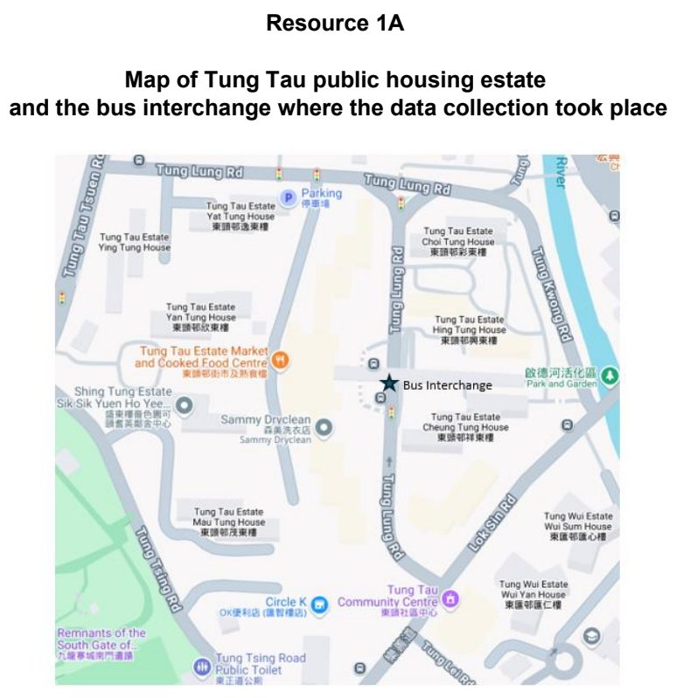

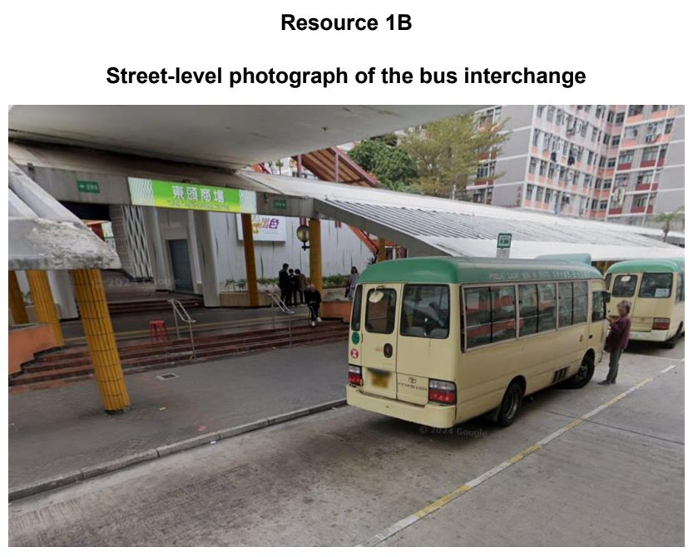

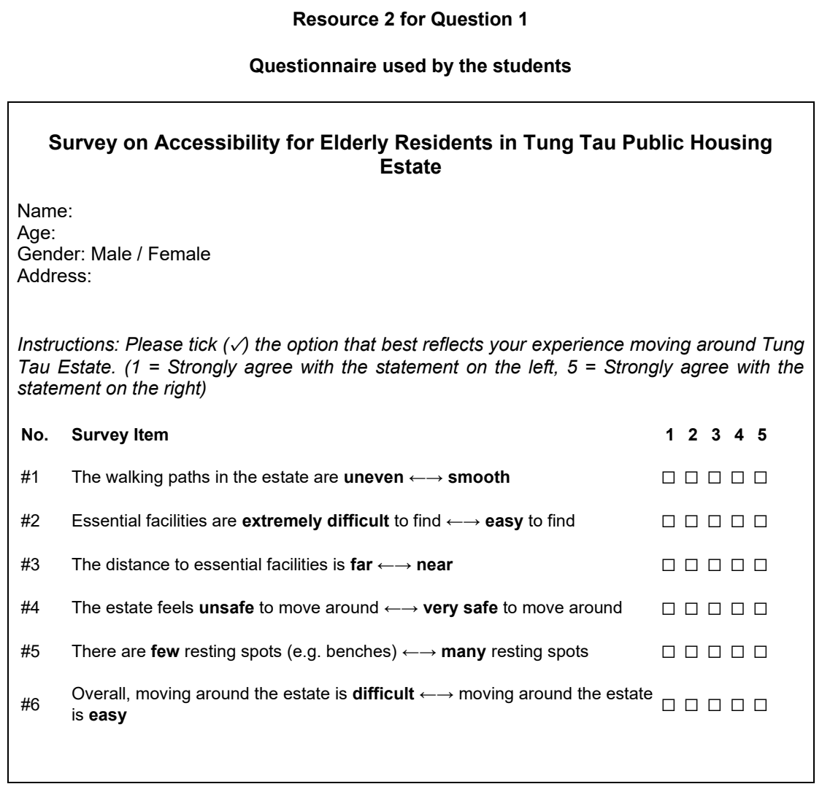

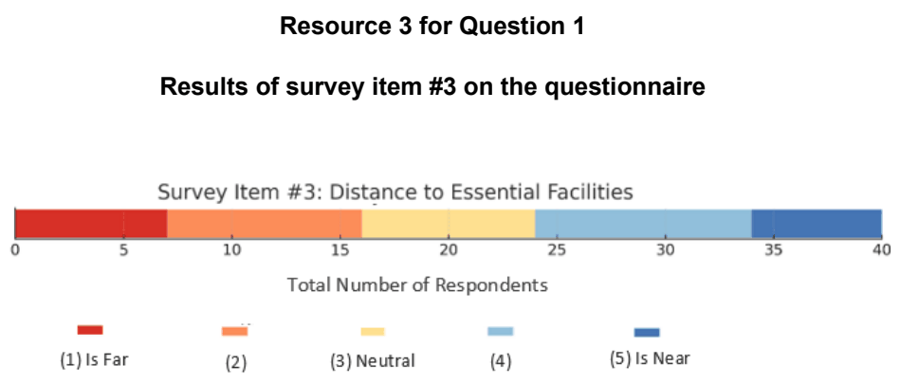

SAJC 2024 — H1 Paper 1 (8834/01), Q1 [30 marks]
Syllabus: 2 Fieldwork | Fieldwork area: Elderly needs
Section A — Cluster 2 Fieldwork
A group of 8 JC1 H2 Geography students wanted to find out if East Coast Park meets the needs of the elderly living in Marine Parade. East Coast Park is a public park in the east of Singapore. It spans 15 kilometers and takes about 2 hours 30 minutes to walk from the Marina East Desalination Plant in Zone A to Zone H.
During the June school holidays, the students allocated one weekday from 8:00 am to 9:00 pm to conduct the fieldwork at East Coast Park. They chose six sites to conduct their research.
The hypothesis for their investigation was:
‘East Coast Park meets the needs of the elderly.’
On the day of the fieldwork, they went to East Coast Park and administered a questionnaire to the elderly they encountered at each of the six sites. They aimed to sample 20 elderly persons per site. They also agreed to take photos and record their observations at each site.
Resource 1 shows a map of East Coast Park with the six sample sites. Resource 2 shows four of the sampling sites. Resource 3 shows selected results of the questionnaire survey.
(a) Explain the strengths and weaknesses of the hypothesis. [4]
(b) With reference to Resources 1 and 2, explain the possible considerations in choosing the sampling sites. [3]
(c) With reference to Resource 2, suggest how students could minimise potential risks when conducting their fieldwork at the four sample sites. [4]
(d) Explain why it is good for students to take photos and record their observations at each sample site. [4]
(e) Using Resource 3, describe how East Coast Park meets the needs of the elderly. [5]
(f) Evaluate the students’ investigation into the extent that East Coast Park meets the needs of the elderly living in Marine Parade. [10]

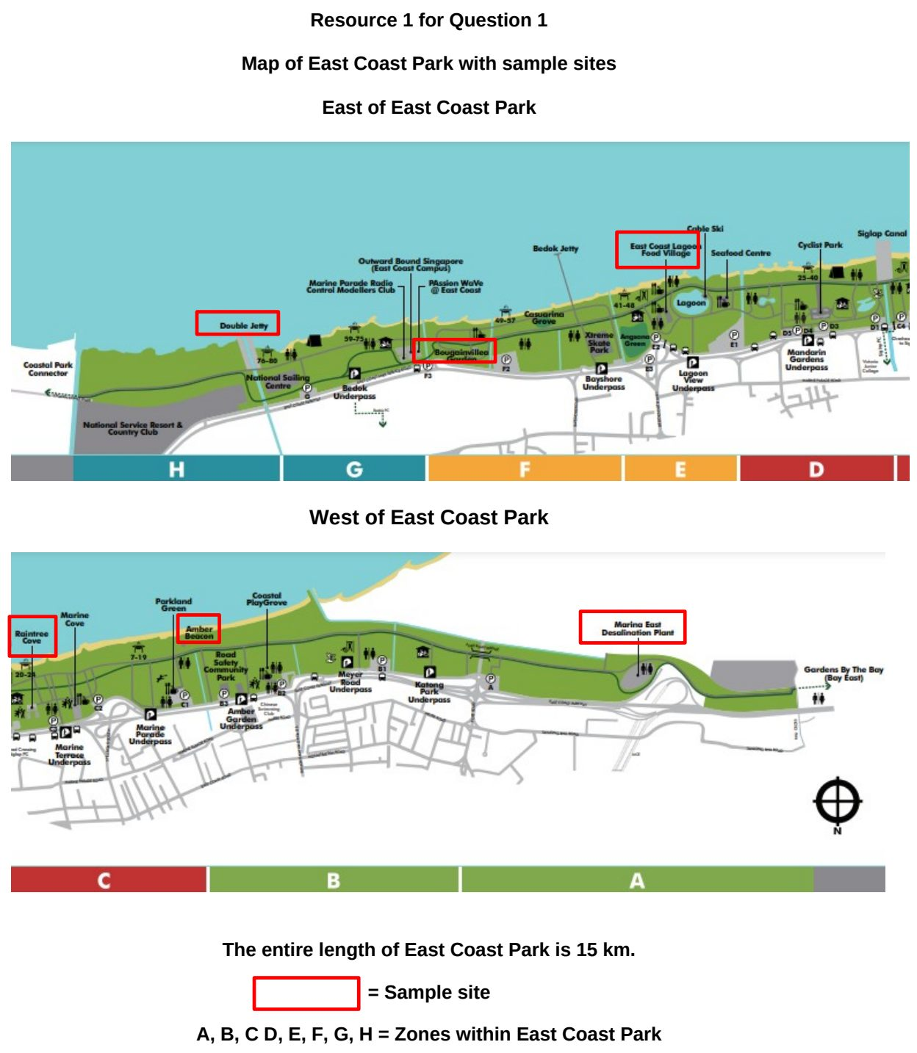

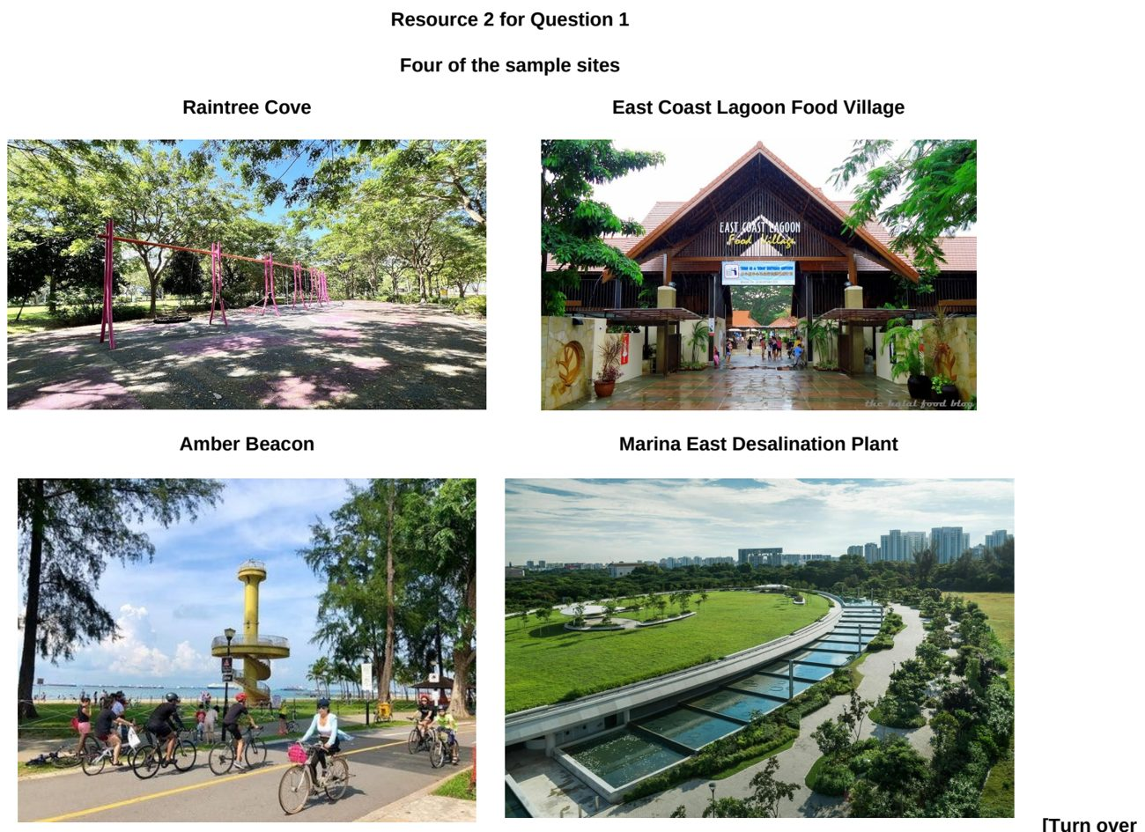

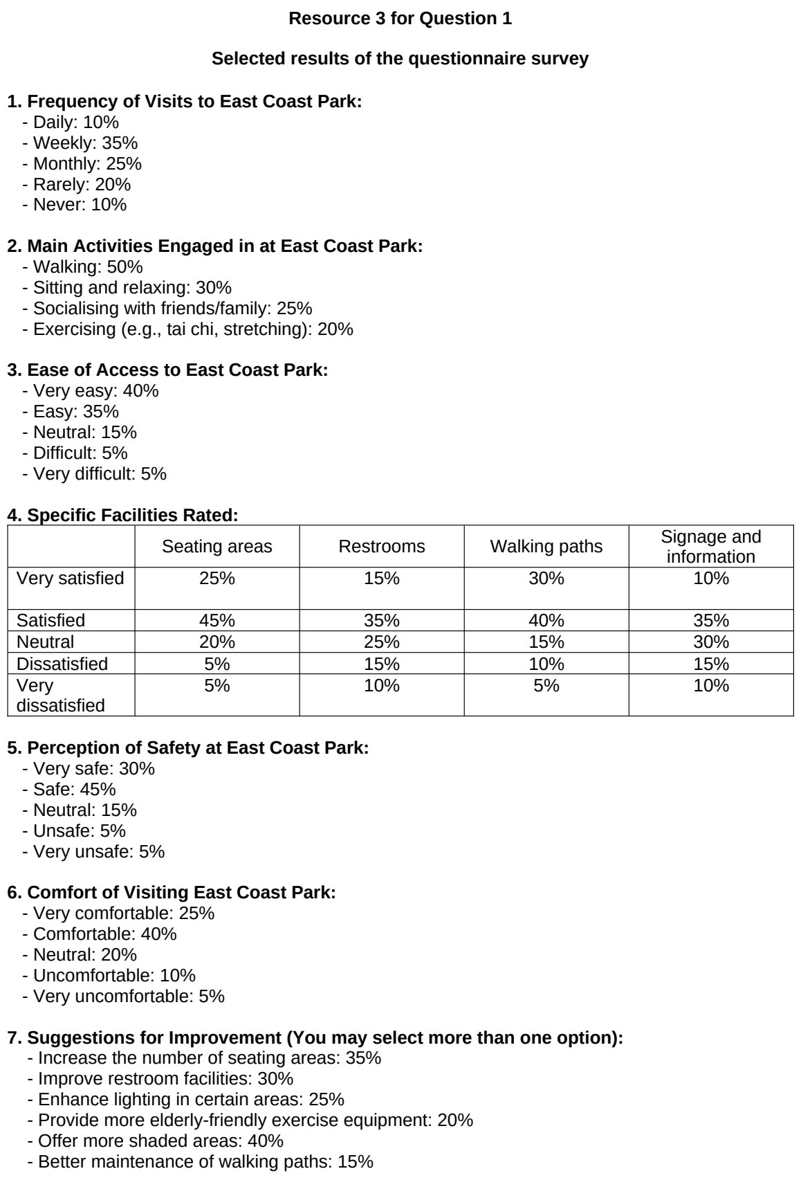

SAJC 2025 — H1 Paper 1 (8834/01), Q1 [30 marks]
Syllabus: 2 Fieldwork | Fieldwork area: Elderly needs
Section A — Cluster 2 Fieldwork
The Silver Volunteer Fund (SVF), launched nationally in 2016 and enhanced in 2023, provides funding to voluntary welfare organisations and community groups to recruit, train and deploy senior volunteers across Singapore. It supports a variety of programmes, such as befriending services, health promotion activities, and community events, enabling seniors to contribute their skills and stay active in their later years.
A group of twelve H1 Geography students from a local junior college planned a fieldwork study to explore the impact of the SVF on the mental health of elderly Singaporeans. Their hypothesis was:
“The SVF improves the mental health of elderly Singaporeans.”
They agreed on the following plan to conduct the fieldwork over three days during the June holidays:
Day 1: Students who had personal contacts among elderly teachers in school or elderly family friends who do volunteer work would administer a quick “straw poll” questionnaire (in English only, via QR code on mobile phones) to these contacts.
Day 2: All twelve students would split into three groups of four, each assigned to one location — The Poiz Centre and The Venue Shoppes in Potong Pasir, and The Woodleigh Mall in Woodleigh — to conduct questionnaire surveys on willing mall users who looked elderly. Before parting ways, one student said to the others, “You know what to do, right?”
Day 3: Only students who were available and had access to elderly teachers or family friends who do volunteer work would conduct observations of these individuals “in action” for about 10–15 minutes. There was no consensus beforehand about what exactly to observe for during these sessions.
Resource 1 shows the locations of the three malls. Resource 2 shows the questionnaire survey used at the malls to survey the respondents. Resource 3 shows the results of the survey. Resource 4 shows the demographic profile of respondents compared to Singapore’s population distribution in 2024.
(a) Explain the strengths and weaknesses of the hypothesis. [4]
(b) Explain how the students may ensure that the fieldwork is carried out ethically. [5]
(c) Explain one potential risk of the investigation. [2]
(d) Explain the students’ considerations in administering a “straw poll” questionnaire before conducting fieldwork at the three malls. [4]
(e) With reference to Resource 3, explain whether the hypothesis can be accepted. [5]
(f) Evaluate the investigation. [10]

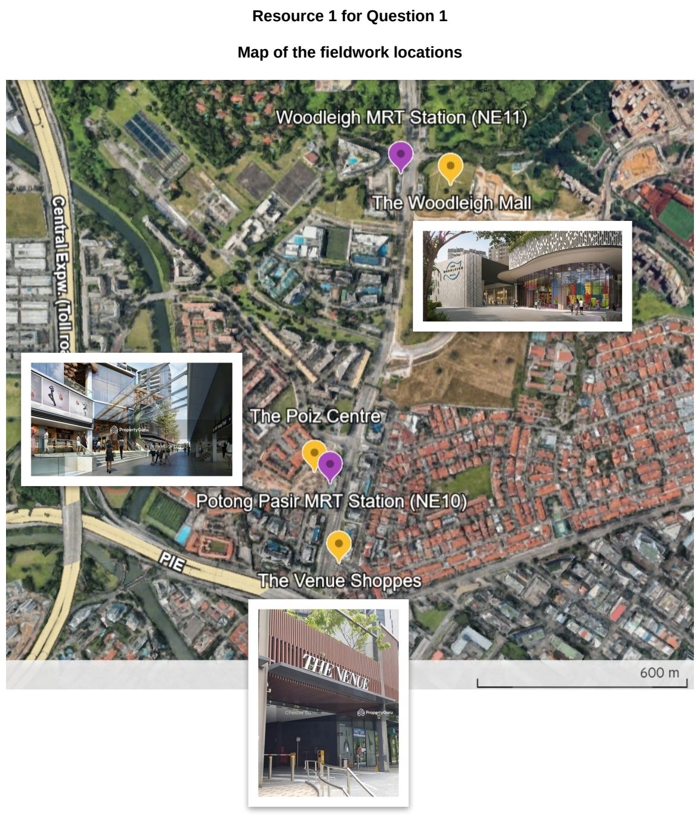

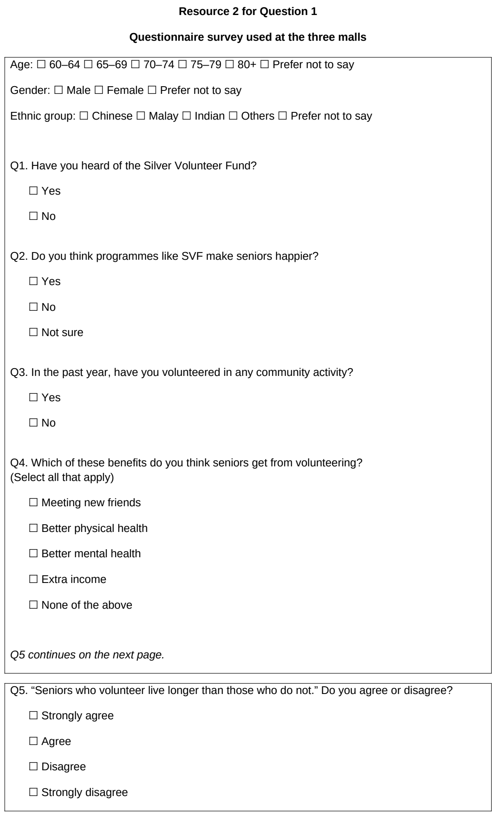

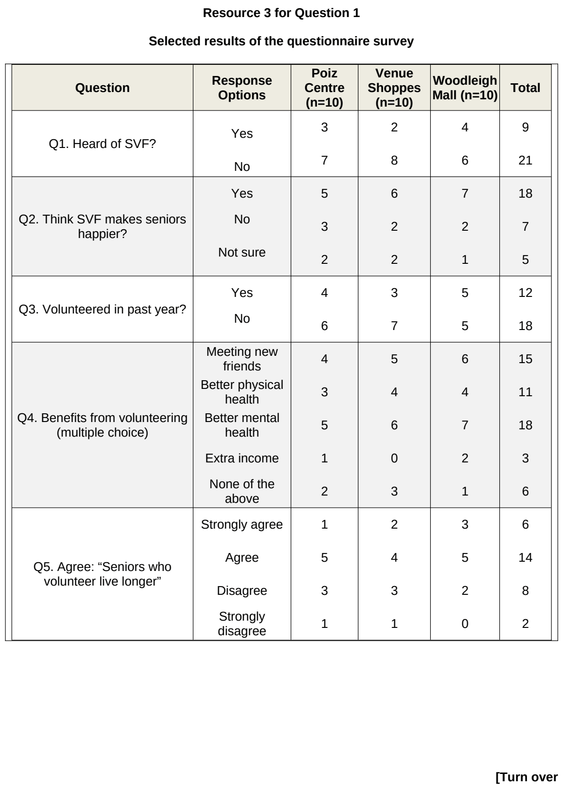

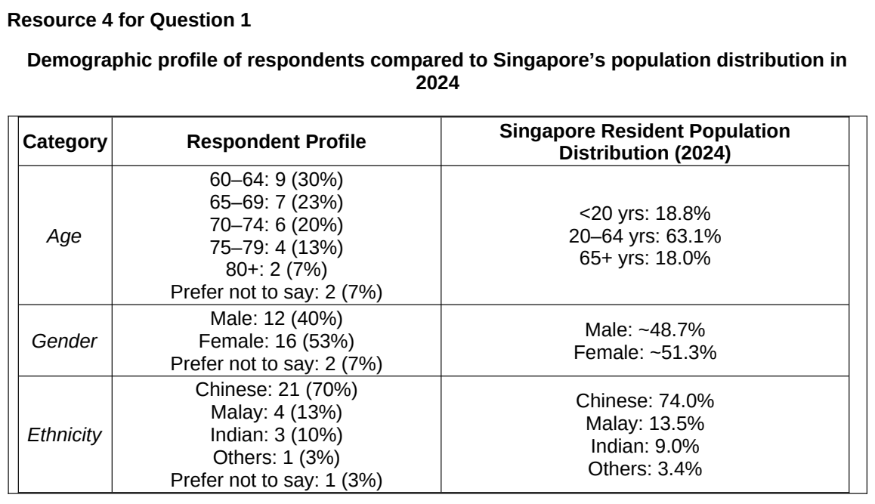

TMJC 2025 — H1 Paper 1 (8834/01), Q1 [30 marks]
Syllabus: 2 Fieldwork | Fieldwork area: Elderly needs
Section A — Cluster 2 Fieldwork
As part of a Geographical Investigation assignment, a group of 6 18-year-old Geography students carried out an investigation during their June holidays to look into the needs of the elderly living in the neighbourhood of Bedok. The hypothesis of their investigation was: “The social needs of the elderly are adequately addressed by the amenities in the Bedok neighbourhood.”
As part of their secondary research, the students found out that residents above 65 make up 25% of the local population of the Bedok neighbourhood. Of the elderly population, they also found out that 46% were male and 54% were female.
The students designed a survey questionnaire and carried out the survey on two days between 9 am and 12 pm. For both days, they split themselves into 3 groups to conduct the survey. For the first day, they visited the Bedok Interchange Hawker Centre and approached elderly persons who were in the hawker centre. At first, they tried approaching those who were browsing the food stalls but faced some difficulty conducting the survey. As such they chose to approach elderly persons who were having their meal or those in a queue. On the second day, they stood outside Heartbeat @ Bedok and approached elderly persons who were passing by. In the span of 2 days, they managed to survey a total of 60 elderly persons.
Resource 1 shows a map of Bedok neighbourhood and the two locations where the surveys were conducted. Resource 2 shows the questionnaire the students used for their survey. Resource 3 shows selected results of the survey.
(a) Explain whether the students’ hypothesis is suitable. [3]
(b) Suggest how the students could minimise two potential risks arising from undertaking the fieldwork in the locations shown in Resource 1. [4]
(c) Suggest possible issues related to research ethics for this investigation. [4]
(d) Explain the strength(s) and limitation(s) of the survey questionnaire seen in Resource 2. [6]
(e) With reference to Resource 3, explain how the data representation can be improved. [3]
(f) The students concluded that the social needs of the elderly were adequately addressed by the amenities in the Bedok Neighbourhood. Evaluate the validity of their conclusion. [10]

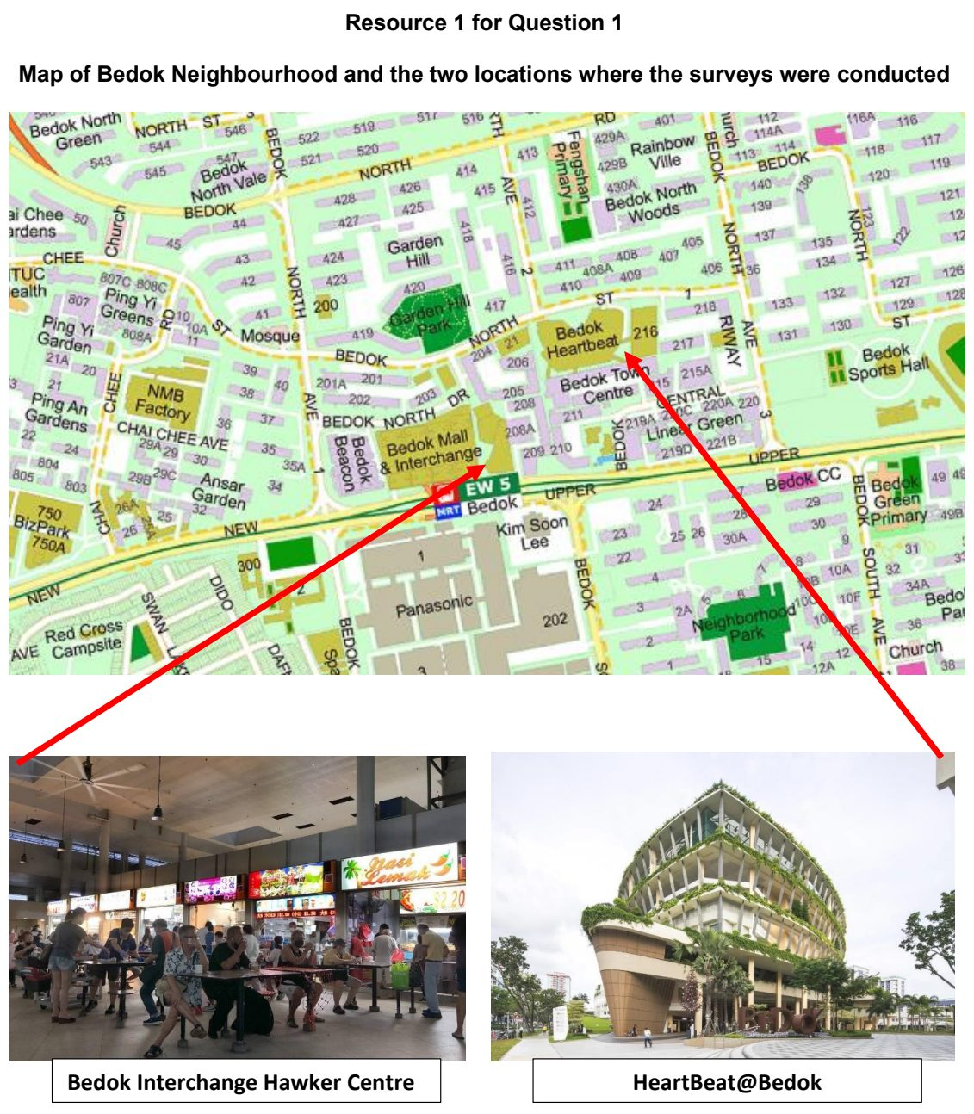

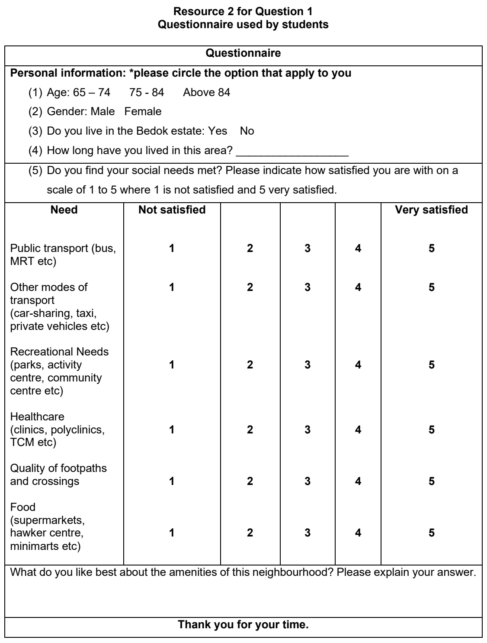

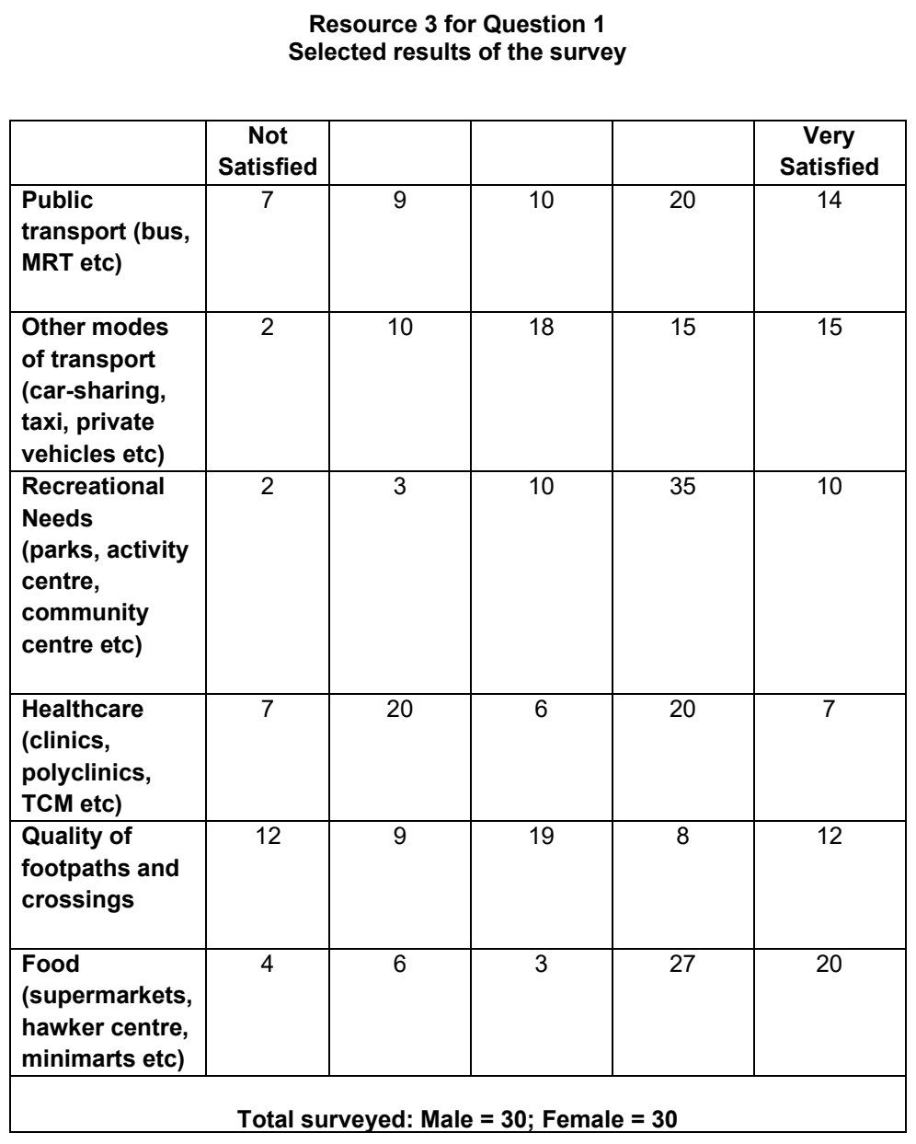

VJC 2024 — H1 Paper 1 (8834/01), Q1 [30 marks]
Syllabus: 2 Fieldwork | Fieldwork area: Elderly needs
Section A — Cluster 2 Fieldwork
A group of four students from Zurich University carried out fieldwork to investigate the perceptions on ageing well among elderly in Winterthur, Switzerland. They identified three elements as important for ageing well: “sense of well-being,” “having good physical health,” and “preserving good mental health.”
Data was first collected through a questionnaire survey with 56 participants. Convenience sampling was used to recruit the participants.
From the 56 participants, ten of them were chosen for face-face interviews. The interview sessions were conducted in familiar, comfortable and accessible settings for the participants within the community or in the participants’ homes. A few of the interviews were carried out in pairs upon the request of the participants. A voice recorder was used to record all the interview sessions.
Resource 1 shows the profile of the 56 participants. Resource 2 shows the survey recording sheet. Resource 3 shows the results of selected survey questions.
(a) Suggest a possible hypothesis for the investigation and explain why the hypothesis is appropriate. [3]
(b) Explain two criteria which the students could use to select participants for the investigation. [4]
(c) With reference to Resource 2, suggest how the survey recording sheet can be improved. [4]
(d) Explain the strengths of the students’ approach to the interviews for the investigation. [5]
(e) Explain how the students could minimize two potential ethical issues which might arise from the investigation. [4]
(f) The students concluded that the elderly in Winterthur, Switzerland perceived having good physical health as the most important element for ageing well. Evaluate the validity of their conclusion. [10]

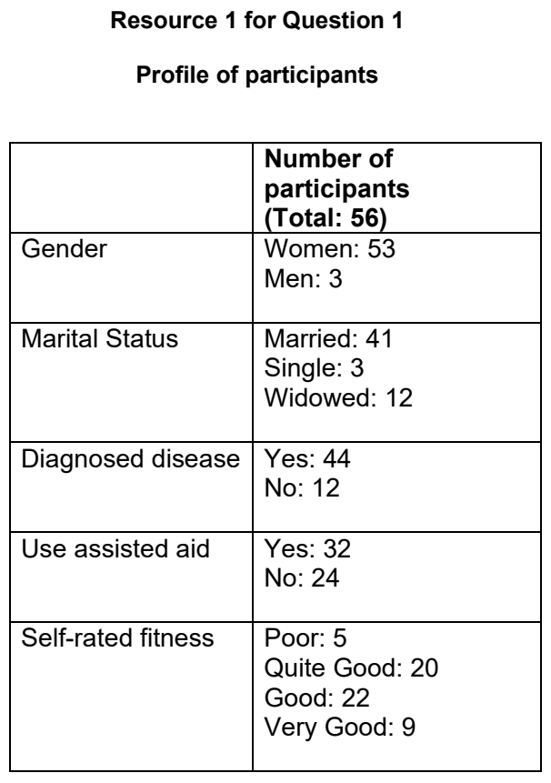

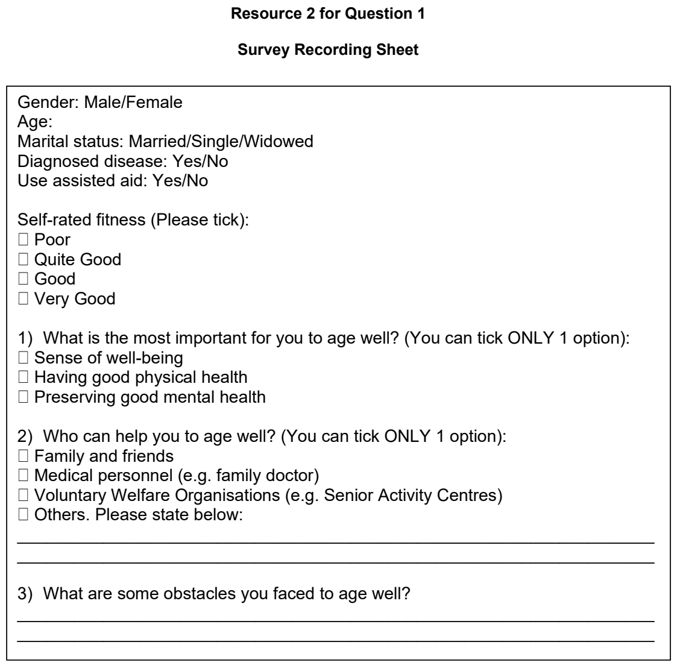

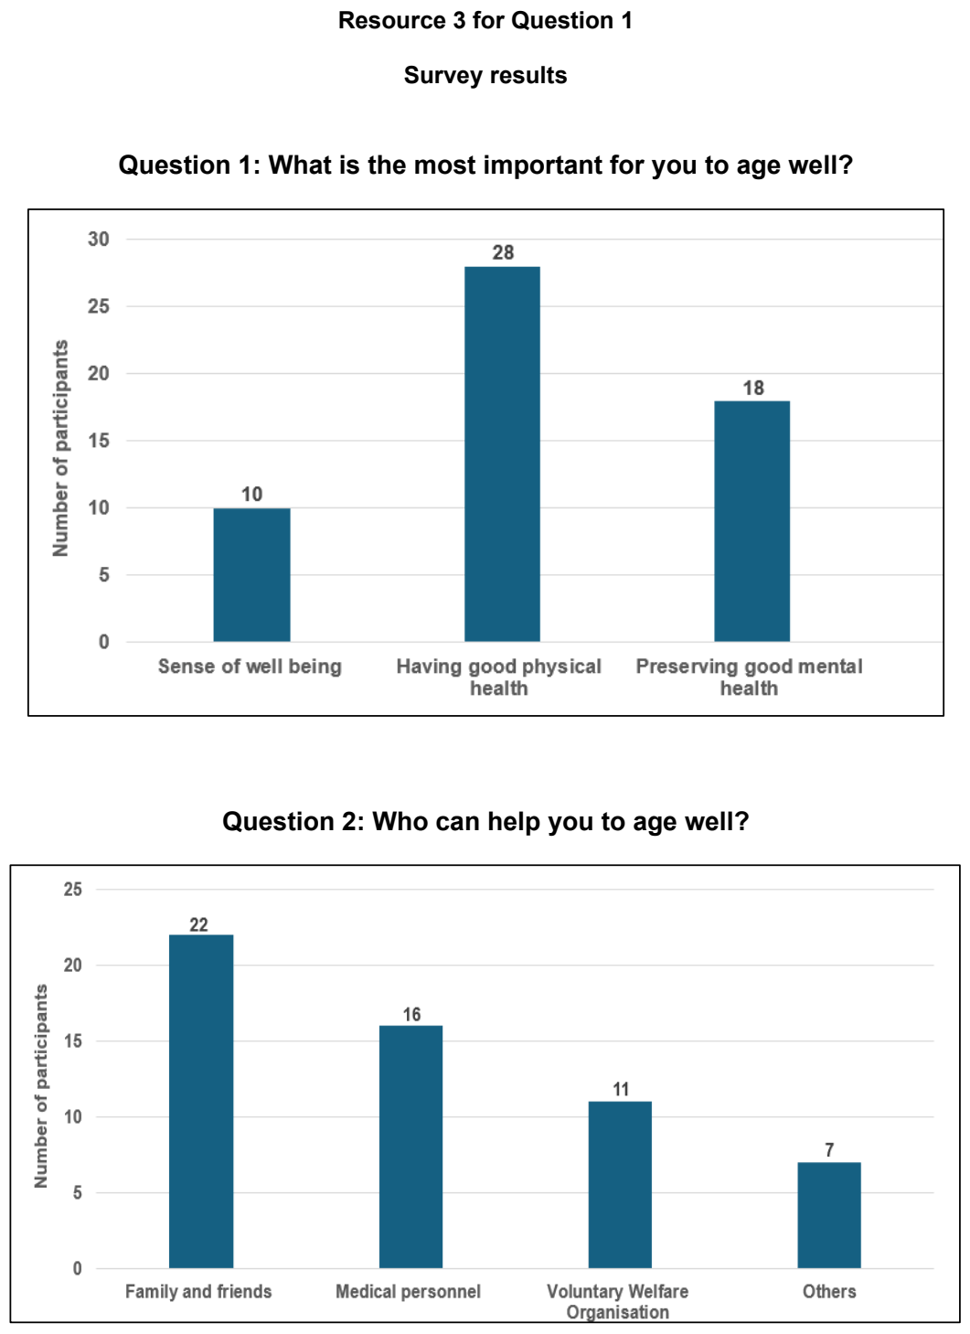

VJC 2025 — H1 Paper 1 (8834/01), Q1 [30 marks]
Syllabus: 2 Fieldwork | Fieldwork area: Elderly needs
Section A — Cluster 2 Fieldwork
In Singapore, residential areas with a high proportion of elderly have been designated as Silver Zones. As of end-2024, more than 40 Silver Zones have been implemented across Singapore.
A group of six students decided to investigate the effectiveness of Silver Zones in meeting the needs of elderly residents.
The students agreed to investigate the following hypothesis: Silver Zones in Singapore have met the needs of elderly above the age of 65 years old.
Prior to their fieldwork, the students researched on the internet on some generic information of features of a Silver Zone. They decided on 2 streets with Silver Zones in Singapore which were in Ang Mo Kio Street 61 and Hougang Street 61. They also did a site recce 2 days before the fieldwork at both streets.
During their fieldwork, students used a questionnaire to survey 100 residents from each street. They conducted their questionnaire at 9am to 6pm at 4 sites of each street and took a total of 2 days in the December holidays to complete their questionnaire. The students identified elderly-looking people who were walking by, verified their age, sought their consent before beginning the questionnaire.
Resource 1 shows the two streets and eight sites where students conducted their onsite investigations. Resource 2 shows photographs of two of the sites where the students conducted their questionnaire. Resource 3 shows the questionnaire that the students used. Resource 4 shows the results of the questionnaire.
(a) Explain two weaknesses of the students’ hypothesis. [4]
(b) Using Resources 1 and 2, explain the strengths and weaknesses of the student’s choice of locations and sample sites where the elderly residents were surveyed. [6]
(c) Explain why the sequence of the student’s data collection was useful for their investigation. [5]
(d) Using Resource 4, sketch a graph to present the data for Question 1 for both sites. [5]
(e) The students concluded that Silver Zones in Singapore have met the needs of elderly above the age of 65 years old. With reference to all resources, evaluate the validity of their conclusion. [10]

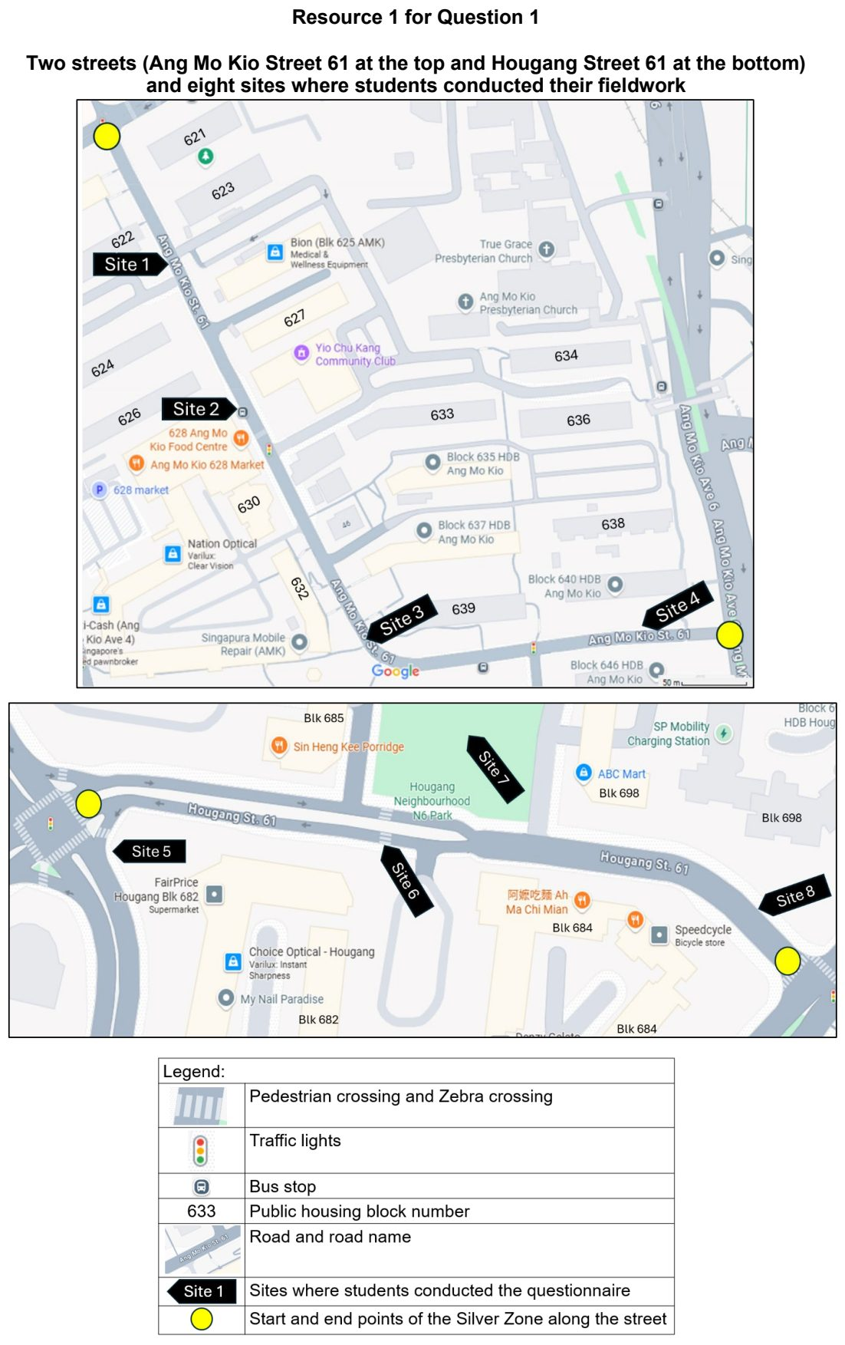

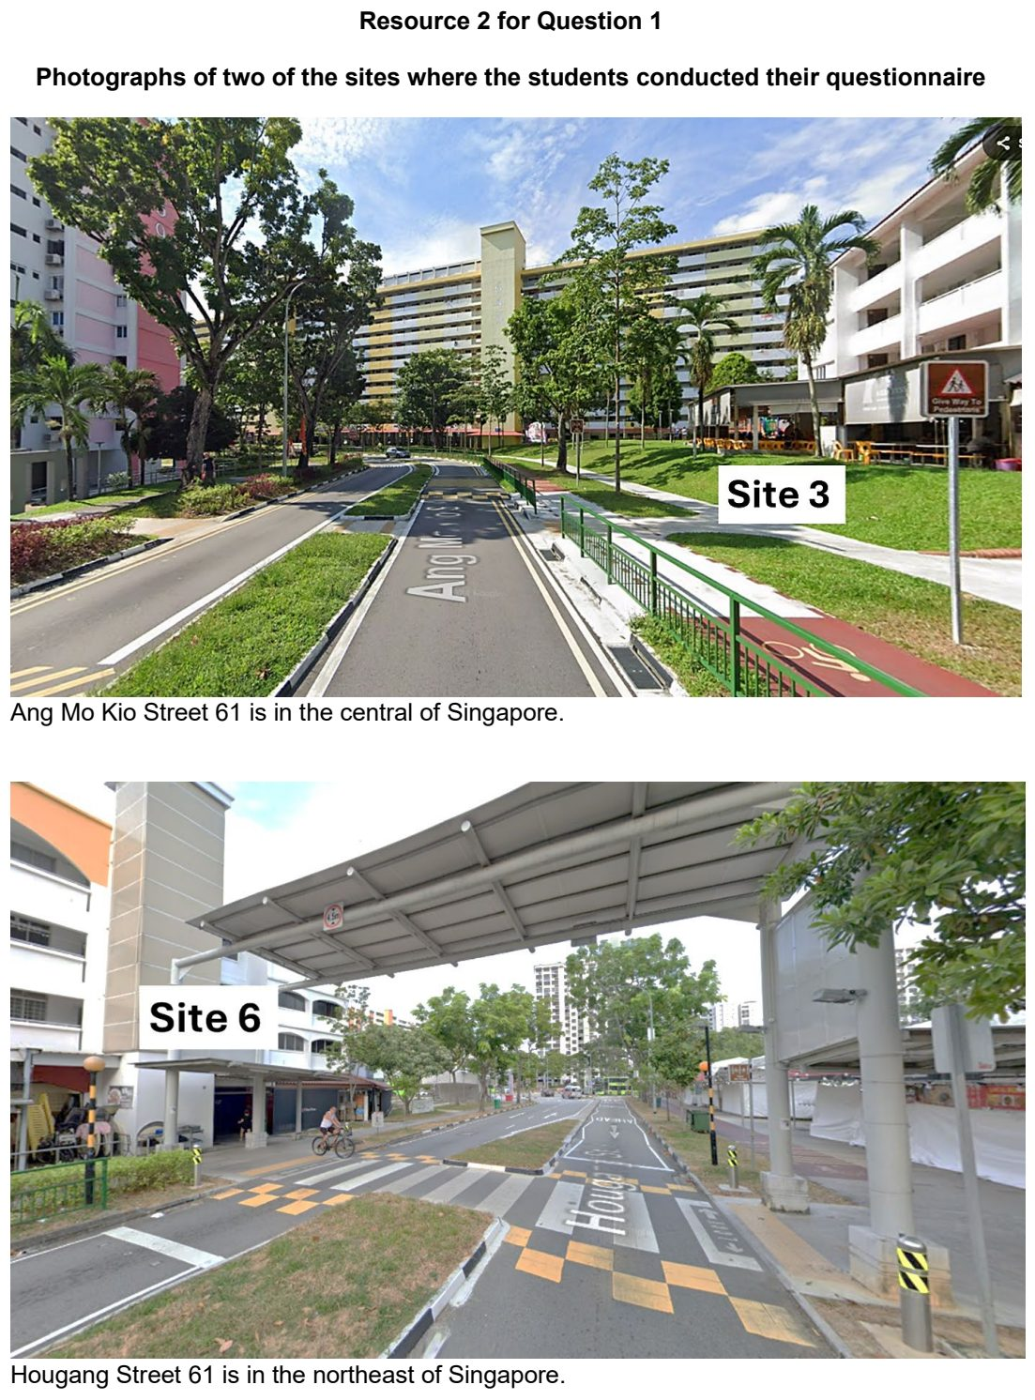

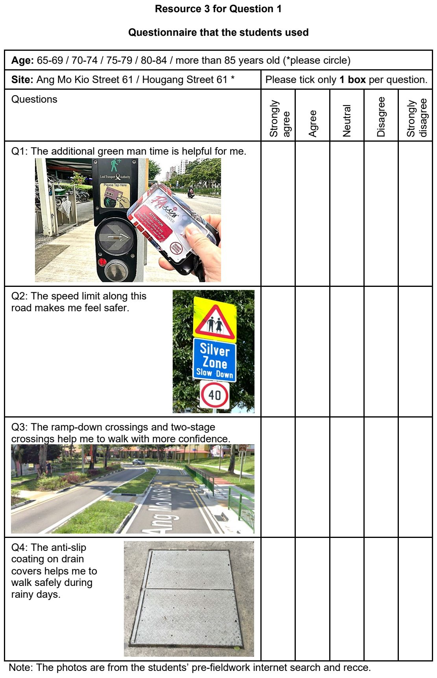

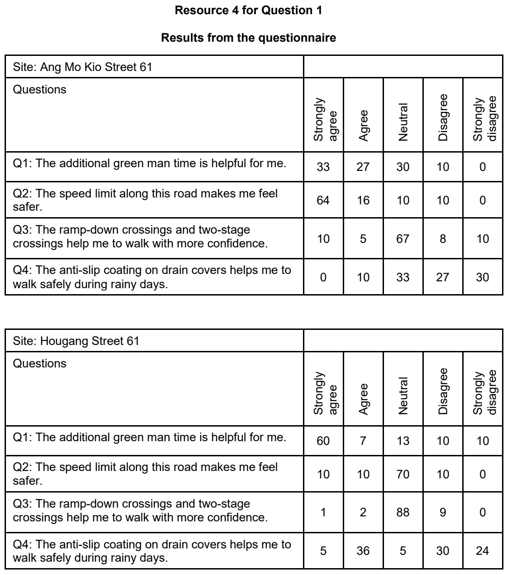

YIJC 2024 — H1 Paper 1 (8834/01), Q1 [30 marks]
Syllabus: 2 Fieldwork | Fieldwork area: Elderly needs
Section A — Cluster 2 Fieldwork
A group of ten 18 year-old Geography students carried out an investigation to look into the transport needs of the elderly living in the Serangoon North neighbourhood. The elderly make up 30% of the local population. Of the elderly residents, 60% were 65-74 years old, 35% were 75-84 years old and 5% were over 84 years old. Females make up 55% of the elderly residents.
The hypothesis of their investigation was: “The majority of elderly residents in the Serangoon North neighbourhood find their transport needs adequately met”.
The students designed a survey questionnaire and carried out the survey on a Friday morning, between 10am to 12noon. They surveyed a total of 80 elderly people.
55 elderly are aged 65 to 74 years old, and 20 elderly are aged 75 to 84 years old. 5 elderly are aged above 84.
Resource 1 shows a location where the students will carry out the fieldwork. Resource 2 shows the questionnaire the students used for their survey. Resource 3 shows selected results of the survey.
(a) Explain whether the students’ hypothesis is suitable. [4]
(b) Suggest how the students could minimise two potential risks arising from undertaking the fieldwork in the location shown in Resource 1. [4]
(c) Suggest two reasons why the students categorised the age groups as shown in Resources 2 and 3. [4]
(d) Suggest two possible issues related to research ethics for this investigation. [4]
(e) Explain the best way the students can present the data they collected from the questionnaire in Resource 3. [4]
(f) The students concluded that the transport needs of the majority of elderly in the Serangoon North neighbourhood are adequately met. Evaluate the validity of their conclusions. [10]

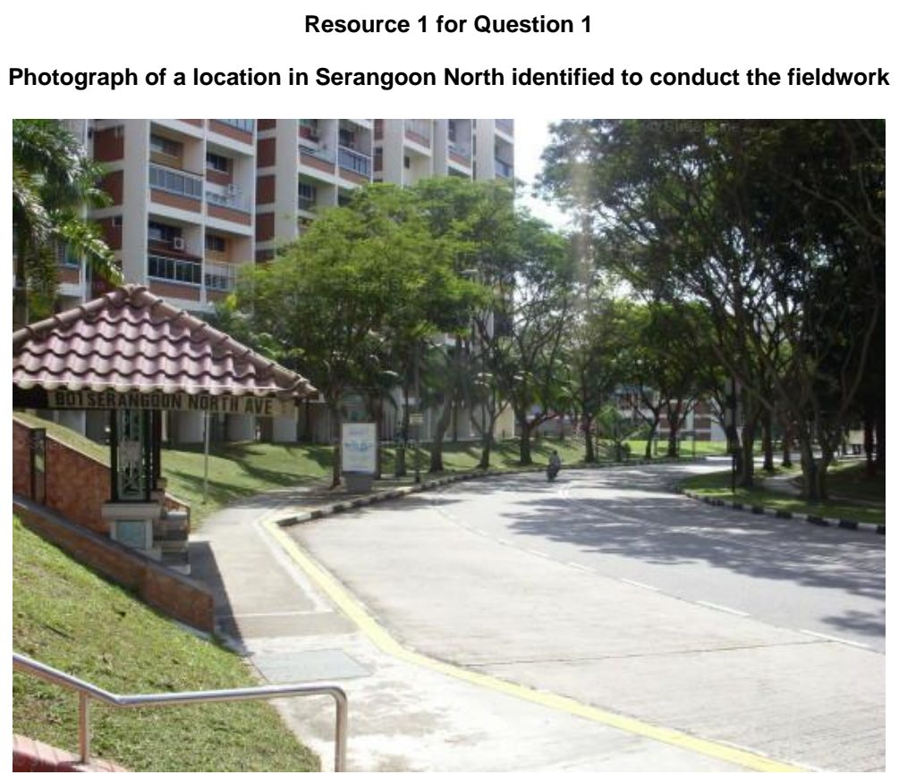

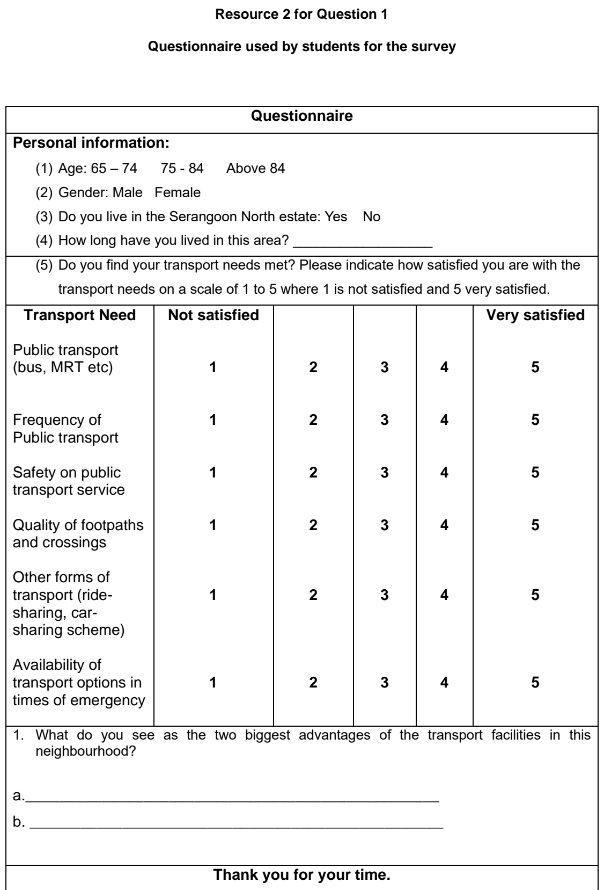

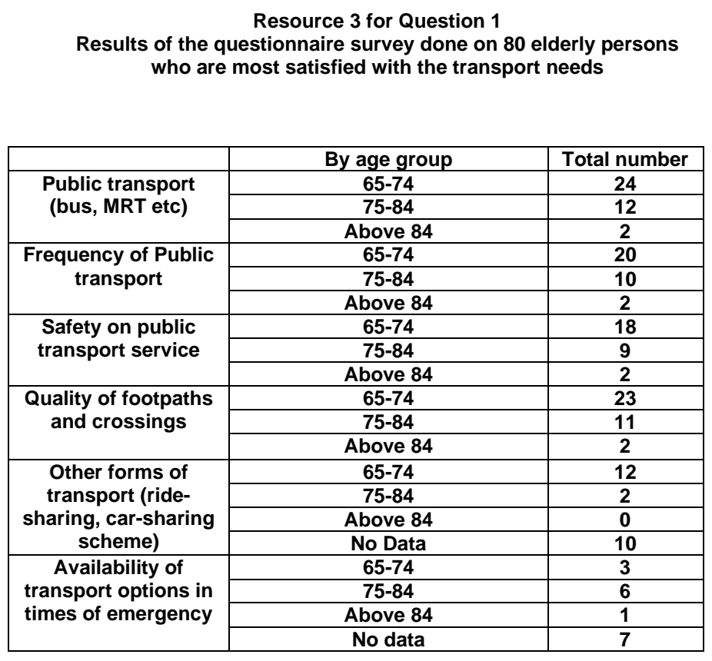

YIJC 2025 — H1 Paper 1 (8834/01), Q1 [30 marks]
Syllabus: 2 Fieldwork | Fieldwork area: Elderly needs
Section A — Cluster 2 Fieldwork
A group of 6 Junior College students in Singapore wanted to investigate the needs of elderly with dementia in Singapore. They decided on the following hypothesis:
Singapore is able to manage elderly dementia.
They decided to conduct their investigations in Yishun and Punggol. Yishun’s population is made up of 20.2% of residents aged 60 and above while Punggol has 11.4% of residents aged 60 and above.
The students conducted their investigations on a Monday in Yishun and on a Wednesday in Punggol, between 10am and 12noon. They used a survey questionnaire to collect primary data for their investigation. The students approached 20 people in Yishun and 30 people in Punggol out of convenience. The survey respondents were from a range of age groups and professions. The students also took some photographs and videos of the residents going about their everyday lives during their investigation.
Resource 1A shows the locations of the students’ investigation in Yishun. Resource 1B shows the locations of the students’ investigation in Punggol. Resource 2 shows the profiles and number of survey respondents in Yishun and Punggol. Resource 3 shows the data collected for selected survey questions.
(a) Explain two ways the students can improve on their hypothesis. [4]
(b) Explain how the students could minimise potential impacts of their investigation. [4]
(c) Suggest how the students could mitigate the risks of their investigation. [3]
(d) With reference to Resource 2, suggest how the students could have obtained a more representative sample of the residents in Yishun and Punggol. [4]
(e) With reference to Resource 3, represent the data using an appropriate data representation method. [5]
(f) The students concluded that their hypothesis is valid. Evaluate the validity of their conclusion. [10]

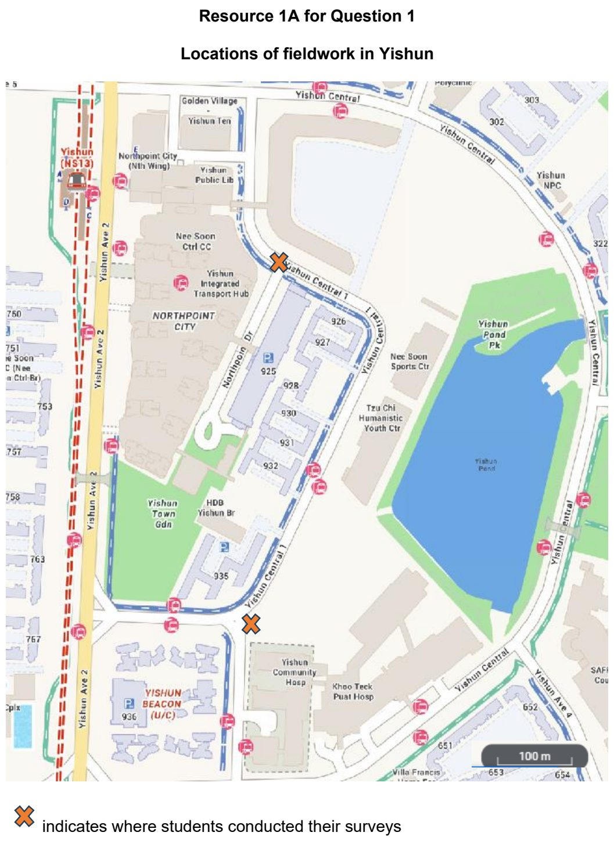

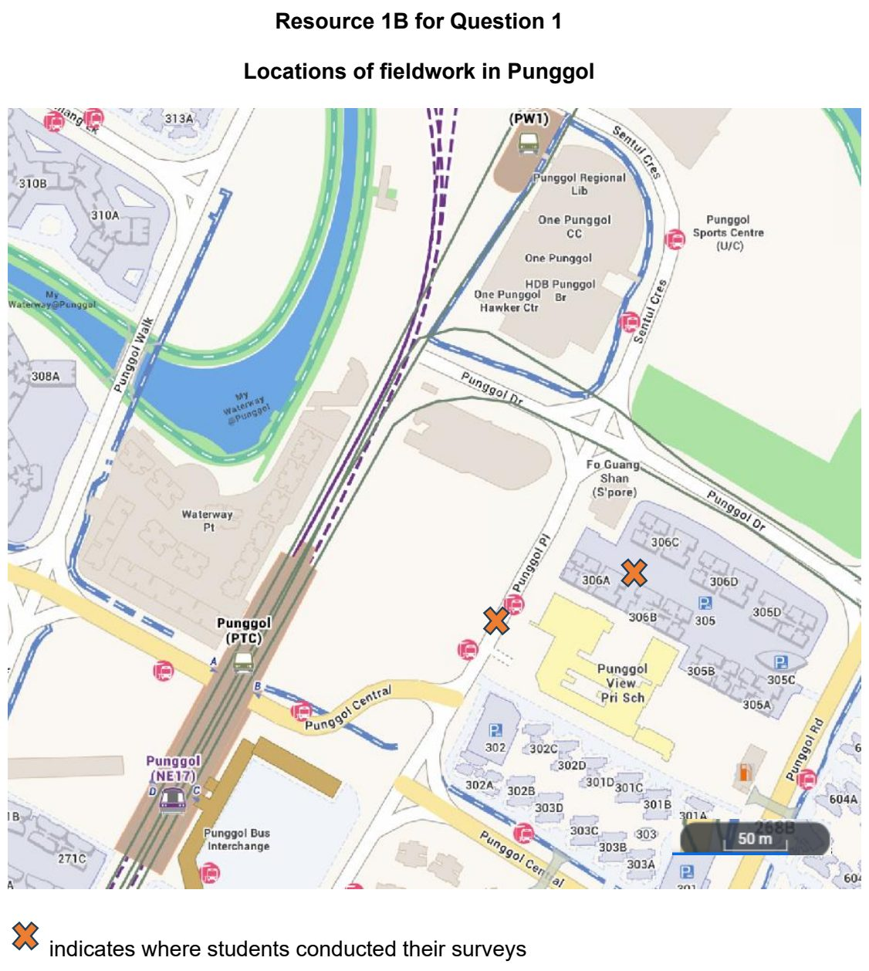

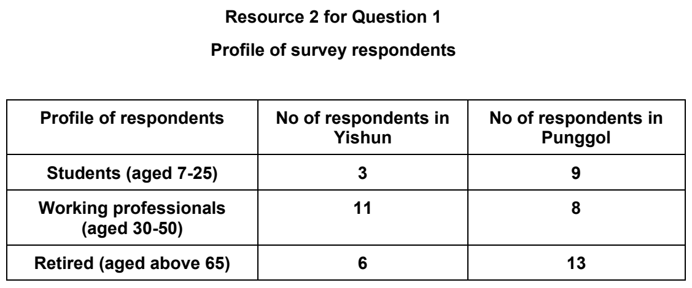

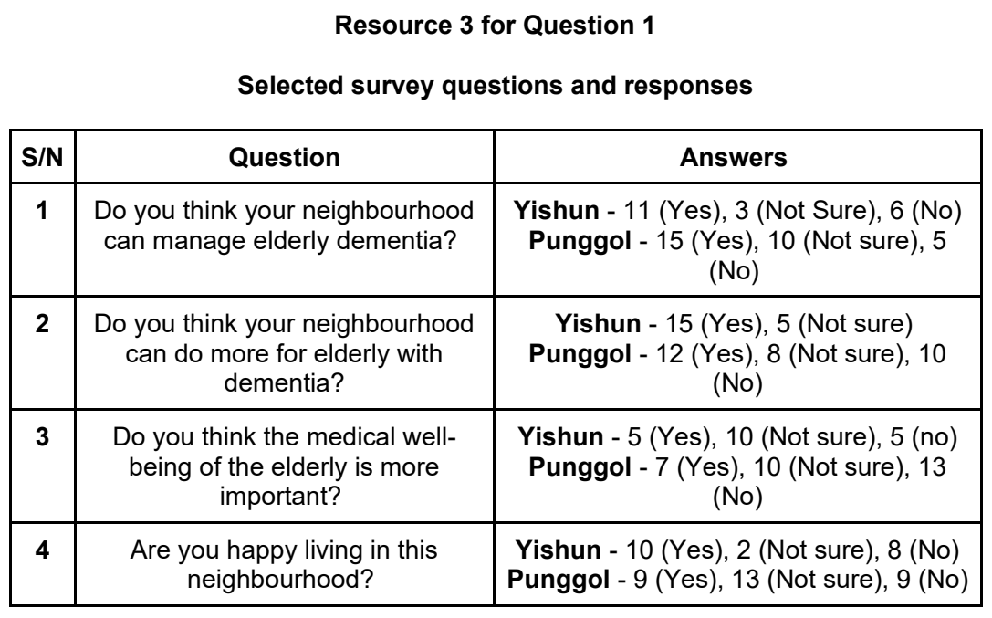

YIJC 2026 — H1 Paper 1 (8834/01), Q1 [30 marks]
Syllabus: 2 Fieldwork | Fieldwork area: Elderly needs
Section A — Cluster 2 Fieldwork
Urban reimaging has been widely adopted in many cities to revitalise declining urban areas and improve their liveability. In Manchester, the Sackville Street and Canal Street have undergone extensive regeneration, introducing new public spaces, mixed land uses and transport infrastructure. As Manchester's population continues to age, there is increasing emphasis on ensuring that regenerated urban environments are inclusive and meet the needs of elderly residents.
A group of 18 Geography students from Singapore’s Champion Junior College visited Manchester from 1–5 December 2025 to investigate the inclusiveness of urban reimaging in meeting the needs of elderly residents in the Sackville Street and Canal Street.
The students developed the following research question:
How inclusive is urban reimaging in meeting the needs of elderly residents in Manchester's Sackville Street and Canal Street?
To investigate this question, the students conducted a questionnaire survey of 50 elderly residents and foreign visitors using convenience sampling. The respondents comprised:
60–69 years: 21 residents and 6 foreign visitors (27 respondents) 70–79 years: 13 residents and 3 foreign visitors (16 respondents) 80 years and above: 5 residents and 2 foreign visitors (7 respondents)
The survey examined respondents' perceptions of personal safety, accessibility, opportunities for social interaction and inclusion, and overall liveability. The students also carried out land-use mapping, pedestrian counts, and an accessibility audit to assess the provision of age-friendly infrastructure, including benches, ramps, lifts, tactile paving, pedestrian crossings and barrier-free access.
Resource 1 shows a map of the study area. Resource 2 shows photographs taken during the field investigation. Resource 3 provides the questionnaire used by the students. Resource 4 presents the data collected from the questionnaire survey.
(a) Explain whether the students’ research question is suitable. [4]
(b) Using Resource 2, explain which of the two study sites, Location A or B, is more suitable for investigating the impact of urban reimaging on elderly residents. [4]
(c) Explain the strengths and limitations of the students' sampling strategy and sample size. [4]
(d) Using Resource 3, describe how you would improve the questionnaire. [4]
(e) With reference to Resource 4, explain the best way the students can present the data they collected from the questionnaire. [4]
(f) Evaluate the effectiveness of the data collection methods used to investigate whether urban reimaging has created an inclusive environment for elderly residents. [10]

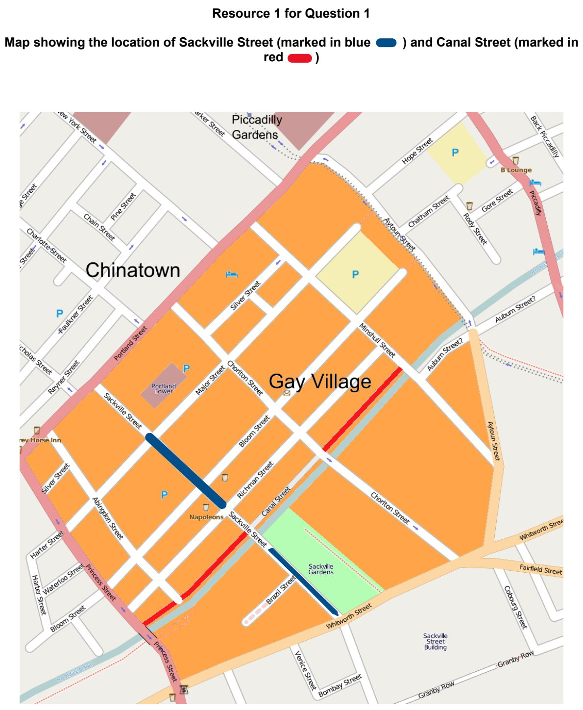

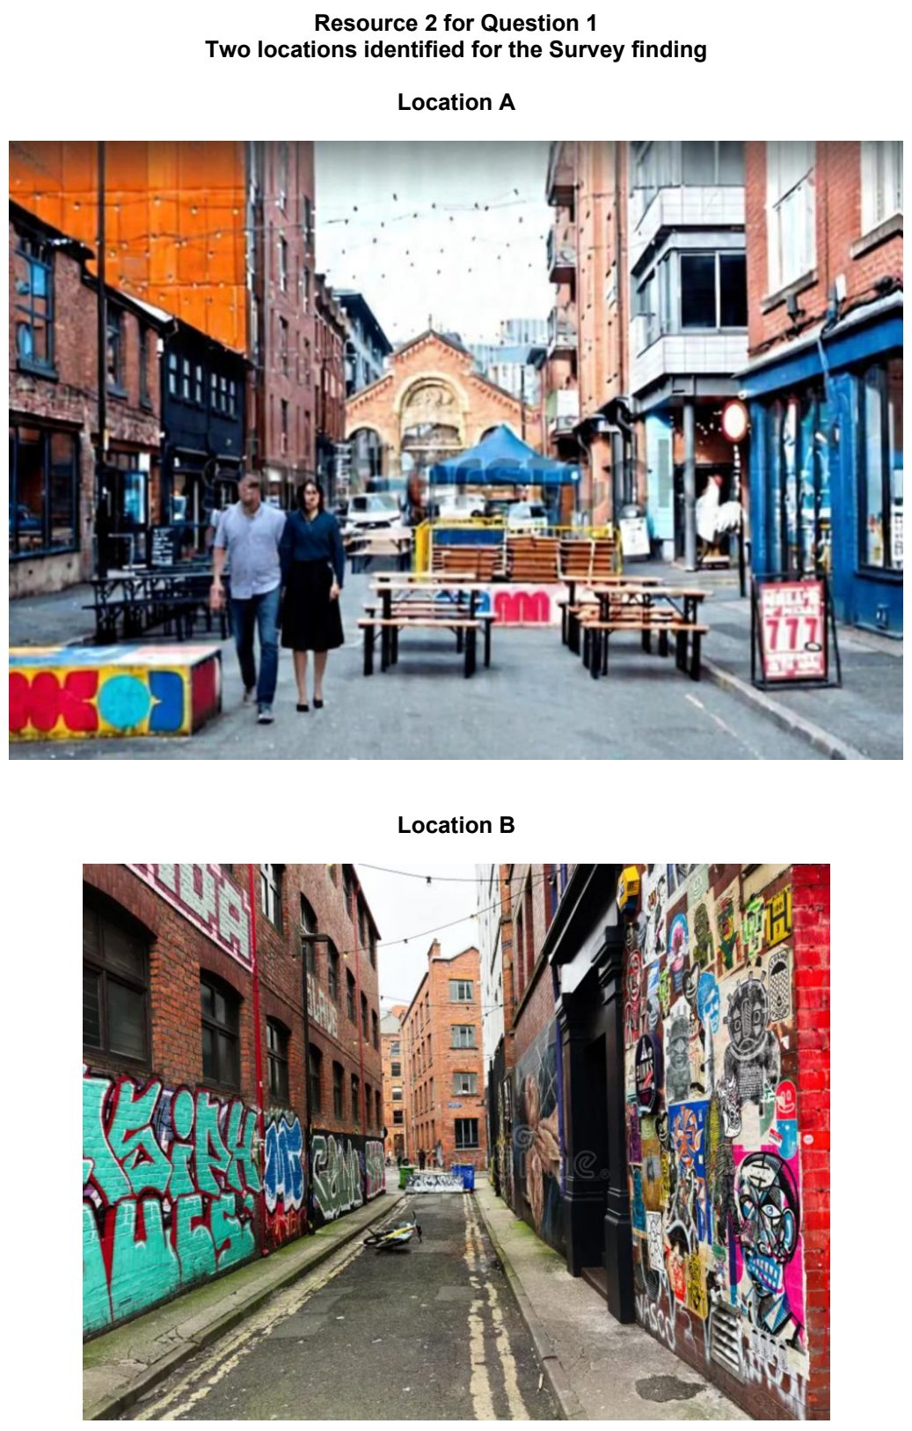

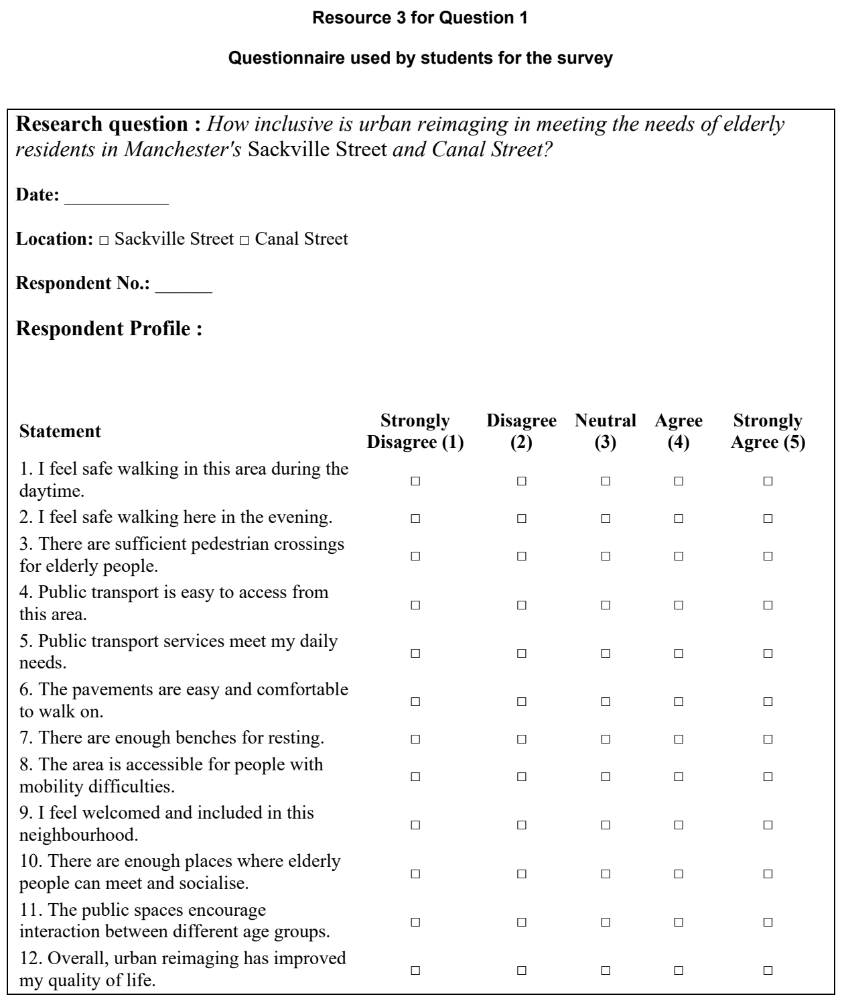

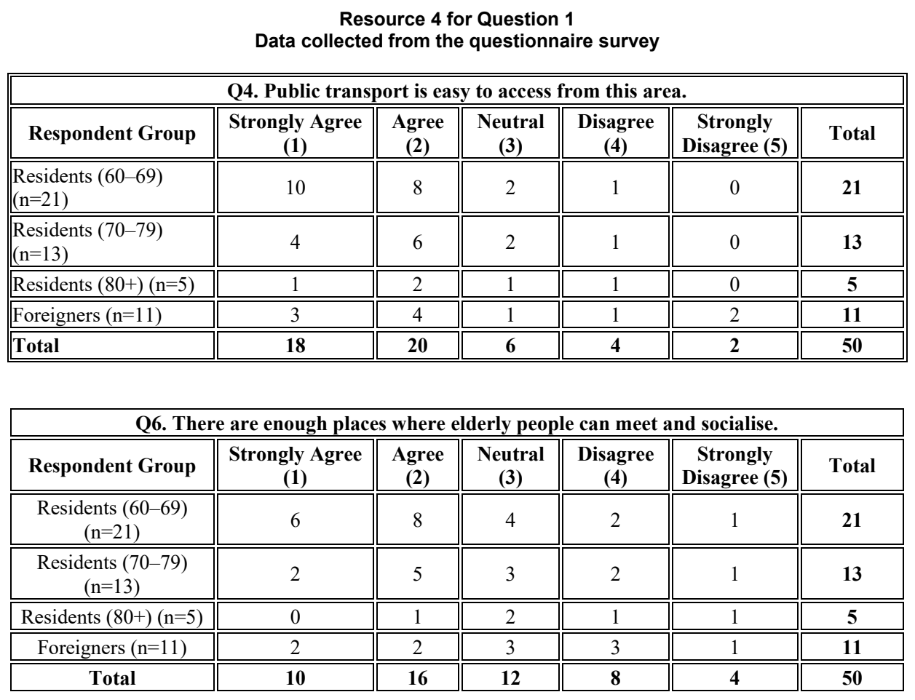

Fieldwork – Others

ACJC 2026 — H1 Paper 1 (8834/01), Q1 [30 marks]
Syllabus: 2 Fieldwork | Fieldwork area: Others
Section A — Cluster 2 Fieldwork
A group of nine students conducted a fieldwork investigation on the community response to the expansion of cycling paths in Ang Mo Kio, Singapore. The focus of their investigation was to assess whether the expansion of dedicated cycling paths has increased the number of residents cycling for daily transport. The hypothesis for their study was:
The expansion of cycling paths in Ang Mo Kio has made it more convenient for residents who cycle for daily transport.
The students conducted the investigation over one weekday in March. Three sites were selected along the current network of cycling paths: Site A, Site B and Site C.
At each site, the students split into groups of three and conducted a count of cyclists passing along the cycling path over one hour. They also administered a questionnaire to any residents whom they saw at the sites to find out about their cycling habits and their views on the cycling paths. A total of 45 respondents participated in the survey across the three sites. The students also took photographs of the conditions along the cycling paths.
Resource 1 is a map of Ang Mo Kio showing the cycling path network and the locations of the fieldwork sites. Resource 2 shows the three fieldwork sites. Resource 3 shows the questionnaire used to survey residents. Resource 4 shows selected results from the cyclist counts at different sites.
(a) Explain one strength and one weakness in the students’ hypothesis. [4]
(b) With reference to Resources 1 and 2, explain how the students could minimise the risks associated with their fieldwork. [6]
(c) Explain the benefits of selecting three different sites for this investigation. [4]
(d) With reference to Resource 3, suggest improvements to the questionnaire. [3]
(e) Suggest a suitable method to present the data shown in Resource 4. Justify your choice. [3]
(f) The students concluded that the expansion of cycling paths has increased the number of residents who cycle. Evaluate the validity of their conclusion. [10]

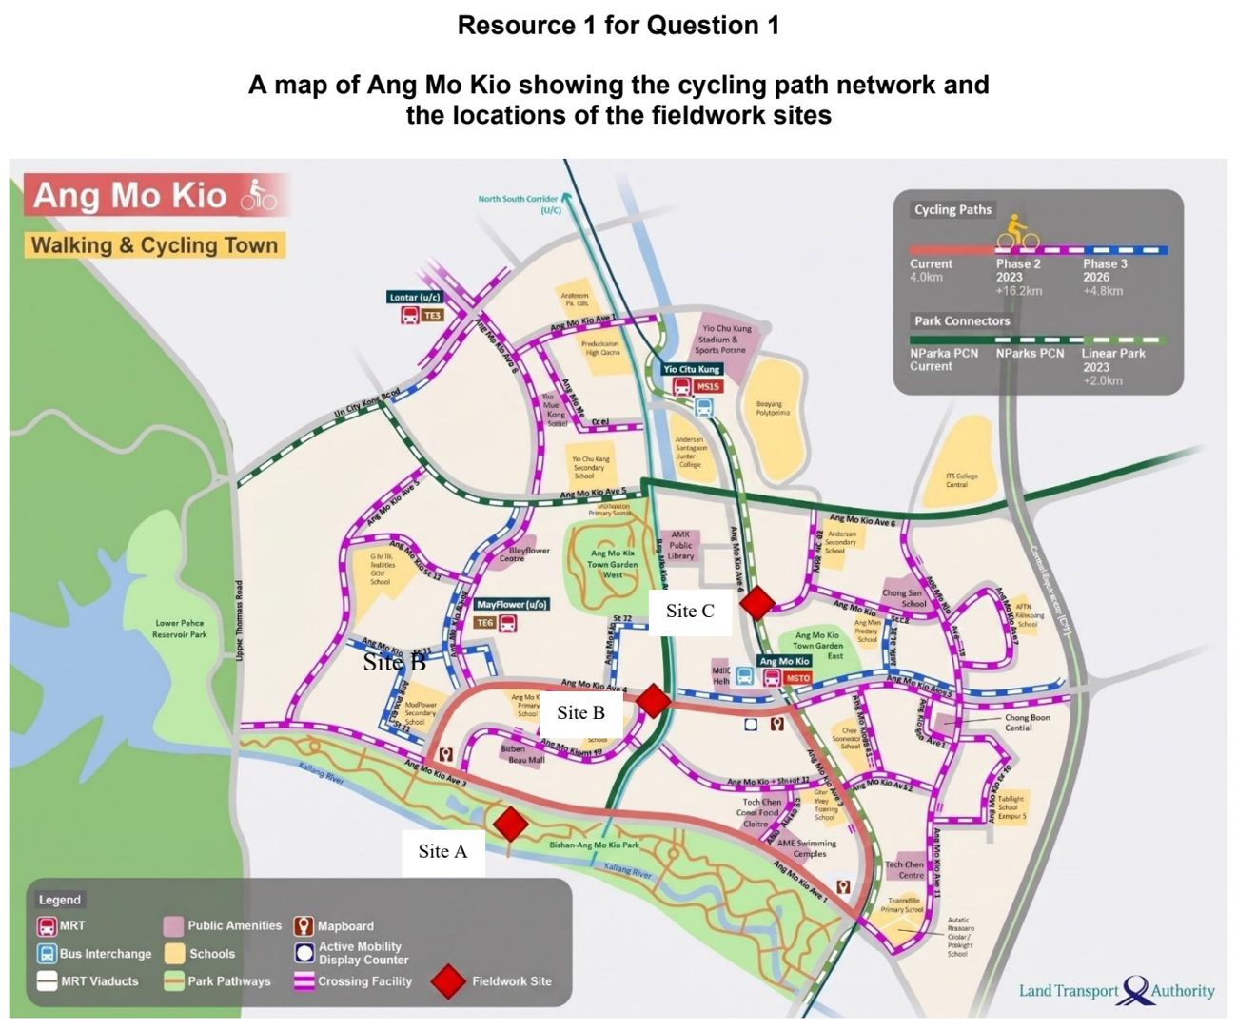

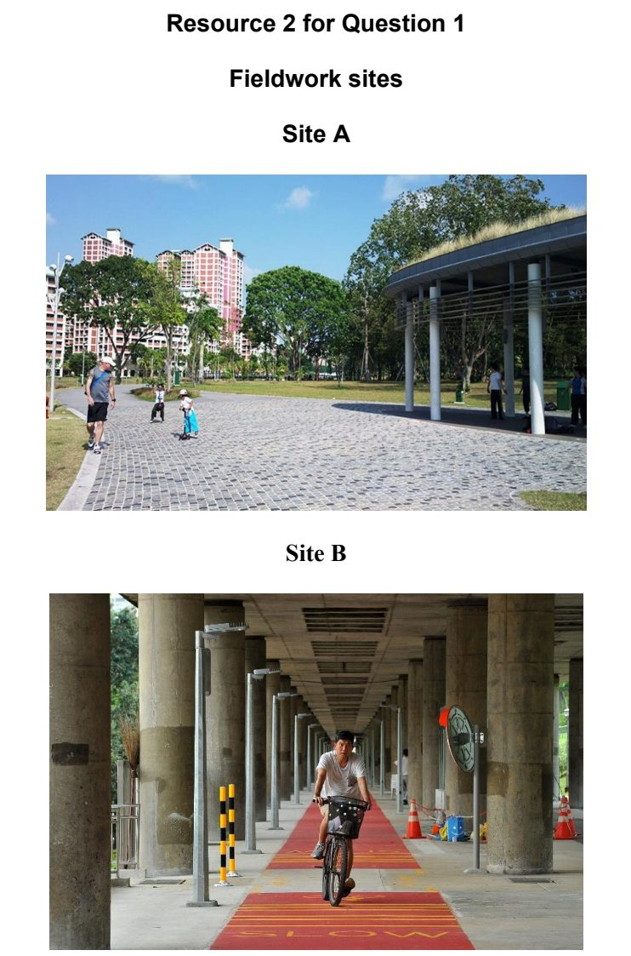
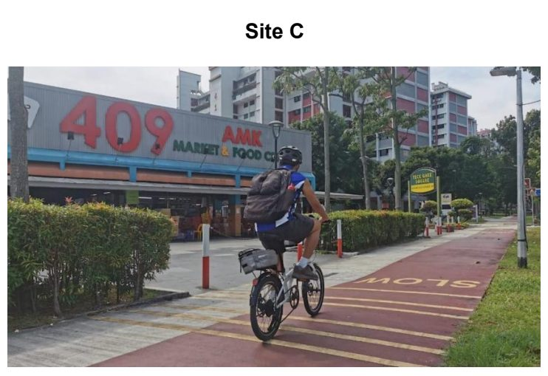

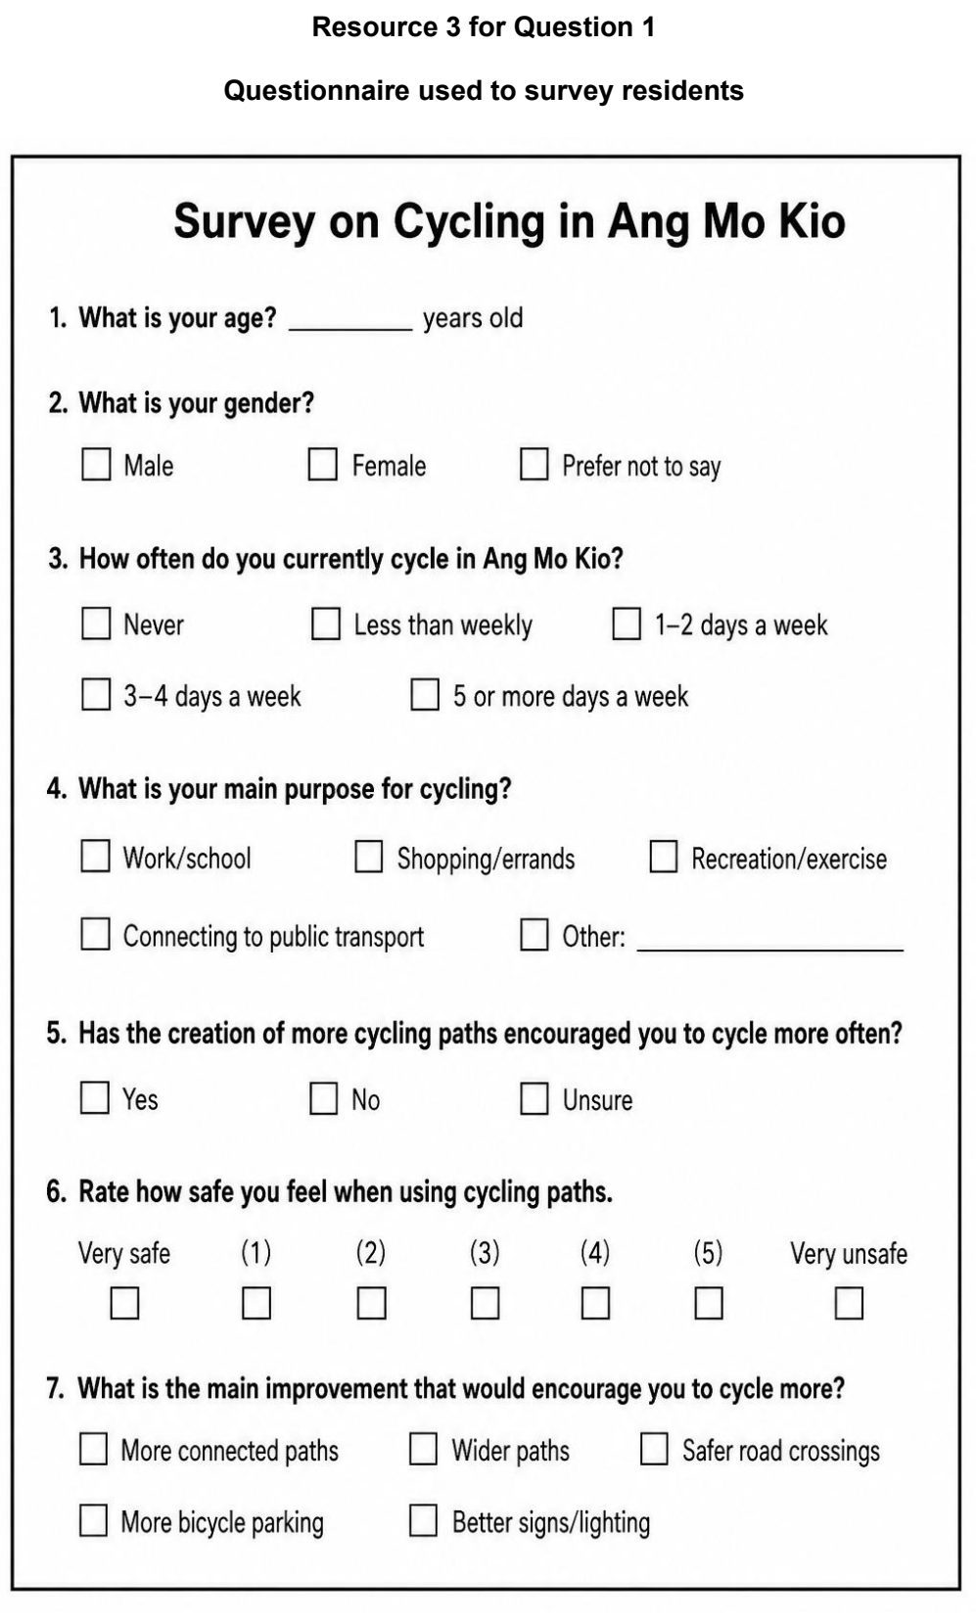

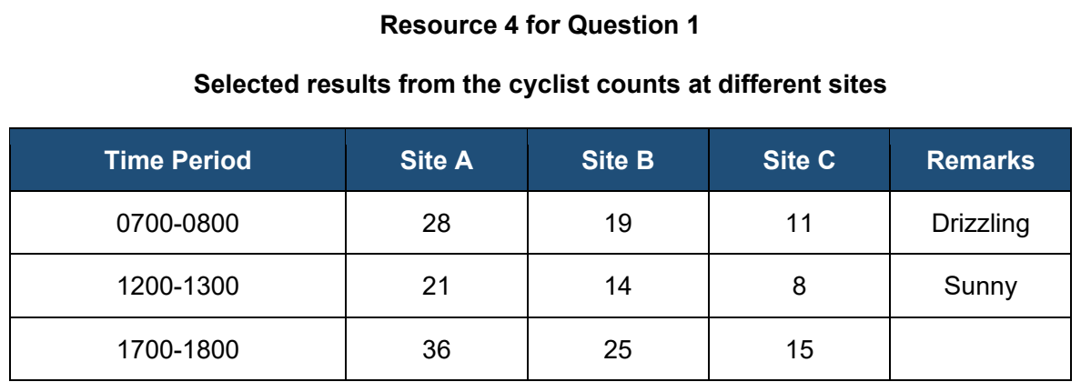

ASRJC 2024 — H1 Paper 1 (8834/01), Q1 [30 marks]
Syllabus: 2 Fieldwork | Fieldwork area: Others
Section A — Cluster 2 Fieldwork
Green Hub @ Bishan is a community project located at the void deck of a HDB block in Bishan to promote sustainability among its residents. It houses an urban community garden and a 24- hour community fridge to encourage food rescue efforts.
A group of 4 Geography students from Singapore decided to investigate the extent to which Green Hub @ Bishan has encouraged sustainable practices among the residents living in its vicinity. They developed the following hypothesis for their fieldwork:
“Green Hub @ Bishan is effective in encouraging sustainable practices among residents living in its vicinity.”
The students visited Green Hub @ Bishan on a Friday afternoon from 3pm to 5pm. They decided to split themselves into two groups to conduct their fieldwork.
1 student stayed at the Green Hub and did a count of the number of residents who either contributed to the community fridge or took food from the community fridge for the duration of their fieldwork investigation. Over 2 hours, the student counted 12 residents in total who either contributed to or took food from the community fridge.
The remaining students conducted questionnaire surveys with residents in the vicinity of the Green Hub to find out if the Green Hub had encouraged them to adopt sustainable practices. They split themselves up between Block 112 (where the Green Hub is located) and Block 113. They used convenience sampling and surveyed 42 residents in total. When they analysed their survey findings, the students noted that 25 residents were aged above 60.
Resource 1 shows the map of the neighbourhood estate where Green Hub @ Bishan is located and the features of Green Hub @ Bishan. Resource 2 shows the recording sheet for the survey. Resource 3 is an extract of the data collected from the survey.
(a) Suggest one limitation of the hypothesis for the investigation. [2]
(b) Explain how the students could minimise the risks associated with their fieldwork. [4]
(c) Suggest why the sampling conducted for the survey was not representative of the residents living in the vicinity of Green Hub @ Bishan. [4]
(d) With reference to Resource 2, explain the strengths and limitations of the recording sheet used for the survey. [5]
(e) Explain one limitation of the data representation method seen in Resource 3 and sketch a diagram to better represent the data collected for Question 3. [5]
(f) The students concluded that Green Hub @ Bishan has been largely effective in encouraging sustainable practices for the residents living in its vicinity. Evaluate the validity of their conclusion. [10]

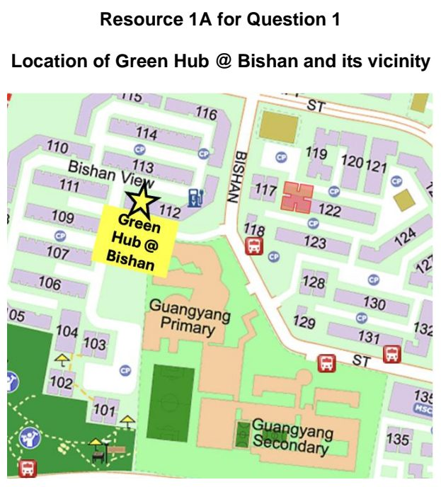

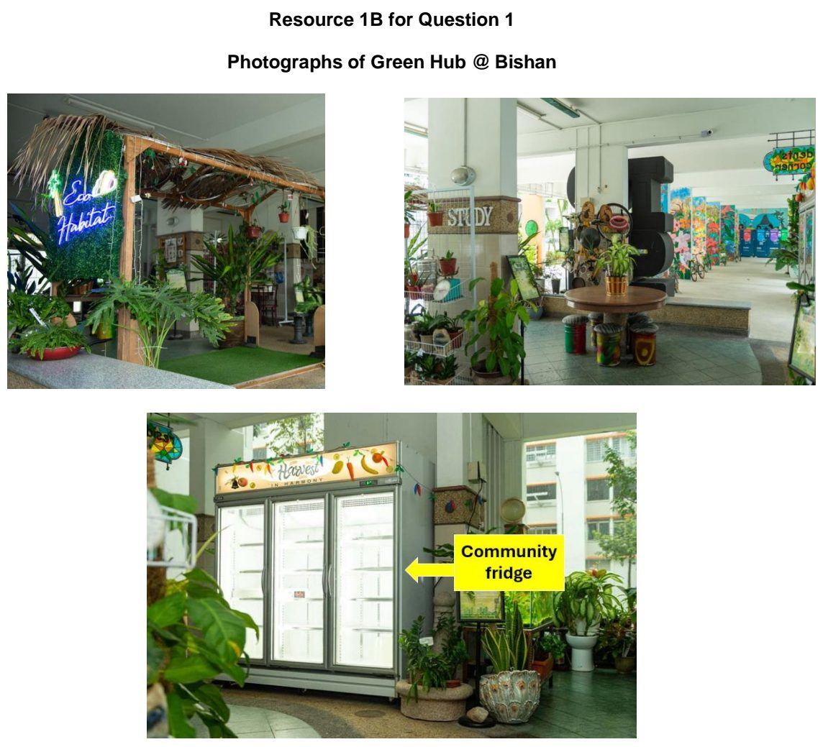

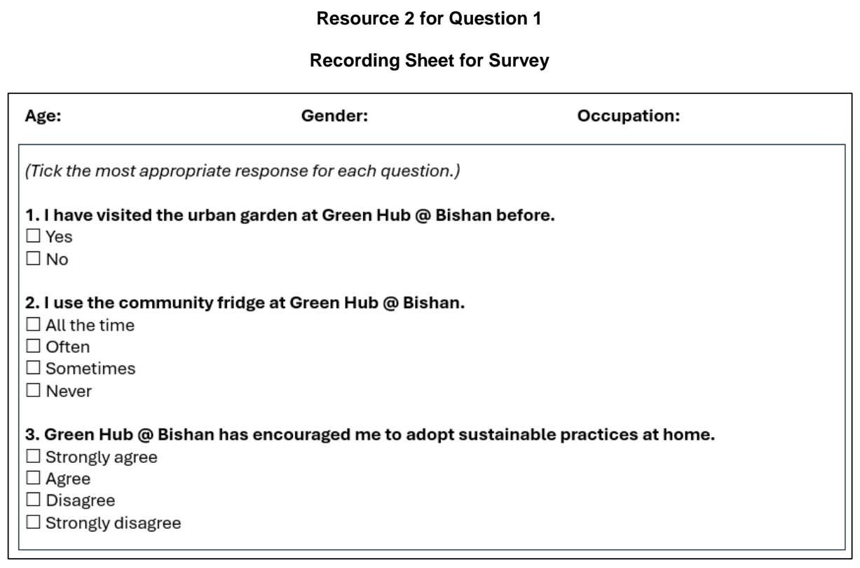

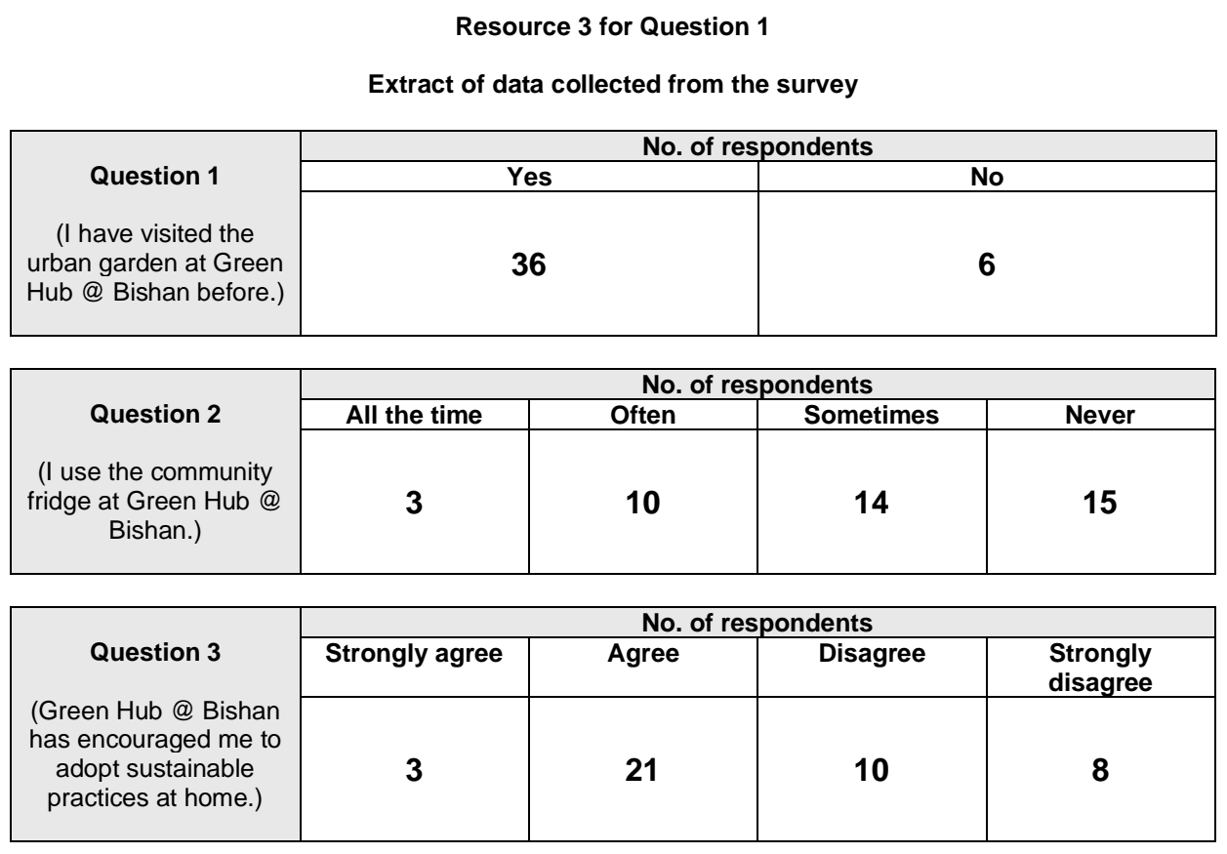

CJC 2024 — H1 Paper 1 (8834/01), Q1 [30 marks]
Syllabus: 2 Fieldwork | Fieldwork area: Others
Section A — Cluster 2 Fieldwork
With the launch of the Singapore Green Plan, which promotes sustainable living as one of its five pillars, a group of five students wanted to find out the extent to which the CJC community of 1200 people was behaving sustainably. They decided to conduct a study on the use of single-use plastics with the following research question:
To what extent does the CJC community use single-use plastics, such as straws, cutlery and packaging, in the school?
For their investigation, they selected a JC2 recess session where they approached anyone who was willing to respond to their questionnaire. They managed to survey a total of 23 people (18 teachers and 5 students). They also embarked on participant observation one day and stood near the drinks stall to see if students requested for straws. Finally, they went to the rubbish bins in the canteen at the end of the same day to observe the amount of plastic waste disposed. Each member went to a bin to observe using his/her own method of measurement.
Resource 1 shows the map of the school canteen. Resource 2 shows the questionnaire questions used by the students. Resource 3 shows the results of the questionnaire and participant observations.
(a) Explain why the students’ research question was suitable for the investigation. [3]
(b) Explain the value of administering a questionnaire and doing participant observations in their research. [5]
(c) Explain how students can improve their sampling method for the survey. [4]
(d) With reference to Resource 2, explain how the students should pilot the questionnaire questions. [3]
(e) Using Resource 3, describe the usage of single-use plastics in CJC. [5]
(f) Evaluate the students’ investigation of the usage of single-use plastics in CJC. [10]

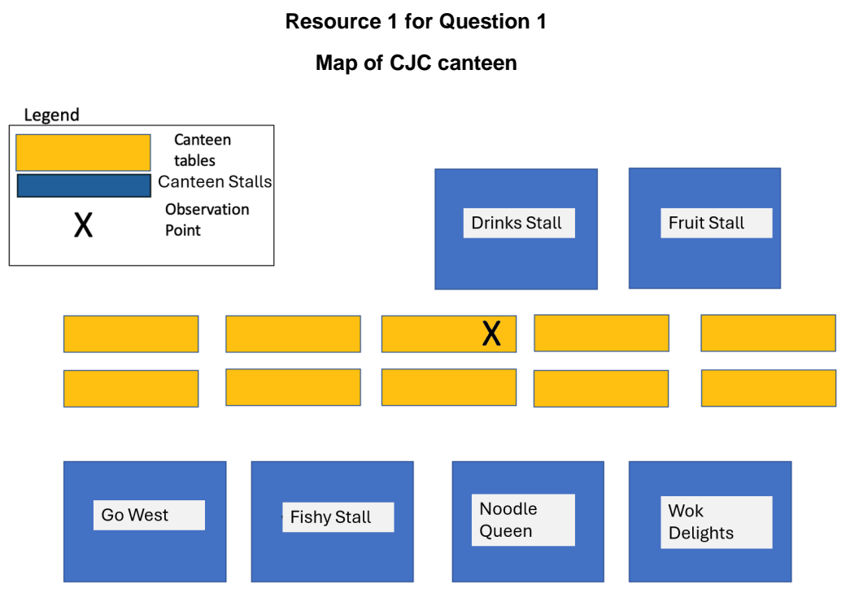

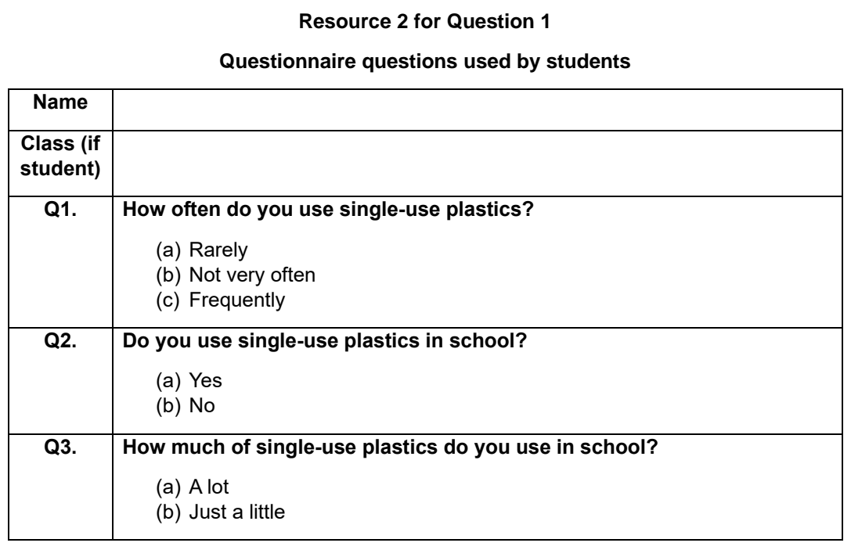

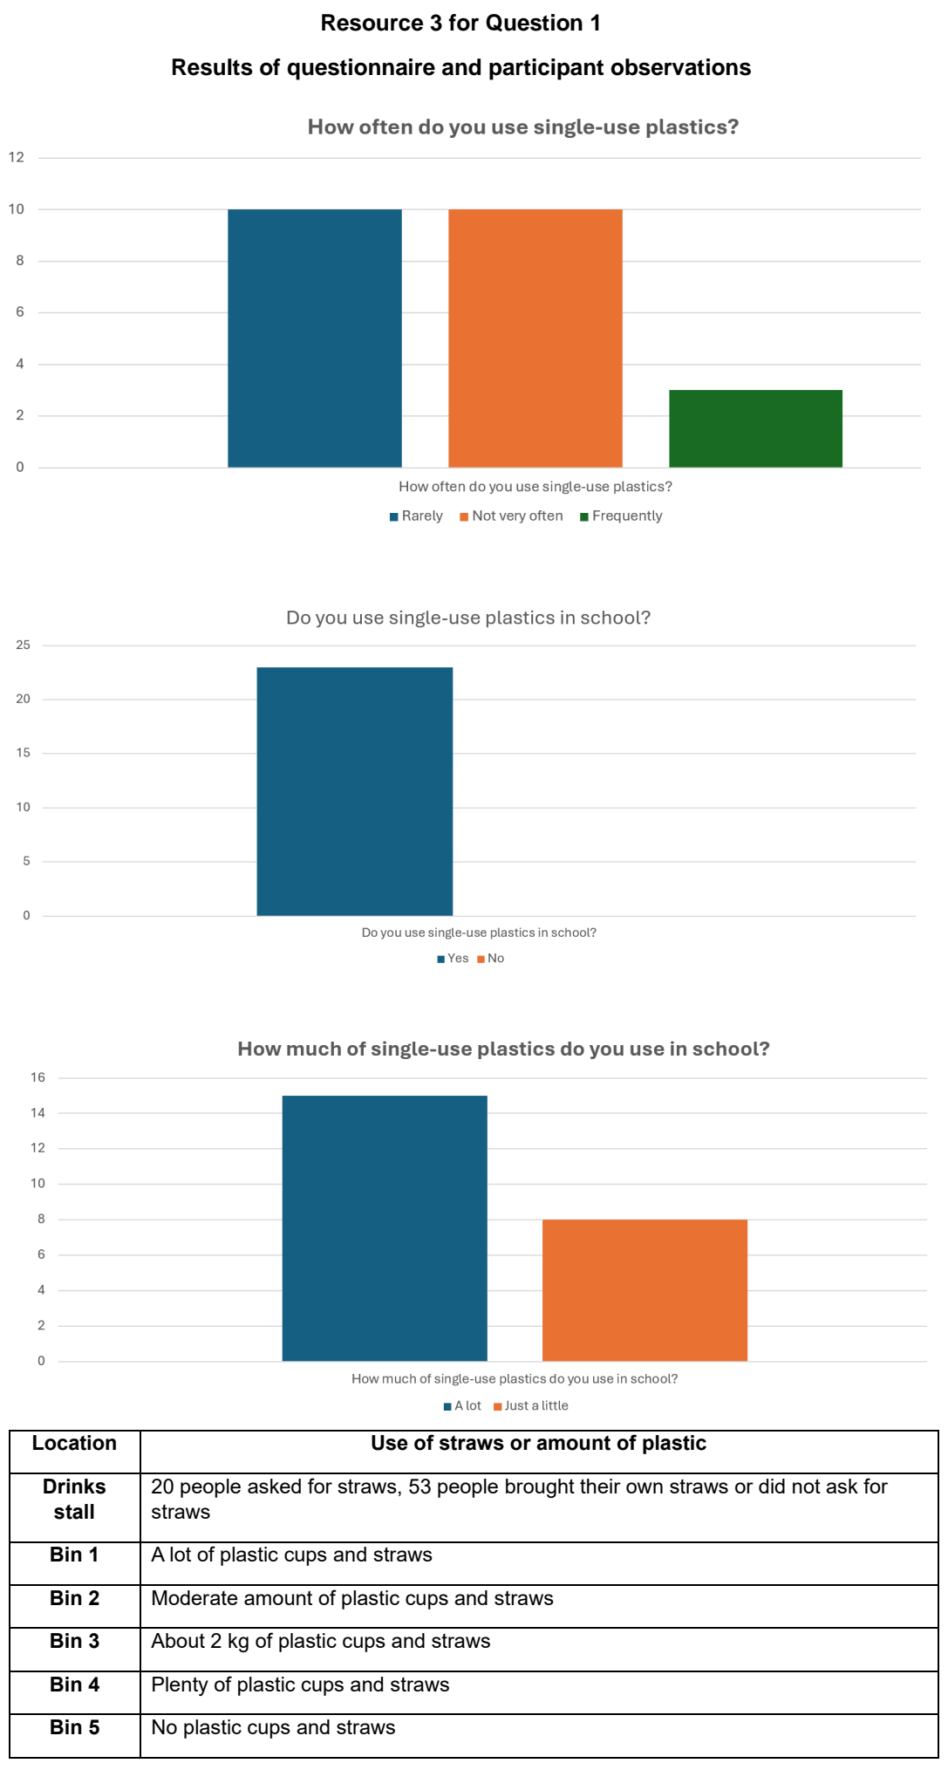

DHS 2024 — H1 Paper 1 (8834/01), Q1 [30 marks]
Syllabus: 2 Fieldwork | Fieldwork area: Others
Section A — Cluster 2 Fieldwork
Four students undertook an investigation of the effectiveness of the initiative ‘Reuse and Return Project’ to encourage the use of reusable containers at a hawker centre in Tampines, Singapore. Customers have a choice of either using single-use containers or reusable containers for food to go. Each single-use container costs $0.30 and each reusable container costs $1 and there is a refund of this charge upon the return of each reusable container. 8 stalls participated in this initiative.
The students saw posters at the food centre which aimed to spread awareness of the initiative. The students surveyed customers and conducted face-to-face interviews with selected respondents at one of the participating stalls. The students also set up a self-recording camera (Resource 1) to record the activity at the stall. The collection of the data was done between 11am and 1pm on a Monday in December.
Resource 1 shows the location of the hawker stall where the students collected the data. Resource 2 shows selected results of the questionnaire survey. Resource 3 shows responses from selected interviewees.
(a) Suggest a suitable research question for the investigation and explain why it is suitable. [4]
(b) Explain some possible issues related to risks and research ethics about the students’ data collection shown in Resource 1. [5]
(c) With reference to Resource 2, describe the results for the customers’ choice of container for food to go. [5]
(d) The students concluded that the initiative has not been effective. With reference to all resources, evaluate the validity of their conclusion. [10]
(e) The town council has asked the group to gather information that will help to reduce single-use plastic packaging in supermarkets in a neighbourhood. Explain how the group would go about gathering the information. [6]

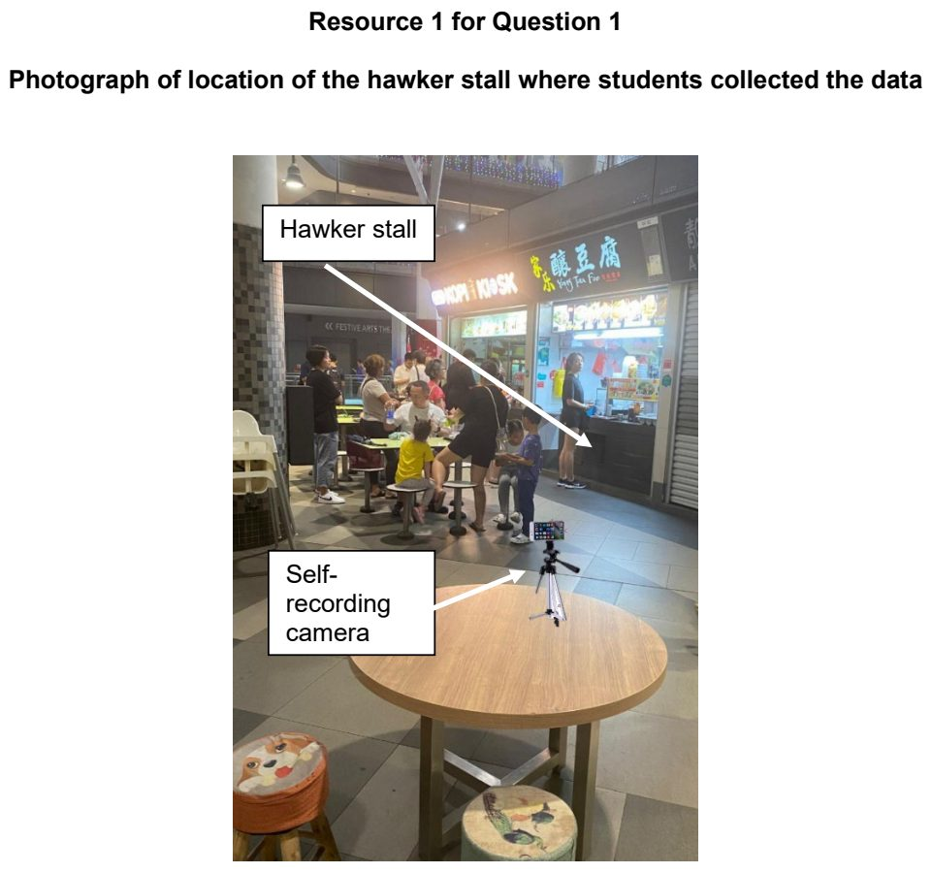

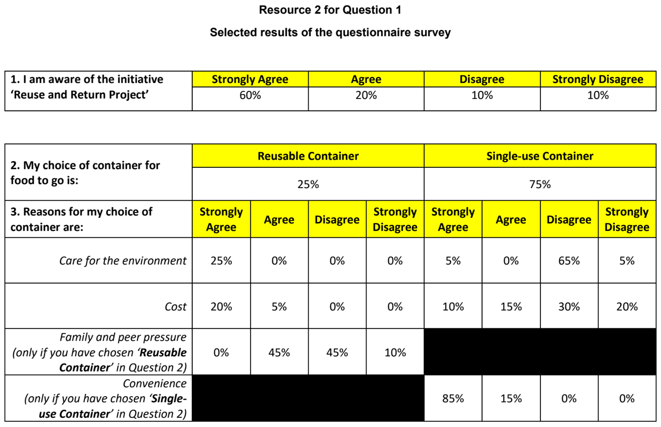

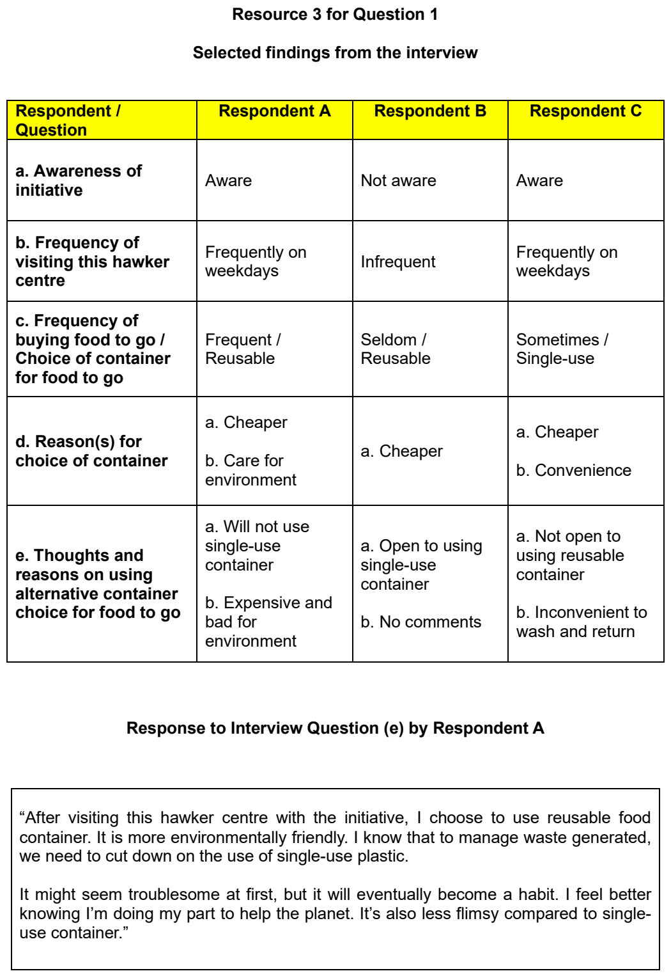

EJC 2024 — H1 Paper 1 (8834/01), Q1 [30 marks]
Syllabus: 2 Fieldwork | Fieldwork area: Others
Section A — Cluster 2 Fieldwork
Four students from Eunoia Junior College decided to investigate the community’s response to the Green Hub, a community space located at the void deck under Block 112 Bishan Street 12. The Green Hub aims to promote sustainable practices amongst the community.
The students came up with the following research question:
‘To what extent is Green Hub effective in promoting sustainable practices in the neighbourhood?’
The students collected their primary data on a Monday morning during their June Holidays, from 9am to 11am.
The students decided to first conduct an on-site observation. The students noted down their observations of the activities in Green Hub and took photographs of the various eco-friendly features available.
The students then proceeded to conduct a survey questionnaire with 24 users of Green Hub and passers-by.
After students have collated their survey results, they interviewed 3 elderly female users who frequent Green Hub during their fieldwork.
Resource 1 shows photographs of the Community Garden and Garden at Green Hub. Resource 2 shows a summary of the various eco-friendly features available at Green Hub. Resource 3 shows the survey questionnaire conducted by the students. Resource 4 shows the survey results for Questions 2, 3 and 4 collated from the survey respondents.
(a) Explain one strength and one weakness of the students’ research question. [4]
(b) With reference to Resources 1 and 2, suggest how the students could minimise potential impacts conducting their fieldwork at Green Hub. [6]
(c) Explain why it is good to administer the survey questionnaires before conducting the interviews. [3]
(d) With reference to Resources 1, 2 and 3, explain how the design of the survey questionnaire shown in Resource 3 can be improved. [3]
(e) Using Resource 4, compare the usage of Green Hub amongst the survey respondents. [4]
(f) The students concluded that Green Hub was effective in promoting sustainable practices in the neighbourhood. Evaluate the validity of their conclusion. [10]

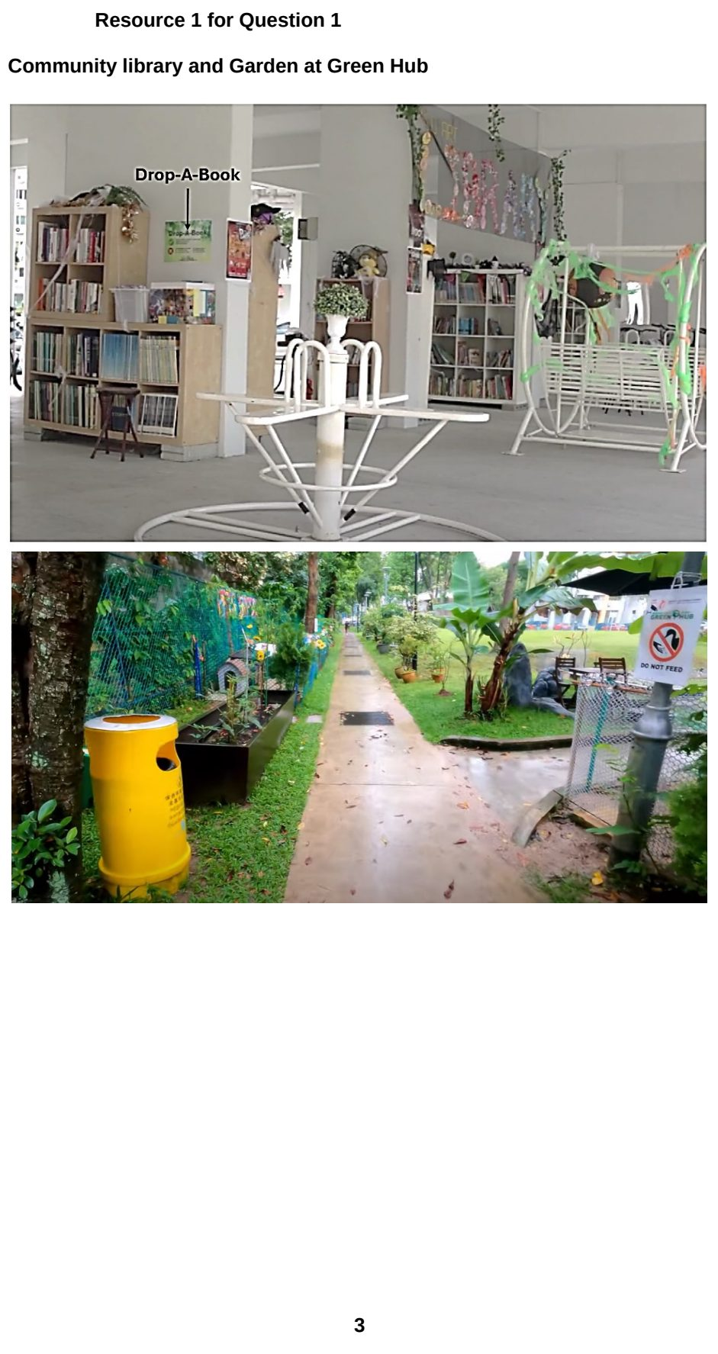

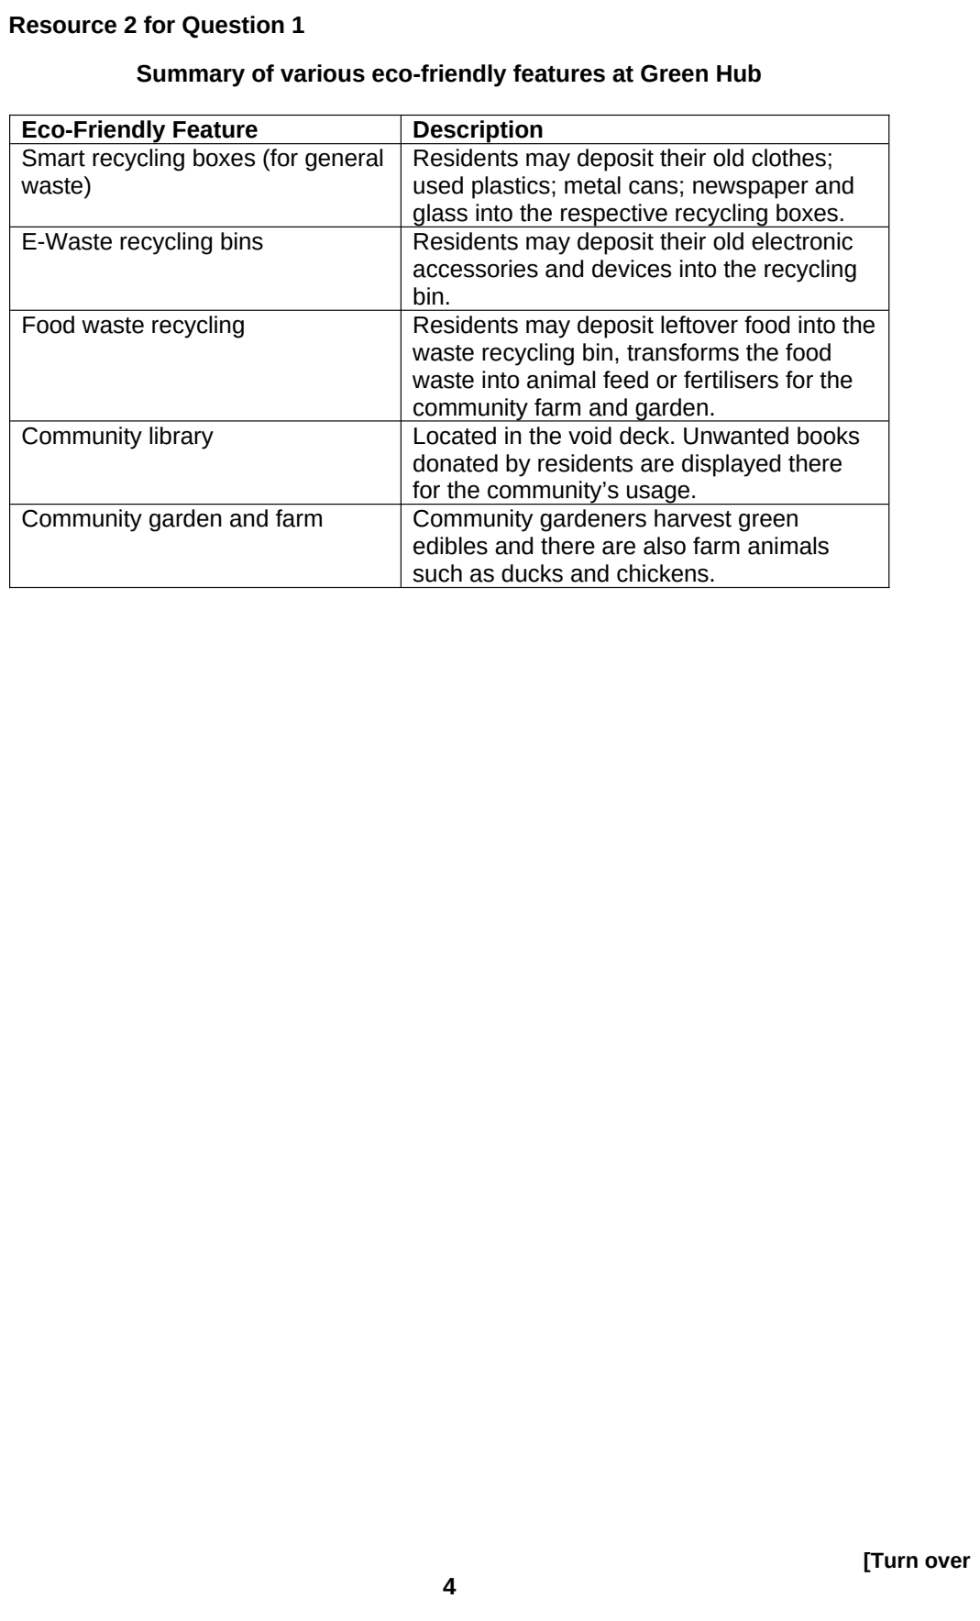

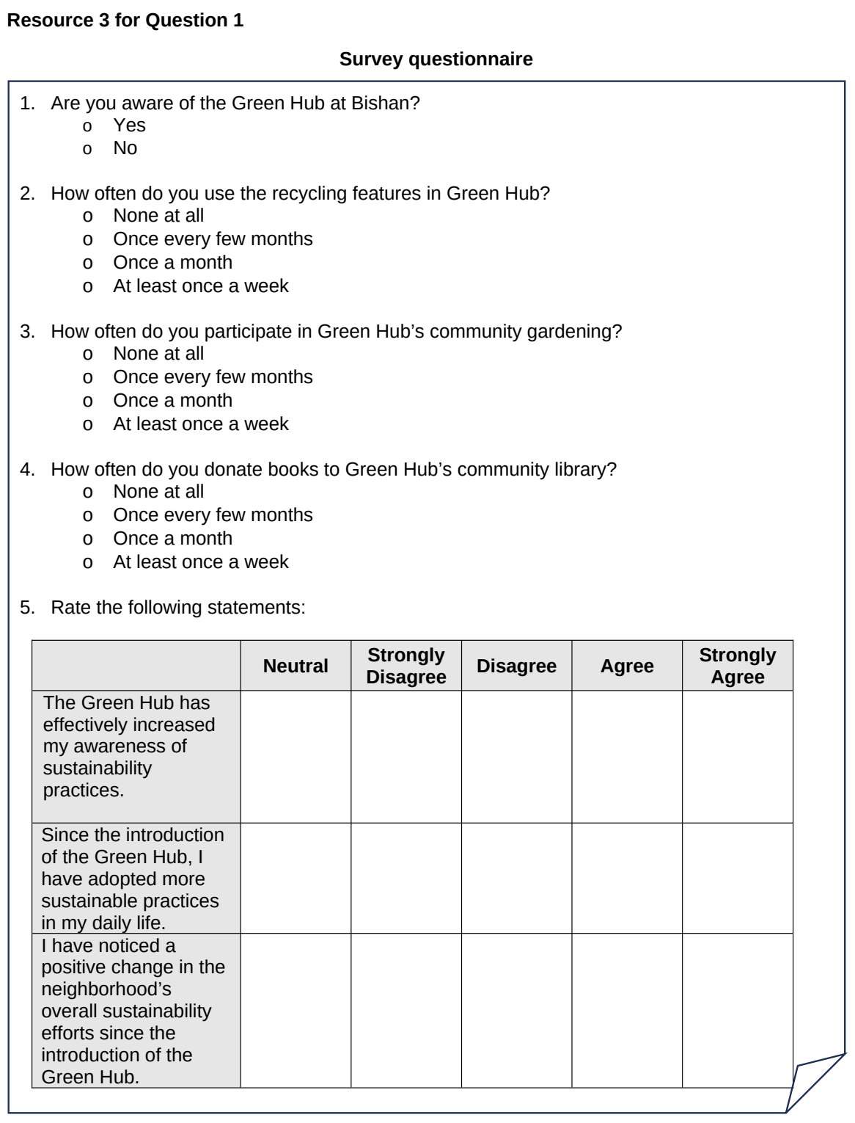

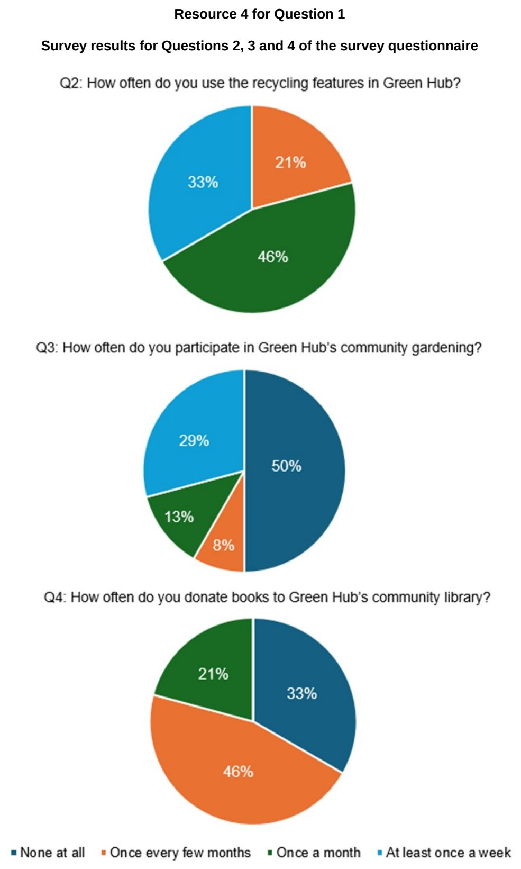

JPJC 2024 — H1 Paper 1 (8834/01), Q1 [30 marks]
Syllabus: 2 Fieldwork | Fieldwork area: Others
Section A — Cluster 2 Fieldwork
Ang Mo Kio is Singapore’s first cycling town, designed to promote cycling as a sustainable mode of transportation. Initial construction was completed in 2016, with ongoing works expected to finish by 2025. These efforts include increasing the length and interlinking of dedicated cycle paths to encourage cycling. The initiative underscores the importance of sustainable transportation in addressing climate change at the community level.
A group of 10 students decided to investigate the effectiveness of the promotion of cycling in changing commuting habits within Ang Mo Kio. They designed the following hypothesis for their study:
‘The promotion of cycling in Ang Mo Kio has been effective in changing commuting habits in the neighbourhood.’
The students crafted a questionnaire as shown in Resource 3. They planned to conduct surveys using the questionnaire on two weekdays in the month of June at five sites in Ang Mo Kio, as shown in Resources 1A and 1B. At each site, 20 respondents would have five minutes each to respond to the questionnaire. Resource 2 shows survey site 1 in Ang Mo Kio. Resource 4 shows selected results from the survey.
(a) Explain why this hypothesis is appropriate for the investigation. [3]
(b) Using Resources 1A and 1B, suggest why site 1 might be a better location than the other sites for the students to conduct the survey. [4]
(c) Explain a suitable sampling method to select survey participants. [4]
(d) With reference to Resource 2, suggest how the students can conduct the research ethically. [4]
(e) Explain the limitations of the questionnaire as shown in Resource 3. [5]
(f) Using all the resources, evaluate the usefulness of the students’ investigation. [10]

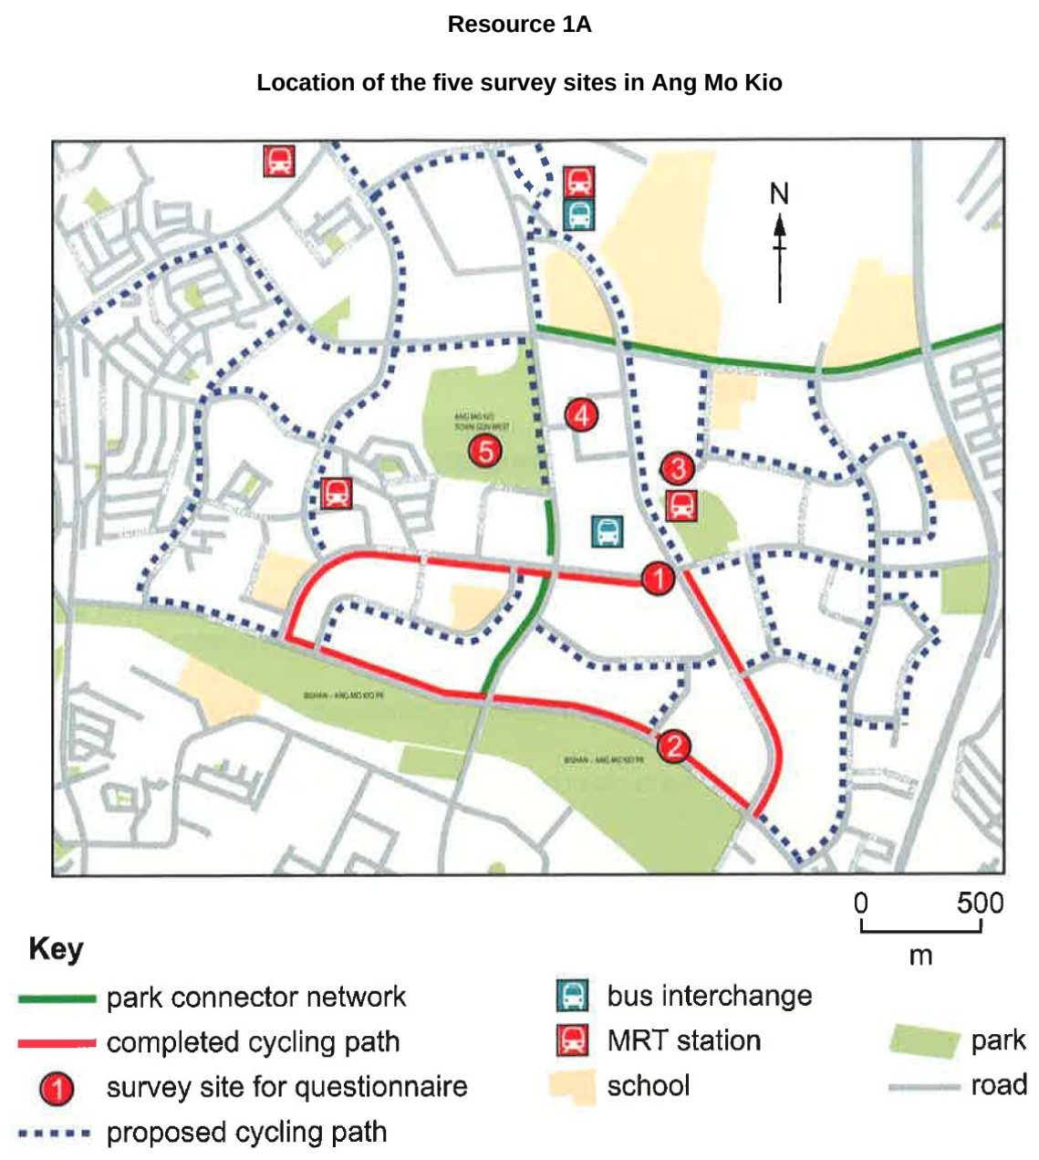

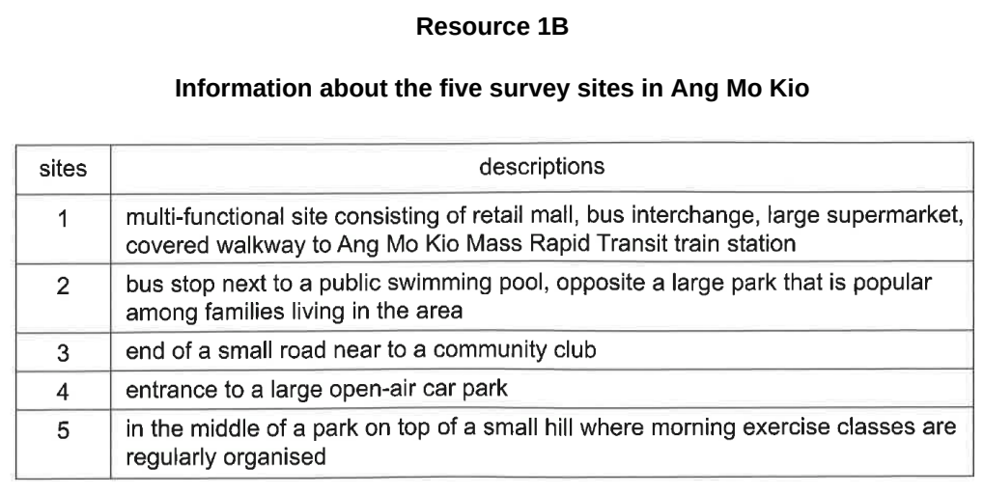

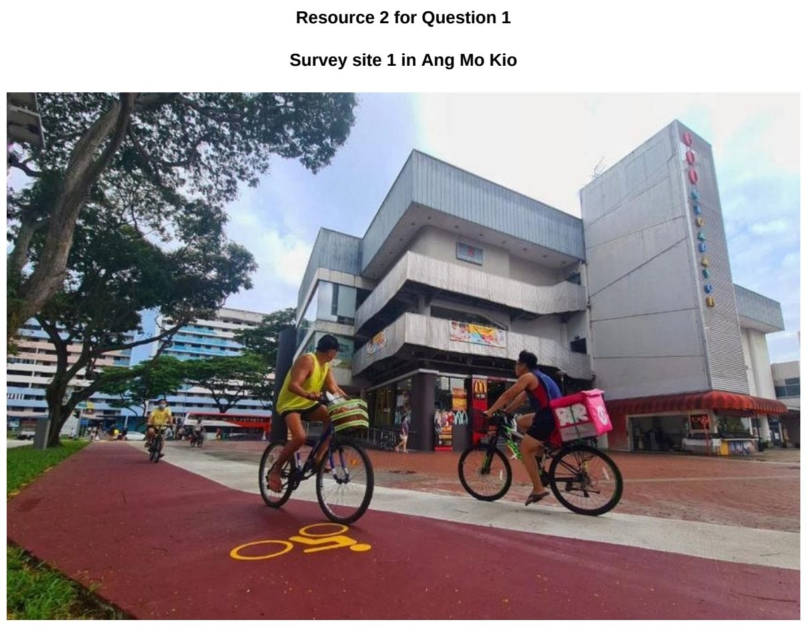

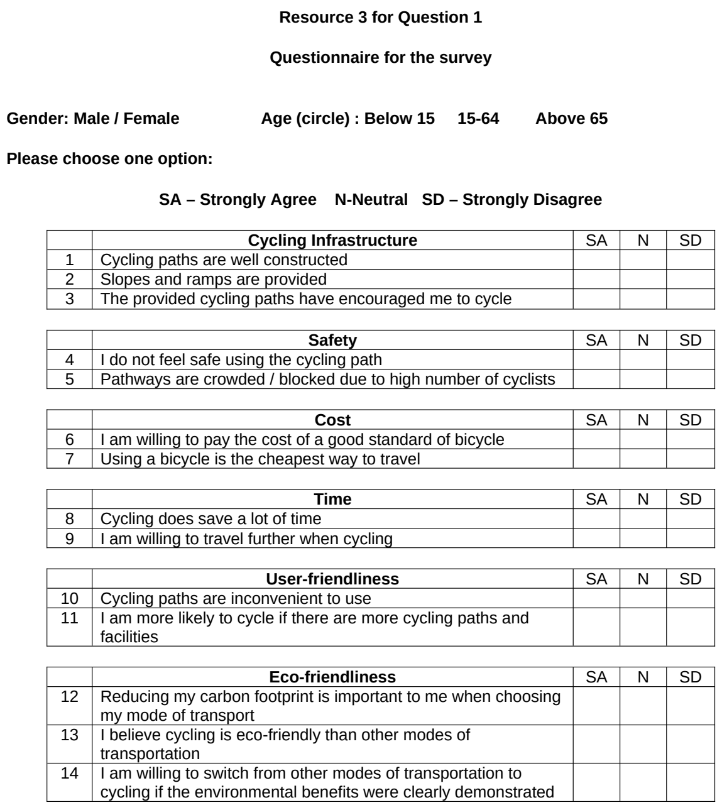

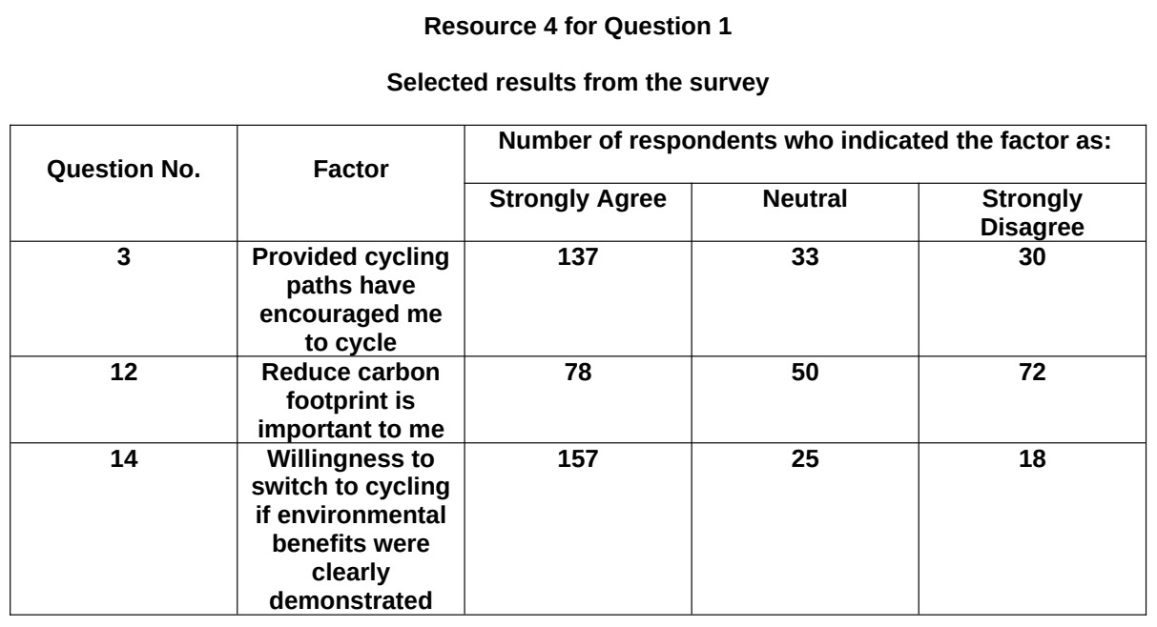

JPJC 2026 — H1 Paper 1 (8834/01), Q1 [30 marks]
Syllabus: 2 Fieldwork | Fieldwork area: Others
Section A — Cluster 2 Fieldwork
A group of six students in Singapore carried out fieldwork to investigate recycling efforts among different age groups in Singapore. The aim of the investigation was to compare the participation of youths in the Beverage Container Return Scheme with that of other older age groups. The Beverage Container Return Scheme encourages consumers to “Return Right” by returning their empty beverage containers made of plastic and metal at dedicated return points across Singapore. The hypothesis was:
Youths are more inclined to participate in the Beverage Container Return Scheme than other age groups.
To test their hypothesis, they counted the number of people (including youths) returning empty beverage containers at return points in Bukit Panjang. Among all the return points in the neighbourhood, three were chosen. The students conducted the study from 8:00 am to 11:00 am on a Friday morning, and they divided themselves into three groups to collect data at the three return points concurrently. In addition, the students also administered questionnaire surveys with youths at the return points who agreed to participate in the study.
Resource 1A is a map showing the locations of the three return points in Bukit Panjang marked as X, Y and Z. Resource 1B shows photographs of the three return points. Resource 2 shows the data collected at each site. Resource 3 shows the questionnaire used by the students.
(a) Suggest how the students’ hypothesis can be improved. [3]
(b) With reference to Resources 1A and 1B, explain one strength and one limitation of the selected return points. [4]
(c) Suggest how students could minimise the impact of their investigation at the three return points. [4]
(d) Describe how the data shown in Resource 2 may be represented. [4]
(e) Explain how the questionnaire shown in Resource 3 may be improved. [5]
(f) Evaluate the data collection methods for this investigation. [10]

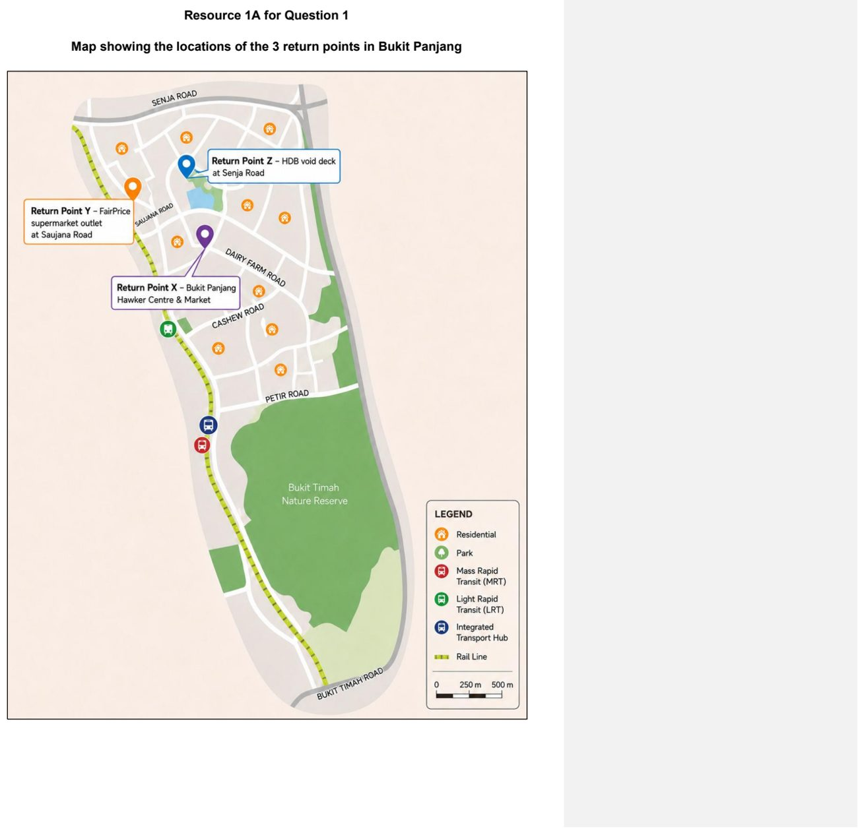

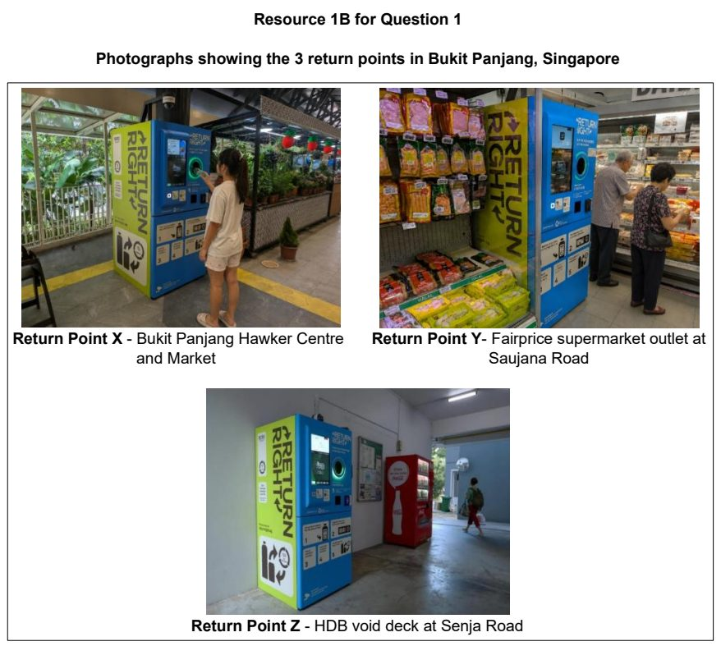

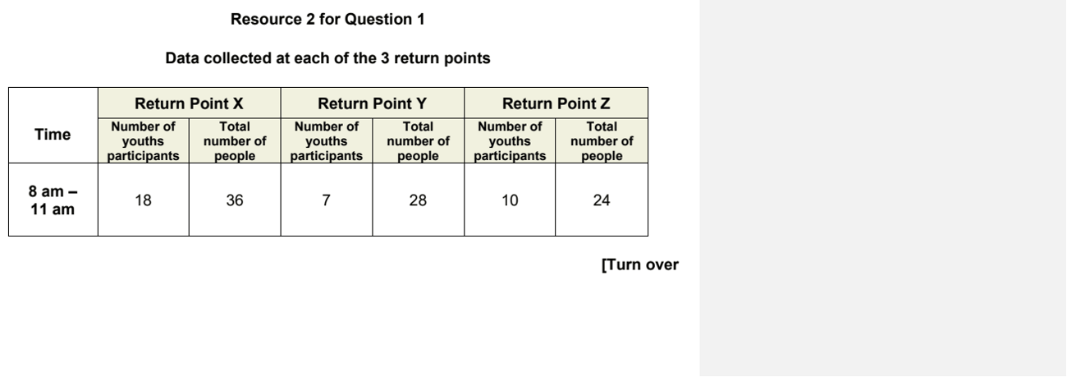

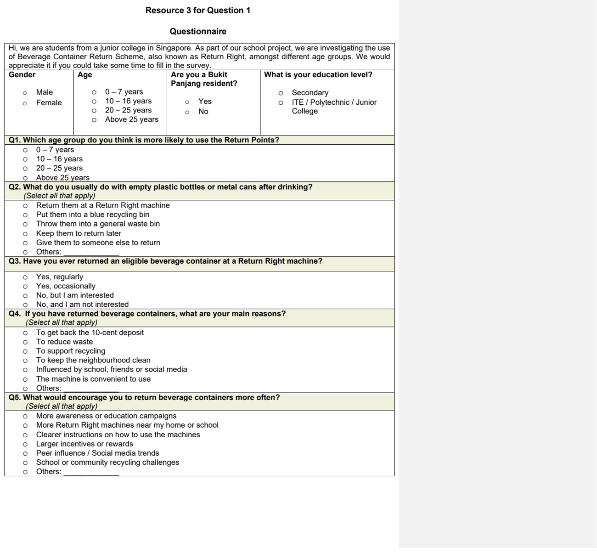

NJC 2025 — H1 Paper 1 (8834/01), Q1 [30 marks]
Syllabus: 2 Fieldwork | Fieldwork area: Others
Section A — Cluster 2 Fieldwork
A group of eight students conducted a geographical investigation into the effectiveness of local food waste reduction efforts in the Bishan neighbourhood of Singapore. These efforts include a 24-hour community fridge and a food recycling locker at Block 112 Bishan Street 12, and periodic food rescue and redistribution events at Bishan Community Club. Their hypothesis was:
“Residents who live nearer to community-based food waste initiatives are more likely to participate in them.”
To test this hypothesis, the students first visited Block 112 Bishan Street 12 and Bishan Community Club on a Saturday afternoon, where they interviewed four resident volunteers to understand how the residents engage with local food waste initiatives. On the following Saturday, they then administered a questionnaire to 40 residents at Bishan Bus Interchange.
Resource 1A is a map showing the locations of their investigation sites and food waste reduction efforts in the Bishan neighbourhood. Resource 1B shows photographs of food waste reduction efforts at Bishan Neighbourhood. Resource 2 shows selected interview responses. Resource 3 shows a survey form used by the students to collect responses. Resource 4 shows a summary of selected survey results.
(a) Explain why this hypothesis is appropriate for investigating food waste reduction. [4]
(b) Suggest ethical considerations the group should take into account when collecting data on-site. [3]
(c) With reference to Resource 2, describe how the data collected from the interviews can be analysed. [5]
(d) With reference to Resource 3, explain the strengths of the questionnaire used in this investigation. [4]
(e) Using Resource 4, sketch a graph to present top reasons for participation in local food waste reduction efforts. [4]
(f) Based on the students’ investigation, the students concluded that their hypothesis was proven wrong. With reference to all resources, evaluate the validity of the fieldwork. [10]

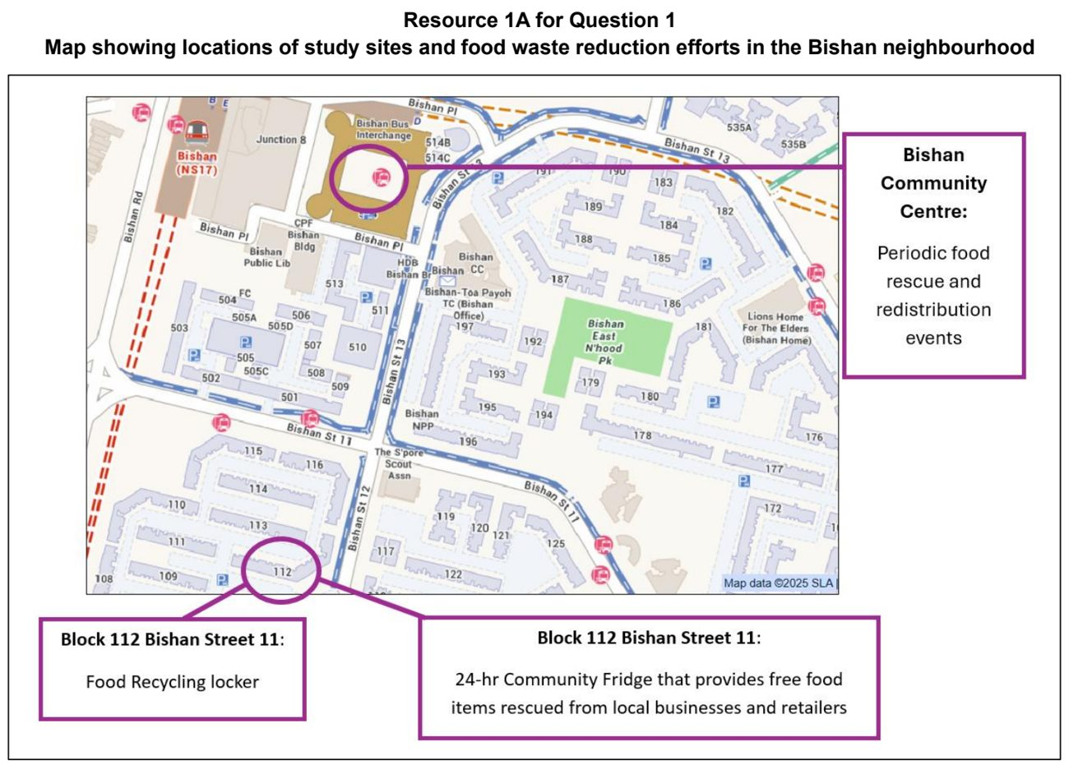

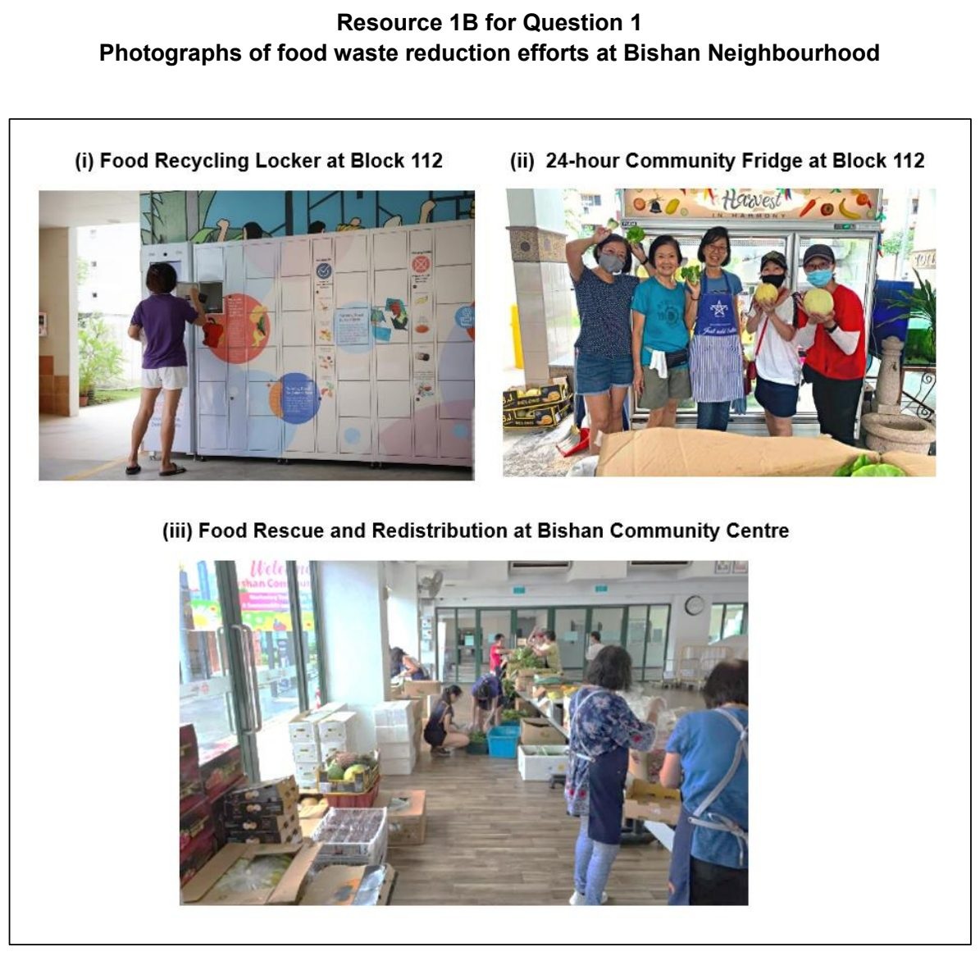

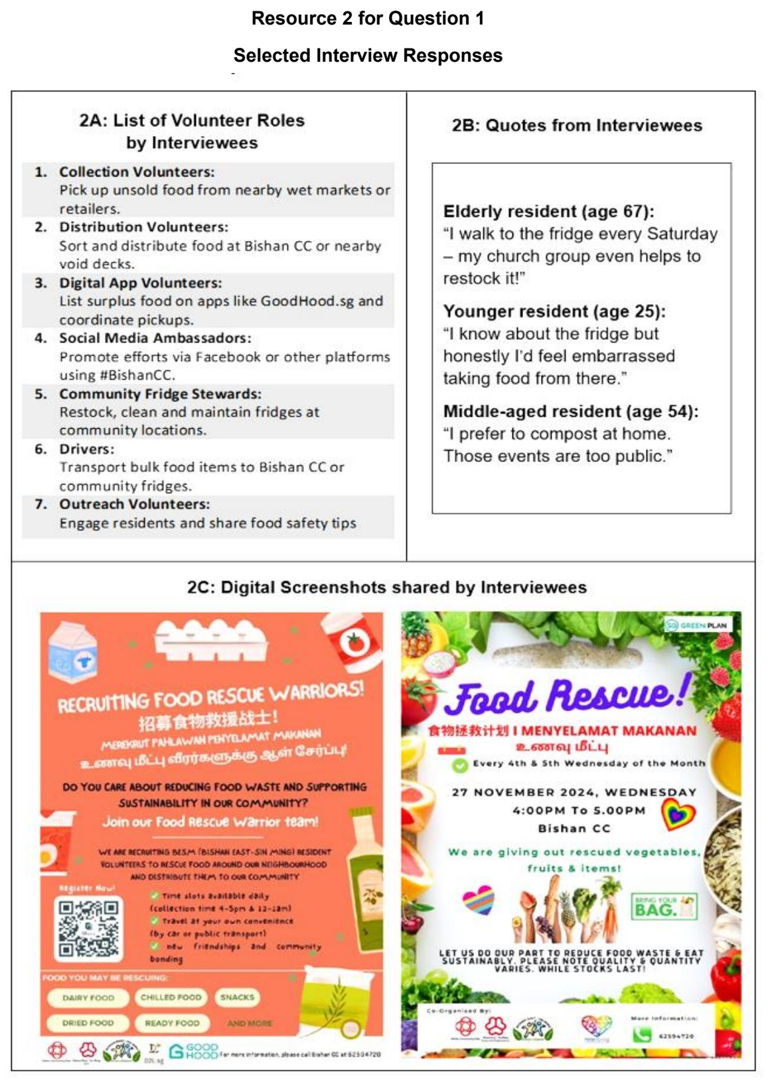

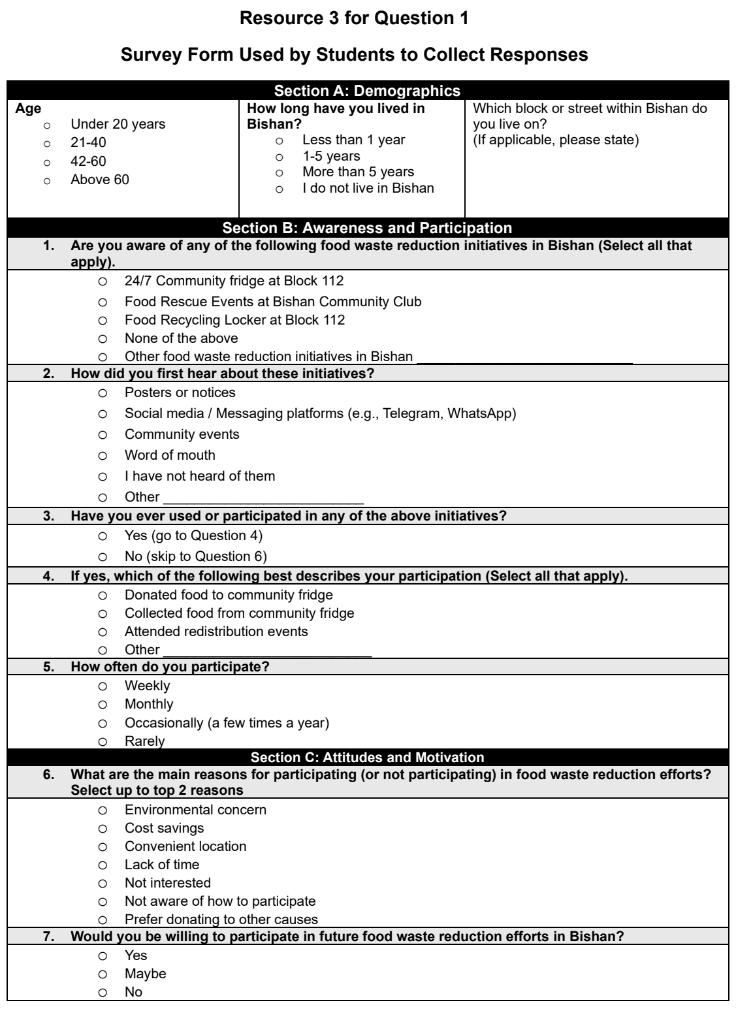

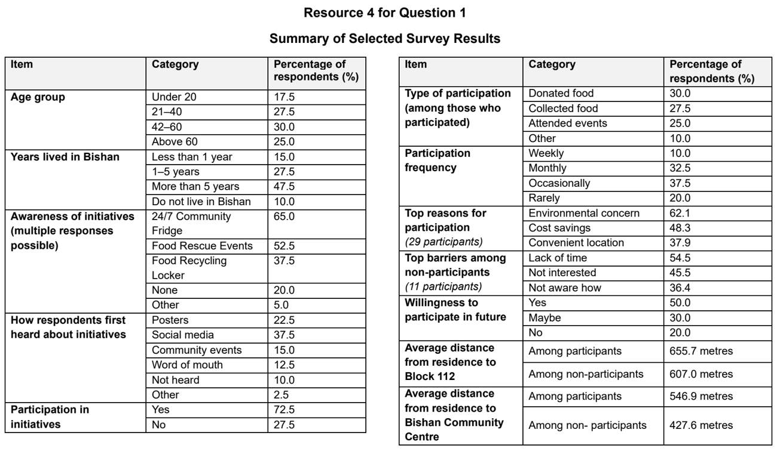

NJC 2026 — H1 Paper 1 (8834/01), Q1 [30 marks]
Syllabus: 2 Fieldwork | Fieldwork area: Others
Section A — Cluster 2 Fieldwork
A group of six students in Fremantle, a port city in Australia, wanted to investigate the local community’s perceptions about sustainable healthy diet practices.
Sustainable healthy diets are defined as “dietary patterns that promote all dimensions of individuals’ health and wellbeing; have low environmental pressure and impact; are accessible, affordable, safe and equitable; and are culturally acceptable” (Food and Agriculture Organization of the United Nations (FAO) and World Health Organization (WHO), 2019).
They came up with the following hypothesis for their investigation:
Adults living in Fremantle with higher educational attainment (above pre-university level) are more likely to be concerned about sustainable healthy diet practices.
They conducted a survey, using a questionnaire, with 100 residents aged from 18 to 75 at two sites on a Friday from 11 am to 2 pm. They used convenience sampling to select the residents for the survey. Two of the residents also agreed to participate in a face-to-face interview to elaborate on their perceptions of sustainable healthy practices.
Resource 1 is a map showing the locations of Site A (Freemantle Markets) and Site B (John Curtin College of the Arts) where the survey was conducted. Resource 2 shows photographs of Sites A and B. Resource 3 shows the number of residents surveyed according to educational attainment. Resource 4 is the questionnaire used in the investigation. Resource 5 shows a summary of responses to selected questions in the questionnaire.
(a) Explain why the students’ hypothesis is appropriate for the investigation. [3]
(b) With reference to Resources 1, 2 and 3, suggest how the students could have obtained a more representative sample of residents in Fremantle. [4]
(c) With reference to Resource 2, suggest how the students could minimise potential risks when conducting the survey. [4]
(d) With reference to Resource 4, explain the strengths and limitations of the questionnaire used in the investigation. [4]
(e) Sketch a graph to present the data that the students obtained for Q3 in Resource 5 and explain its suitability. [5]
(f) Evaluate the validity of the students’ investigation. [10]

